|  |  |
| --- | --- |
| |  | | --- | | **MINISTRY OF EDUCATION AND TRAINING** | |
| Capstone Project Document |
| Vietnamese Study System for Japanese |
| |  |  |  |  | | --- | --- | --- | --- | | Veazy Team | | | | | **Group Members** | Nguyễn Ngọc Minh | SE03174 | Minhnnse03174 | |  | Nguyễn Trọng Duy | SE03235 | Duyntse03235 | |  | Nguyễn Hoàng Linh | SE03295 | Linhnhse03295 | |  | Đào Thanh Tùng | SE03056 | Tungdtse03056 | |  | Phạm Đức Thắng | SE02722 | Thangpdse02722 | |  | Nguyễn Hồng Quân | SE02920 | Quannhse02920 | | **Supervisor** | Mr. Nguyễn Văn Sang | Lecturer at FPT University | | | **Capstone Project code** | **Veazy** | | |   **Hanoi, 24th August, 2016** |

# Table of contents

Table of contents 2

Definition and Acronyms 11

1 Introduction 13

1.1 Project information 13

1.2 Project members 13

1.2.1 Supervisors 13

1.2.2 Team members 13

1.3 Purposes 14

1.4 Abstract 14

1.5 Literature Review 15

1.6 Proposal 17

1.6.1 The idea 17

1.6.2 Objectives 17

1.6.3 Brief description about system 17

1.6.4 System features 17

1.7 Benefit From Project 18

1.7.1 For development team 18

1.7.2 For Community 19

1.8 Critical Assumption and Constraints 19

1.8.1 Assumption 19

1.1.2 Constraints 19

1.9 Potential Risk 20

2 Software Project Management 21

2.1 Project Overview 21

2.1.1 Project Description 21

2.1.2 Purposes of Project 21

2.1.3 Scope Statement 21

2.1.4 The functions of Project 22

2.2 Project Organization 24

2.2.1 Organizational Structure 24

2.2.2 Project Process 25

2.3 Project Schedule 27

2.3.1 Milestone and Deliverables 27

2.3.2 Gantt chart 29

2.4 Risk Management 30

2.5 Communication Management 31

2.6 Tools and Infrastructure 33

2.7 Configuration Management Plan 34

3 Software Requirement Specification 35

3.1 Overview 35

3.1.1 Purpose 35

3.1.2 Scope 35

3.2 User Requirements Specification 36

3.2.1 Business Process Overview 36

3.2.2 Product Features 46

3.3 Sofware Requirements Specification 47

3.3.1 Overall Description 47

3.3.2 Entity Relation Model 50

3.3.3 Functionality 57

3.3.4 Non-Functional Specification Requirements 126

4 Software Design Description 128

4.1 SDD Overview 128

4.2 Architecture Design 128

4.2.1 MVC Model 128

4.2.2 SpringMVC framework 130

4.2.3 HibernateORM framework 133

4.2.4 AngularJS framework 135

4.2.5 Architectural Representation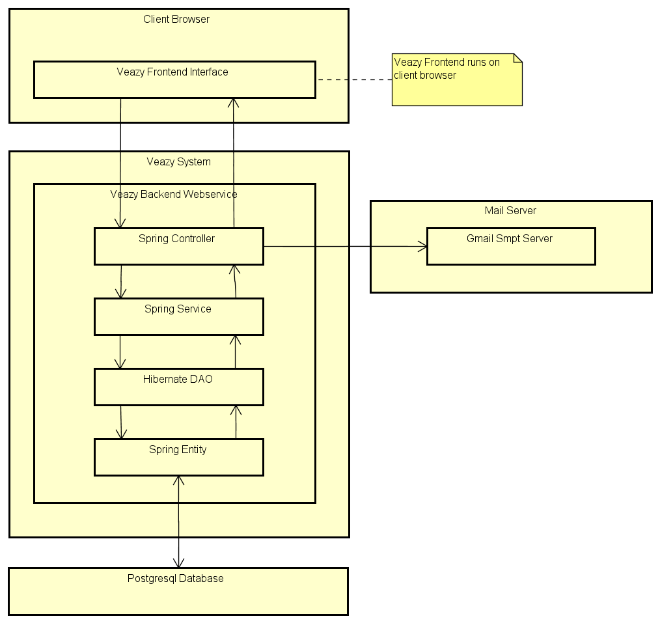 137

4.2.6 Architecture Goals and Constraints 138

4.2.7 Use-Case View 138

4.2.8 Logical View 148

4.2.9 Process View 157

4.2.10 Deployment view 164

4.3 Class Design 165

4.3.1 Packages 167

*4.3.2* core.common Package 167

4.3.3 Class diagram 167

4.3.4 Const class 168

4.3.5 Utils class 172

4.3.6 JsonUtils class 172

4.3.7 HttpUtils Class 173

4.3.8 HtmlUtils Class 173

4.3.9 MailUtils Class 173

4.3.10 Common Sequence Diagram 174

4.4 core.controller Package 174

4.4.1 Class diagram 174

4.4.2 CoreController Class 175

4.4.3 CourseController Class 175

4.4.4 ExamController Class 175

4.4.5 LessonController Class 175

4.4.6 QuestionController Class 176

4.4.7 ReportController Class 176

4.4.8 StatsController Class 177

4.4.9 UserController Class 177

4.4.10 Sequence Diagram 178

4.5 core.dao Package 178

4.5.1 Class diagram 178

4.5.2 HibernateCourseDao Class 179

4.5.3 HibernateExamDao Class 179

4.5.4 HibernateLessonDao Class 180

4.5.5 HibernateLessonVersionDao Class 180

4.5.6 HibernateQuestionDao Class 181

4.5.7 HibernateReportDao Class 181

4.5.8 HibernateUserDao Class 182

4.5.9 HibernateAnswerDao Class 182

4.5.10 HibernateExamQuestionDao Class 183

4.5.11 Sequence diagram 184

4.6 core.exception Package 184

4.6.1 Class diagram 184

4.6.2 CorruptedFormException Class 185

4.6.3 EmailExpectedException Class 185

4.6.4 InvalidEmailException Class 185

4.6.5 PasswordExpectedException Class 186

4.6.6 PasswordIncorrectException Class 186

4.6.7 UsernameExpectedException Class 186

4.6.8 NullOrEmptyContentException Class 186

4.6.9 Sequence Diagram 187

4.7 core.form Package 187

4.7.1 Class diagram 187

4.7.2 AnswerForm Class 188

4.7.3 ChangeRoleForm Class 188

4.7.4 ChgpwdForm Class 188

4.7.5 CreateExamSinglePartForm Class 189

4.7.6 CreateLessonForm Class 189

4.7.7 ExamPartForm Class 189

4.7.8 FileUploadForm Class 190

4.7.9 LoginForm Class 190

4.7.10 QuestionForm Class 190

4.7.11 RegisterForm Class 190

4.7.12 ReportForm Class 191

4.7.13 SubmitExamForm Class 191

4.7.14 SubmitQuestionForm Class 191

4.7.15 SubmitAnswerForm Class 191

4.7.16 UpdateLessonForm Class 191

4.7.17 UpdateUserForm Class 192

4.7.18 Email Class 192

4.7.19 Sequence Diagram 193

4.8 core.model package 193

4.8.1 Class diagram 193

4.8.2 AnswerModel Class 194

4.8.3 BasicModel Class 194

4.8.4 CourseModel Class 194

4.8.5 ExamAnswer Class 195

4.8.6 ExamModel Class 195

4.8.7 ExamQuestionModel Class 195

4.8.8 LessonModel Class 196

4.8.9 LessonVersionModel Class 196

4.8.10 QuestionModel Class 197

4.8.11 ReportModel Class 197

4.8.12 UserModel Class 198

4.8.13 Sequence Diagram 199

4.9 core.response Package 199

4.9.1 Class diagram 199

4.9.2 AddQuestionResponseData Class 200

4.9.3 AnswerResponse Class 201

4.9.4 BriefAnswerResponse Class 201

4.9.5 BriefLessonResponse Class 201

4.9.6 BriefQuestionResponse Class 201

4.9.7 CreateLessonResponse Class 202

4.9.8 ExamAnswerResponse Class 202

4.9.9 ExamPartResponse Class 202

4.9.10 ExamQuestionResponse Class 203

4.9.11 ExamResultResponse Class 203

4.9.12 ExamSinglePartResponseClass 204

4.9.13 GetCourseResponse Class 204

4.9.14 GetExamResponse Class 204

4.9.15 GetLearnerExamsResponseData Class 204

4.9.16 GetLessonResponse Class 204

4.9.17 GetLessonVersionResponse Class 205

4.9.18 GetListUsersResponseData Class 206

4.9.19 GetUserResponseData Class 206

4.9.20 LoginResponse Class 207

4.9.21 QuestionResponse Class 207

4.9.22 Response Class 207

4.9.23 ResponseCode Class 208

4.9.24 StatsLastExamResponse Class 209

4.9.25 StatsLessonsResponse Class 209

4.9.26 StatsQuestionsResponse Class 209

4.9.27 StatsSkillAvgResponse Class 209

4.9.28 StatsUsersResponse Class 210

4.9.29 UploadFileResponse Class 210

4.9.30 Sequence Diagram 210

4.10 core.security package 211

4.10.1 Class diagram 211

4.10.2 Veazy403Handler Class 212

4.10.3 VeazyAuthenEntryPoint Class 212

4.10.4 VeazyAuthenFailureHandler Class 212

4.10.5 VeazyAuthenFilter Class 212

4.10.6 VeazyAuthenProvider Class 213

4.10.7 VeazyAuthenSuccessHandler Class 213

4.10.8 Sequence Diagram 214

4.11 core.service Package 214

4.11.1 Class diagram 214

4.11.2 CourseServiceImpl Class 215

4.11.3 ExamServiceImpl Class 215

4.11.4 LessonServiceImpl Class 215

4.11.5 QuestionBankServiceImpl Class 216

4.11.6 QuestionServiceImpl Class 216

4.11.7 ReportServiceImpl Class 216

4.11.8 StatsServiceImpl Class 217

4.11.9 UserServiceImpl Class 217

4.12 Screen Design 219

4.12.1 Screen Flow 219

4.13 Database design 260

4.13.1 Table diagram 260

4.13.2 Course table 261

4.13.3 Exam table 261

4.13.4 Lesson table 262

4.13.5 LessonVersion table 262

4.13.6 Report table 263

4.13.7 User table 264

4.13.8 Answer table 265

4.13.9 ExamAnswer table 265

4.13.10 ExamQuestion table 266

4.13.11 Question table 266

5 Software Source Code 268

6 Software Test Documentation 269

6.1 INTRODUCTION 269

6.1.1 Purposes 269

6.2 TEST PLAN 269

6.2.1 Scope of Testing 269

6.2.2 Test Strategies 274

6.2.3 Resources 282

6.2.4 Test Milestones 283

6.3 TEST CASES 285

1.3.1 Integration Test Case 285

6.3.1 System Test Case 286

6.4 CHECKLISTS 287

6.4.1 Test Checklist 287

6.4.2 GUI checklist 288

6.5 TEST LOGS 288

6.5.1 Defect Logs 288

6.5.2 Test Reports 289

6.5.3 Quality Report 290

7 Software User Manual 291

7.1 Installation guide 291

7.1.1 Introduction 291

7.1.2 Environment 291

7.1.3 Application Installation 291

7.2 User Guide 297

7.2.1 Overview 297

7.2.2 Details guidelines 297

7.3 Product Judging 353

7.3.1 Product Summary 353

7.3.2 Lessons Learnt 354

7.4 Reference 355

# Definition and Acronyms

|  |  |  |
| --- | --- | --- |
| **Acronym** | **Definition** | **Note** |
| VEAZY | Vietnamese Study System for Japanese |  |
| SRS | Software Requirements Specification |  |
| IT | Information Technology |  |
| JS | JavaScript |  |
| FU | FPT University |  |
| CP | Capstone Project |  |
| SQL | Structured Query Language |  |
| ADD | Architecture Design Document |  |
| CI | Configuration Item |  |
| CM | Configuration Management |  |
| PP | Project Plan |  |
| CSCI | Computer Software Configuration Items |  |
| DDD | Detail Design Document |  |
| PM | Project Manager |  |
| QA | Quality Assurance Officer |  |
| SRS | Software Requirement Specification |  |
| Source | Source Code |  |
| URD | User Requirement Document |  |
| TP | Test Plan |  |
| PIC | Person in Charge |  |
| TL | Test Leader |  |
| TC | Test Plan |  |
| TC | Test Case |  |
| PTL | Project Technical Leader |  |

**Acknowledgements**

D

uring the implementation of this project, we have received overwhelming support from a number of people, to whom we would like to express our great appreciation. Without them, this project would have been done with much more obstacles than it was.

First and foremost, we would like to show our thankfulness to Lecturer Nguyễn Văn Sang, our supervisor of this project during four months and and teacher Do Thi Van, specialized consultants, who taught us Japanese. They have given us not only many valuable advices but also enthusiastic inspirations that helped raising our team members’ spirit to give us the possibility to complete this Capstone Project.

Last but not least, we are thankful to our families, our teachers and our friends in FPT University for their constant encouragement and support throughout this project.

# Introduction

## Project information

* **Project Name:** Vietnamese Study System for Japanese
* **Project Code:** VEAZY
* **Project Type:** Web application
* **Duration:** From 9th May 2016 to 1st September 2016

## Project members

### Supervisors

|  |  |  |  |
| --- | --- | --- | --- |
| **Full name** | **Phone** | **E-Mail** | **Position** |
| Nguyễn Văn Sang | 0912210727 | sangnv@fpt.edu.vn | Supervisor |

### Team members

|  |  |  |  |  |
| --- | --- | --- | --- | --- |
| **Full name** | **Roll No.** | **Phone** | **E-mail** | **Position** |
| Nguyễn Ngọc Minh | SE03174 | 01645698393 | mr.noone1945@gmail.com | Leader |
| Nguyễn Hồng Quân | SE02920 | 0963236323 | quannh265@gmail.com | Tester |
| Phạm Đức Thắng | SE02722 | 01642679718 | thangpdse02722@fpt.edu.vn | Member |
| Nguyễn Hoàng Linh | SE03295 | 01655108408 | linhnhse03295@fpt.edu.vn | Developer |
| Nguyễn Trọng Duy | SE03235 | 0975572524 | fuujin0904@gmail.com | Test Leader |
| Đào Thanh Tùng | SE03056 | 01687559224 | trumdongnat@gmail.com | PTL |

Table 1‑1: Veazy・team members

## Purposes

This document is created as the introduction for project Vietnamese Study System for Japanese (Veazy). The purpose of this document is to convey information about:

1. Background overview & literature review of similar existing system.
2. Brief introduction about the initial idea for Veazy.
3. Main features of Veazy.
4. Constraints and potential risks of the project.

## Abstract

Vietnam is ranked as one of the top 10 nations that attract foreign labor candidates. In order to adapt to new living and working environment, a lot of foreign people who stay and work in Vietnam have high need in studying Vietnamese as a second language.

However, because Vietnam is not seen by media as economic powerhouse, thus, in comparison with English or Japanese, Vietnamese is far from becoming a common language all over the world. Along with its complexity and unclear curriculum structure, Vietnamese causes many difficult to learners, especially those who struggle learning by themselves. Besides, due to working schedules, many people find it difficult to afford their time to enroll a Vietnamese course at the language centers.

Aiming at foreign people working in Vietnam, in particular, Japanese people and those who have interest in Vietnamese as well and striving to achieve the objective of helping users study Vietnamese in an easy and convenient way, the website is expected to solve all limitation above.

## Literature Review

Although Vietnamese is not ranked as one of the most common languages, there still are websites and mobile applications that support users in studying Vietnamese. Each of them has their own unique traits as well as advantages and disadvantages. These following are some typical examples of existing systems which team members carried out analysis:

**123vietnamese.com**

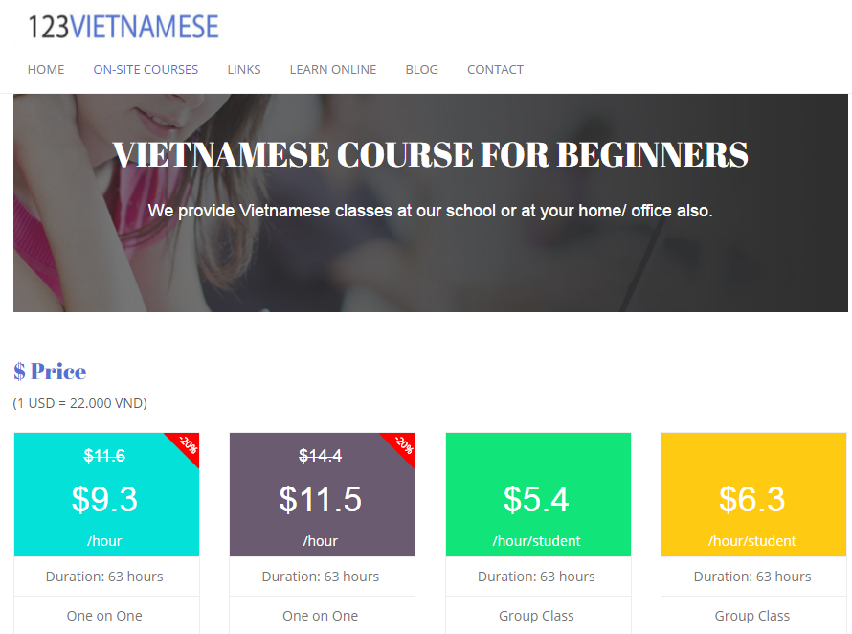

Figure 1. 123Vietnamese

*123VIETNAMESE* is a Vietnamese language training center that was founded in 2010 by a teacher group from Hanoi University of Education and University of Languages & International Studies.

* Advantages:
* The website supports user in studying through video call with lecture, which is flexible in time for students.
* The diverse online lessons are classified based on level of difficulty and purposes (for academy, research or travelling).
* Disadvantages:
* The website charges course fee.

**l-lingo.com**

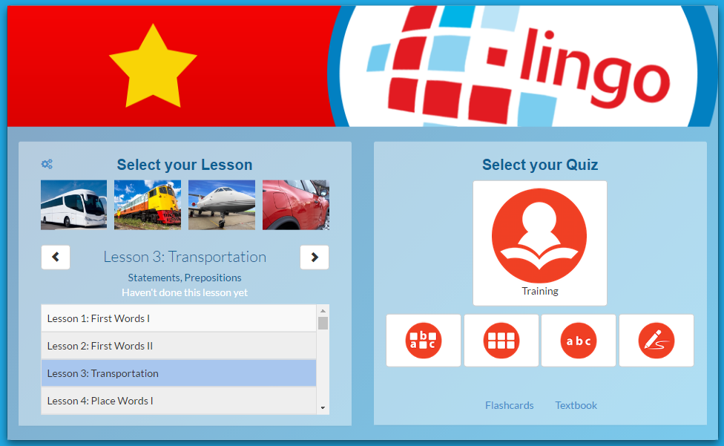

Figure 2. l-lingo

*l-lingo* is a website helping users study 20 Asian & European languages including Vietnamese.

* + - * Advantages:
* The themes of lessons are very diverse.
* The website uses words, images and sound clips of native speakers, which is very convenient for users to study vocabulary and practice listening.
* The website including quiz section at each lesson to help user review.
  + - * Disadvantages:
* The website focuses mostly on teaching vocabulary related to themes. There is no grammar section in each lesson.
* The number of free lessons is limited. User have to register and log in in order to continue studying.

## Proposal

### The idea

Currently, there are lots of applications supporting foreign people to study Vietnamese which diversifies from websites to mobile applications. Still, after having analyzed carefully some of existing systems, team members have found out several disadvantages listed above.

The idea of Veazy is to overcome those limitations by creating a free website for studying Vietnamese, in which our team keeps original basic features such as lessons, small tests while including convenient features for users as well as features adapting to changes in study course’s structure.

### Objectives

Capstone Project (CP) is the final subject included in study program of FPT University (FU). There are 4 main objectives of a CP.

The first and foremost objective of this project is to *achieve the objective which project team set at the beginning*: to release a website supporting users in study Vietnamese. The second object is that this CP serves as a *standard* for CP Council to *decide whether development team is qualified to graduate or not*. The third objective of CP is to help students *review all knowledge related to IT technique and IT project management* studied through 4 years in university. During project management process, students learn how to apply these knowledge and make decision in order to lead the project to success. The fourth objective is to help students *acquire self-study skill through making research* about programming languages and popular frameworks for the need of projects which are not included as a part of the university study program.

### Brief description about system

This software is a web application which offers users almost of main features without registration. The website help users enlarge knowledge about Vietnamese including grammar, vocabulary through activities such as studying by lesson, reading articles and looking up dictionary, taking test corresponding to each skill and level of difficulty. User can send feedback to admin about the contents of the website. After logging in the system, user can see their progress of study and skills accessments.

Veazy uses familiar technologies such as Java, JavaScript, HTML, SQL Server and supports the most used browser like Internet Explorer, Firefox or Chrome.

### System features

Veazy’s features are divided into 4 different categories based on types of users:

* **Features for ordinary users**:
* ***Study* *Vietnamese***: Users can select and enroll in an appropriate course of Vietnamese divided into 6 levels of difficulty. Each lesson contains 6 sections of content: vocabulary, grammar, conversation, listening, practice and reading.
* ***Take Vietnamese tests***: Users can take multiple choice test based on difficulty level and type of skill which user can select.
* ***Report content***: User can send report about the contents of lessons and test questions.
* ***Look up in dictionary***: Users can search for words’ meanings and related examples in both Vietnamese-Japanese and Japanese-Vietnamese dictionary.
* ***View statistics (only available after login)****:* Users can display charts representing current progress of study, assessment on each respective skill.
* ***Log in/Log out***: Users can log into Veazy system with a registered account for more unique futures. Users can register new account or choose to log in by using Facebook or Google account.
* ***Change password/Recover password***: Users can change password when necessary or request to update a new one in case of forgetting the current password.
* **Extra features for content editors**:
* ***Review*** ***report***: Admins & content creators can check the reports or feedbacks sent by users.
* ***Manage*** ***lesson*** ***contents***: Content creators can view list of lessons in each course, create, edit content and delete a lesson.
* ***Manage test question contents***: Content creators can view list of questions, create, edit content and delete a question.
* **Extra features for admins**:
* ***Manage*** ***users***: Admins can view list of accounts as well as each respective account’s detail information, assign authority (admin or content creator) to any account, ban/unban an account.

## Benefit From Project

### For development team

All members in development team gain more experience in each following field:

* **IT Project management**: Team members understand all phases of project management as well as individual responsibility, what needs to achieve, what needs to deliver during an IT project.
* **Programming** **languages**: Front-end developers gain more experience in HTML&CSS, JavaScript while back-end developers gains more experience in Java and SQL-Server.
* **Soft skills**: Each member learns to become a team player who can communicate effectively and know how to delegate and assign tasks to appropriate members as well as support each other.
* **Natural languages**: Team members have the chance to make research about Vietnamese and Japanese at a certain level of depth, which enrich members’ knowledge. Members also get to realize and correct inaccurate ways of speaking and writing Vietnamese which are often mistaken.

### For Community

All Internet users have more resources and channel which are free of charge and allow:

* Studying Vietnamese grammar and vocabulary through online courses.
* Keeping track of study progress and current ability.
* Enhancing reading ability as well as knowledge through reading articles about Vietnam.
* Taking test corresponding to level of difficulty.
* Taking advantage of Vietnamese-Japanese dictionary during learning process.

## Critical Assumption and Constraints

### Assumption

An assumption is a circumstance or event that need to occur for the project to be successful, but are out of range project team can control. These following are circumstances assumed to occur in project:

* Devices used to store data of project are well preserved.
* When a team member becomes sick, there is another members who can take over and continue his or her tasks without delaying project progress.
* Team members are able to use new technologies need for the project after 3 weeks of training.
* Team members are able to devote full 6 hours per day for project commitment.
* Team members can communicate well with each other.

### Constraints

A constraint, in project management, is any restriction that defines a project’s limitation. These following are project constraints defined by team members and classified into categories:

* **Time**: The length of project is 4 months (from May to August, 2016). Project must be delivered and ready for demo before the due date of August 25th.
* **Resources**:
* Team scales is limited to 6 people who are all junior software developer.
* Team members spend at least 6 hours per day for the project.
* **Quality**:
* The website should operate well on popular web browsers such as Internet Explorer (version 9.0 above), Firefox (version 40.0 above) and Google Chrome (version 45.0 above).
* The website should provide full features listed at part 4.4.

## Potential Risk

Project risk is an uncertain event or condition which has an effect on project objective if it occurs. These following are project risks identified which might have the possibility to happen:

* + - * **Insufficient PM Experience:** Schedules do not meet because of shortage of PM experience. PM needs to prepare knowledge and learn from other PMs' experience and supervisor.
      * **Too many requirement changes:** Initiative requirement maybe not suitable or clear. It is be changed while the project is running.
      * **Shortage of Human resource:** Member leaves the project team or fall seriously ill.
      * **Not meeting performance requirements:** The lack of experience causes low quality Japanese documents.
      * **Unclear requirements:** Member don’t understand the requirements.
      * **Lack member experience:** Member cannot afford requirements, low quality work
      * **Memberconflict**: Conflicts between members caused by misunderstanding during communication or being unable to reach a consensus can affect teamwork, which decreases productivity.

# Software Project Management

## Project Overview

### Project Description

|  |  |  |  |
| --- | --- | --- | --- |
| Project Code | Veazy | Contract Type | None |
| Customer | FPT University | 2nd Customer | None |
| Project Level | Group | Project Rank | None |
| Application Type | Website | Project Manager | Nguyen Ngoc Minh |
| Project Category | Development | Business Domain | Education |

**Table 2‑1:** Project description

### Purposes of Project

This project is a capstone project of our group at FPT University. By releasing this project, we want to not only pass the capstone challenge but build a website that helps Japanese people, who are interested in Vietnam, study about Vietnam as well. After analyzing the business specifications, we found out that there is too few useful resources which can help foreigners, especially Japanese people, study about Vietnamese language and culture. Even both Japanese and Vietnamese are affected by Chinese culture, but it is still quite difficult to understand each other. Thus, our product is on purpose to provide a system to help Japanese people study about Vietnam in a way that is as natural as possible.

On the other hand, through 4 months of this project, we hope that every member can gain more experience and knowledge about software development, improve personal and group working skills.

### Scope Statement

The scope of this project contains: Requirement Analysis, Design, Coding and Testing (Unit Test, Integration Test, System Test).

### The functions of Project

* **User account**: Allows users register new accounts in order to log into the system and provide features of updating and viewing profiles.
* **E-learning system**: Provides a well-organized lessons system divided based on level of difficulty.
* **Testing system**: Allow users to take after setting up as well as viewing the test result.

|  |  |  |  |
| --- | --- | --- | --- |
| No | Actor | Use-case name | Description |
| 1 | Guest | Register | Registering new account to log into the system |
| 2 | Log In | Logging into the system |
| 3 | Guest, Member | View Lesson List | Viewing lesson list of courses |
| 4 | View Lesson Details | Viewing detail of lesson |
| 5 | Create Test | Creating a test |
| 6 | Take Test | Taking a multiple-choice test |
| 7 | View Test Result | Viewing result of test |
| 8 | Change Language | Changing language |
| 9 | Member | View Profile | Viewing detail information of their profile |
| 10 | Update Profile | Updating user’s profile |
| 11 | Change Password | Changing user’s password |
| 12 | View Statistics | Viewing statistics of user |
| 13 | Log Out | Logging out of system |
| 14 | View List Test History | Viewing list of test history |
| 15 | View Test History | Viewing detail of test history |
| 16 | Retake Test | Retaking a test in list test history |
| 17 | Report Lesson | Reporting content of lessons that having wrong content |
| 18 | Report Question | Reporting content of questions that having wrong content |
| 19 | Content Editor | View Profile | Viewing detail information of their profile |
| 20 | Update Profile | Updating user’s profile |
| 21 | Change Password | Changing user’s password |
| 22 | Log Out | Logging out of system |
| 23 | View Lesson List | Viewing lesson list of courses |
| 24 | Filter Lesson | filtering lesson |
| 25 | View Lesson Details | View detail of lesson |
| 26 | Edit Lesson | Editing content of lesson |
| 27 | Delete Lesson | Deleting lesson |
| 28 | Create Lesson | Creating new lesson of course |
| 29 | View Questions List | Viewing question list |
| 30 | Filter Question | Filtering question |
| 31 | View Question Details | View detail of question |
| 32 | Edit Question | Editing content of question |
| 33 | Delete Question | Deleting question |
| 34 | Create Question | Creating new question of course |
| 35 | Administrator | View Profile | Viewing detail information of their profile |
| 36 | Update Profile | Updating profile |
| 37 | Change Password | Changing password |
| 38 | Log Out | Logging out of system |
| 39 | View Users List | Viewing list of user |
| 40 | Search User | Searching user |
| 41 | View User Profile | Viewing detail information of user |
| 42 | Ban User | Blocking user of system |
| 43 | Unban User | Unblocking user |
| 44 | Set User Role | Setting role for user |
| 45 | View System Statistics | Viewing statistics of system |

Table 2-2: List function

## Project Organization

### Organizational Structure

Figure 2‑1 Project organizational structure

### Project Process

#### Fsoft Process Model



Figure 2‑2 Fsoft Process Model

The software lifecycle is broken into *cycles*, each cycle working on a new generation of the product. The Fsoft process divides one development cycle in six consecutive *phases*:

* Initiation phase
* Definition phase
* Solution phase
* Construction phase
* Transition
* Termination

#### Project Life Cycle

Basing on Fsoft process and real-world project, we decided to divide the project into four phases: Initiation, Solution, Construction, Termination:

**- Initiation Phase:** This is the explanatory phase of the project. Project objective and description is described at this stage. The purpose of this phase is to collect and understand business requirements, detail the project plan and agree upon a high level statement of work. Our primary objectives are complete project identification and project plan. After these are completed, the project is checked against the following criteria:

* + Identify business functions of the system
  + Determining the scope, conditions and limitations of the project
  + List the main functions of the system
  + List one or more suitable architecture for the system
  + Identify project risks
  + Complete Report 1, and Report 2

**- Solution Phase:**

* + In this phase, the architecture of the system is designed. The goal is to translate requirements and specification into a technical solution to produce Technical Design. Our primary objectives are complete requirement specification, architecture design and database design.
  + Finally, the plan must provide (including estimates of cost and time) for the construction phase. The plan must ensure proper and accurate based on experience.
  + Complete Report 3 and Report 4

**- Construction Phase:**

* + This is the longest phase of a project life cycle.
  + In this phase, all functions of the system will be installed. The installation will be divided into small stages, each stage of the installation a few functions. The results of each phase will be the release of the module function can be executed.
  + Construction and improvement of products until the final product is ready to deliver to the user. During this phase, all the components and other features of the application is developed and integrated into the product.
  + This phase emphasizes the resource management and control operations to optimize cost, time and quality.
  + Complete software packages and Report 5, Report 6

**- Termination Phase:**

* + This is the final phase in the life cycle of a project.
  + Their products will be deployed to the client. The feedback received during the transfer process will be recorded and put on the new functional requirements or functionality enhancements in the next version of the product.
  + Phase transfer switch also includes the training system and the new system for the user.

## Project Schedule

The Effort estimation is documented in the table below.

|  |  |  |  |  |  |
| --- | --- | --- | --- | --- | --- |
|  | Initiation | Solution | Construction | Termination | Total |
| Effort(person/day) | 75 | 147 | 198 | 30 | 450 |
| Total % budgeted Effort Usage (%) | 100 | 100 | 100 | 100 |  |

Table 2-3: Effort Estimate

### Milestone and Deliverables

| No | Stage | Committed Delivery date | Description of Deliverable | Delivery media |
| --- | --- | --- | --- | --- |
| Initiation | |  | Requirements agreed, Report 1 reviewed | |
| 1 | Project Introduction | 16-05-2016 | Criteria: Documentation reviewed |  |
| 2 | User Requirement Specification | 16-05-2016 | Criteria: Documentation reviewed |  |
| 3 | Screen mockups | 19-05-2016 | Criteria: Documentation reviewed |  |
| 4 | Project Plan | 24-05-2016 | Criteria: Documentation reviewed |  |
| Solution | |  |  | |
| 1 | Architecture Design | 27-05-2016 | Criteria: Documentation reviewed |  |
| 2 | SRS | 01-06-2016 | Criteria: Documentation reviewed |  |
| 3 | Detail Data Design | 06-06-2016 | Criteria: Documentation reviewed |  |
| 4 | Screen Design | 07-06-2016 | Criteria: Documentation reviewed |  |
| 5 | Class Design | 07-06-2016 | Criteria: Documentation reviewed |  |
| 6 | Test Plan | 09-06-2016 | Criteria: Documentation reviewed |  |
| 7 | Integration Test Case | 29-06-2016 | Criteria: Documentation reviewed |  |
| Construction | |  | Product developed & tested and released to supervisor, documentation reviewed. | |
| 1 | Source code | 01-08-2016 | Source code  Acceptance criteria: Product unit tested |  |
| 2 | System Test Case | 07-07-2016 | Criteria: Documentation reviewed |  |
| 3 | Test report | 12-08-2016 | Criteria: Documentation reviewed |  |
| 4 | Final report document and CD source code | 24-08-2016 | Final Documents and Source Code |  |
| Termination | |  | Project post-mortem is conducted, Project assets archived and released to supervisor | |
| 1 | Lesson learned | 01-09-2016 | Criteria: Completed |  |

Table 2‑4: Milestone and Deliverables

### Gantt chart

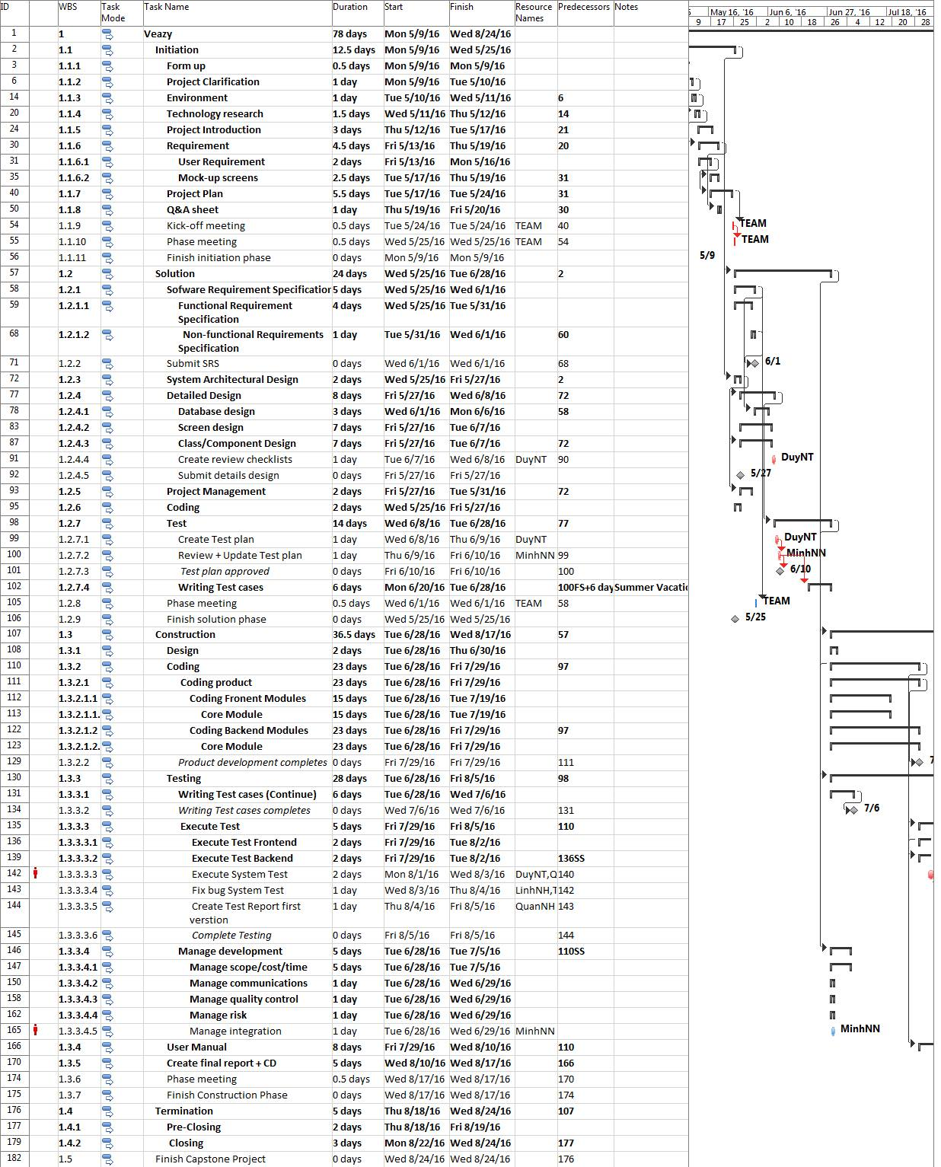

Figure 2-3: VEAZY Gantt chart

## Risk Management

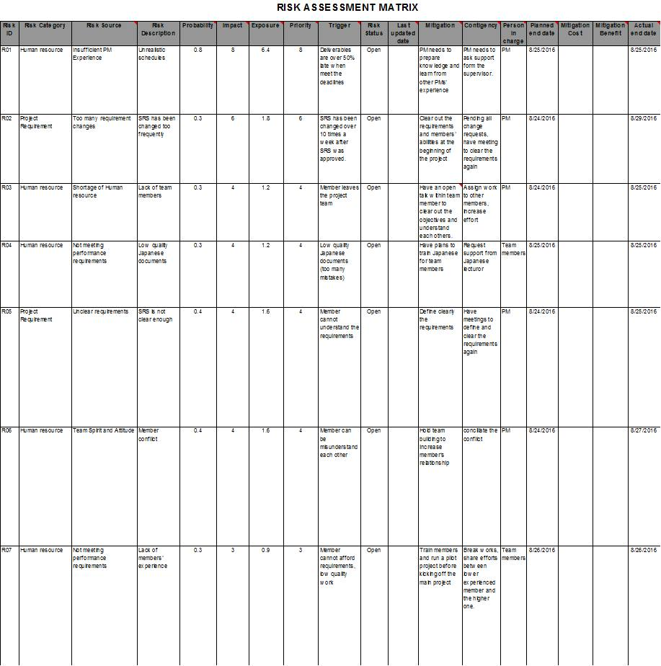

Table 2-5: Risk Management

## 

## Communication Management

| Communication Type | Method / Tool | When | Information | Participants / Responsible | |
| --- | --- | --- | --- | --- | --- |
| Project Task Tracking | | | | | |
| Task scheduling | MS Project Professional 2010 | At the beginning of every stage, and weekly  Refinement and rescheduling as necessary |  | PM | |
| Task assignment | MS Project Professional 2010 | Weekly |  | PTL | |
| Task status reporting | Daily Report | Daily |  | Project Team Members | |
| Project Meeting | | | | | |
| Kick-off Meeting | Face to face | Initiation stage | Project introduction; Project plan review; Risk identification; stakeholders identify. | PM, Project Team Members | |
| Project Progress Review Meetings | Face to face | Weekly and on event | Communicate project status  Communicate and resolve any open issue, risks, and changes  Discuss any suggested improvement | PM, Project Team Members | |
| Milestone Meetings | Face to face | 1 days After the completion of stages: Definition, Solution & Construction | Project objective review, evaluate project performance (quality, schedule, effort), Causal analysis, update project plan for next stage | PM, Project Team Members, QA, Supervisor | |
| Transfer/Sharing of project documentation/information | Github | When available | All project documentation and information | PM, Project Team Members, QA | |
| Supervisor Communication and Reporting: | | | | | |
| Project Report | Agreed Fsoft and FU standard format | 5pm Monday, Weekly | Project status report, Issue requiring clarifications, escalation, if any | | PM |
| Project Meetings with supervisor | Face to face | 12h45 Friday, Weekly | As above | | PM |
| Requirement gathering/clarification | Face to face meeting | During requirement analysis phase | As in Q&A list | | PM |
| Communication with Supervisor | | | | | |
| Review Project Plan & Project schedule | By attend project meeting | Significant changes to WO, PP and Project schedule (scope, objectives Organization, HR, major milestone, deliverables ) |  | | PM |
| Project Progress Review | By email and/or via Operation meeting at Group/Division level | Weekly | Project status report, Issue requiring clarifications, escalation, if any | | PM |
| Project Milestone Review | By email and via project milestone review meeting | End of every stage | Project objective review, evaluate project performance (quality, schedule, effort), Causal analysis, update project plan for next stage | | PM |

Table 2-6: Communication Management

## Tools and Infrastructure

Below is the list of tools and infrastructure requirements needed for development environment.

| Item | Description | Expected Availability by | Note |
| --- | --- | --- | --- |
| Development Environment | | | |
| Operating System | Window 7 or above version, Ubuntu LTS 14.04, CentOS 6.6 |  |  |
| Browser | Google Chrome, Firefox (all version) |  |  |
| Development language | Java 8 |  |  |
| Technology | | | |
| Development language | Java 8 |  |  |
| Server | Tomcat 7 (server localhost) |  |  |
| Hardware Requirement | | | |
| Hardware Configuration | 2GB workspaces on server |  |  |
| Equipment & Tools | | | |
| Source Version Control | Git | Definition stage |  |
| Task Tracking | MS Project Professional 2010 | Initiation stage |  |
| SRS | Microsoft Office Word, Microsoft Office Excel, Astah Professional | Initiation stage |  |

Table 2-7: Tools and Infrastructure

## Configuration Management Plan

The detail configuration management is available in file ***Veazy_CMPlan_v1.0_EN.docx***.

# Software Requirement Specification

## Overview

### Purpose

The purpose of this document is to present a detailed description of the Veazy. It explains the interface and the features of the system, what the system does, the constraints under which it must operate and how the system reacts to external stimuli..

### Scope

Veazy is a website which supports Japanese people study Vietnamese.

There are four basic users Guest, Member, Content Editor and Admin.

* Guest can study via lessons and do test.
* Member can access basic functions of guests and manage profile, redo recently taken tests and view statistics assessed based on those taken tests.
* Editor can manage website content which contains of contents of lesson and test question.
* Administrator can manage users, including checking user detailed information, assign authority and ban/unban.

## User Requirements Specification

### Business Process Overview

#### Register workflow

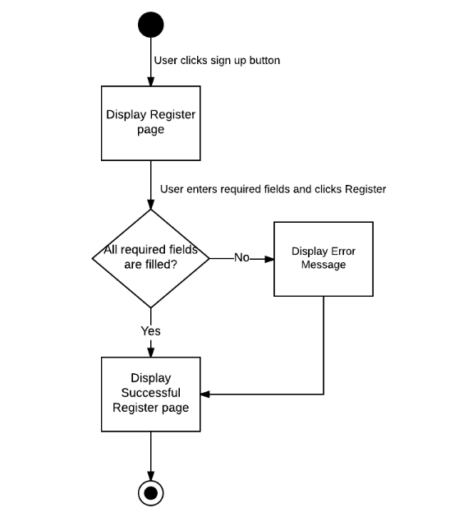

Brief description: Guest can use this function. Steps:

* Step 1: User clicks on Sign Up button.
* Step 2: System display Sign Up page.
* Step 3: User enters required fields and clicks on Register button.
* Step 4: System display Successful Register page or Error Message.

#### Login workflow

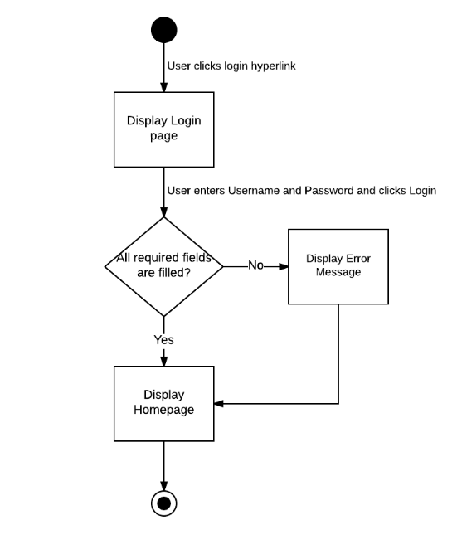

Brief description: Guest can use this function. Steps:

* Step 1: User clicks on Login hyperlink.
* Step 2: System display Login page.
* Step 3: User enters Username and Password and clicks on Login button.
* Step 4: System display Homepage or Error Message.

#### Forgot Password workflow

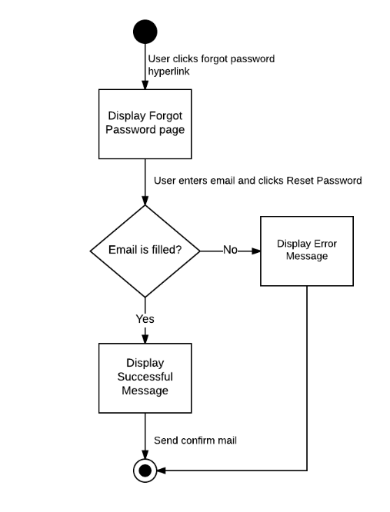

Brief description: Guest can use this function. Steps:

* Step 1: User clicks on Forgot Password hyperlink.
* Step 2: System display Forgot Password popup.
* Step 3: User enters email and clicks on Reset Password button.
* Step 4: System display Successful Message or Error Message.

#### Search workflow

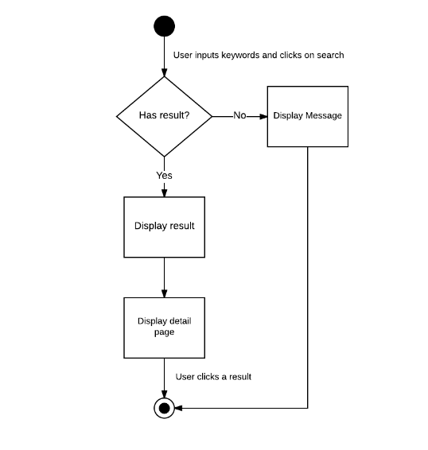

Brief description: Guest and Member can use this function. Steps:

* Step 1: User inputs keywords into search textbox and clicks on Search button.
* Step 2: System return search results or message if nothing found.
* Step 3: User can click returned results to view detail.

#### Study workflow

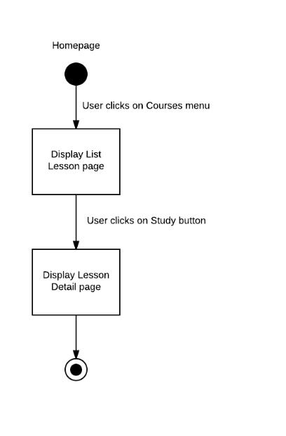

Brief description: Guest and Member can use this function. Steps:

* Step 1: User clicks on Courses menu.
* Step 2: System display List Lesson page.
* Step 3: User clicks on Study button.
* Step 4: System display Lesson Detail page.

#### Testing workflow

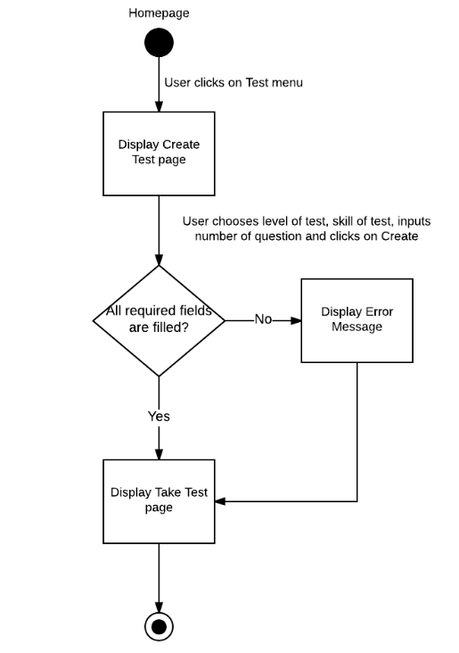

Brief description: Guest and Member can use this function. Steps:

* Step 1: User clicks on Test menu.
* Step 2: System display Create Test page.
* Step 3: User chooses level of test, skill test, and number of questions.
* Step 4: User clicks on Create button.
* Step 5: System display Take Test page.

#### Add Lesson workflow

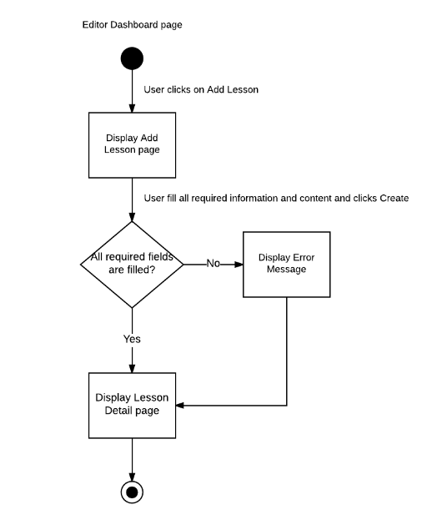

Brief description: Content Editor can use this function. Steps:

* Step 1: Content Editor clicks on Add Lesson in Lesson menu.
* Step 2: System display Add Lesson page..
* Step 3: Content Editor fills all required information and content of lesson and clicks on Create button.
* Step 4: System display Lesson Detail page or Error Message.

#### Add Question workflow

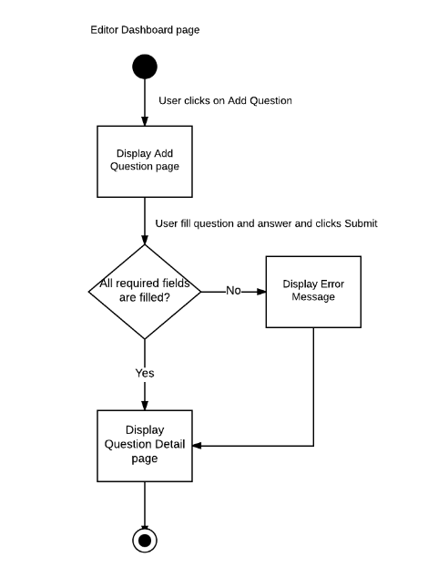

Brief description: Content Editor can use this function. Steps:

* Step 1: Content Editor clicks on Add Question in Question menu.
* Step 2: System display Add Question page..
* Step 3: Content Editor fills question and answer of question and clicks on Submit button.
* Step 4: System display Question Detail page or Error Message.

#### Report Content workflow

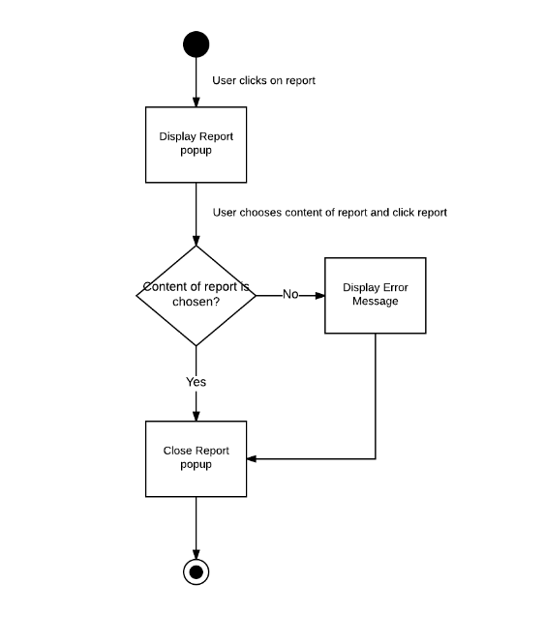

Brief description: Member can use this function. Steps:

* Step 1: Member clicks on Report button.
* Step 2: System display Report popup.
* Step 3: Member chooses content of report and clicks on Report.
* Step 4: System close Report popup or Error Message.

#### Ban/Unban user workflow

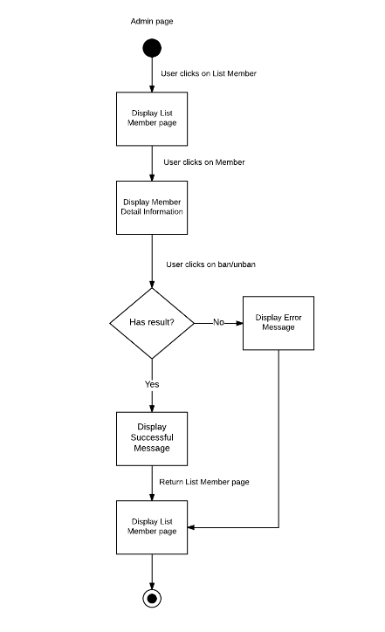

Brief description: Administrator can use this function. Steps:

* Step 1: Administrator clicks on List Member menu.
* Step 2: System display List Member page.
* Step 3: Administrator clicks on Member who Administrator want to ban/unban.
* Step 4: System display Member Detail Information page.
* Step 5: Administrator clicks on Ban/Unban button.
* Step 6: System display Successful Message or Error Message.
* Step 7: System display List Member page.

### Product Features

Veazy is a website, user only connect to internet to use website. System provides these main functions:

#### Guest features

* **Register:** User can register new account and login to use all features of Veazy.
* **Login:** User login to Veazy system.
* **Search:** User can search lessons, words and system will display all of result related to keywords.
* **Forgot Password:** If user forgot their password, user can send a request to reset their password.
* **Learning:** User can learn Vietnamese through lessons of system.
* **Testing**: User can take a multiple-choice test and view result at the end of test.

#### Member features

* **Management Profile:** System just allows user who logins as Member can manage their profile such as view their information, update their information, change new password, as well as view their statistical learning process.
* **Report Content:** System just allows user as Member can send a report to Content Editor about wrong content of lesson or question.
* **Retake Test:** System just allows user as Member can view their list test history, review test and retake test.

#### Content Editor features

* **Management Profile:** When user logins as a Content Editor, user can manage their profile such as view Content Editor information, update information and change password.
* **Manage Lesson:** When user logins as a Content Editor, user can manage lesson of system. So that user can view all lesson of system, search, add new lesson, edit or delete lesson.
* **Manage Question:** When user logins as a Content Editor, user can manage question of system. So that user can view all question of system, search, add new question, edit or delete question.
* **View Report:** System’s Member send reports about wrong content of lesson or question. Content Editor can view this reports to determined that the content is wrong or not and edit it.

#### Admin features

* **Management Profile:** When user logins as a Admin, user can manage their profile such as view Admin information and change password.
* **Manage user:** When user logins as a Admin, user can manage member of system as: view list member of system, view detail information, ban/unban member or set permission for member.

**System statistics:** When user logins as a Admin, user can view statistics of system..

## Sofware Requirements Specification

### Overall Description

#### System overview

The product is a web-based system implementing client-server model. Veazy system serves as an e-learning system which targets mainly Japanese people who working in Vietnam and have demand for studying Vietnamese.

The purpose of Veazy is to create a friendly, easy-to-use and free-of-charge Vietnamese learning system with various features that improves efficiency in study significantlyas well asprovideacoherent system of ability assessment to help users keep track of their level in Vietnamese language..

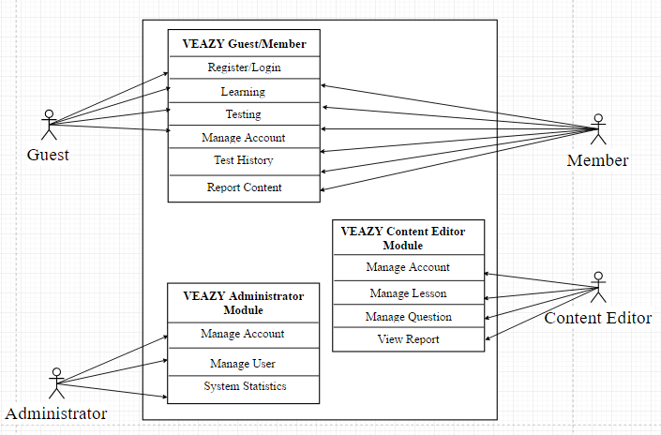

Figure 3-5: System overview

#### Product Features

The following are the main features that are included in the system:

* User Account Management: Allows users register new accounts in order to log into the system and provide features of updating and viewing profiles.
* E-learning System: Provides a well-organized lessons system divided in courses based on level of difficulty.
* Taking Test: Allows users to take small test and display test result.

**Main functions of Users:**

|  |  |  |
| --- | --- | --- |
| User | Function Name | Description |
| Guest | **Register new Account** | User registers new account to log into the system |
| **Login** | User login to the system. |
| **View Lesson List** | User views list lessons of courses. |
| **View Lesson Detail** | User views the content of the selected lesson. |
| **Take Test** | User takes a multiple-choice test. |
| **View Test Result** | User views result of their test. |
| Member | **View Profile** | User views their own profile. |
| **Edit Profile** | User edits their own profile. |
| **Change Password** | User changes their password |
| **View Test Statistic** | User views summary about their test and their score |
| **Logout** | User logs out of system. |
| **Report Lesson** | User sends their report to Content Editor about wrong content of lesson |
| **Report Question** | User sends their report to Content Editor about wrong content of question |
| **View List Test History** | User views list test history |
| **View Test History** | User views test history detail |
| **Retake Test** | User retake test |
| Content Editor | **View Profile** | User views their own profile |
| **Edit Profile** | User edits their own profile |
| **Change Password** | User changes their password |
| **Logout** | User logs out of system. |
| **View Lesson List** | User views list lessons of courses. |
| **View Lesson Detail** | User views the content of the selected lesson. |
| **Filter Lesson** | User filters lesson list |
| **Create Lesson** | User creates new lesson |
| **Edit Lesson** | User edits lesson |
| **Delete Lesson** | User deletes lesson |
| **View Question List** | User views list question |
| **View Question Detail** | User views question detail |
| **Filter Question** | User filters question list |
| **Create Question** | User creates new question |
| **Edit Question** | User edits question |
| **Delete Question** | User deletes question |
| **View Report** | User views report about wrong content |
| Admin | **View Profile** | User views their own profile |
| **Change Password** | User changes their password |
| **Logout** | User logs out of system. |
| **View User List** | User views list member of system |
| **View User Profile** | User views member’s profile. |
| **Set Role User** | User sets role for member’s system. |
| **Ban User** | User bans member out of system. |
| **Unban User** | User unbans member. |
| **View System Statistic** | User views statistic of system. |
| **Search User** | User searching for user. |

Table 3-1: Product features

#### User Characteristics

There are 3 types of users involving in the system:

* Normal users (Guest, Member): Requires basic knowledge of internet & computer.
* Content Editor: Required basic knowledge of internet & computer as normal user. In addition to that, they need to have upper-level of Vietnamese language and ability write academic articles as well as managing them.
* Administrators: Required to have high-level technical, management skills and the ability to promote the website.

#### User Documentation

List of document when delivering this application is in the table below:

|  |  |
| --- | --- |
| Name | Description |
| User Manual | Provide detailed explanation about the system, screens and guide users how to use all features of VEAZY website. |

#### Assumption

The system depends on which type and version of browser being installed on the client machine i.e. the browser should support both HTML5 and CSS3. The internet connection speed and bandwidth is also a dependency of the system.

One assumption that user has a strong enough internet connect which can adapt to system load. If the speed and bandwidth is slow, there is one scenario that browser cannot fully load the webpage, which may affect web layout displaying. Another scenario is that when user plays media such as listening or watching conversation, the media quality may be affected badly by a weak internet connection, which results a bad user experience.

Another assumption is that user is using a fully technical supported browser. If the browser does not support full technique, website cannot adapt full functionalities..

### Entity Relation Model

#### Entity-Relationship Diagram



Figure 3-6: Entity Relationship Diagram

|  |  |  |
| --- | --- | --- |
| **No** | **Entity** | **Description** |
| 1 | Admin | System administrator |
| 2 | Learner | The end-user who learn on the website |
| 3 | Content Editor | The user who create, update lesson content and questions. |
| 4 | Question | Question for the exam |
| 5 | Lesson | The lesson |
| 6 | Exam | Examination for the user |

#### Table Details

##### Table diagram

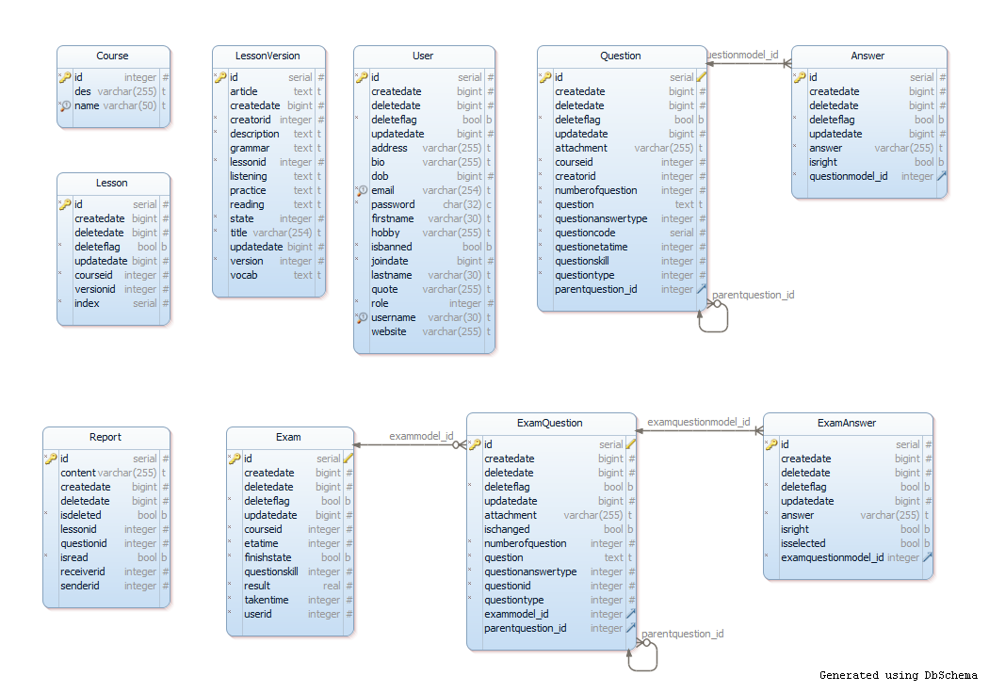

Figure 2: Table diagram

##### Course table

|  |  |  |  |  |  |  |  |  |
| --- | --- | --- | --- | --- | --- | --- | --- | --- |
| **No** | **Field Name** | **Type** | **Max**  **Length** | **Null** | **Unique** | **P/F Key** | **Default** | **Description** |
| 1 | id | integer |  | NOT |  | P |  |  |
| 2 | des | character | 255 |  |  |  |  | description |
| 3 | name | character | 50 | NOT | U |  |  |  |

##### Exam table

|  |  |  |  |  |  |  |  |
| --- | --- | --- | --- | --- | --- | --- | --- |
| **No** | **Field Name** | **Type** | **Null** | **Unique** | **P/F Key** | **Default** | **Description** |
| 1 | id | serial | NOT |  | P |  |  |
| 2 | createdate | bigint |  |  |  |  |  |
| 3 | deletedate | bigint |  |  |  |  |  |
| 4 | deleteflag | bool | NOT |  |  | FALSE |  |
| 5 | updatedate | bigint |  |  |  |  |  |
| 6 | courseid | integer | NOT |  |  |  |  |
| 7 | etatime | integer | NOT |  |  | 0 | estimate time |
| 8 | finishstate | bool | NOT |  |  |  |  |
| 9 | questionskill | integer |  |  |  |  |  |
| 10 | result | real | NOT |  |  | 0.0 |  |
| 11 | takentime | integer | NOT |  |  | 0 |  |
| 12 | userid | integer | NOT |  |  |  |  |

##### Lesson table

|  |  |  |  |  |  |  |  |
| --- | --- | --- | --- | --- | --- | --- | --- |
| **No** | **Field Name** | **Type** | **Null** | **Unique** | **P/F Key** | **Default** | **Description** |
| 1 | id | serial | NOT |  | P |  |  |
| 2 | createdate | bigint |  |  |  |  |  |
| 3 | deletedate | bigint |  |  |  |  |  |
| 4 | deleteflag | bool | NOT |  |  | FALSE |  |
| 5 | updatedate | bigint |  |  |  |  |  |
| 6 | courseid | integer | NOT |  |  |  |  |
| 7 | versionid | integer |  |  |  |  |  |
| 8 | index | serial | NOT |  |  |  |  |

##### LessonVersion table

|  |  |  |  |  |  |  |  |  |
| --- | --- | --- | --- | --- | --- | --- | --- | --- |
| **No** | **Field Name** | **Type** | **Max**  **Length** | **Null** | **Unique** | **P/F Key** | **Default** | **Description** |
| 1 | id | serial |  | NOT |  | P |  |  |
| 2 | article | text |  |  |  |  |  |  |
| 3 | createdate | bigint |  |  |  |  |  |  |
| 4 | creatorid | integer |  | NOT |  |  | FALSE |  |
| 5 | description | text |  | NOT |  |  |  |  |
| 6 | grammar | text |  |  |  |  |  |  |
| 7 | lessonid | integer |  | NOT |  |  |  |  |
| 8 | listening | text |  |  |  |  |  |  |
| 9 | practice | text |  |  |  |  |  |  |
| 10 | reading | text |  |  |  |  |  |  |
| 11 | state | integer |  | NOT |  |  | 1 |  |
| 12 | title | varchar | 254 | NOT |  |  |  |  |
| 13 | updatedate | bigint |  |  |  |  |  |  |
| 14 | version | integer |  | NOT |  |  | 1 |  |
| 15 | vocab | text |  |  |  |  |  |  |

##### Report table

|  |  |  |  |  |  |  |  |
| --- | --- | --- | --- | --- | --- | --- | --- |
| **No** | **Field Name** | **Type** | **Null** | **Unique** | **P/F Key** | **Default** | **Description** |
| 1 | id | serial | NOT |  | P |  |  |
| 2 | createdate | bigint |  |  |  |  |  |
| 3 | deletedate | bigint |  |  |  |  |  |
| 4 | deleteflag | bool | NOT |  |  | FALSE |  |
| 5 | updatedate | bigint |  |  |  |  |  |
| 6 | lessonid | integer |  |  |  |  |  |
| 7 | questionid | integer |  |  |  |  |  |
| 8 | isread | bool | NOT |  |  | FALSE |  |
| 9 | receiverid | integer |  |  |  |  |  |
| 10 | senderid | integer |  |  |  |  |  |

##### Answer table

|  |  |  |  |  |  |  |  |  |
| --- | --- | --- | --- | --- | --- | --- | --- | --- |
| **No** | **Field Name** | **Type** | **Max Length** | **Null** | **Unique** | **P/F Key** | **Default** | **Description** |
| 1 | id | serial |  | NOT |  | P |  | Auto increase |
| 2 | createdate | bigint |  |  |  |  |  |  |
| 3 | deletedate | bigint |  |  |  |  |  |  |
| 4 | deleteflag | bool |  | NOT |  |  | FALSE |  |
| 5 | updatedate | bigint |  |  |  |  |  |  |
| 6 | answer | varchar | 255 | NOT |  |  |  |  |
| 7 | isright | bool |  | NOT |  |  | FALSE |  |
| 8 | questionmodel_id | integer |  | NOT |  | F |  |  |

##### User table

|  |  |  |  |  |  |  |  |  |
| --- | --- | --- | --- | --- | --- | --- | --- | --- |
| **No** | **Field Name** | **Type** | **Max**  **Length** | **Null** | **Unique** | **P/F Key** | **Default** | **Description** |
| 1 | id | serial |  | NOT |  | P |  | Auto increase |
| 2 | createdate | bigint |  |  |  |  |  |  |
| 3 | deletedate | bigint |  |  |  |  |  |  |
| 4 | deleteflag | bool |  | NOT |  |  | FALSE |  |
| 5 | updatedate | bigint |  |  |  |  |  |  |
| 6 | address | varchar | 255 |  |  |  |  |  |
| 7 | bio | varchar | 255 |  |  |  |  | biographic |
| 8 | dob | bigint |  |  |  |  |  | date of birth |
| 9 | email | varchar | 254 | NOT | U |  |  |  |
| 10 | password | char(32) |  | NOT |  |  |  |  |
| 11 | firstname | varchar | 30 |  |  |  |  |  |
| 12 | hobby | varchar | 255 |  |  |  |  |  |
| 13 | isbanned | bool |  | NOT |  |  | FALSE |  |
| 14 | joindate | bigint |  | NOT |  |  |  |  |
| 15 | lastname | varchar | 30 |  |  |  |  |  |
| 16 | quote | varchar | 255 |  |  |  |  |  |
| 17 | role | integer |  | NOT |  |  | 3 |  |
| 18 | username | varchar | 30 |  | U |  |  |  |
| 19 | website | varchar | 255 |  |  |  |  |  |

##### ExamAnswer table

|  |  |  |  |  |  |  |  |  |
| --- | --- | --- | --- | --- | --- | --- | --- | --- |
| **No** | **Field Name** | **Type** | **Max Length** | **Null** | **Unique** | **P/F Key** | **Default** | **Description** |
| 1 | id | serial |  | NOT |  | P |  | Auto increase |
| 2 | createdate | bigint |  |  |  |  |  |  |
| 3 | deletedate | bigint |  |  |  |  |  |  |
| 4 | deleteflag | bool |  | NOT |  |  | FALSE |  |
| 5 | updatedate | bigint |  |  |  |  |  |  |
| 6 | answer | varchar | 255 | NOT |  |  |  |  |
| 7 | isright | bool |  | NOT |  |  | FALSE |  |
| 8 | isselected | bool |  | NOT |  |  | FALSE |  |
| 9 | examquestionmodel_id | integer |  |  |  | F |  |  |

##### ExamQuestion table

|  |  |  |  |  |  |  |  |  |
| --- | --- | --- | --- | --- | --- | --- | --- | --- |
| **No** | **Field Name** | **Type** | **Max Length** | **Null** | **Unique** | **P/F Key** | **Default** | **Description** |
| 1 | id | serial |  | NOT |  | P |  | Auto increase |
| 2 | createdate | bigint |  |  |  |  |  |  |
| 3 | deletedate | bigint |  |  |  |  |  |  |
| 4 | deleteflag | bool |  | NOT |  |  | FALSE |  |
| 5 | updatedate | bigint |  |  |  |  |  |  |
| 6 | attachment | varchar | 255 |  |  |  |  |  |
| 7 | ischanged | bool |  |  |  |  |  |  |
| 8 | numberofquestion | integer |  | NOT |  |  | 1 |  |
| 9 | question | text |  | NOT |  |  |  |  |
| 10 | questionanswertype | integer |  | NOT |  |  | 1 |  |
| 11 | questionid | integer |  | NOT |  |  |  |  |
| 12 | questiontype | integer |  | NOT |  |  | 1 |  |
| 13 | exammodel_id | integer |  |  |  | F |  |  |
| 14 | parentquestion_id | integer |  |  |  | F |  |  |

##### Question table

|  |  |  |  |  |  |  |  |  |
| --- | --- | --- | --- | --- | --- | --- | --- | --- |
| **No** | **Field Name** | **Type** | **Max Length** | **Null** | **Unique** | **P/F Key** | **Default** | **Description** |
| 1 | id | serial |  | NOT |  | P |  | Auto increase |
| 2 | createdate | bigint |  |  |  |  |  |  |
| 3 | deletedate | bigint |  |  |  |  |  |  |
| 4 | deleteflag | bool |  | NOT |  |  | FALSE |  |
| 5 | updatedate | bigint |  |  |  |  |  |  |
| 6 | attachment | varchar | 255 |  |  |  |  |  |
| 7 | courseid | integer |  | NOT |  |  |  |  |
| 8 | creatorid | integer |  | NOT |  |  |  |  |
| 9 | numberofquestion | integer |  | NOT |  |  | 1 |  |
| 10 | question | text |  | NOT |  |  |  |  |
| 11 | questionanswertype | integer |  | NOT |  |  | 1 |  |
| 12 | questioncode | serial |  | NOT |  |  |  |  |
| 13 | questionetatime | integer |  | NOT |  |  | 60 |  |
| 14 | questionskill | integer |  | NOT |  |  | 1 |  |
| 15 | questiontype | integer |  | NOT |  |  | 1 |  |
| 16 | parentquestion_id | integer |  |  |  | F |  |  |

### Functionality

#### Guest

##### Manage Account

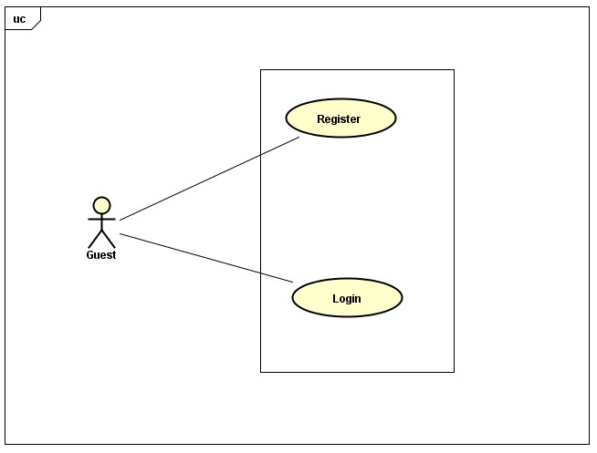

Figure 3‑1 : UC: Manage account

###### 3.3.3.1.1.1 UC-G-001: Login

|  |  |  |  |  |
| --- | --- | --- | --- | --- |
| Use Case Name | Log In | | | |
| Use Case ID | UC-G-001 | | | |
| Created By | QuanNH | | Last Updated By | ThangPD |
| Date Created | 27/06/2016 | | Date Last Updated | 19/07/2016 |
| Actor | Guest | | | |
| Description | User to login to Veazy system | | | |
| Pre-condition | * Website is available * User has a registered account * “Login” hyperlinkis active at the right top of menu | | | |
| Trigger | * User inputs username and password into textboxes respectively in “Login” page * User clicks “Login” button on “Login” page | | | |
| Post Condition | * Login successfully and redirect to “Home” page * If exceptions are thrown, the result must match with output of each described exception. | | | |
| Main Success Scenario | | | | |
| Step | **User** | **System’s Response** | | |
| 1 | Click “Login” hyperlink at the right top of menu | Shows “Login” page | | |
| 2 | Enters username and password | Username and “Password” textbox border changes to green color | | |
| 3 | Clicks “Login” button | Redirects to “Home” page | | |
| Exception | | | | |
| At Step | **User** | **System’s Response** | | |
| 2 | If “Username” textbox is null | Border of “Username” textbox changes into red  Displays the message:“Username required!” | | |
| 2 | If“Password” textbox is null | Border of “Password” textbox changes into red  Displays the message “Password required!” | | |
| 3 | If user enters the wrong password or username | Displays the message "Incorrect username or password! | | |

###### UC-G-002: Register

|  |  |  |  |  |
| --- | --- | --- | --- | --- |
| Use Case Name | Register | | | |
| Use Case ID | UC-G-002 | | | |
| Created By | QuanNH | Last Updated By | | ThangPD |
| Date Created | 27/06/2016 | Date Last Updated | | 29/07/2016 |
| Actor | Guest | | | |
| Description | User registers new account to log into the system | | | |
| Pre-condition | * Website is available | | | |
| Trigger | * User clicks “Sign up” button on “Home” page * User inputs username, email, password and confirms password * User clicks “Register” button on “Register” page | | | |
| Post Condition | * Register successfully and redirect to “Register Success” page * If exceptions are thrown, the result must match with output of each described exception. | | | |
| Main Success Scenario | | | | |
| Step | **User** | | **System’s Response** | |
| 1 | Clicks “Sign up” button on “Home” page | | Shows “Register” page | |
| 2 | Inputs username, email, password and password confirmation | |  | |
| 3 | Clicks “Register” button | | Redirects to “Register Success” page | |
| Alternative Scenario | | | | |
| At Step | **User** | | **System’s Response** | |
| Exception | | | | |
| At Step | **User** | | **System’s Response** | |
| 2 | If “Username” textbox is null | | Border of “Username” textbox changes to red color.  Displays the message: “Username required!” | |
| 2 | If “Email” textbox is null | | Border of “Email” textbox changes to red color.  Displays the message: “Email required!” | |
| 2 | If “Password” textbox is null | | Border of “Password” textbox changes to red color  Displays the message: “Password required!” | |
| 2 | If user inputs username that is less than 6 characters | | Border of “Username” textbox changes to red color  Displays the message: “Username must be at least 6 characters long!” | |
| 2 | If user inputs username that is more than 30 characters | | Border of “Username” textbox changes to red color  Displays the message: “Username must be no more than 30 characters long!” | |
| 2 | If user inputs invalid email | | Border of “Email” textbox changes to red color  Displays the message: “Invalid email!” | |
| 2 | If user inputs password that is less than 6 characters | | Border of “Password” textbox changes to red color  Displays the message: “Password must be at least 6 characters long!” | |
| 2 | If user inputs password that is more than 32 characters | | Border of “Password” textbox changes to red color  Displays the message: “Password must be no more than 32 characters long!” | |
| 2 | If the confirmed password is not the same with password | | Border of “Confirm Password” textbox changes to red color  Displays the message: “Password does not matched!” | |

##### Learning

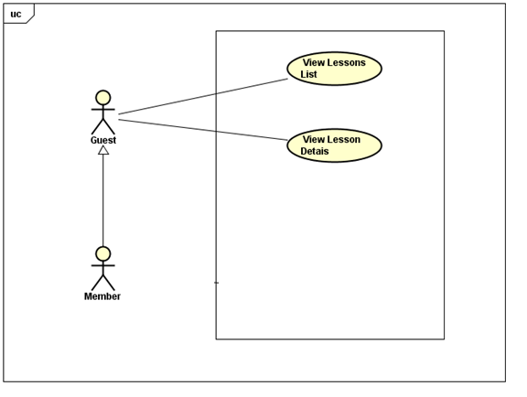

Figure 3‑2 : UC: Learning

###### UC-G-003: View Lessons List

|  |  |  |  |  |
| --- | --- | --- | --- | --- |
| Use Case Name | View Lessons List | | | |
| Use Case ID | UC-G-003 | | | |
| Created By | QuanNH | Last Updated B**y** | | ThangPD |
| Date Created | 27/06/2016 | Date Last Updated | | 12/08/2016 |
| Actor | Guest, Member | | | |
| Description | User views list lessons of courses | | | |
| Pre-condition | * Website is available * “Courses” hyperlink is active in top menu * Course level hyperlink in dropdown list is active | | | |
| Trigger | User clicks “Course” link on top menu then clicks the hyperlink of the course level that user wants to choose in dropdown list | | | |
| Post Condition | System redirects to “Course” pagewhich displays lesson list in selected course level | | | |
| Main Success Scenario | | | | |
| Step | **User** | | **System’s Response** | |
| 1 | Clicks “Course” link on top menu | | Shows level dropdown list | |
| 2 | Clicks a course level hyperlink in dropdown list | | Redirect to “Courses” page and displays lesson list in the selected course | |

###### UC-G-004: View Lesson Details

|  |  |  |  |  |
| --- | --- | --- | --- | --- |
| Use Case Name | View Lesson Details | | | |
| Use Case ID | UC-G-004 | | | |
| Created By | QuanNH | Last Updated By | | ThangPD |
| Date Created | 27/06/2016 | Date Last Updated | | 19/07/2016 |
| Actor | Guest, Member | | | |
| Description | User views the content of the selected lesson | | | |
| Pre-condition | Website is available | | | |
| Trigger | User clicks “Study” button that belongs to the lesson user wants to study on “Course” page | | | |
| Post Condition | System redirects to “Lesson” pagewhich displays the content of the selected lesson | | | |
| Main Success Scenario | | | | |
| Step | **User** | | **System’s Response** | |
| 1 | Clicks “Study” button of a lesson on “Course” page | | Redirects to “Lesson” page and displays lesson content | |

##### Testing

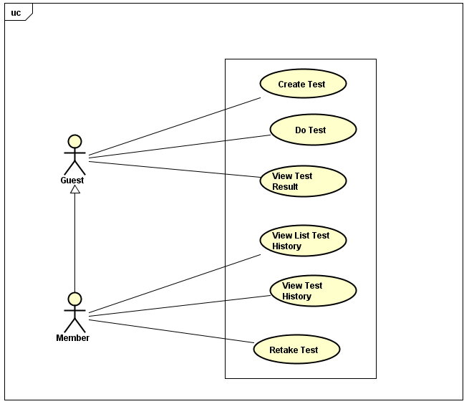

Figure 3‑3 UC: Testing

###### UC-G-005: Create Test

|  |  |  |  |  |
| --- | --- | --- | --- | --- |
| Use Case Name | Create Test | | | |
| Use Case ID | UC-G-005 | | | |
| Created By | QuanNH | Last Updated By | | ThangPD |
| Date Created | 04/07/2016 | Date Last Updated | | 14/08/2016 |
| Actor | Guest, Member | | | |
| Description | User setups to create a new test | | | |
| Pre-condition | Website is available | | | |
| Trigger | * User clicks “Test” link at top menu * User clicks “Level” dropdown list to select difficulty level * User clicks “Test skill” dropdown list to select the skill that user wants to test * User clicks the upward/downward arrow of “Number of question” spin box to increase/decrease the number of questions in test * User clicks “Create” button on “Test” page | | | |
| Post Condition | * + - * System redirects to “Test” page and displays test content which contains the questions in accordance with user’s setup       * If exceptions are thrown, the result must match with output of each described exception. | | | |
| Main Success Scenario | | | | |
| Step | **User** | | **System’s Response** | |
| 1 | Clicks “Test” link at top menu | | Redirects to “Test” page | |
| 2 | Clicks “Level” dropdown list to select difficulty level | |  | |
| 3 | Clicks “Test skill” dropdown list to select test skill | |  | |
| 4 | Clicks the upward/downward arrow of “Number of question” | | The number of questions goes up/down | |
| 5 | Clicks “Create” button on “Test” page | | System shows test content | |
| Exception | | | | |
| At step | **User** | | **System’s response** | |
| 5 | If there is no questions that can be generated in accordance with user’s selected level, skill | | Displays the message: “No question of this level & skill are added yet!” | |

###### UC-G-006: Do Test

|  |  |  |  |  |
| --- | --- | --- | --- | --- |
| Use Case Name | Do Test | | | |
| Use Case ID | UC-G-006 | | | |
| Created By | QuanNH | Last Updated By | | ThangPD |
| Date Created | 04/07/2016 | Date Last Updated | | 19/07/2016 |
| Actor | Guest, Member | | | |
| Description | User do test | | | |
| Pre-condition | * Website is available * Done UC-G-005 successfully | | | |
| Trigger | * User clicks the checkbox of the answer that user think is the right answer of a question. | | | |
| Main Success Scenario | | | | |
| Step | **User** | | **System’s Response** | |
| 1 | User clicks the checkbox of answers of questions | | The checkbox value changes to “true/false” value, indicating the answer(s) selected by user | |

###### UC-G-007: View Test Result

|  |  |  |  |  |
| --- | --- | --- | --- | --- |
| Use Case Name | View Exam Result | | | |
| Use Case ID | UC-G-007 | | | |
| Created By | QuanNH | Last Updated By | | ThangPD |
| Date Created | 04/07/2016 | Date Last Updated | | 19/07/2016 |
| Actor | Guest, Member | | | |
| Description | User submit test and views result | | | |
| Pre-condition | * Website is available | | | |
| Trigger | * + - * User clicks “Check Answer” button at bottom test content on “Taking Test” page to submit the test.       * User can also wait for time duration to run out so that the test is automatically submitted. | | | |
| Post Condition | System redirects to “Test Result” page which displays test result | | | |
| Main Success Scenario | | | | |
| Step | **User** | | **System’s Response** | |
| 1 | Clicks “Check Answer” button | | Redirects to “Test Result” page and displays test result | |

##### Change Interface Language

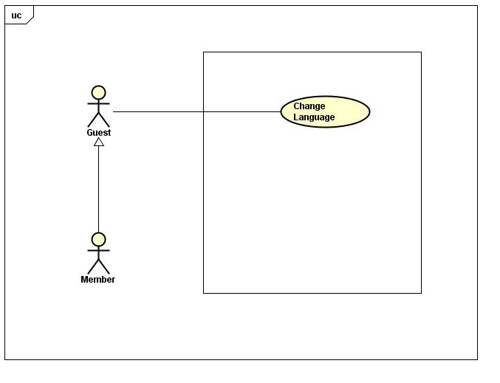

Figure 3‑4: UC: Change Interface Language

###### UC-G-008: Change Language

|  |  |  |  |  |
| --- | --- | --- | --- | --- |
| Use Case Name | Change Language | | | |
| Use Case ID | UC-G-008 | | | |
| Created By | ThangPD | Last Updated By | | ThangPD |
| Date Created | 27/07/2016 | Date Last Updated | | 05/08/2016 |
| Actor | Member | | | |
| Description | User changes language of website | | | |
| Pre-condition | Website is available | | | |
| Trigger | User clicks “Veazy” logo at the top of menu of the webpage | | | |
| Post Condition | System changes language of website to Japanese (if current language is English) or English (if current language is Japanese) | | | |
| Main Success Scenario | | | | |
| Step | **User** | | **System’s Response** | |
| 1 | Clicks “Veazy” logo | | System changes language of website to Japanese/English | |

#### Member

##### Manage Account

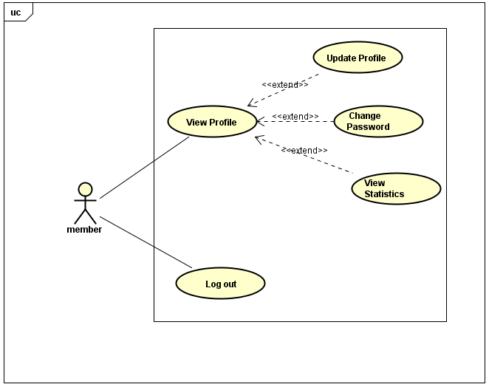

Figure 3‑5. UC Manage Account

###### UC-M-001: View Profile

|  |  |  |  |  |
| --- | --- | --- | --- | --- |
| Use Case Name | View Profile | | | |
| Use Case ID | UC-M-001 | | | |
| Created By | QuanNH | Last Updated By | | ThangPD |
| Date Created | 27/06/2016 | Date Last Updated | | 29/07/2016 |
| Actor | Member | | | |
| Description | User views profile information | | | |
| Pre-condition | * Website is available * Member logged in the system | | | |
| Trigger | User clicks username hyperlink at the right corner of top menu of website | | | |
| Post Condition | System redirects to “User Profile” page | | | |
| Main Success Scenario | | | | |
| Step | **User** | | **System’s Response** | |
| 1 | User clicks username hyperlink at the right corner of top menu | | Redirects to “User Profile” page | |

###### UC-M-002: Update Profile

|  |  |  |  |  |
| --- | --- | --- | --- | --- |
| Use Case Name | Update Profile | | | |
| Use Case ID | UC-M-002 | | | |
| Created By | QuanNH | Last Updated By | | ThangPD |
| Date Created | 04/07/2016 | Date Last Updated | | 29/07/2016 |
| Actor | Member | | | |
| Description | User edits information of their own profile | | | |
| Pre-condition | * Website is available * Member logged in the system * Done UC-M-001 successfully | | | |
| Trigger | * User clicks “Update Profile” in “Actions” dropdown list * User inputs information (including first name, last name, birthday, address, hobbies, about me, favorite quote, website) * User clicks “Save” button at the bottom of “Update Profile Information” popup | | | |
| Post Condition | * System closes dialog, reloads “User Profile” page and show update successfully * If exceptions are thrown, the result must match with output of each described exception. | | | |
| Main Success Scenario | | | | |
| Step | **User** | | **System’s Response** | |
| 1 | Clicks “Update Profile” in “Actions” dropdown list | | Shows “Update Profile Information” popup | |
| 2 | Inputs first name, last name, birthday, address, hobbies, about me, favorite quote, website in respective textbox | |  | |
| 3 | Click “Save” button. | | Updated information of user, then closes popup and reloads “User Profile” page | |
| Alternative Scenario | | | | |
| At step | **User** | | **System’s Response** | |
| 3 | Clicks “Cancel” button | | Cancels editing profile action and closes “Update Profile Information” popup | |
| Exception | | | | |
| At Step | **User** | | **System’s Response** | |
| 2 | If any of those textbox is null | | System skips and does not update the information of the textbox | |

###### UC-M-003: Change Password

|  |  |  |  |  |
| --- | --- | --- | --- | --- |
| Use Case Name | Change Password | | | |
| Use Case ID | UC-M-003 | | | |
| Created By | QuanNH | Last Updated By | | ThangPD |
| Date Created | 27/06/2016 | Date Last Updated | | 29/07/2016 |
| Actor | Member | | | |
| Description | User changes their password | | | |
| Pre-condition | * Website is available * Member logged in the system * Done UC-M-001 successfully | | | |
| Trigger | * User click “Change Password” in “Actions” dropdown list * User inputs current password, new password and re-type new password * User clicks “Change” button at the bottom of “Change Password” popup | | | |
| Post Condition | * System stays on initial screen and password is changed successfully. * If exceptions are thrown, the result must match with output of each described exception. | | | |
| Main Success Scenario | | | | |
| Step | **User** | | **System’s Response** | |
| 1 | Clicks “Change Password” in“Actions” dropdown list. | | Shows “Change password” popup | |
| 2 | Inputs current password, new password and password confirmation | |  | |
| 3 | Clicks “Change” button. | | Changes password successfully and closes popup | |
| Alternative Scenario | | | | |
| At Step | **User** | | **System’s Response** | |
| 3 | Clicks “Cancel” button | | Cancels changing password action and closes “Change Password” popup | |
| Exception | | | | |
| At Step | **User** | | **System’s Response** | |
| 2 | If “Current Password” textbox is null | | Displays the message: “Password required!” | |
| 2 | If “New Password” textbox is null | | Displays the message: “Password required!” | |
| 2 | If new password and re-typed password is not the same | | Displays the message: “Password does not match” | |
| 2 | If user inputs new password that is less than 6 characters | | Displays the message: “Password must be at least 6 characters long!” | |
| 2 | If user inputs new password that is more than 32 characters | | Displays the message: “Password must be no more than 32 characters long!” | |
| 2 | If current password is incorrect | | Displays the message: “Incorrect password!” | |

###### UC-M-005: View Statistics

|  |  |  |  |  |
| --- | --- | --- | --- | --- |
| Use Case Name | View Statistics | | | |
| Use Case ID | UC-M-005 | | | |
| Created By | QuanNH | Last Updated By | | ThangPD |
| Date Created | 27/06/2016 | Date Last Updated | | 29/07/2016 |
| Actor | Member | | | |
| Description | User views statistics assessed based on their test marks | | | |
| Pre-condition | * Website is available * Member logged in the system * Done UC-M-001 successfully | | | |
| Trigger | User clicks “Statistics” hyperlink on “User Profile” page | | | |
| Post Condition | System shows statistics successfully | | | |
| Main Success Scenario | | | | |
| Step | **User** | | **System’s Response** | |
| 1 | Click “Statistics” button in “User Profile” page | | System displays 3 types of statistics: radar chart of level, line chart of 10 recently taken tests and bar chart of skills. | |

###### UC-M-006: Logout

|  |  |  |  |  |
| --- | --- | --- | --- | --- |
| Use Case Name | Logout | | | |
| Use Case ID | UC-M-006 | | | |
| Created By | QuanNH | Last Updated By | | ThangPD |
| Date Created | 27/06/2016 | Date Last Updated | | 12/07/2016 |
| Actor | Member | | | |
| Description | User logs out of Veazy system | | | |
| Pre-condition | * Website is available * Member logged in the system | | | |
| Trigger | User clicks username hyperlink at the right top of menu then clicks “Logout” hyperlink in dropdown list | | | |
| Post Condition | Redirect to “Login” page and signs user out successfully | | | |
| Main Success Scenario | | | | |
| Step | **User** | | **System’s Response** | |
| 1 | Clicks username hyperlink at the right top of menu | | Shows dropdown list | |
| 2 | Clicks “Logout” hyperlink in dropdown list | | Signs user out, then redirects to “Login” page | |

##### C:\Users\Shiba Tatsuya\Desktop\report.PNG Report Content

Figure 3‑6. UC Report Content

###### UC-M-007: Report Lesson

|  |  |  |  |  |
| --- | --- | --- | --- | --- |
| Use Case Name | Report Lesson | | | |
| Use Case ID | UC-M-007 | | | |
| Created By | QuanNH | Last Updated By | | ThangPD |
| Date Created | 04/07/2016 | Date Last Updated | | 14/08/2016 |
| Actor | Member | | | |
| Description | User sends reports about wrong content of lesson to Content Editor | | | |
| Pre-condition | * Website is available * Member logged in the system * Done UC-G-004 successfully | | | |
| Trigger | User clicks “Report” hyperlink on “Lesson” page | | | |
| Post Condition | System sends the report to Content Editor for review purpose | | | |
| Main Success Scenario | | | | |
| Step | **User** | | **System’s Response** | |
| 1 | Clicks “Report” hyperlink on “Lesson” page | | Shows “Report Lesson” popup | |
| 2 | Inputs content of report (i.e, the reason why user reports the lesson) | |  | |
| 2 | Clicks ”Report” button on “Report Lesson” popup | | Sends report to Content Editorfor review, then and displays the message “Your report has been submitted for review. Thank you for your contribution.” | |
| Alternative Scenario | | | | |
| At Step | **User** | | **System’s Response** | |
| 1 | Clicks “Cancel” button on “Report lesson” popup | | Cancels reporting lesson and closes the popup | |

###### UC-M-008: Report Question

|  |  |  |  |  |
| --- | --- | --- | --- | --- |
| Use Case Name | Report Question | | | |
| Use Case ID | UC-M-008 | | | |
| Created By | QuanNH | Last Updated By | | ThangPD |
| Date Created | 04/07/2016 | Date Last Updated | | 29/07/2016 |
| Actor | Member | | | |
| Description | User sends reports about wrong content of question to Content Editor | | | |
| Pre-condition | * Website is available * Member logged in the system * Done UC-G-006 successfully | | | |
| Trigger | User clicks “Report” button at the right side of the question that user wants to report on “Test Result” page | | | |
| Post Condition | System sends the report to Content Editor for review purpose | | | |
| Main Success Scenario | | | | |
| Step | **User** | | **System’s Response** | |
| 1 | Clicks “Report” button at the right of question | | Shows “Report question” popup | |
| 2 | Inputs content of report (i.e, the reason why user reports the question) | |  | |
| 3 | Clicks ”Report” button in “Report question” popup | | Sends the report to Content Editor for review, then and displays the message “Your report has been submitted for review. Thank you for your contribution.” | |
| Alternative Scenario | | | | |
| At Step | **User** | | **System’s Response** | |
| 3 | Clicks “Cancel” button on “Report question” popup | | Cancels reporting question and closes the popup | |

##### Test History



Figure 3‑7. UC Test History

###### UC-M-009: View List Test History

|  |  |  |  |  |
| --- | --- | --- | --- | --- |
| Use Case Name | View List Test History | | | |
| Use Case ID | UC-M-009 | | | |
| Created By | QuanNH | Last Updated By | | ThangPD |
| Date Created | 27/06/2016 | Date Last Updated | | 20/07/2016 |
| Actor | Member | | | |
| Description | User views list of their taken test (aka test history) | | | |
| Pre-condition | * Website is available * Member logged in the system | | | |
| Trigger | User clicks “Test History” tabon “User Profile” page | | | |
| Post Condition | Shows list test history in “Test History” tab | | | |
| Main Success Scenario | | | | |
| Step | **User** | | **System’s Response** | |
| 1 | Clicks “Test History” tabon“User profile” page | | Shows a lists of taken test records and their details including skill of test, course level, time allowed & time taken, result. | |

###### UC-M-010: View Test History

|  |  |  |  |  |
| --- | --- | --- | --- | --- |
| Use Case Name | View Test History | | | |
| Use Case ID | UC-M-010 | | | |
| Created By | QuanNH | Last Updated By | | ThangPD |
| Date Created | 04/07/2016 | Date Last Updated | | 29/07/2016 |
| Actor | Member | | | |
| Description | User views the details of taken tests including all questions, answers (both true answers and their selected answers) as well as the test result | | | |
| Pre-condition | * Website is available * Member logged in the system * Done UC-M-009 successfully | | | |
| Trigger | User clicks “See result” in “Actions” dropdown list in user profile page | | | |
| Post Condition | System redirects to “Test Result” page | | | |
| Main Success Scenario | | | | |
| Step | **User** | | **System’s Response** | |
| 1 | Clicks “See result” in “Actions” dropdown list in user profile page | | Shows “Test Details” page | |

###### UC-M-011: Retake Test

|  |  |  |  |  |  |
| --- | --- | --- | --- | --- | --- |
| Use Case Name | Retake Test | | | | |
| Use Case ID | UC-M-011 | | | | |
| Created By | QuanNH | Last Updated By | | ThangPD | |
| Date Created | 04/07/2016 | Date Last Updated | | | 28/07/2016 |
| Actor | Member | | | | |
| Description | User takes the tests (in their test history list) one more time | | | | |
| Pre-condition | * Website is available * Member logged in the system * Done UC-M-009 successfully | | | | |
| Trigger | User clicks “Retake this test” in “Actions” dropdown list on “User Profile” page | | | | |
| Post Condition | System redirects to “Taking Test” page | | | | |
| Main Success Scenario | | | | | |
| Step | **User** | | **System’s Response** | | |
| 1 | Clicks “Actions” hyperlink on the top right corner of the test record | | Displays dropdown list | | |
| 2 | Clicks “Retake this test” hyperlink | | Replicates the tests and redirects to “Taking Test” page | | |
| Alternative Scenario | | | | | |
| At Step | **User** | | **System’s Response** | | |
| 2 | Click “Cancel” button | |  | | |
| Exception | | | | | |
| At Step | **User** | | **System’s Response** | | |

#### Content Editor

##### Manage Account

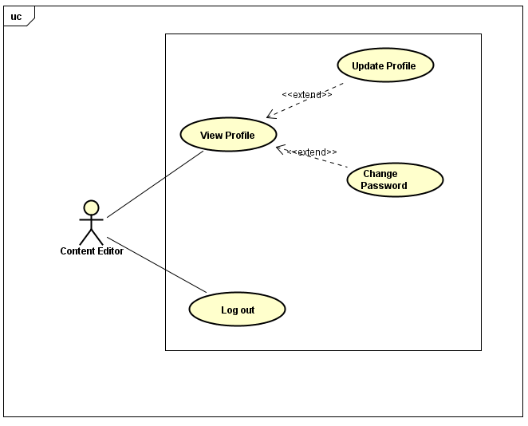

Figure 3‑8. UC Manage Account

###### UC-E-001: View Profile

|  |  |  |  |  |
| --- | --- | --- | --- | --- |
| Use Case Name | View Profile | | | |
| Use Case ID | UC-E-001 | | | |
| Created By | QuanNH | Last Updated By | | ThangPD |
| Date Created | 27/06/2016 | Date Last Updated | | 29/07/2016 |
| Actor | Content Editor | | | |
| Description | User views their profile | | | |
| Pre-condition | * Website is available * Content editor logged in the system | | | |
| Trigger | User clicks username hyperlink at right-sided editor menu | | | |
| Post Condition | System redirects to “Editor Profile” page | | | |
| Main Success Scenario | | | | |
| Step | **User** | | **System’s Response** | |
| 1 | Clicks username hyperlink at the right of avatar | | Redirects to “Editor Profile” page | |

###### UC-E-002: Update Profile

|  |  |  |  |  |
| --- | --- | --- | --- | --- |
| Use Case Name | Update Profile | | | |
| Use Case ID | UC-E-002 | | | |
| Created By | QuanNH | Last Updated By | | ThangPD |
| Date Created | 04/07/2016 | Date Last Updated | | 29/07/2016 |
| Actor | Content Editor | | | |
| Description | User edits information of their own profile | | | |
| Pre-condition | * Website is available * Content editor logged in the system | | | |
| Trigger | * User clicks “Update Profile” in “Actions” dropdown list * User inputs information (including first name, last name, birthday, address, hobbies, about me, favorite quote, website) * User clicks “Save” button at the bottom of “Update Profile Information” popup | | | |
| Post Condition | * System closes the dialog, reloads “Editor Profile” page and shows update successfully * If exceptions are thrown, the result must match with output of each described exception. | | | |
| Main Success Scenario | | | | |
| Step | **User** | | **System’s Response** | |
| 1 | Clicks “Update Profile” in “Actions” dropdown list | | Shows “Update Profile Information” popup | |
| 2 | Inputs first name, last name, birthday, address, hobbies, about me, favorite quote, website in respective textbox | |  | |
| 3 | Clicks “Save” button | | Updates profile successfully, closes dialog and reload “Editor Profile” page | |
| Alternative Scenario | | | | |
| At Step | **User** | | **System’s Response** | |
| 3 | Clicks “Cancel” button. | | Cancels editing profile action and closes “Update Profile Information” popup | |
| Exception | | | | |
| At Step | **User** | | **System’s Response** | |
| 2 | If any of those textbox is null | | System skips and does not update the information of the textbox | |

###### UC-E-003: Change Password

|  |  |  |  |  |
| --- | --- | --- | --- | --- |
| Use Case Name | Change Password | | | |
| Use Case ID | UC-E-003 | | | |
| Created By | QuanNH | Last Updated By | | ThangPD |
| Date Created | 27/06/2016 | Date Last Updated | | 12/07/2016 |
| Actor | Content Editor | | | |
| Description | User changes their password | | | |
| Pre-condition | * Website is available * Content Editor logged in the system * Done UC-E-001 successfully | | | |
| Trigger | User clicks “Change password” hyperlink in “Actions” dropdown list on “Editor Profile” page | | | |
| Post Condition | * User click “Change Password” in “Actions” dropdown list * User inputs current password, new password and re-type new password * User clicks “Change” button at the bottom of “Change Password” popup | | | |
| Main Success Scenario | | | | |
| Step | **User** | | **System’s Response** | |
| 1 | Clicks “Change Password” in “Actions” dropdown list. | | Show “Change Password” popup | |
| 2 | Inputs current password, new password and password confirmation | |  | |
| 3 | Click “Save” button. | | Changes password successfully and closes popup | |
| Alternative Scenario | | | | |
| At Step | **User** | | **System’s Response** | |
| 1 | Clicks “Cancel” button. | | Cancels changing password action and closes “Change Password” popup | |
| Exception | | | | |
| At Step | **User** | | **System’s Response** | |
| 2 | If “Current Password” textbox is null | | Displays the message: “Password required!” | |
| 2 | If “New Password” textbox is null | | Displays the message: “Password required!” | |
| 2 | If new password and re-typed password is not the same | | Displays the message: “Password does not match” | |
| 2 | If user inputs new password that is less than 6 characters | | Displays the message: “Password must be at least 6 characters long!” | |
| 2 | If user inputs new password that is more than 32 characters | | Displays the message: “Password must be no more than 32 characters long!” | |
| 2 | If current password is incorrect | | Displays the message: “Incorrect password!” | |

###### UC-E-004: Logout

|  |  |  |  |  |
| --- | --- | --- | --- | --- |
| Use Case Name | Logout | | | |
| Use Case ID | UC-E-004 | | | |
| Created By | QuanNH | Last Updated By | | ThangPD |
| Date Created | 27/06/2016 | Date Last Updated | | 19/07/2016 |
| Actor | Content Editor | | | |
| Description | User logouts of the Veazy system | | | |
| Pre-condition | * Website is available * Content editorlogged in the system | | | |
| Trigger | User clicks “Logout” hyperlink at right-sided editor menu | | | |
| Post Condition | Signs user out successfully and redirects to “Login” page | | | |
| Main Success Scenario | | | | |
| Step | **User** | | **System’s Response** | |
| 1 | Click “Logout” hyperlink | | System redirects to “Login” page | |

##### Change Interface Language

###### UC-E-005: Change Language

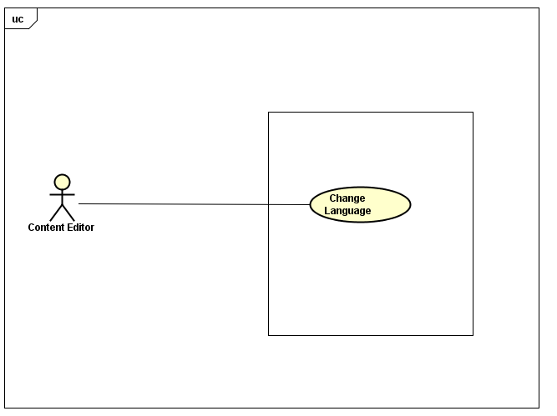

Figure 3‑9. UC Change language

|  |  |  |  |  |
| --- | --- | --- | --- | --- |
| Use Case Name | Change Language | | | |
| Use Case ID | UC-E-005 | | | |
| Created By | ThangPD | Last Updated By | | ThangPD |
| Date Created | 27/07/2016 | Date Last Updated | | 05/08/2016 |
| Actor | Content Editor | | | |
| Description | User changes language of website | | | |
| Pre-condition | Website is available | | | |
| Trigger | User clicks “Change Language To Japanese/English” hyperlink atright-sided editor menu | | | |
| Post Condition | System changes language of website to English/Japanese | | | |
| Main Success Scenario | | | | |
| Step | **User** | | **System’s Response** | |
| 1 | Click “Change Language to English/Japanese” hyperlink | | System changes language of website to English/Japanese | |

##### Manage Lessons

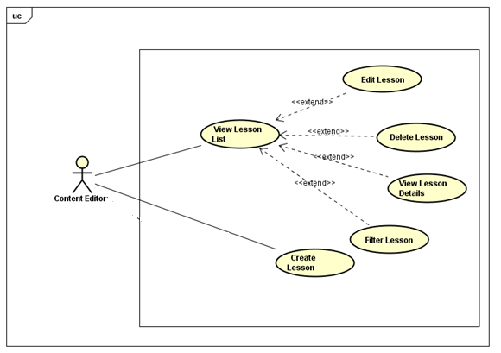

Figure 3‑10. UC Manage Lessons

###### UC-E-006: View Lesson List

|  |  |  |  |  |
| --- | --- | --- | --- | --- |
| Use Case Name | View Lesson List | | | |
| Use Case ID | UC-E-006 | | | |
| Created By | QuanNH | Last Updated By | | ThangPD |
| Date Created | 27/06/2016 | Date Last Updated | | 05/08/2016 |
| Actor | Content Editor | | | |
| Description | User views list lessons of courses | | | |
| Pre-condition | * Website is available * Content editor logged in the system | | | |
| Trigger | User clicks “Lessons” hyperlink at right-sided editor menu, then clicks “Lesson List” hyperlink | | | |
| Post Condition | System redirects to “Lesson List” page | | | |
| Main Success Scenario | | | | |
| Step | **User** | | **System’s Response** | |
| 1 | Clicks “Lessons” hyperlink | | Shows “Lesson List”hyperlink and “Add Lesson ” hyperlink | |
| 2 | Clicks “Lesson List” hyperlink | | Redirect to “Lesson List” page | |

###### UC-E-007:Filter lesson

|  |  |  |  |  |
| --- | --- | --- | --- | --- |
| Use Case Name | Search Lesson | | | |
| Use Case ID | UC-E-007 | | | |
| Created By | QuanNH | Last Updated By | | ThangPD |
| Date Created | 27/06/2016 | Date Last Updated | | 03/08/2016 |
| Actor | Content Editor | | | |
| Description | User searches lessons in lesson list page | | | |
| Pre-condition | * Website is available * Content editor logged in the system | | | |
| Trigger | * User chooses lesson level in “Level” dropdown list * User type a keyword in “Keyword” textbox * User clicks “Filter” button in lesson list page | | | |
| Post Condition | Searches lessons successfully. System filters all lessons of the selected level and contains the keyword, then displays results | | | |
| Main Success Scenario | | | | |
| Step | **User** | | **System’s Response** | |
| 1 | Choose lesson level in “Level” dropdown list | |  | |
| 2 | Inputs keyword in “Keyword” textbox | |  | |
| 3 | Clicks “Filter” button | | System filters and displays result | |

###### UC-E-008: View Lesson Details

|  |  |  |  |  |
| --- | --- | --- | --- | --- |
| Use Case Name | View Lesson Details | | | |
| Use Case ID | UC-E-008 | | | |
| Created By | QuanNH | Last Updated By | | ThangPD |
| Date Created | 27/06/2016 | Date Last Updated | | 05/08/2016 |
| Actor | Content Editor | | | |
| Description | User views lesson details | | | |
| Pre-condition | * Website is available * Content editor logged in the system | | | |
| Trigger | User clicks title name of the lessons in table that users want to view its detail | | | |
| Post Condition | System redirects to “Lesson Detail” page | | | |
| Main Success Scenario | | | | |
| Step | **User** | | **System’s Response** | |
| 1 | Click title name link | | Redirect to “Lesson Detail”page | |

###### UC-E-009: Create Lesson

|  |  |  |  |  |
| --- | --- | --- | --- | --- |
| Use Case Name | Create Lesson | | | |
| Use Case ID | UC-E-009 | | | |
| Created By | QuanNH | Last Updated B**y** | | ThangPD |
| Date Created | 27/06/2016 | Date Last Updated | | 12/08/2016 |
| Actor | Content Editor | | | |
| Description | User creates new lesson | | | |
| Pre-condition | * Website is available * Content editor logged in the system | | | |
| Trigger | User clicks “Lessons”hyperlinkat right-sided editor menu, then clicks “Add Lesson” hyperlink | | | |
| Post Condition | * System redirects to “Add Lesson” page * If exceptions are thrown, the result must match with output of each described exception. | | | |
| Main Success Scenario | | | | |
| Step | **User** | | **System’s Response** | |
| 1 | Clicks “Lessons” link | | Shows “Lesson List”hyperlink and “Add Lesson ” hyperlink | |
| 2 | Clicks “Add Lesson” hyperlink | | Redirects to “Add Lesson” page | |
| 3 | Inputs content of lesson for each section including vocabulary, grammar, conversation, listening, practice and reading | |  | |
| 4 | Clicks “Create” button | | Creates new lesson successfully and redirects to “Lesson Detail” page | |
| Exception | | | | |
| At Step | **User** | | **System’s Response** | |
| 3 | If “Title” textbox is null | | Displays the message: “Failed to create new lesson! Please make sure you do not leave any section content & lesson information blank.” | |
| 3 | If “Description” textbox is null | | Displays the message: “Failed to create new lesson! Please make sure you do not leave any section content & lesson information blank.” | |
| 3 | If any section of lesson is null or left blank | | Displays the message: “Failed to create new lesson! Please make sure you do not leave any section content & lesson information blank.” | |

###### UC-E-010: Edit Lesson

|  |  |  |  |  |
| --- | --- | --- | --- | --- |
| Use Case Name | Edit Lesson | | | |
| Use Case ID | UC-E-010 | | | |
| Created By | QuanNH | Last Updated By | | ThangPD |
| Date Created | 27/06/2016 | Date Last Updated | | 12/08/2016 |
| Actor | Content Editor | | | |
| Description | User edits content of a lesson | | | |
| Pre-condition | * Website is available * Content editor logged in the system | | | |
| Trigger | User clicks “Edit” button of the lesson in table that user wants to edit | | | |
| Post Condition | * System edits successfully and redirects to “Lesson Detail” page * If exceptions are thrown, the result must match with output of each described exception. | | | |
| Main Success Scenario | | | | |
| Step | **User** | | **System’s Response** | |
| 1 | Clicks “Edit” button | | Redirects to “Edit lesson” page | |
| 2 | Inputs content of lesson for each section including vocabulary, grammar, conversation, listening, practice and reading | |  | |
| 3 | Click “Update” button | | Updates successfully and redirect to “Lesson Detail” page. The version of lesson automatically goes up | |
| Alternative Scenario | | | | |
| At Step | **User** | | **System’s Response** | |
| 3 | Clicks “Save draft” button | | System saves the draft version of lesson so that the next time user edits the lesson, the draft version can be re-created. The lesson does not make any changes in content. | |
| 3 | Clicks “Back to Detail” button | | System redirects to “Lesson Detail” page | |
| Exception | | | | |
| At Step | **User** | | **System’s Response** | |

|  |  |  |
| --- | --- | --- |
| 3 | If “Title” textbox is null | Displays the message: “Failed to create new lesson! Please make sure you do not leave any section content & lesson information blank.” |
| 3 | If “Description” textbox is null | Displays the message: “Failed to create new lesson! Please make sure you do not leave any section content & lesson information blank.” |
| 3 | If any section of lesson is null or left blank | Displays the message: “Failed to create new lesson! Please make sure you do not leave any section content & lesson information blank.” |

###### UC-E-011: Delete Lesson

|  |  |  |  |  |
| --- | --- | --- | --- | --- |
| Use Case Name | Delete Lesson | | | |
| Use Case ID | UC-E-011 | | | |
| Created By | QuanNH | Last Updated By | | ThangPD |
| Date Created | 27/06/2016 | Date Last Updated | | 12/07/2016 |
| Actor | Content Editor | | | |
| Description | User deletes lesson | | | |
| Pre-condition | * Website is available * Content editor logged in the system | | | |
| Trigger | * User clicks “Delete” of the lesson in table that user wants to delete, then clicks “Delete” button in “Delete Lesson” popup | | | |
| Post Condition | Delete lesson successfully and system redirects to “Lesson list” page | | | |
| Main Success Scenario | | | | |
| Step | **User** | | **System’s Response** | |
| 1 | Clicks “Delete” button | | Shows “Delete Lesson” popup | |
| 2 | Clicks “Delete” button | | Deletes lesson and closes popup, then reload “Lesson List” page | |
| Alternative Scenario | | | | |
| At Step | **User** | | **System’s Response** | |
| 1 | Clicks “Cancel” button in “Delete Lesson” popup | | Cancels action of deleting system and closes popup | |
| Exception | | | | |
| At Step | **User** | | **System’s Response** | |

##### Manage Questions

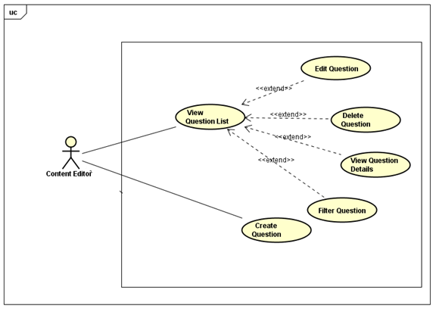

###### UC-E-012: View Question List

|  |  |  |  |  |
| --- | --- | --- | --- | --- |
| Use Case Name | View Question List | | | |
| Use Case ID | UC-E-012 | | | |
| Created By | QuanNH | Last Updated By | | ThangPD |
| Date Created | 04/07/2016 | Date Last Updated | | 05/08/2016 |
| Actor | Content Editor | | | |
| Description | User views list questions | | | |
| Pre-condition | * Website is available * Content editor logged in the system | | | |
| Trigger | User clicks “Questions” hyperlink at right-sided bar on dashboard, then clicks “Questions List” hyperlink | | | |
| Post Condition | View questions list successfully and system redirects to “Questions List” page | | | |
| Main Success Scenario | | | | |
| Step | **User** | | **System’s Response** | |
| 1 | Clicks “Questions” hyperlink at right-sided editor menu | | Shows “Question List” hyperlink and “Add Question” Hyperlink | |
| 2 | Clicks “Question List” hyperlink | | Redirects to “Question List” page | |

###### UC-E-013: Filter question

|  |  |  |  |  |
| --- | --- | --- | --- | --- |
| Use Case Name | Search Question | | | |
| Use Case ID | UC-E-013 | | | |
| Created By | QuanNH | Last Updated By | | ThangPD |
| Date Created | 04/07/2016 | Date Last Updated | | 04/08/2016 |
| Actor | Content Editor | | | |
| Description | User searches question | | | |
| Pre-condition | * Website is available * Content editor logged in the system | | | |
| Trigger | * User chooses question type in “Type” dropdown list on “Question List” page * User chooses question level in “Level” dropdown liston “Question List” page * User chooses question skill in “Skill” dropdown liston“Question List” page * User inputs a keyword in “Keyword” textbox * User clicks “Filter” button in question list page | | | |
| Post Condition | Search questions successfully and system filtersall questions of the selected combination of type, level, skill and contains the keyword, then displays results | | | |
| Main Success Scenario | | | | |
| Step | **User** | | **System’s Response** | |
| 1 | User chooses question type in “Type” dropdown list | |  | |
| 2 | User chooses question level in “Level” dropdown list | |  | |
| 3 | User chooses question skill in “Skill” dropdown list | |  | |
| 4 | User clicks “Filter” button in question list page | | System filters and displays result | |

###### UC-E-014: View Question Details

|  |  |  |  |  |
| --- | --- | --- | --- | --- |
| Use Case Name | View Question Details | | | |
| Use Case ID | UC-E-014 | | | |
| Created By | QuanNH | Last Updated By | | ThangPD |
| Date Created | 04/07/2016 | Date Last Updated | | 19/07/2016 |
| Actor | Content Editor | | | |
| Description | User views question details | | | |
| Pre-condition | * Website is available * Content editor logged in the system * Done UC-E-014 successfully | | | |
| Trigger | User clicks “Click here to see content” hyperlink of the question in table on “Question List” page | | | |
| Post Condition | System redirects to “Question Detail” page | | | |
| Main Success Scenario | | | | |
| Step | **User** | | **System’s Response** | |
| 1 | Clicks “Click here to see content” hyperlink of a question | | Redirect to “Question Detail” page | |

###### Create Question

**UC-E-015: Create Single-typed Question**

|  |  |  |  |  |
| --- | --- | --- | --- | --- |
| Use Case Name | Create Single-typed Question | | | |
| Use Case ID | UC-E-015 | | | |
| Created By | QuanNH | Last Updated By | | ThangPD |
| Date Created | 27/06/2016 | Date Last Updated | | 12/08/2016 |
| Actor | Content Editor | | | |
| Description | User creates a new single-typed question (which includes question content and multiple answers) | | | |
| Pre-condition | * + - * Website is available       * Content editor logged in the system | | | |
| Trigger | User click “Questions”hyperlink atright-sided editor menu, then click “Add Question” hyperlink | | | |
| Post Condition | Creates question successfully and system redirects to “Questions Detail” page  If exceptions are thrown, the result must match with output of each described exception. | | | |
| Main Success Scenario | | | | |
| Step | **User** | | **System’s Response** | |
| 1 | Clicks “Add Question” hyperlink | | Redirects to “Add Question” Page | |
| 2 | Chooses “Single” in “Question Type” dropdown list | |  | |
| 3 | Chooses question level in “Level” dropdown list | |  | |
| 4 | Chooses question skill in “Test Skill” dropdown list | |  | |
| 5 | Inputs question and answer and chooses right answer | |  | |
| 6 | Clicks “+” button under answer list | | Adds one more answers into answer list of question | |
| 7 | Adds one more answers into answer list of question | |  | |
| 8 | Clicks “X” button at an answer | | Removes theanswer | |
| 9 | Clicks “Create” button | | Creates question successfully and redirects to “Question Detail” page | |
| Alternative Scenario | | | | |
| At Step | **User** | | **System’s Response** | |
| 4 | If user chooses “Listening” in “Test Skill” dropdown list | | Displays input that allows user select audio file | |
| Exception | | | | |
| At Step | **User** | | **System’s Response** | |
| 4 | If file chosen to upload is not “.mp3” type | | Displays the message: “This is not valid audio file. Only .mp3 type is allowed!” | |
| 5 | If “Question” textbox is null | | Displays the message: “Failed to create new question! Please make sure you do not leave any question & answer's contents blank.” | |
| 5 | If “Answer” textbox is null | | Displays the message: “Failed to create new question! Please make sure you do not leave any question & answer's contents blank.” | |
| 5 | If user does not choose at least 1 right answer | | Displays the message: “There must be at least one right answer in each question!” | |

**UC-E-016: Create Group-typed Question**

|  |  |  |  |  |
| --- | --- | --- | --- | --- |
| Use Case Name | Create Group-typed Question | | | |
| Use Case ID | UC-E-016 | | | |
| Created By | QuanNH | Last Updated By | | ThangPD |
| Date Created | 27/06/2016 | Date Last Updated | | 12/08/2016 |
| Actor | Content Editor | | | |
| Description | User creates new group-typed question (which include a section of reading paragraph and multiple questions) | | | |
| Pre-condition | * + - * Website is available       * Content editor logged in the system | | | |
| Trigger | User click “Questions” hyperlink at right-sided editor menu, then click “Add Question” hyperlink | | | |
| Post Condition | Creates question successfully and system redirects to “Questions Detail” page  If exceptions are thrown, the result must match with output of each described exception. | | | |
| Main Success Scenario | | | | |
| Step | **User** | | **System’s Response** | |
| 1 | Clicks “Add Question” hyperlink | | Redirects to “Add Question” Page | |
| 2 | Chooses “Group” in “Question Type” dropdown list | |  | |
| 3 | Chooses question level in “Level” dropdown list | | Show level dropdown list | |
| 4 | Input reading paragraph in “Content” editor | |  | |
| 5 | Inputs question and answer and choose right answer | |  | |
| 6 | Clicks “+” button under answer list | | Adds one more answers intothe question’s answer list of question | |
| 7 | Clicks “+” button under question label | | Adds one more single question into question list | |
| 8 | Clicks “X” button under answer list | | Removes the answer from the answer list of the question | |
| 9 | Clicks “X” button under question label | | Remove the question from question list | |
| 10 | Clicks time icon to select time allowed | |  | |
| 11 | Clicks “Create” button | | Creates question successfully and redirects to “Question Detail” page | |
| Exception | | | | |
| At Step | **User** | | **System’s Response** | |
| 4 | If “Content” section is null or left blank | | Displays the message: “Failed to create new question! Please make sure you do not leave any question & answer's contents blank.” | |
| 5 | If “Question” textbox is null | | Displays the message: “Failed to create new question! Please make sure you do not leave any question & answer's contents blank.” | |
| 5 | If “Answer” textbox is null | | Displays the message: “Failed to create new question! Please make sure you do not leave any question & answer's contents blank.” | |
| 5 | If user does not choose at least 1 right answer in each question | | Displays the message: “There must be at least one right answer in each question!” | |

###### Edit Question

**.UC-E-017: Edit Question Single**

|  |  |  |  |  |
| --- | --- | --- | --- | --- |
| Use Case Name | Edit Question Single | | | |
| Use Case ID | UC-E-017 | | | |
| Created By | QuanNH | Last Updated By | | ThangPD |
| Date Created | 27/06/2016 | Date Last Updated | | 03/08/2016 |
| Actor | Content Editor | | | |
| Description | User edits the content of a single-typed question | | | |
| Pre-condition | * Website is available * Content editor logged in the system * Done UC-E-014 successfully | | | |
| Trigger | User clicks “Edit” button of a question in table on “Question List” page | | | |
| Post Condition | * Edit question successfully and redirect to“Question Detail”page * If exceptions are thrown, the result must match with output ofeach described exception. | | | |
| Main Success Scenario | | | | |
| Step | **User** | | **System’s Response** | |
| 1 | Clicks “Edit” button | | Redirects to “Edit Question” page | |
| 2 | Chooses question level in “Level” dropdown list | |  | |
| 3 | Chooses question skill in “Test Skill” dropdown list | |  | |
| 4 | Inputs question and answer and chooses right answer | |  | |
| 5 | Clicks “+” button under answer list | | Adds one more answers into answer list of question | |
| 6 | Adds one more answers into answer list of question | |  | |
| 7 | Clicks “X” button at an answer | | Removes the answer | |
| 8 | Clicks “Update” button | | Updates question successfully and redirects to “Question Detail” page | |
| Alternative Scenario | | | | |
| At Step | **User** | | **System’s Response** | |
| 4 | If user chooses “Listening” in “Test Skill” dropdown list | | Displays input that allows user select audio file | |
| 8 | Clicks “Back to Detail” button | | Cancels action of editing question and redirects to “Question Detail” page | |
| Exception | | | | |
| At Step | **User** | | **System’s Response** | |
| 3 | If file chosen to upload is not “.mp3” type | | Displays the message: “This is not valid audio file. Only .mp3 type is allowed!” | |
| 4 | If “Question” textbox is null | | Displays the message: “Failed to create new question! Please make sure you do not leave any question & answer's contents blank.” | |
| 4 | If “Answer” textbox is null | | Displays the message: “Failed to create new question! Please make sure you do not leave any question & answer's contents blank.” | |
| 4 | If user does not choose at least 1 right answer | | Displays the message: “There must be at least one right answer in each question!” | |

**UC-E-018: Edit Group-typed Question**

|  |  |  |  |  |
| --- | --- | --- | --- | --- |
| Use Case Name | Edit Group-typed Question | | | |
| Use Case ID | UC-E-018 | | | |
| Created By | QuanNH | Last Updated By | | ThangPD |
| Date Created | 27/06/2016 | Date Last Updated | | 12/08/2016 |
| Actor | Content Editor | | | |
| Description | User edits content of a group-typed question | | | |
| Pre-condition | * Website is available * Content editor logged in the system * Done UC-E-014 successfully | | | |
| Trigger | User clicks “Edit” button of a question in table on “Question List” page | | | |
| Post Condition | * Edit question successfully and redirect to “Question Detail” page * If exceptions are thrown, the result must match with output of each described exception. | | | |
| Main Success Scenario | | | | |
| Step | **User** | | **System’s Response** | |
| 1 | Clicks “Edit” button | | Redirects to “Edit Question” page | |
| 2 | Chooses question level in “Level” dropdown list | | Show level dropdown list | |
| 3 | Input reading paragraph in “Content” editor | |  | |
| 4 | Inputs question and answer and choose right answer | |  | |
| 5 | Clicks “+” button under answer list | | Adds one more answers into the question’s answer list of question | |
| 6 | Clicks “+” button under question label | | Adds one more single question into question list | |
| 7 | Clicks “X” button under answer list | | Removes the answer from the answer list of the question | |
| 8 | Clicks “X” button under question label | | Remove the question from question list | |
| 9 | Clicks time icon to select time allowed | |  | |
| 10 | Clicks “Update” button | | Edits question successfully and redirects to “Question Detail” page | |
| Alternative Scenario | | | | |
| At Step | **User** | | **System’s Response** | |
| 9 | Click “Back to Detail” button | | Cancel edit question and redirect to question detail page | |
| Exception | | | | |
| At Step | **User** | | **System’s Response** | |
| 3 | If “Content” section is null or left blank | | Displays the message: “Failed to create new question! Please make sure you do not leave any question & answer's contents blank.” | |
| 4 | If “Question” textbox is null | | Displays the message: “Failed to create new question! Please make sure you do not leave any question & answer's contents blank.” | |
| 4 | If “Answer” textbox is null | | Displays the message: “Failed to create new question! Please make sure you do not leave any question & answer's contents blank.” | |
| 4 | If user does not choose at least 1 right answer in each question | | Displays the message: “There must be at least one right answer in each question!” | |

###### UC-E-019: Delete Question

|  |  |  |  |  |
| --- | --- | --- | --- | --- |
| Use Case Name | Delete Lesson | | | |
| Use Case ID | UC-E-019 | | | |
| Created By | QuanNH | Last Updated By | | ThangPD |
| Date Created | 05/07/2016 | Date Last Updated | | 05/08/2016 |
| Actor | Content Editor | | | |
| Description | User deletes question | | | |
| Pre-condition | * Website is available * Content editor logged in the system * Done UC-E-014 successfully | | | |
| Trigger | User clicks “Delete” button of a question in table on “Question List” page | | | |
| Post Condition | Delete question successfully and system reloads “Question List” page | | | |
| Main Success Scenario | | | | |
| Step | **User** | | **System’s Response** | |
| 1 | Clicks “Delete” button on “Question List” page | | Shows “Delete Question” popup | |
| 2 | Clicks “Delete” button in popup | | Deletes question and closes popup, reload “Question List” page | |
| Alternative Scenario | | | | |
| At Step | **User** | | **System’s Response** | |
| 1 | Clicks “Cancel” button in “Delete Question” popup | | Cancels action of deleting system and closes popup | |
| Exception | | | | |
| At Step | **User** | | **System’s Response** | |

##### Manage Reports

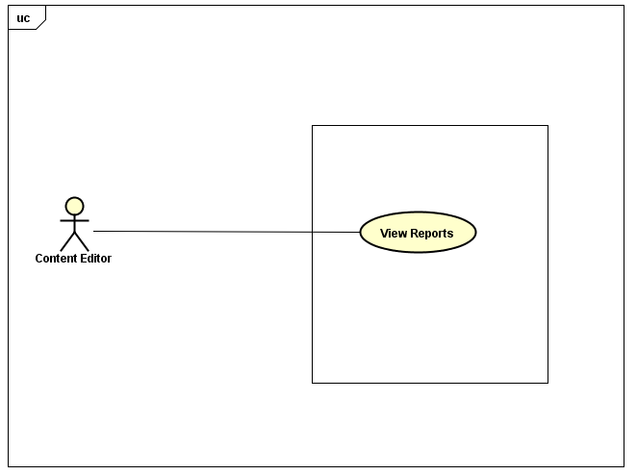

###### UC-E-020: View Reports

|  |  |  |  |  |
| --- | --- | --- | --- | --- |
| Use Case Name | View Reports | | | |
| Use Case ID | UC-E-020 | | | |
| Created By | QuanNH | Last Updated By | | ThangPD |
| Date Created | 27/06/2016 | Date Last Updated | | 25/07/2016 |
| Actor | Content Editor | | | |
| Description | User views reports about lesson & question sent from user | | | |
| Pre-condition | * + - * Website is available       * Content editor logged in the system | | | |
| Trigger | User clicks “Reports” hyperlink at the right-sided editor menu | | | |
| Post Condition | Redirects to “Report List” page which displays report list | | | |
| Main Success Scenario | | | | |
| Step | **User** | | **System’s Response** | |
| 1 | Click “Reports” hyperlink | | Redirects to “Report List” page and display reports list | |

###### 3.1.3.5.2 UC-E-021: View Reported Lesson

|  |  |  |  |  |
| --- | --- | --- | --- | --- |
| Use Case Name | View Reported Lesson | | | |
| Use Case ID | UC-E-021 | | | |
| Created By | QuanNH | Last Updated By | | ThangPD |
| Date Created | 27/06/2016 | Date Last Updated | | 25/07/2016 |
| Actor | Content Editor | | | |
| Description | User views the content of the lesson reported by user for review purpose | | | |
| Pre-condition | * + - * Website is available       * Content editor logged in the system       * Done UC-E-020 successfully | | | |
| Trigger | User clickslesson title hyperlink in a report in table to display the detail of the lesson | | | |
| Post Condition | Redirects to “Lesson Detail” page which displays lesson detail | | | |
| Main Success Scenario | | | | |
| Step | **User** | | **System’s Response** | |
| 1 | Clicks lesson titlehyperlink | | Redirects to “Lesson Detail” page and displays the content of the lesson | |

###### 3.1.3.5.2 UC-E-021: View Reported Question

|  |  |  |  |  |
| --- | --- | --- | --- | --- |
| Use Case Name | View Reported Question | | | |
| Use Case ID | UC-E-021 | | | |
| Created By | QuanNH | Last Updated By | | ThangPD |
| Date Created | 27/06/2016 | Date Last Updated | | 25/07/2016 |
| Actor | Content Editor | | | |
| Description | User views the content of the question reported by user for review purpose | | | |
| Pre-condition | * + - * Website is available       * Content editor logged in the system       * Done UC-E-020 successfully | | | |
| Trigger | User clicksquestion ID hyperlink in a report in table to display the detail of the lesson | | | |
| Post Condition | Redirects to “Question Detail” page which displays question detail | | | |
| Main Success Scenario | | | | |
| Step | **User** | | **System’s Response** | |
| 1 | Clicks question IDhyperlink | | Redirects to “Question Detail” page and displays the content of the question | |

#### Administrator

##### Manage Account



###### UC-A-001: View Profile

|  |  |  |  |  |
| --- | --- | --- | --- | --- |
| Use Case Name | View Profile | | | |
| Use Case ID | UC-A-001 | | | |
| Created By | QuanNH | Last Updated By | | ThangPD |
| Date Created | 27/06/2016 | Date Last Updated | | 19/07/2016 |
| Actor | Administrator | | | |
| Description | User views user’s profile detail | | | |
| Pre-condition | * Website is available * Admin logged in the system | | | |
| Trigger | User clicks username hyperlink at right-sided bar of admin dashboard | | | |
| Post Condition | System redirects to “Admin Profile” page | | | |
| Main Success Scenario | | | | |
| Step | **User** | | **System’s Response** | |
| 1 | Clicks username hyperlink at the right of avatar | | Redirects to “Admin Profile” page | |

###### UC-A-002: Update Profile

|  |  |  |  |  |
| --- | --- | --- | --- | --- |
| Use Case Name | Update Profile | | | |
| Use Case ID | UC-A-002 | | | |
| Created By | QuanNH | Last Updated By | | ThangPD |
| Date Created | 04/07/2016 | Date Last Updated | | 29/07/2016 |
| Actor | Administrator | | | |
| Description | User edits information of their own profile | | | |
| Pre-condition | * Website is available * Admin logged in the system * Done UC-A-001 successfully | | | |
| Trigger | * User inputs information (including first name, last name, birthday, address, hobbies, about me, favorite quote, website) * User clicks “Save” button at the bottom of “Update Profile Information” popup Information” popup | | | |
| Post Condition | * System closes the dialog, reloads “Admin Profile” page and shows update successfully * If exceptions are thrown, the result must match with output of each described exception. | | | |
| Main Success Scenario | | | | |
| Step | **User** | | **System’s Response** | |
| 1 | Clicks “Update Profile” in “Actions” dropdown list | | Shows “Update Profile Information” popup | |
| 2 | Inputsfirst name, last name, birthday, address, hobbies, about me, favorite quote, website in respective textbox | |  | |
| 3 | Clicks “Save” button | | Updates profile successfully, closes dialog and reload “Admin Profile” page | |
| Alternative Scenario | | | | |
| At step | **User** | | **System’s Response** | |
| 3 | Clicks “Cancel” button | | Cancels editing profile action and closes “Update Profile Information” popup | |
| Exception | | | | |
| At Step | **User** | | **System’s Response** | |
| 2 | If any of those textbox is null | | System skips and does not update the information of the textbox | |

###### UC-A-004: Change Password

|  |  |  |  |  |
| --- | --- | --- | --- | --- |
| Use Case Name | Change Password | | | |
| Use Case ID | UC-A-004 | | | |
| Created By | QuanNH | Last Updated By | | ThangPD |
| Date Created | 27/06/2016 | Date Last Updated | | 19/07/2016 |
| Actor | Administrator | | | |
| Description | User change their password | | | |
| Pre-condition | * Website is available * Done UC-A-001 successfully * Admin logged in the system | | | |
| Trigger | User clicks “Change password” hyperlink in “Actions” dropdown list on “Editor Profile” page | | | |
| Post Condition | * + - * User click “Change Password” in “Actions” dropdown list       * User inputs current password, new password and re-type new password       * User clicks “Change” button at the bottom of “Change Password” popup | | | |
| Main Success Scenario | | | | |
| Step | **User** | | **System’s Response** | |
| 1 | Clicks “Change Password” in “Actions” dropdown list. | | Shows “Change Password” popup | |
| 2 | Inputs current password, new password and password confirmation | |  | |
| 3 | Click “Save” button. | | Changes password successfully and closes popup | |
| Alternative Scenario | | | | |
| At Step | **User** | | **System’s Response** | |
| 1 | Clicks “Cancel” button. | | Cancels changing password action and closes “Change Password” popup | |
| Exception | | | | |
| At Step | **User** | | **System’s Response** | |
| 2 | If “Current Password” textbox is null | | Displays the message: “Password required!” | |
| 2 | If “New Password” textbox is null | | Displays the message: “Password required!” | |
| 2 | If new password and re-typed password is not the same | | Displays the message: “Password does not match” | |
| 2 | If user inputs new password that is less than 6 characters | | Displays the message: “Password must be at least 6 characters long!” | |
| 2 | If user inputs new password that is more than 32 characters | | Displays the message: “Password must be no more than 32 characters long!” | |
| 2 | If current password is incorrect | | Displays the message: “Incorrect password!” | |

###### UC-A-005: Logout

|  |  |  |  |  |
| --- | --- | --- | --- | --- |
| **Use Case Name** | **Logout** | | | |
| **Use Case ID** | UC-A-003 | | | |
| **Created By** | QuanNH | Last Updated By | | ThangPD |
| **Date Created** | 27/06/2016 | Date Last Updated | | 19/07/2016 |
| **Actor** | Administrator | | | |
| **Description** | User logs out of the Veazy system | | | |
| **Pre-condition** | * Website is available * Admin login the website | | | |
| **Trigger** | User clicks “Logout” hyperlink at right-sided bar of admin dashboard | | | |
| **Post Condition** | Signs user out successfully and redirects to “Login” page | | | |
| Main Success Scenario | | | | |
| Step | **User** | | **System’s Response** | |
| **1** | Click “Logout” hyperlink at admin dashboard | | System redirects to “Login” page | |

##### Manage User

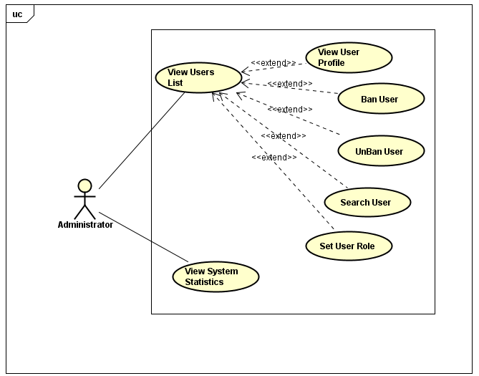

###### UC-A-006: View User List

|  |  |  |  |  |
| --- | --- | --- | --- | --- |
| **Use Case Name** | **View User List** | | | |
| **Use Case ID** | UC-A-006 | | | |
| **Created By** | QuanNH | Last Updated By | | QuanNH |
| **Date Created** | 27/06/2016 | Date Last Updated | | 12/07/2016 |
| **Actor** | Administrator | | | |
| **Description** | User views list of Veazy members | | | |
| **Pre-condition** | * Website is available * Admin logged in the system | | | |
| **Trigger** | Admin click “User Management” hyperlink at the right-sided administration menu | | | |
| **Post Condition** | System redirects to “User List” page which displays list of Veazy members, including both User and Editor | | | |
| Main Success Scenario | | | | |
| Step | **User** | | **System’s Response** | |
| **1** | Clicks “User Management” hyperlink | | Redirects to “User List” page and display member list | |

###### UC-A-007: View User Profile

|  |  |  |  |  |
| --- | --- | --- | --- | --- |
| **Use Case Name** | **View User Profile** | | | |
| **Use Case ID** | UC-A-007 | | | |
| **Created By** | QuanNH | Last Updated By | | QuanNH |
| **Date Created** | 27/06/2016 | Date Last Updated | | 12/07/2016 |
| **Actor** | Administrator | | | |
| **Description** | User views member's profile | | | |
| **Pre-condition** | * Website is available * Done UC-A-006 successfully * Admin logged in the system | | | |
| **Trigger** | Users username hyperlink of member in table on “User List” page | | | |
| **Post Condition** | System shows “User Profil1e” popup which displays user information including occupation, first name, last name, birthday, address, hobbies, favorite quote and website. | | | |
| Main Success Scenario | | | | |
| Step | **User** | | **System’s Response** | |
| **1** | Clicks username hyperlink | | Shows “User Profile” dialog and display user information | |

###### UC-A-008: Assign User as Admin

|  |  |  |  |  |
| --- | --- | --- | --- | --- |
| **Use Case Name** | **Assign User as Admin** | | | |
| **Use Case ID** | UC-A-008 | | | |
| **Created By** | QuanNH | Last Updated By | | QuanNH |
| **Date Created** | 27/06/2016 | Date Last Updated | | 12/07/2016 |
| **Actor** | Administrator | | | |
| **Description** | User assigns a user as admin of Veazy | | | |
| **Pre-condition** | * Website is available * Done UC-A-006 successfully * Admin logged in the system | | | |
| **Trigger** | User clicks “Manage” hyperlink of a user in table, then clicks “Assign as admin” in dropdown list | | | |
| **Post Condition** | The user is assigned as new admin of Veazysytem and can access exclusive features of admin after login. | | | |
| Main Success Scenario | | | | |
| Step | **User** | | **System’s Response** | |
| **1** | Click “Manage” hyperlink | | Show dropdown list that contains “Assign as editor”, “Assign as admin”, “Ban” hyperlink | |
| **2** | Clicks “Assign as admin” | | Changes user type of the user to “Admin” and reloads “User List” page, shows update successfully | |
| Alternative Scenario | | | | |
| At Step | **User** | | **System’s Response** | |
| Exception | | | | |
| At Step | **User** | | **System’s Response** | |

###### UC-A-009: Assign User as Editor

|  |  |  |  |  |
| --- | --- | --- | --- | --- |
| **Use Case Name** | **Assign User as Editor** | | | |
| **Use Case ID** | UC-A-009 | | | |
| **Created By** | QuanNH | Last Updated By | | QuanNH |
| **Date Created** | 27/06/2016 | Date Last Updated | | 12/07/2016 |
| **Actor** | Administrator | | | |
| **Description** | User sets role for member of system | | | |
| **Pre-condition** | * Website is available * Done UC-A-006 successfully * Admin logged in the system | | | |
| **Trigger** | User clicks “Manage” hyperlink of a user in table, then clicks “Assign as editor” in dropdown list | | | |
| **Post Condition** | The user is assigned as new editor of Veazy system and can access exclusive features of editor after login. | | | |
| Main Success Scenario | | | | |
| Step | **User** | | **System’s Response** | |
| **1** | Click “Manage” hyperlink | | Show dropdown list that contains “Assign as editor”, “Assign as admin”, “Ban” hyperlink | |
| **2** | Clicks “Assign as editor” | | Changes user type of the user to “Editor” and reloads “User List” page, shows update successfully | |
| Alternative Scenario | | | | |
| At Step | **User** | | **System’s Response** | |
| Exception | | | | |
| At Step | **User** | | **System’s Response** | |

###### UC-A-010: Ban User

|  |  |  |  |  |
| --- | --- | --- | --- | --- |
| **Use Case Name** | **Ban user** | | | |
| **Use Case ID** | UC-A-010 | | | |
| **Created By** | QuanNH | Last Updated By | | QuanNH |
| **Date Created** | 27/06/2016 | Date Last Updated | | 12/07/2016 |
| **Actor** | Administrator | | | |
| **Description** | User bans member | | | |
| **Pre-condition** | * Website is available * Done UC-A-005 successfully * Admin logged in the system * The status of the user is “Active” | | | |
| **Trigger** | User clicks “Manage” hyperlink of a user in table, then clicks “Ban” in dropdown list | | | |
| **Post Condition** | Systems reload “User List” page and shows update successfully. The user can no longer log in Veazy system under their username | | | |
| Main Success Scenario | | | | |
| Step | **User** | | **System’s Response** | |
| **1** | Clicks “Manage” hyperlink | | Shows dropdown list that contains “Assign as editor”, “Assign as admin”, “Ban” hyperlink | |
| **2** | Clicks “Ban” | | Changes user’s status to “Banned” and prevents that user from logging into system. | |
| Alternative Scenario | | | | |
| At Step | **User** | | **System’s Response** | |
| Exception | | | | |
| At Step | **User** | | **System’s Response** | |

###### UC-A-011: Unban User

|  |  |  |  |  |
| --- | --- | --- | --- | --- |
| **Use Case Name** | **Unban user** | | | |
| **Use Case ID** | UC-A-011 | | | |
| **Created By** | QuanNH | Last Updated By | | QuanNH |
| **Date Created** | 27/06/2016 | Date Last Updated | | 12/07/2016 |
| **Actor** | Administrator | | | |
| **Description** | User unban member | | | |
| **Pre-condition** | * Website is available * Done UC-A-006 successfully * Admin logged in the system * The status of the user is “Banned” | | | |
| **Trigger** | User clicks “Manage” hyperlink of a user in table, then clicks “Unban” in dropdown list | | | |
| **Post Condition** | Systems reload “User List” page and shows update successfully. The user is enabled to log in Veazy system under their username | | | |
| Main Success Scenario | | | | |
| Step | **User** | | **System’s Response** | |
| **1** | Clicks “Manage” hyperlink | | Shows dropdown list that contains “Assign as editor”, “Assign as admin”, “Unban” hyperlink | |
| **2** | Clicks “Unban” | | Changes user’s status to “Active” and allow that user to log into system. | |
| Alternative Scenario | | | | |
| At Step | **User** | | **System’s Response** | |
| Exception | | | | |
| At Step | **User** | | **System’s Response** | |

###### UC-A-012: View System Statistics

|  |  |  |  |  |
| --- | --- | --- | --- | --- |
| **Use Case Name** | **View System Statistics** | | | |
| **Use Case ID** | UC-A-011 | | | |
| **Created By** | QuanNH | Last Updated By | | QuanNH |
| **Date Created** | 27/06/2016 | Date Last Updated | | 12/07/2016 |
| **Actor** | Administrator | | | |
| **Description** | User views statistics of system | | | |
| **Pre-condition** | * Website is available * Admin logged in the system | | | |
| **Trigger** | Clicks “Statistics” hyperlink at right-sided admin menu | | | |
| **Post Condition** | Systems redirect to “System Statistics” page which displays the statistics of users, lessons, questions and reports | | | |
| Main Success Scenario | | | | |
| Step | **User** | | **System’s Response** | |
| **1** | Clicks “Statistics” hyperlink | | Redirects to “System Statistics” page and displays statistics of users, lessons, questions and reports | |

### Non-Functional Specification Requirements

#### Usability

* Interface should be simple, clear, user-friendly, easy to learn how to use and easy to remember how to use.
* Interface design should support the following from the perspectives of its primary users:
  + Efficiency of use:each action is taken by no more than 8 steps.
  + Intuitiveness: the interface is easy to learn and navigate: buttons, headings, and help/error messages are simple to read and understand.
  + Low perceived workload: the interface appears easy to use, rather than intimidating, demanding and frustrating.
* Users need to understand the function of each section to be able to use reasonable discretion and its effectiveness.
* Users should be supported and guided how to use the functionality of the system to use system easily after short time.
  + In the role “Administrator” – after 2 hours of training
  + In the role “Content Editor” – after 1 hour of training
  + In the role “Member” – after 30 minutes of training
  + In the role “Guest” – after 15 minutes of training
* The system should have the flexibility to be can satisfied future changed as:
  + Can add more lessons, tests and new words.
  + Changes in processing of information.
* The system must meet the requirements for data memory, need to calculate the amount of memory to be able to meet the requirements of the development of the system.

#### Security

* + - * Password of user is md5-hashed before being sent in request to server and saved into database
      * Request sent from client is authorize using cookies.

#### Maintainability & Extensibility

* + - * Strictly follow Java & JavaScript best practices and English-like syntax naming convention in order to help improve readability of source code and keep the Veazy website maintainable in the future.

#### Performance

* Response time when accessing an action on the system depending on system condition such as number of visitors, access tasks.
* Time for loading image, media will be at most 15 seconds and time to progress any function will not exceed 17 seconds.

#### Supportability

* + - * Web system is written in Java and Bootstrap, easily manage and upgrade and easily connect to database system.

#### Design Constraints

* Because the system is built on the Web Platform, therefore development language easily manages and upgrade.
* The system must execute independently, less influenced by other systems and capable of performing well on many different operating systems.

#### User Manual Documentation

* Integration guild with both English and Japanese language, image and clear explanation

# Software Design Description

## SDD Overview

This document provides a comprehensive architectural overview of the system VEAZY, using a number of different architectural views to depict different aspects of the system. It is intended to capture and convey the significant architectural decisions that have been made on the system.

This section of document is the **software design description** of the project in order to develop the software, it includes four main parts: Architecture Design, Class Design, Detail Design, and Database design.

## Architecture Design

### MVC Model

The architecture of Veazy system is structured based on MVC model combined with layered architecture, Spring framework and AngularJS framework.

#### ****MVC Model overview****

*Model–view–controller (MVC)* is a software [architectural pattern](https://en.wikipedia.org/wiki/Architectural_pattern) for implementing [user interfaces](https://en.wikipedia.org/wiki/User_interface) on computers. It divides a given software application into three interconnected parts: the model, the view, and the controller, so as to separate internal representations of information from the ways that information is presented to or accepted from the user. The model consists of application data, business rules, logic and functions. A view can be any output representation of data, such as a chart or a diagram. Multiple views of the same data are possible, such as bar chart for management and a tabular view for accountants. The controller mediates input, converting it to commands for the model or view.

The MVC design pattern assigns objects in an application one of three roles: model, view, or controller. The pattern defines not only the roles objects playing in the application but the way objects communicate with each other as well. Each of the three types of objects is separated from the others by abstract boundaries and communicates with objects of the other types across those boundaries. The collection of objects of a certain MVC type in an application sometimes referred to as a layer—for example, model layer.



Figure 4-1: MVC Model

In addition to dividing the application into three kinds of components, the MVC design defines the interactions between them:

* **A controller:** can send commands to its associated view to change the view's presentation of the model (e.g., by scrolling through a document). It can also send commands to the model to update the model's state (e.g., editing a document).
* **A model:** notifies its associated views and controllers when there has been a change in its state. This notification allows the views to produce updated output, and the controllers to change the available set of commands. A passive implementation of MVC omits these notifications, because the application does not require them or the software platform does not support them.
* **A view:** requests from the model the information that it needs to generate an output representation to the user.

#### ****Advantages and disadvantages of MVC model****

* Advantages:
* The MVC model demonstrates professionalism in programming and design analysis. It is divided into independent components to help develop applications faster, simpler, easier upgrades and maintenance.
* Many MVC vendor framework tool kits are available.
* Multiple views synchronized with same data model.
* Easy to change or plug in new interface views, allowing updating of interface views with new technologies without overhauling the rest of system.
* Very effective for deployment if graphic, programming and database development professionals are working in a team in a designed project.
* Disadvantages:
* For small projects that apply MVC model caused cumbersome, time consuming in development process.
* Time consuming to transits data between components.
* Not suitable for agent-oriented applications such as interactive mobile and robotics applications.
* Multiple pairs of controllers and views based on the same data model make data model change expensive.
* The division between the View and the Controller is not clear in some cases.

#### ****The reason of choosing MVC model****

* - Easily manage the complexity of application by dividing the application into three components: model, view and controller.
* Better support for TDD.
* It is a good support for application built by project team that has many developers and designers but still managed application features.
* Veazy system is an incomplete system for now. Veazy is built in the way that towards extensibility and maintainability in the future.

### SpringMVC framework

#### ****Overview****

*Spring’s web MVC framework* is, like many other web MVC frameworks, request-driven, designed around a central Servlet that dispatches requests to controllers and offers other functionality that facilitates the development of web applications. Spring’s DispatcherServlet however, does more than just that. It is completely integrated with the Spring IoC container and as such allows you to use every other feature that Spring has.

The Spring’s web MVC framework provides model-view-controller architecture and ready components that can be used to develop flexible and loosely coupled web applications. The MVC pattern results in separating the different aspects of the application (input logic, business logic, and UI logic), while providing a loose coupling between these elements.

* The Model encapsulates the application data and in general they will consist of POJO.
* The View is responsible for rendering the model data and in general it generates HTML output that the client's browser can interpret.
* The Controller is responsible for processing user requests and building appropriate model and passes it to the view for rendering.

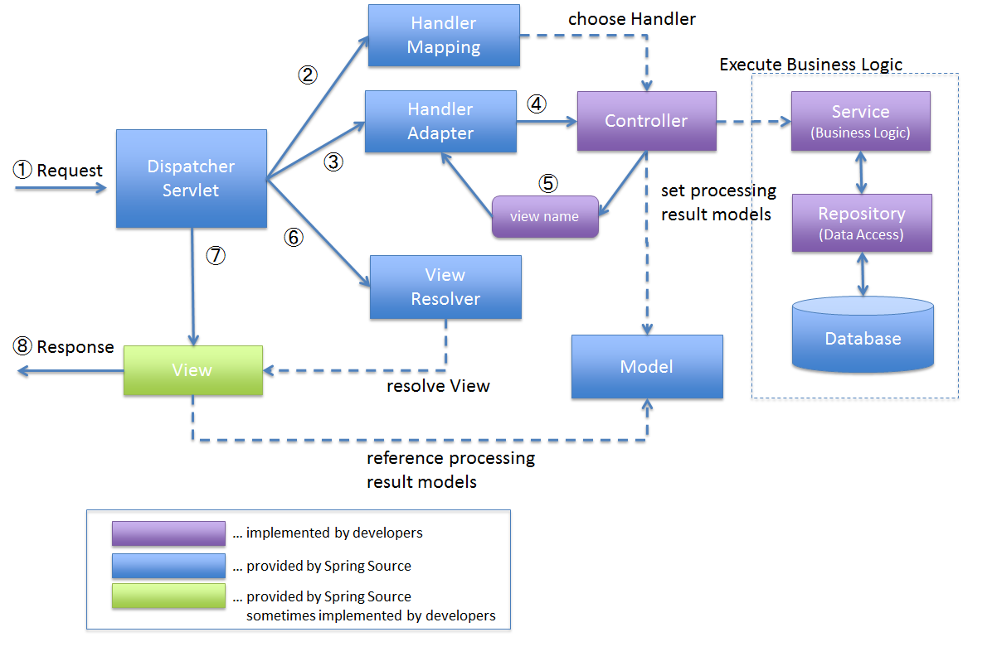

*Figure 2‑2 SpringMVC process flow*

1. *DispatcherServlet* receives the request.
2. *DispatcherServlet* dispatches the task of selecting an appropriate controller to *HandlerMapping*. *HandlerMapping* selects the controller which is mapped to the incoming request URL and returns the (selected *Handler*) and *Controller* to *DispatcherServlet*.
3. *DispatcherServlet* dispatches the task of executing of business logic of *Controller* to *HandlerAdapter*.
4. *HandlerAdapter* calls the business logic process of *Controller*.
5. *Controller* executes the business logic, sets the processing result in *Model* and returns the logical name of view to *HandlerAdapter*.
6. *DispatcherServlet* dispatches the task of resolving the *View* corresponding to the *View* name to *ViewResolver*. *ViewResolver* returns the *View* mapped to *View* name.
7. *DispatcherServlet* dispatches the rendering process to returned *View*.
8. *View* renders *Model* data and returns the response.

#### ****Advantages and disadvantages****

* Advantages
  + No need to reinvent the wheel: It utilizes some of the well-known technologies, ORM frameworks, logging frameworks, JEE, JDK timers, Quartz and so on
  + Dependency Injection gears up testability.
  + Inversion control and APIs: Spring framework provides inversion control and APIs to translate technology-driven exceptions, specifically thrown by JDBC, Hibernate or JDO, into unchecked and consistent ones.
  + Modularity: Spring makes it easy for the developers to know which packages or classes are to be used and which one should be ignored.
  + Consistent Transaction Management: With the help of consistent transaction management interface, Spring framework easily scale down or scale up local as well as global transactions.
  + Spring AOP also brings tons of benefits: There is no need for a developer to have a separate compilation unit or a separate class loader.
* Disadvantages
  + Complex: One of the major criticisms faced by the Spring framework is that it is complex.
  + Longer Learning Curve: it would be quite difficult to learn Spring framework. The main reason behind this is a whole host of new programming methods and detailing require understanding how to set up the Spring XML configuration file.
  + All the Spring applications require a lot of XML: the applications developed using Spring framework often require a huge amount of XML
  + Tons of parallel mechanisms frustrate developers: It makes developers to spend lots of understanding each of them and choose the best one among them.
  + Lack of Guidelines: No clear guidance on cross-site scripting attacks and cross-site request forgery attacks in Spring MVC documentation

#### ****The reason of choosing****

* + - Spring provides a very clean division between controllers, JavaBean models, and views.
  + Spring’s MVC is very flexible, it is entirely based on interfaces.
  + Spring provides interceptors as well as controllers, making it easy to factor out behavior common to the handling of many requests.
  + Spring Controllers are configured via IoC. This makes them easy to test, and beautifully integrated with other objects managed by Spring.
  + No ActionForms. Bind directly to domain objects.
  + Spring has a well defined interface to business layerArchitectural Representation

### **HibernateORM framework**

#### **Overview**

*Hibernate* is an implementation of the Java persistence API (JPA) specification, it can easily used in any environment supporting JPA including Java SE applications, Java EE applications, Java EE application servers, Enterprise OSGi containers and so on. It is a powerful, high performance Object-Relational Persistence and Query service for any Java Application.

Hibernate maps Java classes to database tables and from Java data types to SQL data types and relieve the developer from 95% of common data persistence related programming tasks.

Hibernate sits between traditional Java objects and database server to handle all the work in persisting those objects based on the appropriate O/R mechanisms and patterns.

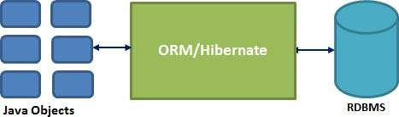

*Figure 2‑3 Hibernate ORM*

**4.2..3.4Advantages & Disadvantages**

* Advantages
  + Hibernate takes care of mapping Java classes to database tables using XML files and without writing any line of code.
  + Provides simple APIs for storing and retrieving Java objects directly to and from the database.
  + If there is change in Database or in any table then the only need to change XML file properties.
  + Abstract away the unfamiliar SQL types and provide us to work around familiar Java Objects.
  + Hibernate does not require an application server to operate.
  + Manipulates complex associations of objects of your database.
  + Minimize database access with smart fetching strategies.
  + Provides simple querying of data.
* Disadvantages
  + Slower than JDBC: Hibernate is slower than pure JDBC as it is generating lots of SQL statements in runtime.
  + Not suitable for Batch processing: It is advisable to use pure JDBC for batch processing.
  + Not suitable for Small projects : For small project having few tables, it is useless to work with hibernate.
  + Does not allow multiple inserts : Hibernate does not allow some type of queries which are supported by JDBC.
  + Generates complex queries with many joins : For complex data, mapping from Object-to-tables and vise versa reduces performance and increases time of conversion.

#### **The reason of choosing**

* + Productivity: It helps developers get rid of writing complex and tedious SQL statement, no more need of JDBC APIs for result set or data handling. It makes developers more concentrate on the business logic and increase the project’s productivity.
  + Maintainability: It helps reduce the lines of code, makes system more understandable and emphasizes more on business logic rather than persistence work (SQLs).
  + Portability: It abstracts our application away from the underlying SQL database and sql dialect. Switching to other SQL database requires few changes in Hibernate configuration file.

### AngularJS framework

#### **Overview**

*AngularJS* is a structural framework for dynamic web apps. It lets you use HTML as your template language and lets you extend HTML's syntax to express your application's components clearly and succinctly. Angular's data binding and dependency injection eliminate much of the code you would otherwise have to write. And it all happens within the browser, making it an ideal partner with any server technology.



*Figure 2‑4 Multi-page flow*



*Figure 2‑5 Single-page flow*

#### **Advantages & Disadvantages**

* Advantages
  + AngularJS provides capability to create Single Page Application in a very clean and maintainable way.
  + AngularJS provides data binding capability to HTML thus giving user a rich and responsive experience
  + AngularJS code is unit testable.
  + AngularJS uses dependency injection and make use of separation of concerns.
  + AngularJS provides reusable components.
  + With AngularJS, developer write less code and get more functionality.
  + In AngularJS, views are pure html pages, and controllers written in JavaScript do the business processing.
* Disadvantages
  + Not Secure − Being JavaScript only framework, application written in AngularJS are not safe. Server side authentication and authorization is must to keep an application secure.
  + Not degradable − If your application user disables JavaScript then user will just see the basic page and nothing more.

#### **The reason of choosing**

* + Expressive User Interface: Angular employs HTML to define application user interface. HTML carries special attributes explaining which controllers to use for elements.
  + Less code: By ignoring writing of own pipeline, use of html, simple data model and use of filters, angular makes it coding free for developers.
  + Testability: AngularJs has been developed keeping in mind the testing process of coding and developing at each and every stage of application development so as to avoid wastage of time.

### Architectural RepresentationC:\Users\MinhNN\Pictures\Data Flow Diagram0.png

Figure 4-2: System overview

We follow MVC architecture to implement the Veazy project. MVC offers architectural benefits over jQuery and AngularJS — it helps us write better-organized and therefore more maintainable code.

**Model** is where the application’s data objects are stored. A model object is in charge of encapsulating application state and one object could be related to other objects establishing a one-to-one or one-to-many relationship. When a model changes, typically it will notify its observers that a change has occurred. As with any data object it contains instance variables and getter/setter methods.

**DAO** is an abbreviation of Data Access Object which provides an abstract [interface](https://en.wikipedia.org/wiki/Interface_(computer_science)) to some type of [database](https://en.wikipedia.org/wiki/Database) or other persistence mechanism. By mapping application calls to the persistence layer, DAO provide some specific data operations without exposing details of the database.

**Service** defines set of available operations in regards with interfacing client layers i.e. encapsulates the application's business logic.

**Controller** is the decision maker and the glue between the model and view; it handles user actions and gestures, and responds to user events.

### Architecture Goals and Constraints

**Availability:** The application must be available 95% of time. Users can access to it everywhere from there .Web browser with internet connection.

**Maintainability:**

* Coding standards and naming conventions
  + Output of the project must include coding standards and naming conventions documentations. Implementation code must be easy to maintain.
  + All code must be clearly commented, including class, method documentations.
  + If some components are reused, the documentations of those components must also be included.
* Design
  + The design of the system must be loosely coupled that chances on some module will not affect others.
* Logging
  + All the errors should be logged, supporting for bug fixing and maintenance.
  + All strange or sensitive situations should also be logged.

**Usability:** Usability Requirements support the following from the perspective of its primary users:

* Efficiency of use**:** user can complete each function in less than 12 actions
* Intuitiveness**:** all help/error messages are simple to understand; user can know exactly how to do each feature after one time using it.

**Capacity and scalability:** throughput, storage and growth requirements.

### Use-Case View

The use-case view consists of 4 parts according to 4 user roles in the system: guest, member, editor and admin.

#### Guest

##### **Register account**

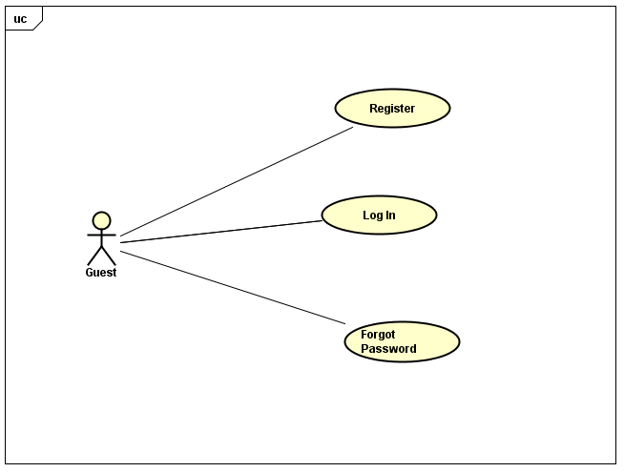

*Figure 5‑1* *****Register account*****

|  |  |  |  |
| --- | --- | --- | --- |
| No | Use-case name | Actor | Description |
| 1 | Register | Guest | Registering new account to log into the system |
| 2 | Log In | Guest | Logging into the system |
| 3 | Forgot Password | Guest | Resetting user’s password |

##### **Learning**

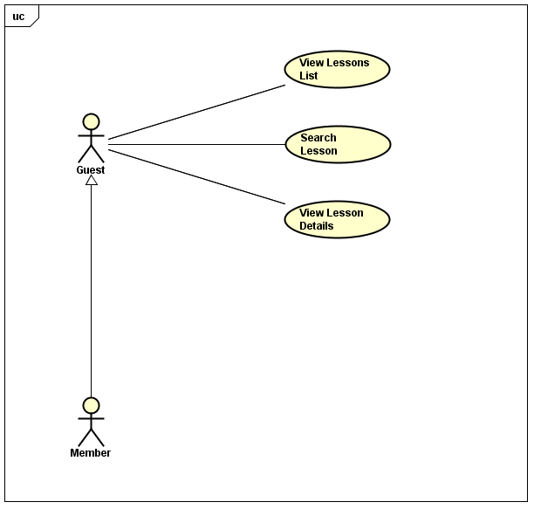

*Figure 5‑2 Learning*

|  |  |  |  |
| --- | --- | --- | --- |
| No. | Use-case name | Actor | Description |
| 1 | View Lesson List | Guest, Member | Viewing lesson list of courses |
| 2 | Search Lesson | Guest, Member | Searching lesson |
| 3 | View Lesson Details | Guest, Member | Viewing detail of lesson |

##### Testing

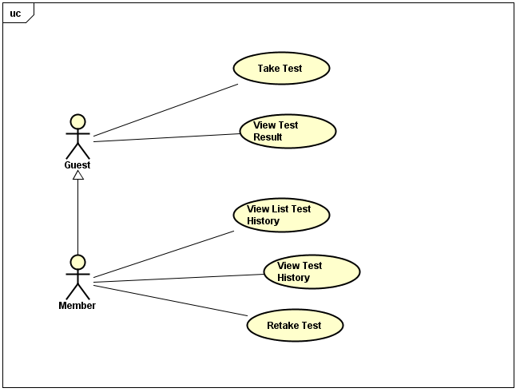

*Figure 5‑3 Tesing*

|  |  |  |  |
| --- | --- | --- | --- |
| No. | Use-case name | Actor | Description |
| 1 | Take Test | Guest, Member | Taking a multiple-choice test |
| 2 | View Test Result | Guest, Member | Viewing result of test |

Use Case

|  |  |  |  |
| --- | --- | --- | --- |
| **No.** | **Use-case name** | **Actor** | **Description** |
| 1 | Doing test | Member | Doing test and tracking the learning process |
| 2 | Training listening | Member and Visitor | Training listening level N2,N3,N4 |
| 3 | Listening conversation | Member and Visitor | Listening conversation |
| 4 | Reading document | Member and Visitor | Reading document |

#### Member

##### Private Account Management

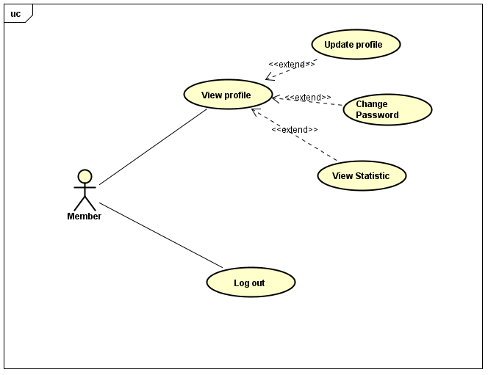

*Figure 5‑4 Private Account Management*

|  |  |  |  |
| --- | --- | --- | --- |
| No. | Use-case name | Actor | Description |
| 1 | View Profile | Member | Viewing detail information of their profile |
| 2 | Update Profile | Member | Updating user’s profile |
| 3 | Change Password | Member | Changing user’s password |
| 4 | View Statistic | Member | Viewing statistics of user |
| 5 | Log Out | Member | Logging out of system |

##### Testing



*Figure 5‑5 Testing*

|  |  |  |  |
| --- | --- | --- | --- |
| No. | Use-case name | Actor | Description |
| 1 | View List Test History | Member | Viewing list of test history |
| 2 | View Test History | Member | Viewing detail of test history |
| 3 | Retake Test | Member | Retaking a test in list test history |

##### Content Reporting

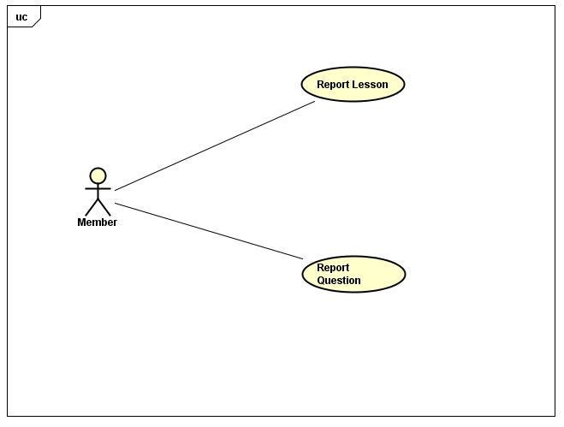

*Figure 5‑6 Content Reporting*

|  |  |  |  |
| --- | --- | --- | --- |
| No. | Use-case name | Actor | Description |
| 1 | Report Lesson | Member | Reporting content of lessons that having wrong content |
| 2 | Report Question | Member | Reporting content of questions that having wrong content |

#### Editor

##### Private Account Management

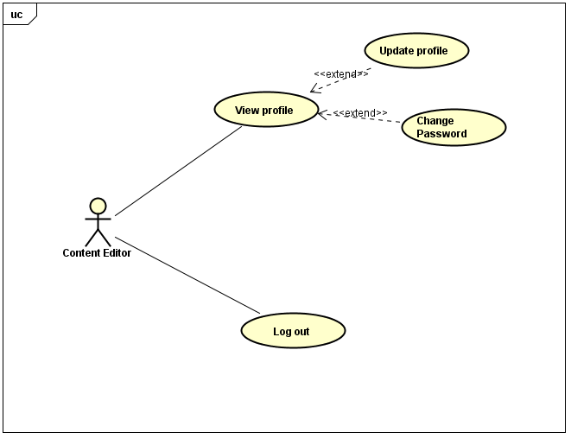

*Figure 5‑7 Private Account Management*

|  |  |  |  |
| --- | --- | --- | --- |
| No. | Use-case name | Actor | Description |
| 1 | View Profile | Content Editor | Viewing detail information of their profile |
| 2 | Update Profile | Content Editor | Updating user’s profile |
| 3 | Change Password | Content Editor | Changing user’s password |
| 4 | Log Out | Content Editor | Logging out of system |

##### Lesson Management

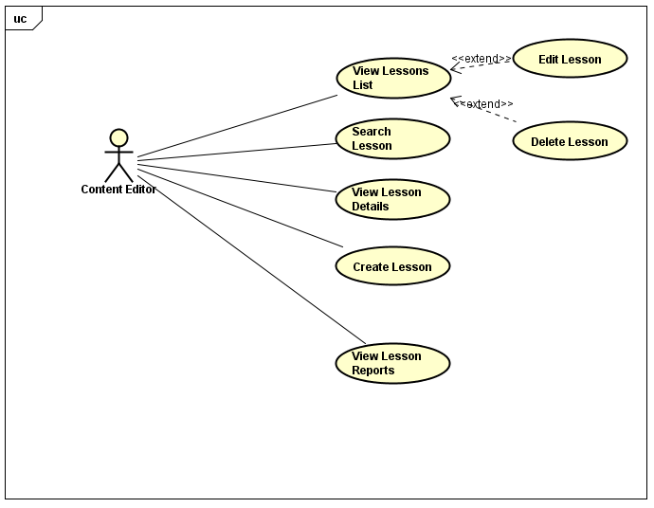

*Figure 5‑8 Lesson Management*

|  |  |  |  |
| --- | --- | --- | --- |
| No. | Use-case name | Actor | Description |
| 1 | View Lessons List | Content Editor | Viewing lesson list of courses |
| 2 | Search Lesson | Content Editor | Searching lesson |
| 3 | View Lesson Details | Content Editor | View detail of lesson |
| 4 | Edit Lesson | Content Editor | Editing content of lesson |
| 5 | Delete Lesson | Content Editor | Deleting lesson |
| 6 | Create Lesson | Content Editor | Creating new lesson of course |
| 7 | View Lesson Reports | Content Editor | Viewing list report about wrong content from member |

##### Question Management

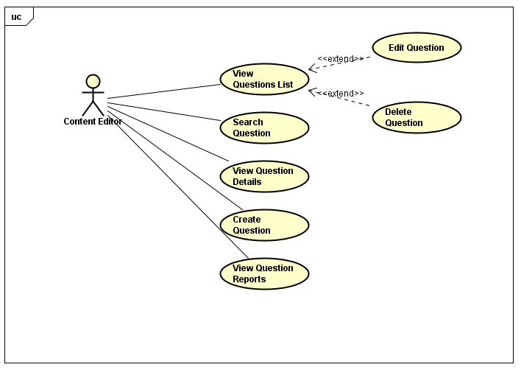

*Figure 5‑9 Question Management*

|  |  |  |  |
| --- | --- | --- | --- |
| No. | Use-case name | Actor | Description |
| 1 | View Questions List | Content Editor | Viewing question list |
| 2 | Search Question | Content Editor | Searching question |
| 3 | View Question Details | Content Editor | View detail of question |
| 4 | Edit Question | Content Editor | Editing content of question |
| 5 | Delete Question | Content Editor | Deleting question |
| 6 | Create Question | Content Editor | Creating new question of course |
| 7 | View Question Report | Content Editor | Viewing list report about wrong content from member |

### Logical View

#### Overview

Logical View includes Package diagram and Class diagram. Package diagram describes the organization of packages and elements. Class Diagram provides an overview of the target system by describing the objects and classes inside the system and the relationships between them. It provides a wide variety of usages; from modeling the domain-specific data structure to detailed design of the target system

* Controller contain the interface between
* Associated models
* Associated views
* The input devices (e.g., keyboard, pointing device, time).
* Send commands to the model to update the model's state.
* Model is:
  + the domain-specific software simulation
  + Or implementation of the application's central structure.
* View deal with everything graphical
* Requests data from their model
* Display the data

#### Architecturally Significant Design Packages

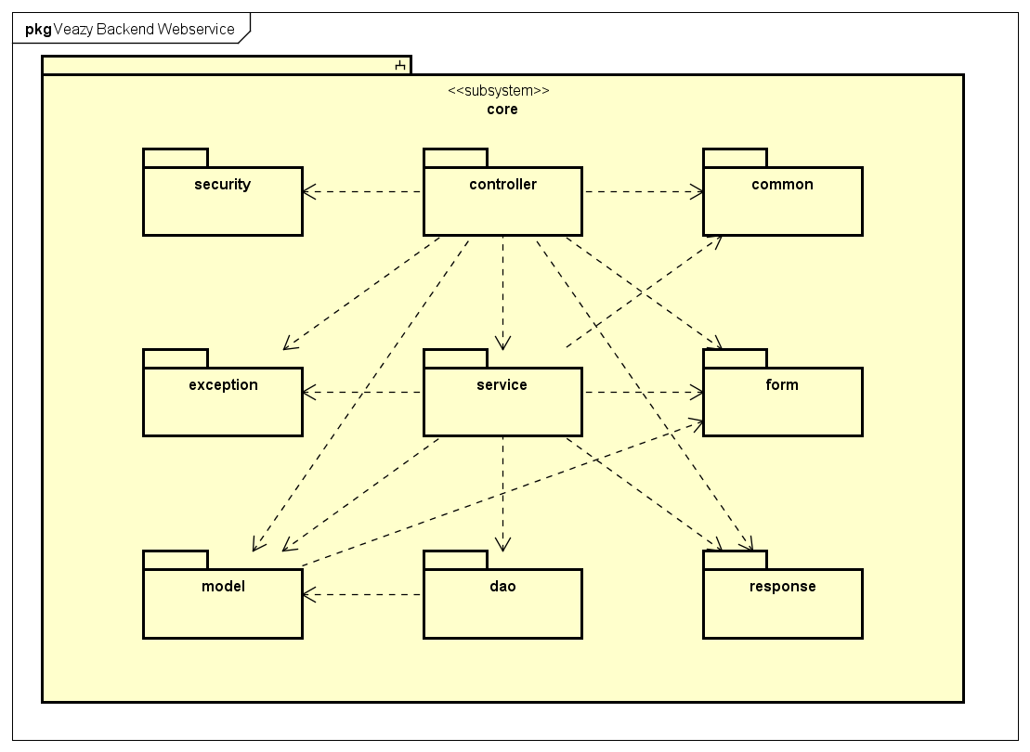

Figure 4-17: Package Diagram

* **Controller**

|  |  |  |
| --- | --- | --- |
| No. | Controller class | Role |
| 1 | CoreController | Processes common core api requests |
| 2 | CourseController | Processes api requests related to course |
| 3 | TestController | Processes api requests related to test |
| 4 | LessonController | Processes api requests related to lesson |
| 5 | QuestionController | Processes api requests related to question |
| 6 | ReportController | Processes api requests related to report |
| 7 | StatsController | Processes api requests related to statistic |
| 8 | UserController | Processes api requests related to user |

* **Service**

|  |  |  |
| --- | --- | --- |
| No. | Service class | Role |
| 1 | CourseServiceImpl | Contains business logical functions for processing course data |
| 2 | TestServiceImpl | Contains business logical functions for processing test data |
| 3 | LessonServiceImpl | Contains business logical functions for processing lesson data |
| 4 | QuestionBankServiceImpl | Contains business logical functions for processing question bank data |
| 5 | QuestionServiceImpl | Contains business logical functions for processing question data |
| 6 | ReportServiceImpl | Contains business logical functions for processing report data |
| 7 | StatsServiceImpl | Contains business logical functions for processing statistic data |
| 8 | UserServiceImpl | Contains business logical functions for processing user data |

* **Model**

|  |  |  |
| --- | --- | --- |
| No. | Model class | Role |
| 1 | AnswerModel | Stores data of a single answer of a question |
| 2 | BasicModel | Contains common fields of model |
| 3 | CourseModel | Stores data of a course (as known as a level) |
| 4 | TestAnswerModel | Stores data of a single answer of a question in a generated test |
| 5 | TestModel | Stores data of a test |
| 6 | TestQuestionModel | Stores data of a question in a generated test |
| 7 | LessonModel | Stores data of a lesson |
| 8 | LessonVersionModel | Stores data of a version of lesson |
| 9 | QuestionModel | Stores data of a question in the questionbank |
| 10 | ReportModel | Stores data of a report |
| 11 | UserModel | Stores data of an user |

* **DAO**

|  |  |  |
| --- | --- | --- |
| No. | DAO class | Role |
| 1 | HibernateCourseDao | Provides methods to manage course data in database |
| 2 | HibernateTestDao | Provides methods to manage test data in database |
| 3 | HibernateLessonDao | Provides methods to manage lesson data in database |
| 4 | HibernateLessonVersionDao | Provides methods to manage versions of lesson in database |
| 5 | HibernateQuestionDao | Provides methods to manage question data in database |
| 6 | HibernateReportDao | Provides methods to manage report data in database |
| 7 | HibernateUserDao | Provides methods to manage user data in database |
| 8 | HibernateAnswerDao | Provides methods to manage answers data in a question in database |

* **Exception**

|  |  |  |
| --- | --- | --- |
| No. | Exception class | Role |
| 1 | CorruptedFormException | Exception throwed when user submitted a corrupted form i.e. form that does not have enough expected data |
| 2 | EmailExpectedException | Exception throwed when submitted form does not contain email |
| 3 | InvalidEmailException | Exception throwed when submitted form contains invalid email |
| 4 | PasswordExpectedException | Exception throwed when submitted form does not contain password |
| 5 | PasswordIncorrectException | Exception throwed when submitted form contains incorrect username or password |
| 6 | UsernameExpectedException | Exception throwed when submitted form does not contain username |
| 7 | NullOrEmptyContentException | Exception throwed when submitted data is null or empty |

* **Form**

|  |  |  |
| --- | --- | --- |
| No. | Form class | Role |
| 1 | AnswerForm | Answer form |
| 2 | ChangeRoleForm | Form for requesting change user role |
| 3 | ChgpwdForm | Form for requesting change password |
| 4 | CreateTestSinglePartForm | Form for generating a single-skill test |
| 5 | CreateLessonForm | Form for creating a test |
| 6 | TestPartForm | Form for generating a test |
| 7 | FileUploadForm | Upload file form |
| 8 | LoginForm | Login form |
| 9 | QuestionForm | Question form |
| 10 | RegisterForm | Register form |
| 11 | ReportForm | Report form |
| 12 | SubmitTestForm | Test form for submittion |
| 13 | SubmitQuestionForm | Question form for test submittion |
| 14 | SubmitAnswerForm | Answer of a question form for test submittion |
| 15 | UpdateLessonForm | Lesson information form for updating a lesson |
| 16 | UpdateUserForm | User information form for updating an user |

* **Response**

|  |  |  |
| --- | --- | --- |
| No. | Response class | Role |
| 1 | AddQuestionResponse | Response for adding a new question api |
| 2 | AnswerResponse | Response for an answer in a question |
| 3 | BriefAnswerResponse | Response for a brief answer in a brief question in a generated test |
| 4 | BriefLessonResponse | Response for a brief lesson |
| 5 | BriefQuestionResponse | Response for a brief question in a generated test |
| 6 | CreateLessonResponse | Response for creating a lesson api |
| 7 | TestAnswerResponse | Response for an answer of a question in a generated test |
| 8 | TestPartResponse | Response for a generated test |
| 9 | TestQuestionResponse | Response for a question in a generated test |
| 10 | TestResultResponse | Response for test result |
| 11 | TestSinglePartResponse | Response for generating a single-skill test api |
| 12 | GetCourseResponse | Response for getting list courses api |
| 13 | GetTestResponse | Response for getting a taken test api |
| 14 | GetLearnerTestsResponse | Response for getting learner tests api |
| 15 | GetLessonResponse | Response for getting a lesson api |
| 16 | GetLessonVersionResponse | Response for getting a lesson version api |
| 17 | GetListUsersResponse | Response for getting list users api |
| 18 | GetUserResponse | Response for getting a user api |
| 19 | LoginResponse | Response for login api |
| 20 | QuestionResponse | Response for a question |
| 21 | Response | Response form for all api |
| 22 | ResponseCode | Return code for each api |
| 23 | StatsCourseAvgResponse | Response for getting average result of tests via course statistic api |
| 24 | StatsLastTestResponse | Response for getting last test statistic api |
| 25 | StatsLessonsResponse | Response for getting lesson statistic api |
| 26 | StatsQuestionsResponse | Response for getting questions statistic api |
| 27 | StatsSkillAvgResponse | Response for getting average result of tests via skill statistic api |
| 28 | StatsUsersResponse | Response for getting users statistic api |
| 29 | UploadFileResponse | Response for uploading api |

* **Security**

|  |  |  |
| --- | --- | --- |
| No. | Security class | Role |
| 1 | Veazy403Handler | Handles 403 forbidden error |
| 2 | VeazyAuthenEntryPoint | Handles anonymous requests |
| 3 | VeazyAuthenFailureHandler | Handles authentication failure requests |
| 4 | VeazyAuthenFilter | Filters authentication requests |
| 5 | VeazyAuthenProvider | Provides authentication mechanism |
| 6 | VeazyAuthenSuccessHandler | Handles authentication success requests |

* **Common**

|  |  |  |
| --- | --- | --- |
| No. | Common class | Role |
| 1 | Const | Contains common system constants |
| 2 | Utils | Contains common utility functions |
| 3 | JsonUtils | Contains json utility functions |
| 4 | HttpUtils | Contains http utility functions |
| 5 | HtmlUtils | Contains html utility functions |

### Process View

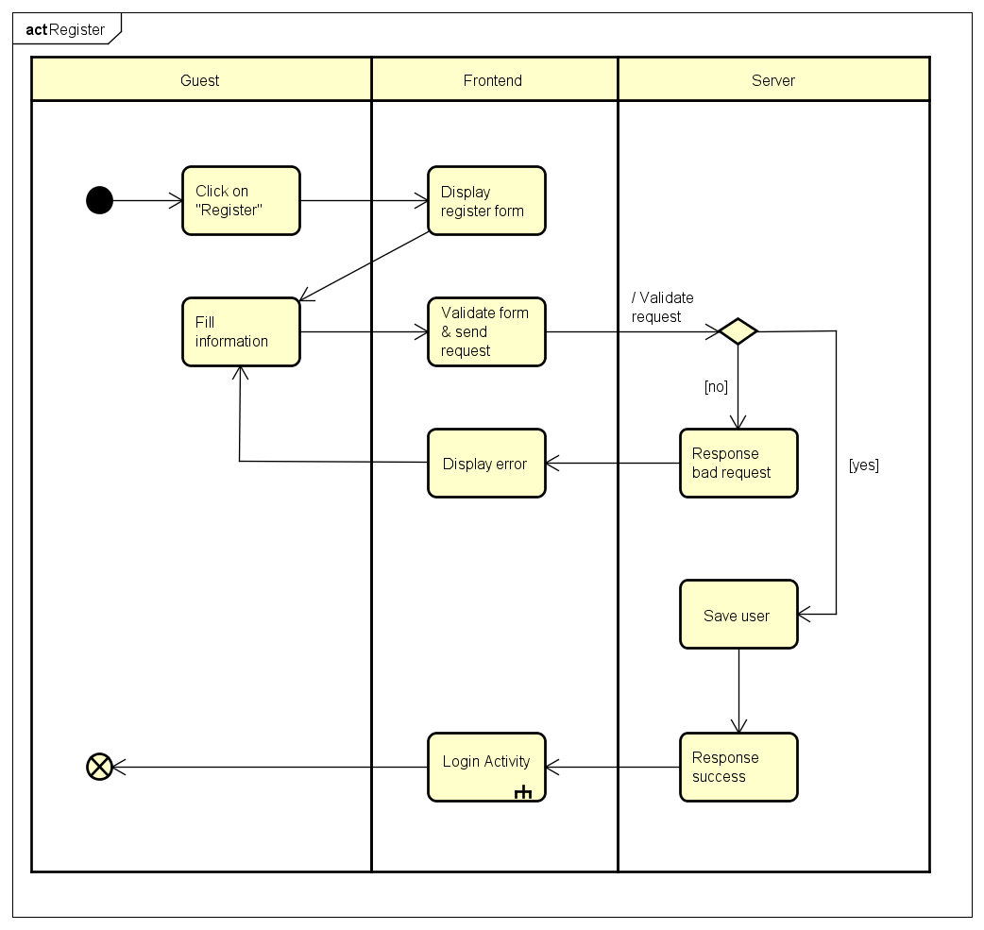

*Figure 7‑1 Register activity*

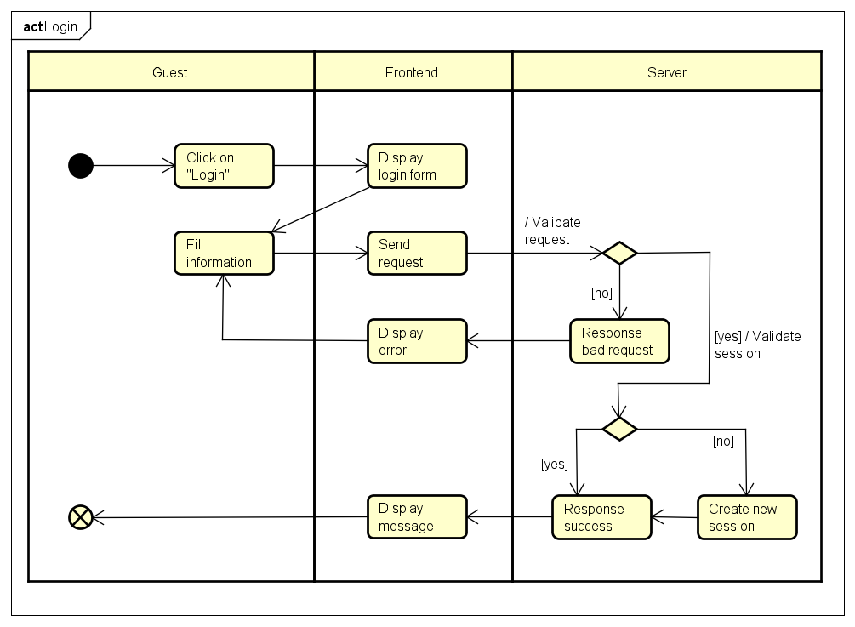

*Figure 7‑2 Login activity*

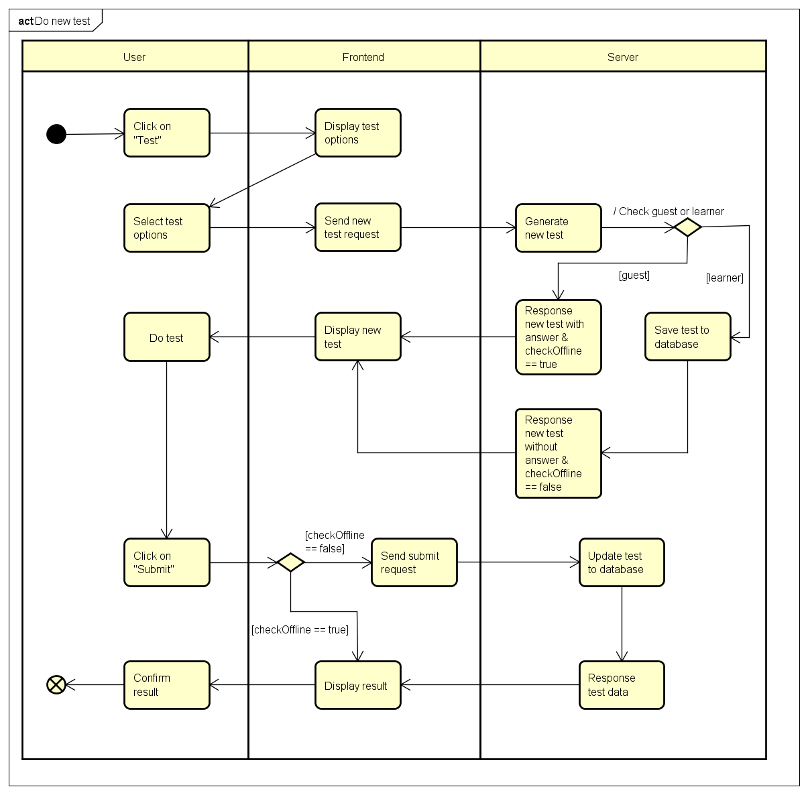

*Figure 7‑3 Do test activity*

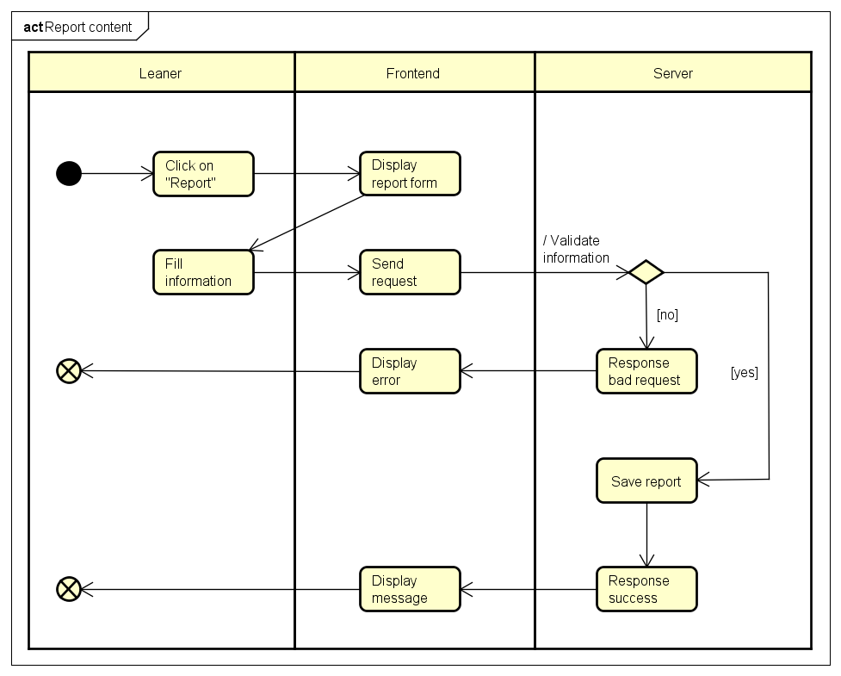

*Figure 7‑4 Report content activity*

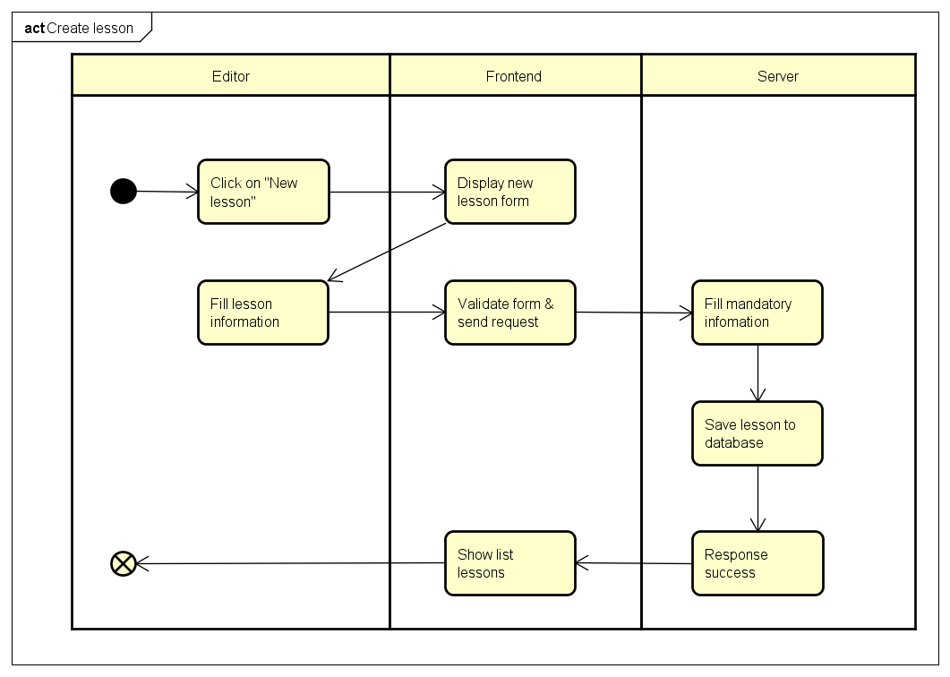

*Figure 7‑5 Create lesson activity*

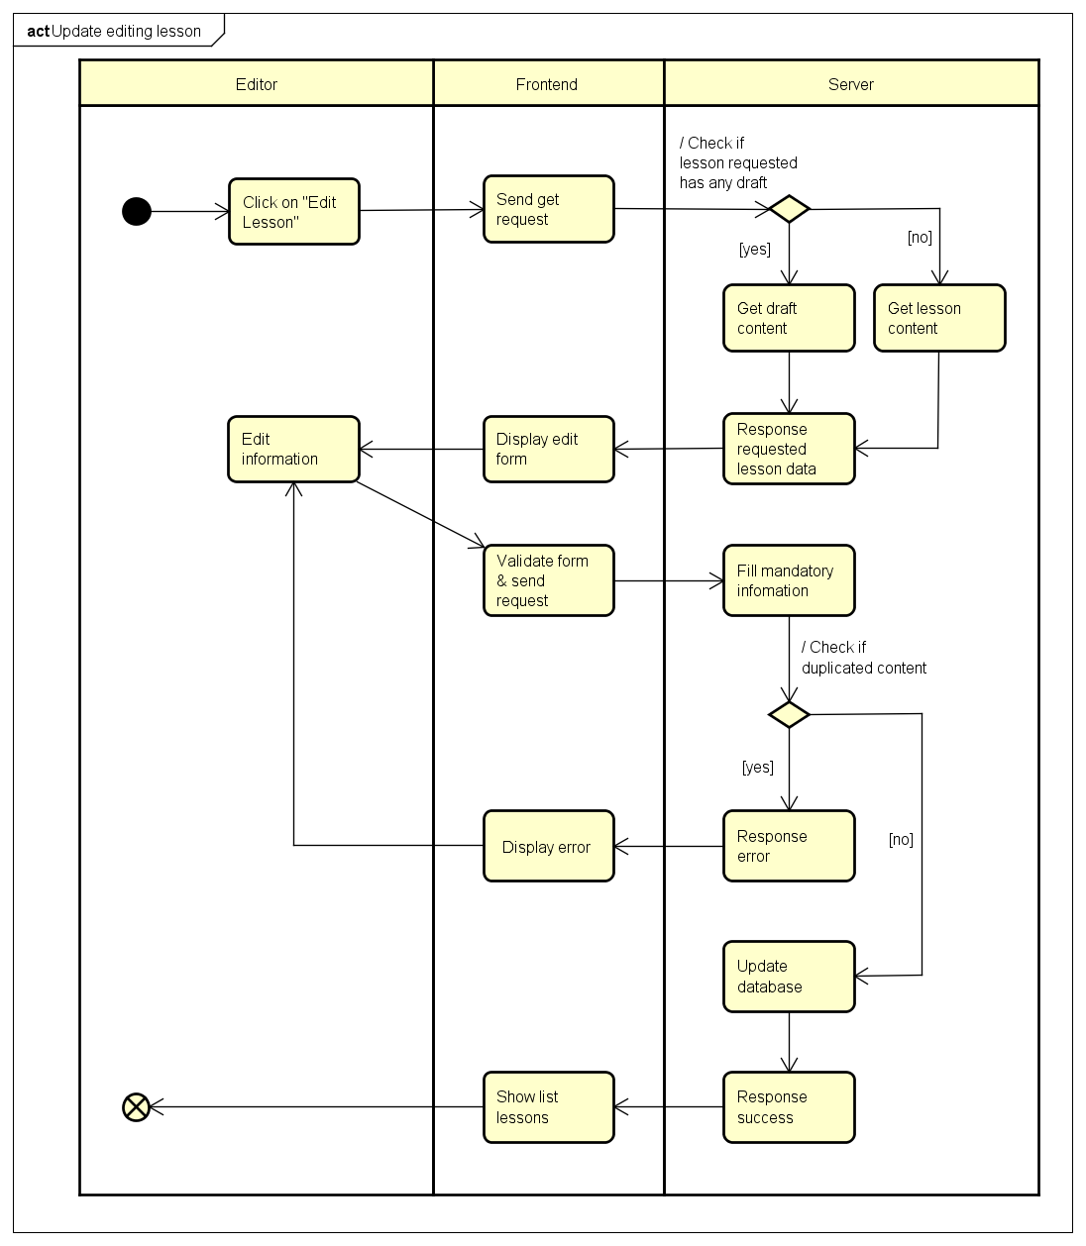

*Figure 7‑6 Update lesson activity*

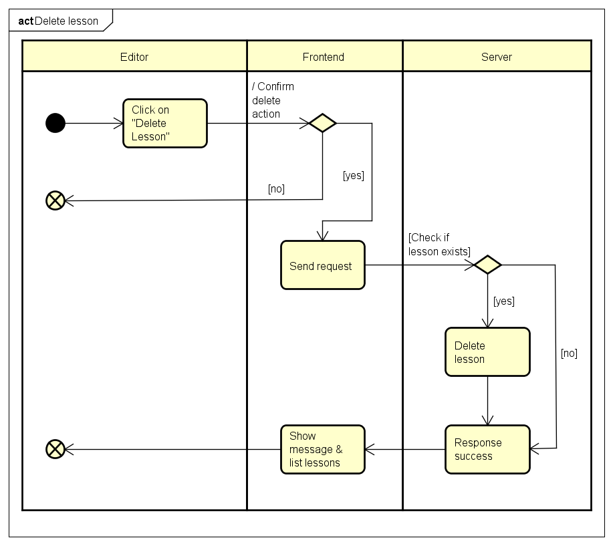

*Figure 7‑7 Delete lesson activity*

### Deployment view

Deployment view of Veazy system

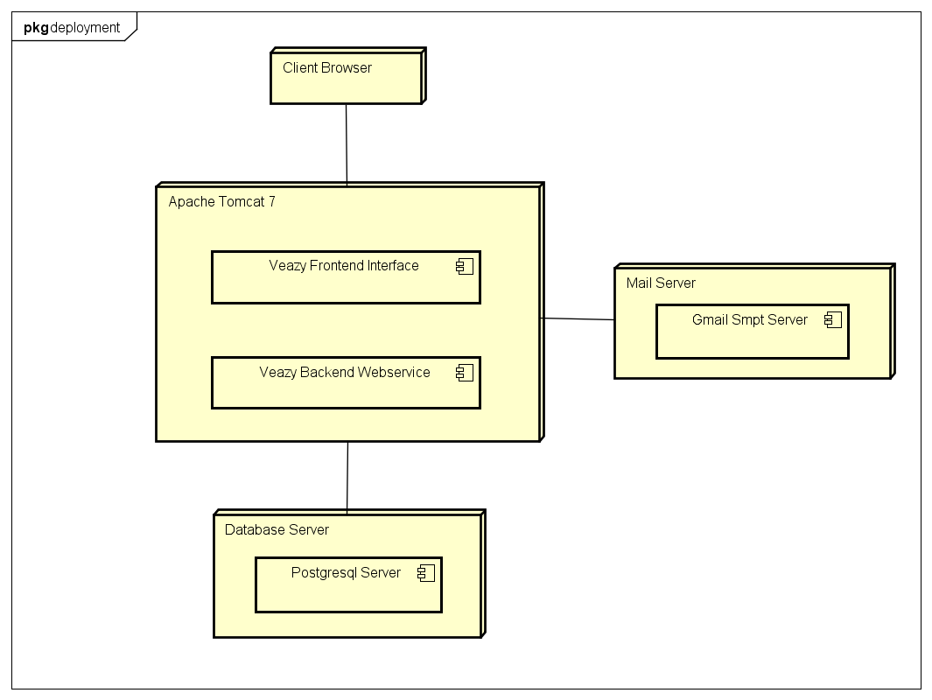

*Figure 8‑1 Deployment diagram*

|  |  |  |
| --- | --- | --- |
| No. | Name | Description |
| 1 | Postgresql Server | Postgresql server to persist data. Postgresql 9.4 or higher |
| 2 | Mail Server | Mail server to send email to user |
| 3 | Web Server | Web server hosting system |
| 4 | Client Browser | Web browser to display system. Firefox 20, Chrome 36 or higher. |

## Class DesignC:\Users\MinhNN\Pictures\pkg.png

**Figure 0: List Packages**

|  |  |  |  |
| --- | --- | --- | --- |
| No | Package | Language | Description |
| 1. 01 | core | JAVA | Contains classes related to core functions |
|  | common | JAVA | Contains common shared classes |
|  | controller | JAVA | Contains Spring controllers |
|  | dao | JAVA | Contains Hibernate data access object classes |
|  | exception | JAVA | Contains user-defined exceptions |
|  | form | JAVA | Contains pojo data forms |
|  | model | JAVA | Contains Spring entity classes |
|  | response | JAVA | Contains data response classes |
|  | security | JAVA | Contain classes related to security |
|  | service | JAVA | Contains Spring service classes |

### Packages

### core.common Package

### Class diagram

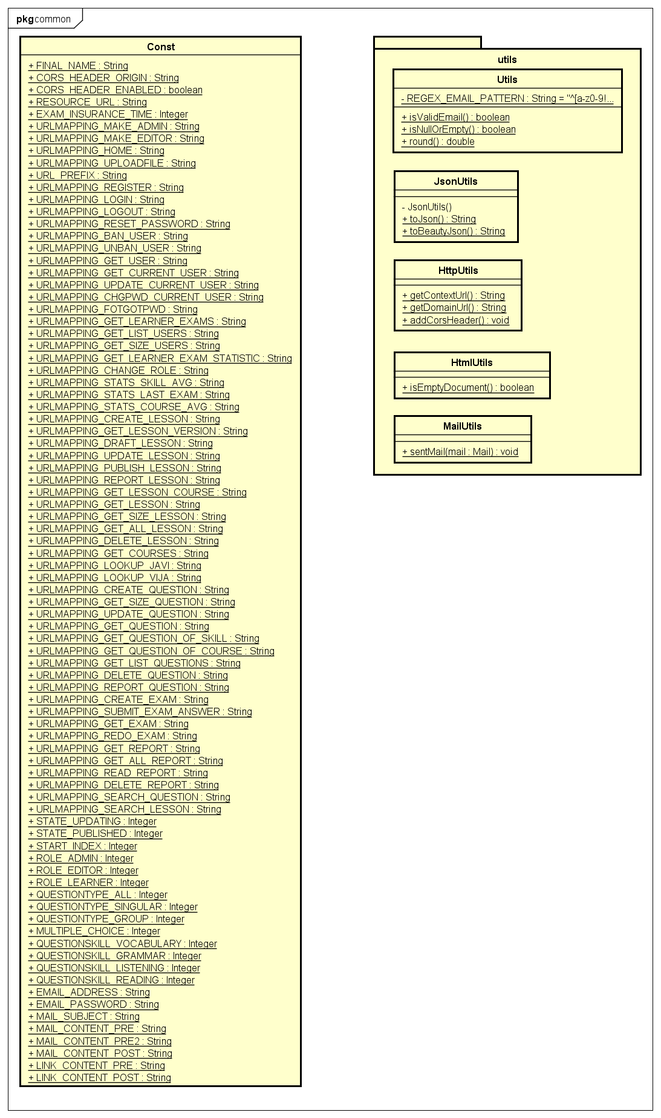

**Figure 1: Class diagram core.common package**

|  |  |  |
| --- | --- | --- |
| No | Class Name | Description |
| 1 | Const | Contain constant variable |
| 2 | Utils | Contain common utility function |
| 3 | JsonUtils | Contain utility function about JSON |
| 4 | HttpUtils | Contain utility function about http |
| 5 | HtmlUtils | Contain utility function about html |
| 6 | MailUtils | Contain utility function about mail |

### Const class

#### Attributes

|  |  |  |  |
| --- | --- | --- | --- |
| No | Attribute | Type | Value |
| 1. 1 | FINAL_NAME | String | Veazy |
|  | CORS_HEADER_ORIGIN | String | Origin |
| 1. 2 | CORS_HEADER_ENABLED | boolean | TRUE |
| 1. 3 | RESOURCE_URL | String | /res |
| 1. 3 | EXAM_INSURANCE_TIME | Integer | 30 |
|  | URLMAPPING_MAKE_ADMIN | String | /mkad/{user_id} |
|  | URLMAPPING_MAKE_EDITOR | String | /mked/{user_id} |
|  | URLMAPPING_HOME | String | / |
|  | URLMAPPING_UPLOADFILE | String | /uploadfile |
|  | URL_PREFIX | String | /api |
|  | URLMAPPING_REGISTER | String | URL_PREFIX + "/register" |
|  | URLMAPPING_LOGIN | String | URL_PREFIX + "/login" |
|  | URLMAPPING_LOGOUT | String | URL_PREFIX + "/logout" |
|  | URLMAPPING_RESET_PASSWORD | String | URL_PREFIX + "/users/reset_password" |
|  | URLMAPPING_BAN_USER | String | URL_PREFIX + "/users/ban/{user_id}" |
|  | URLMAPPING_UNBAN_USER | String | URL_PREFIX + "/users/unban/{user_id}" |
|  | URLMAPPING_GET_USER | String | URL_PREFIX + "/users/{user_id}" |
|  | URLMAPPING_GET_CURRENT_USER | String | URL_PREFIX + "/user" |
|  | URLMAPPING_UPDATE_CURRENT_USER | String | URL_PREFIX + "/user/update" |
|  | URLMAPPING_CHGPWD_CURRENT_USER | String | URL_PREFIX + "/user/chgpwd" |
|  | URLMAPPING_FOTGOTPWD | String | URL_PREFIX + "/user/forgotpwd" |
|  | URLMAPPING_GET_LEARNER_EXAMS | String | URL_PREFIX + "/user/exams" |
|  | URLMAPPING_GET_LIST_USERS | String | URL_PREFIX + "/users" |
|  | URLMAPPING_GET_SIZE_USERS | String | URL_PREFIX + "/users/count" |
|  | URLMAPPING_GET_LEARNER_EXAM_STATISTIC | String | URL_PREFIX + "/users/{user_id}/exams/statistics" |
|  | URLMAPPING_CHANGE_ROLE | String | URL_PREFIX + "/users/change_roll/{user_id}" |
|  | URLMAPPING_STATS_SKILL_AVG | String | URL_PREFIX + "/stats/skill/avg" |
|  | URLMAPPING_STATS_LAST_EXAM | String | URL_PREFIX + "/stats/exam/last/{number}" |
|  | URLMAPPING_STATS_COURSE_AVG | String | URL_PREFIX + "/stats/course/avg" |
|  | URLMAPPING_CREATE_LESSON | String | URL_PREFIX + "/lessons/new" |
|  | URLMAPPING_GET_LESSON_VERSION | String | URL_PREFIX + "/lessons/{lesson_id}/ver{version}" |
|  | URLMAPPING_DRAFT_LESSON | String | URL_PREFIX + "/lessons/savedraft/{lesson_id}" |
|  | URLMAPPING_UPDATE_LESSON | String | URL_PREFIX + "/lessons/update/{lesson_id}" |
|  | URLMAPPING_PUBLISH_LESSON | String | URL_PREFIX + "/lessons/publish/{lesson_id}" |
|  | URLMAPPING_REPORT_LESSON | String | URL_PREFIX + "/lessons/report/{lesson_id}" |
|  | URLMAPPING_GET_LESSON_COURSE | String | URL_PREFIX + "/courses/{course_id}/lessons" |
|  | URLMAPPING_GET_LESSON | String | URL_PREFIX + "/lessons/{lesson_id}" |
|  | URLMAPPING_GET_SIZE_LESSON | String | URL_PREFIX + "/lessons/count" |
|  | URLMAPPING_GET_ALL_LESSON | String | URL_PREFIX + "/lessons" |
|  | URLMAPPING_DELETE_LESSON | String | URL_PREFIX + "/lessons/delete/{lesson_id}" |
|  | URLMAPPING_GET_COURSES | String | URL_PREFIX + "/courses" |
|  | URLMAPPING_LOOKUP_JAVI | String | URL_PREFIX + "/dict/javi/" |
|  | URLMAPPING_LOOKUP_VIJA | String | URL_PREFIX + "/dict/vija/" |
|  | URLMAPPING_CREATE_QUESTION | String | URL_PREFIX + "/questions/new" |
|  | URLMAPPING_GET_SIZE_QUESTION | String | URL_PREFIX + "/questions/count" |
|  | URLMAPPING_UPDATE_QUESTION | String | URL_PREFIX + "/questions/update/{question_id}" |
|  | URLMAPPING_GET_QUESTION | String | URL_PREFIX + "/questions/{question_id}" |
|  | URLMAPPING_GET_QUESTION_OF_SKILL | String | URL_PREFIX + "/skill/{skill_id}/questions" |
|  | URLMAPPING_GET_QUESTION_OF_COURSE | String | URL_PREFIX + "/courses/{course_id}/questions" |
|  | URLMAPPING_GET_LIST_QUESTIONS | String | URL_PREFIX + "/questions" |
|  | URLMAPPING_DELETE_QUESTION | String | URL_PREFIX + "/questions/delete/{question_id}" |
|  | URLMAPPING_REPORT_QUESTION | String | URL_PREFIX + "/questions/report/{question_id}" |
|  | URLMAPPING_CREATE_EXAM | String | URL_PREFIX + "/exams" |
|  | URLMAPPING_SUBMIT_EXAM_ANSWER | String | URL_PREFIX + "/exams/submit" |
|  | URLMAPPING_GET_EXAM | String | URL_PREFIX + "/exams/{exam_id}" |
|  | URLMAPPING_REDO_EXAM | String | URL_PREFIX + "/exams/{exam_id}/redo" |
|  | URLMAPPING_GET_REPORT | String | URL_PREFIX + "/report/get/{report_id}" |
|  | URLMAPPING_GET_ALL_REPORT | String | URL_PREFIX + "/report/all" |
|  | URLMAPPING_READ_REPORT | String | URL_PREFIX + "/report/read/{report_id}" |
|  | URLMAPPING_DELETE_REPORT | String | URL_PREFIX + "/report/delete/{report_id}" |
|  | URLMAPPING_SEARCH_QUESTION | String | URL_PREFIX + "/search/question" |
|  | URLMAPPING_SEARCH_LESSON | String | URL_PREFIX + "/search/lesson" |
|  | UPDATING | Integer | 1 |
|  | PUBLISHED | Integer | 2 |
|  | START_INDEX | Integer | 1 |
|  | ROLE_ADMIN | Integer | 1 |
|  | ROLE_EDITOR | Integer | 2 |
|  | ROLE_LEARNER | Integer | 3 |
|  | QUESTIONTYPE_ALL | Integer | 0 |
|  | QUESTIONTYPE_SINGULAR | Integer | 1 |
|  | QUESTIONTYPE_GROUP | Integer | 2 |
|  | MULTIPLE_CHOICE | Integer | 1 |
|  | QUESTIONSKILL_VOCABULARY | Integer | 1 |
|  | QUESTIONSKILL_GRAMMAR | Integer | 2 |
|  | QUESTIONSKILL_LISTENING | Integer | 3 |
|  | QUESTIONSKILL_READING | Integer | 4 |
|  | EMAIL_ADDRESS | String | veazysystem@gmail.com |
|  | EMAIL_PASSWORD | String | veazy123 |
|  | MAIL_SUBJECT | String | Veazy Reset Password |
|  | MAIL_CONTENT_PRE | String | Hey |
|  | MAIL_CONTENT_PRE2 | String | ,\nSomeone has requested a new password for your Veazy account.\n |
|  | MAIL_CONTENT_POST | String | If you didn't make this request then you can safely ignore this email.\nBest,\n\nThe Veazy Team |
|  | LINK_CONTENT_PRE | String | <a href=\" |
|  | LINK_CONTENT_PRE | String | \">Reset Password</a> |

### Utils class

#### Attributes

|  |  |  |  |  |
| --- | --- | --- | --- | --- |
| No | Attribute | Type | Note | Description |
| 1 | REGEX_EMAIL_PATTERN | String | private | Regex pattern to determine an email |

#### Methods

|  |  |  |
| --- | --- | --- |
| No | Method | Description |
| 1 | isValidEmail() | Check if a string is a valid email or not. |
| 2 | isNullOrEmpty() | Check if a string is null or empty. |
| 3 | round() | round a decimal number |

### JsonUtils class

#### Methods

|  |  |  |
| --- | --- | --- |
| No | Method | Description |
| 1 | toJson() | Convert an object to a json format |
| 2 | toBeautyJson() | Convert an object to a beautiful json format |

### HttpUtils Class

#### Methods

|  |  |  |
| --- | --- | --- |
| No | Method | Description |
| 1 | getContextUrl() | Extracts context url from requested url |
| 2 | addCorsHeader() | Adds CORS headers if enabled |

### HtmlUtils Class

#### Methods

|  |  |  |
| --- | --- | --- |
| No | Method | Description |
| 1 | isEmptyDocument() | Check if Html document is empty |

### MailUtils Class

#### Methods

|  |  |  |
| --- | --- | --- |
| No | Method | Description |
| 1 | sentMail() | Send an email |

### Common Sequence Diagram

## core.controller Package

### Class diagram

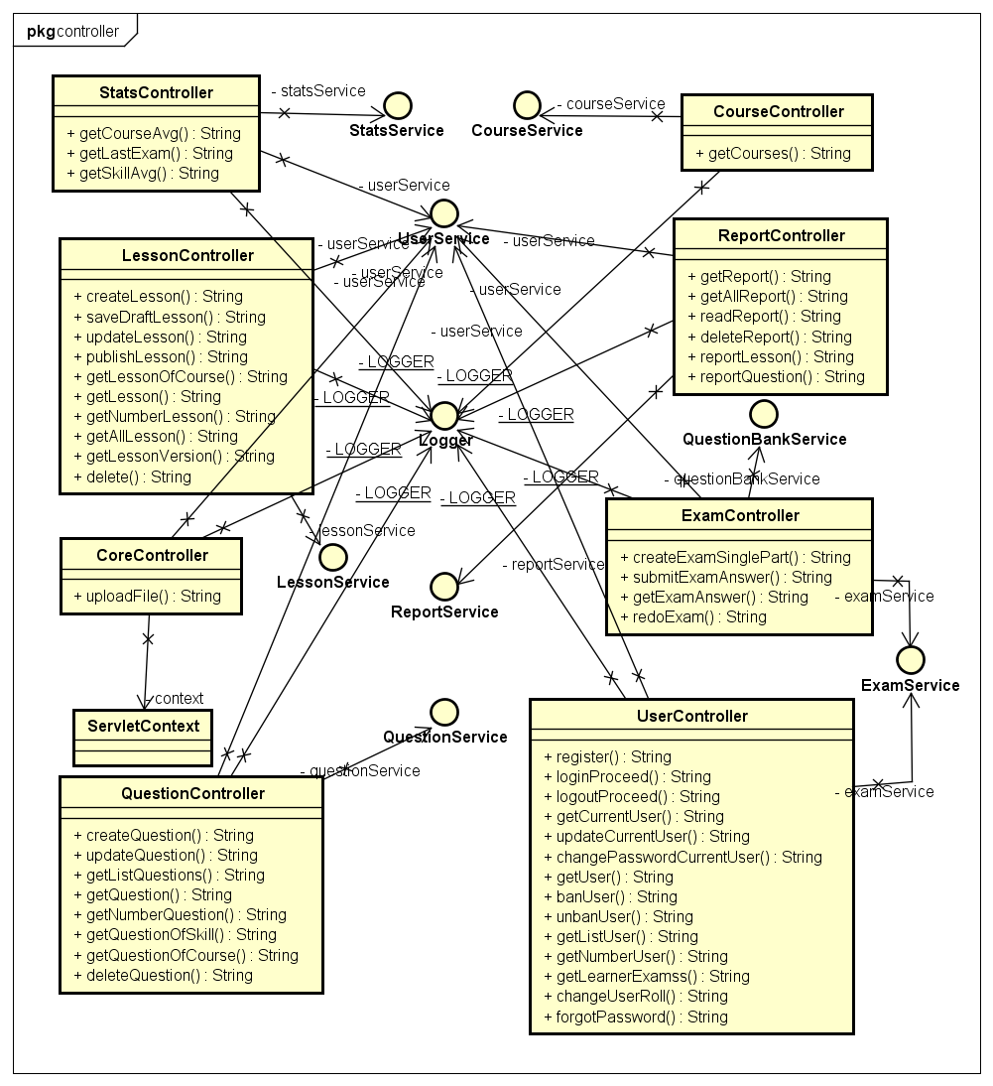

**Figure 2: Class diagram core.controller package**

|  |  |  |
| --- | --- | --- |
| No | Class Name | Description |
| 1 | CoreController | Control core API |
| 2 | CourseController | Control course API |
| 3 | ExamController | Control exam API |
| 4 | LessonController | Control lesson API |
| 5 | QuestionController | Control question API |
| 6 | ReportController | Control report API |
| 8 | StatsController | Control user statistic API |
| 9 | UserController | Control user API |

### CoreController Class

#### Methods

|  |  |  |
| --- | --- | --- |
| No | Method | Description |
| 2 | uploadFile() | To upload file |

### CourseController Class

#### Methods

|  |  |  |
| --- | --- | --- |
| No | Method | Description |
| 1 | getCourses() | Return all courses |

### ExamController Class

#### Methods

|  |  |  |
| --- | --- | --- |
| No | Method | Description |
| 1 | createExamSinglePart() | Generate an exam for learner and return the exam. |
| 2 | submitExamAnswer() | Submit exam answers. |
| 3 | getExamAnswer() | Return the answer of an exam |
| 4 | redoExam() | Return an exam the user had done. |

### LessonController Class

#### Methods

|  |  |  |
| --- | --- | --- |
| No | Method | Description |
| 1 | createLesson | Create a lesson. |
| 2 | saveDraftLesson | Save lesson as draft. |
| 3 | updateLesson | Update a lesson. |
| 4 | publishLesson | Make updating lesson version to publish state. |
| 5 | getLessonOfCourse | Return all lesson of a course. |
| 6 | getLesson | Return a lesson. |
| 7 | getNumberLesson | Return the number of lesson in system. |
| 8 | getAllLesson | Return all lesson of system |
| 9 | getLessonVersion | Return the version of lesson |
| 10 | delete | Delete a lesson |

### QuestionController Class

#### Methods

|  |  |  |
| --- | --- | --- |
| No | Method | Description |
| 1 | createQuestion() | Create a question. |
| 2 | updateQuestion() | Update a question. |
| 3 | getListQuestions() | Return list of question. |
| 4 | getQuestion() | Return a question. |
| 5 | getNumberQuestion() | Return the number of question in system. |
| 6 | getQuestionOfSkill() | Return all question by a skill. |
| 7 | getQuestionOfCourse() | Return all question in a course. |
| 8 | deleteQuestion() | Delete a question. |

### ReportController Class

#### Methods

|  |  |  |
| --- | --- | --- |
| No | Method | Description |
| 1 | getReport () | Return a report |
| 2 | getAllReport () | Return all report |
| 3 | readReport () | Make a report as read state |
| 4 | deleteReport () | Delete a report |
| 5 | reportLesson | Report a lesson. |
| 6 | reportQuestion() | Report a question. |

### StatsController Class

#### Methods

|  |  |  |
| --- | --- | --- |
| No | Method | Description |
| 1 | getCourseAvg | Return the average point of a course. |
| 2 | getLastExam | Return the last exam of user |
| 3 | getSkillAvg | Return the average point of a test skill. |

### UserController Class

#### Methods

|  |  |  |
| --- | --- | --- |
| No | Method | Description |
| 1 | register() | Sign up an account |
| 2 | loginProceed() | Login to system |
| 3 | logoutProceed() | Logout system |
| 4 | getCurrentUser() | Return current user information |
| 5 | updateCurrentUser() | Update user information |
| 6 | changePasswordCurrentUser() | Change password |
| 7 | getUser() | Return an user information |
| 8 | banUser() | Ban a user. |
| 9 | unbanUser() | Unban a user. |
| 10 | getListUser() | Return list of the user. |
| 11 | getNumberUser() | Return the number of user in system. |
| 12 | getLearnerExamss() | Return the done exam of a learner. |
| 13 | changeUserRoll() | Change user role. |

### Sequence Diagram

## core.dao Package

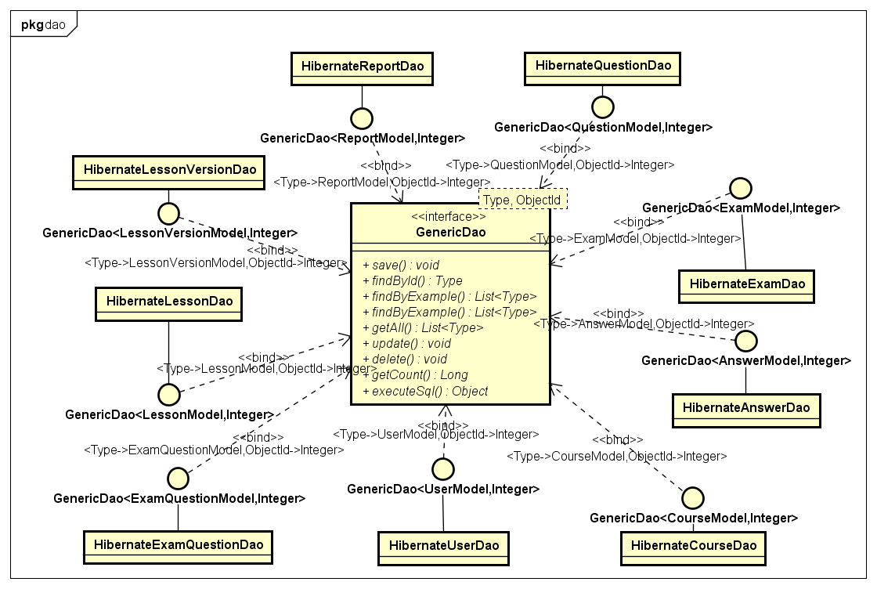

**Figure 3: Class diagram core.dao package**

### Class diagram

|  |  |  |
| --- | --- | --- |
| No | Class Name | Description |
| 1 | HibernateCourseDao | Provides methods to manage course data in database |
| 2 | HibernateExamDao | Provides methods to manage test data in database |
| 3 | HibernateLessonDao | Provides methods to manage lesson data in database |
| 4 | HibernateLessonVersionDao | Provides methods to manage versions of lesson in database |
| 5 | HibernateQuestionDao | Provides methods to manage question data in database |
| 6 | HibernateReportDao | Provides methods to manage report data in database |
| 7 | HibernateUserDao | Provides methods to manage user data in database |
| 8 | HibernateAnswerDao | Provides methods to manage course data in database |
| 9 | HibernateExamQuestionDao | Provides methods to manage test data in database |

### HibernateCourseDao Class

#### Methods

|  |  |  |
| --- | --- | --- |
| No | Method | Description |
| 1 | save() | Save a course to database |
| 2 | findById() | Find a course by its id |
| 3 | findByExample() | Find all course have same feature with example |
| 4 | findByExample() | Find some course have same feature with example |
| 5 | getAll() | Return all course |
| 6 | update() | Update a course |
| 7 | delete() | Delete a course |
| 8 | getCount() | Return the number of the course in database |
| 9 | executeSql() | Return the courses execute by sql |

### HibernateExamDao Class

#### Methods

|  |  |  |
| --- | --- | --- |
| No | Method | Description |
| 1 | save() | Save an exam to database |
| 2 | findById() | Find an exam by its id |
| 3 | findByExample() | Find all exam have same feature with example |
| 4 | findByExample() | Find some exam have same feature with example |
| 5 | getAll() | Return all exam |
| 6 | update() | Update an exam |
| 7 | delete() | Delete an exam |
| 8 | getCount() | Return the number of the exam in database |
| 9 | executeSql() | Return the exams execute by sql |

### HibernateLessonDao Class

#### Methods

|  |  |  |
| --- | --- | --- |
| No | Method | Description |
| 1 | save() | Save a lesson to database |
| 2 | findById() | Find a lesson by its id |
| 3 | findByExample() | Find all lesson have same feature with example |
| 4 | findByExample() | Find some lesson have same feature with example |
| 5 | getAll() | Return all lesson |
| 6 | update() | Update a lesson |
| 7 | delete() | Delete a lesson |
| 8 | getCount() | Return the number of the lesson in database |
| 9 | executeSql() | Return the lessons execute by sql |

### HibernateLessonVersionDao Class

#### Methods

|  |  |  |
| --- | --- | --- |
| No | Method | Description |
| 1 | save() | Save a lesson version to database |
| 2 | findById() | Find a lesson version by its id |
| 3 | findByExample() | Find all lesson version have same feature with example |
| 4 | findByExample() | Find some lesson version have same feature with example |
| 5 | getAll() | Return all lesson version |
| 6 | update() | Update a lesson version |
| 7 | delete() | Delete a lesson version |
| 8 | getCount() | Return the number of the lesson version in database |
| 9 | executeSql() | Return the lesson versions execute by sql |

### HibernateQuestionDao Class

#### Methods

|  |  |  |
| --- | --- | --- |
| No | Method | Description |
| 1 | save() | Save a question to database |
| 2 | findById() | Find a question by its id |
| 3 | findByExample() | Find all question have same feature with example |
| 4 | findByExample() | Find some question have same feature with example |
| 5 | getAll() | Return all question |
| 6 | update() | Update a question |
| 7 | delete() | Delete a question |
| 8 | getCount() | Return the number of the question in database |
| 9 | executeSql() | Return the questions execute by sql |

### HibernateReportDao Class

#### Methods

|  |  |  |
| --- | --- | --- |
| No | Method | Description |
| 1 | save() | Save a report to database |
| 2 | findById() | Find a report by its id |
| 3 | findByExample() | Find all report have same feature with example |
| 4 | findByExample() | Find some report have same feature with example |
| 5 | getAll() | Return all report |
| 6 | update() | Update a report |
| 7 | delete() | Delete a report |
| 8 | getCount() | Return the number of the report in database |
| 9 | executeSql() | Return the reports execute by sql |

### HibernateUserDao Class

#### Methods

|  |  |  |
| --- | --- | --- |
| No | Method | Description |
| 1 | save() | Save an account to database |
| 2 | findById() | Find an account by its id |
| 3 | findByExample() | Find all account have same feature with example |
| 4 | findByExample() | Find some account have same feature with example |
| 5 | getAll() | Return all account |
| 6 | update() | Update an account |
| 7 | delete() | Delete an account |
| 8 | getCount() | Return the number of the account in database |
| 9 | executeSql() | Return the accounts execute by sql |

### HibernateAnswerDao Class

#### Methods

|  |  |  |
| --- | --- | --- |
| No | Method | Description |
| 1 | save() | Save an answer to database |
| 2 | findById() | Find an answer by its id |
| 3 | findByExample() | Find all answer have same feature with example |
| 4 | findByExample() | Find some answer have same feature with example |
| 5 | getAll() | Return all answer |
| 6 | update() | Update an answer |
| 7 | delete() | Delete an answer |
| 8 | getCount() | Return the number of the answer in database |
| 9 | executeSql() | Return the answer execute by sql |

### HibernateExamQuestionDao Class

#### Methods

|  |  |  |
| --- | --- | --- |
| No | Method | Description |
| 1 | save() | Save an exam question to database |
| 2 | findById() | Find an exam question by its id |
| 3 | findByExample() | Find all exam question have same feature with example |
| 4 | findByExample() | Find some exam question have same feature with example |
| 5 | getAll() | Return all exam question |
| 6 | update() | Update an exam question |
| 7 | delete() | Delete an exam question |
| 8 | getCount() | Return the number of the exam question in database |
| 9 | executeSql() | Return the exam questions execute by sql |

### Sequence diagram

## core.exception Package

### C:\Users\CuHo\Desktop\Exception.pngClass diagram

***Figure 4: Class diagram Practice core.exception package***

|  |  |  |
| --- | --- | --- |
| No | Class Name | Description |
| 1 | CorruptedFormException | Exception throwed when user submitted a corrupted form i.e. form that does not have enough expected data |
| 2 | EmailExpectedException | Exception throwed when submitted form does not contain email |
| 3 | InvalidEmailException | Exception throwed when submitted form contains invalid email |
| 4 | PasswordExpectedException | Exception throwed when submitted form does not contain password |
| 5 | PasswordIncorrectException | Exception throwed when submitted form contains incorrect username or password |
| 6 | UsernameExpectedException | Exception throwed when submitted form does not contain username |
| 7 | NullOrEmptyContentException | Exception throwed when submitted data is null or empty |

### CorruptedFormException Class

#### Attributes

|  |  |  |  |  |  |
| --- | --- | --- | --- | --- | --- |
| No | Attribute | Type | Default | Note | Description |
| 1 | ERROR_CODE | int |  | private |  |

#### Methods

|  |  |  |
| --- | --- | --- |
| No | Method | Description |
| 1 | getCode() |  |

### EmailExpectedException Class

#### Attributes

|  |  |  |  |  |  |
| --- | --- | --- | --- | --- | --- |
| No | Attribute | Type | Default | Note | Description |
| 1 | ERROR_CODE | int |  | private |  |

#### Methods

|  |  |  |
| --- | --- | --- |
| No | Method | Description |
| 1 | getCode() |  |

### InvalidEmailException Class

#### Attributes

|  |  |  |  |  |  |
| --- | --- | --- | --- | --- | --- |
| No | Attribute | Type | Default | Note | Description |
| 1 | ERROR_CODE | int |  | private |  |

#### Methods

|  |  |  |
| --- | --- | --- |
| No | Method | Description |
| 1 | getCode() |  |

### PasswordExpectedException Class

#### Attributes

|  |  |  |  |  |  |
| --- | --- | --- | --- | --- | --- |
| No | Attribute | Type | Default | Note | Description |
| 1 | ERROR_CODE | int |  | private |  |

#### Methods

|  |  |  |
| --- | --- | --- |
| No | Method | Description |
| 1 | getCode() |  |

### PasswordIncorrectException Class

#### Attributes

|  |  |  |  |  |  |
| --- | --- | --- | --- | --- | --- |
| No | Attribute | Type | Default | Note | Description |
| 1 | ERROR_CODE | int |  | private |  |

#### Methods

|  |  |  |
| --- | --- | --- |
| No | Method | Description |
| 1 | getCode() |  |

### UsernameExpectedException Class

#### Attributes

|  |  |  |  |  |  |
| --- | --- | --- | --- | --- | --- |
| No | Attribute | Type | Default | Note | Description |
| 1 | ERROR_CODE | int |  | private |  |

#### Methods

|  |  |  |
| --- | --- | --- |
| No | Method | Description |
| 1 | getCode() |  |

### NullOrEmptyContentException Class

#### Attributes

|  |  |  |  |  |  |
| --- | --- | --- | --- | --- | --- |
| No | Attribute | Type | Default | Note | Description |
| 1 | ERROR_CODE | int |  | private |  |

#### Methods

|  |  |  |
| --- | --- | --- |
| No | Method | Description |
| 1 | getCode() |  |

### Sequence Diagram

## core.form Package

### C:\Users\CuHo\Desktop\Diagram v2\Form.pngClass diagram

**Figure 5: Class diagram core.form package**

|  |  |  |
| --- | --- | --- |
| No | Class Name | Description |
| 1 | AnswerForm | Answer form |
| 2 | ChangeRoleForm | Change user role form |
| 3 | ChgpwdForm | Change password form |
| 4 | CreateExamSinglePartForm | Create exam form |
| 5 | CreateLessonForm | Create lesson form |
| 6 | ExamPartForm | Form for generating a exam |
| 7 | FileUploadForm | Upload file form |
| 8 | LoginForm | Login form Lookup word form |
| 9 | QuestionForm | Get a question form |
| 10 | RegisterForm | Register form |
| 11 | ReportForm | Report a question or lesson form |
| 12 | SubmitExamForm | Submit an exam |
| 13 | SubmitQuestionForm | Submit questions of an exam |
| 14 | SubmitAnswerForm | Submit answers of a question |
| 15 | UpdateLessonForm | Update question lesson form |
| 16 | UpdateUserForm | Update user form |
| 17 | Mail | Send email form |

### AnswerForm Class

#### Attributes

|  |  |  |  |  |
| --- | --- | --- | --- | --- |
| No | Attribute | Type | Note | Description |
| 1 | answer | String | private | The question answer. |
| 2 | isRight | Boolean | private | The answer is correct or not |

### ChangeRoleForm Class

#### Attributes

|  |  |  |  |  |
| --- | --- | --- | --- | --- |
| No | Attribute | Type | Note | Description |
| 1 | userId | Integer | private | The user id. |
| 2 | role | Integer | private | The new role of user. |

### ChgpwdForm Class

#### Attributes

|  |  |  |  |  |
| --- | --- | --- | --- | --- |
| No | Attribute | Type | Note | Description |
| 1 | oldPassword | String | private | Old password. |
| 2 | newPassword | String | private | New password. |

### CreateExamSinglePartForm Class

#### Attributes

|  |  |  |  |  |
| --- | --- | --- | --- | --- |
| No | Attribute | Type | Note | Description |
| 1 | courseId | Integer | private | The course of the exam |
| 2 | skill | Integer | private | The skill of the exam |
| 3 | numberOfQuestion | Integer | private | The number question of the exam |

### CreateLessonForm Class

#### Attributes

|  |  |  |  |  |
| --- | --- | --- | --- | --- |
| No | Attribute | Type | Note | Description |
| 1 | courseId | Integer | private | The course id of lesson. |
| 2 | lessonTitle | String | private | The lesson title. |
| 3 | description | String | private | The lesson description. |
| 4 | vocabulary | String | private | The lesson vocabulary. |
| 5 | grammar | String | private | The lesson grammar. |
| 6 | reading | String | private | The lesson reading part. |
| 7 | listening | String | private | The lesson listening part. |
| 8 | practice | String | private | The lesson practice part. |
| 9 | article | String | private | The lesson article. |

### ExamPartForm Class

#### Attributes

|  |  |  |  |  |
| --- | --- | --- | --- | --- |
| No | Attribute | Type | Note | Description |
| 1 | skill | int | private | The skill of exam. |
| 2 | numberOfQuestion | int | private | The number of question in exam. |

### FileUploadForm Class

### LoginForm Class

#### Attributes

|  |  |  |  |  |
| --- | --- | --- | --- | --- |
| No | Attribute | Type | Note | Description |
| 1 | username | String | private | The user name. |
| 2 | encryptedPassword | String | private | The user password has been encrypted. |

### QuestionForm Class

#### Attributes

|  |  |  |  |  |
| --- | --- | --- | --- | --- |
| No | Attribute | Type | Note | Description |
| 1 | questionId | Integer | private | The question Id. |
| 2 | questionAnswerType | Integer | private | The question answer type. |
| 3 | questionType | Integer | private | The question type. |
| 4 | questionSkill | Integer | private | The question skill. |
| 5 | courseId | Integer | private | The course id of question. |
| 6 | creatorId | Integer | private | The id of user who create question. |
| 7 | numberOfQuestion | Integer | private | The number of child question. |
| 8 | etaTime | Integer | private | Estimate time to complete the question |
| 9 | question | String | private | The question. |
| 10 | attachment | String | private | The file attach with question |

### RegisterForm Class

#### Attributes

|  |  |  |  |  |
| --- | --- | --- | --- | --- |
| No | Attribute | Type | Note | Description |
| 1 | username | String | private | The user name. |
| 2 | password | String | private | The user password. |
| 3 | email | String | private | The user email. |

### ReportForm Class

#### Attributes

|  |  |  |  |  |
| --- | --- | --- | --- | --- |
| No | Attribute | Type | Note | Description |
| 1 | content | String | private | The report content. |

### SubmitExamForm Class

#### Attributes

|  |  |  |  |  |
| --- | --- | --- | --- | --- |
| No | Attribute | Type | Note | Description |
| 1 | examId | Integer | private | The exam id. |
| 2 | takenTime | Integer | private | The time user do exam. |

### SubmitQuestionForm Class

#### Attributes

|  |  |  |  |  |
| --- | --- | --- | --- | --- |
| No | Attribute | Type | Note | Description |
| 1 | questionId | Integer | private | The question id. |

### SubmitAnswerForm Class

#### Attributes

|  |  |  |  |  |
| --- | --- | --- | --- | --- |
| No | Attribute | Type | Note | Description |
| 1 | answer | String | private | The answer |
| 2 | isSelected | Boolean | private | User select this answer or not |

### UpdateLessonForm Class

#### Attributes

|  |  |  |  |  |
| --- | --- | --- | --- | --- |
| No | Attribute | Type | Note | Description |
| 1 | lessonId | Integer | private | The lesson id |
| 2 | courseId | Integer | private | The course id of lesson. |
| 3 | lessonTitle | String | private | The lesson title. |
| 4 | description | String | private | The lesson description. |
| 5 | vocabulary | String | private | The lesson vocabulary. |
| 6 | grammar | String | private | The lesson grammar. |
| 7 | reading | String | private | The lesson reading part. |
| 8 | listening | String | private | The lesson listening part. |
| 9 | practice | String | private | The lesson practice part. |
| 10 | article | String | private | The lesson article. |

### UpdateUserForm Class

#### Attributes

|  |  |  |  |  |
| --- | --- | --- | --- | --- |
| No | Attribute | Type | Note | Description |
| 1 | firstName | String | private | The user first name. |
| 2 | lastName | String | private | The user last name. |
| 3 | dob | Long | private | date of birth |
| 4 | address | String | private | The user address. |
| 5 | hobby | String | private | The user hobby. |
| 6 | bio | String | private | The user introduction. |
| 7 | website | String | private | The user website. |
| 8 | quote | String | private | Favorite quote |

### Email Class

#### Attributes

|  |  |  |  |  |
| --- | --- | --- | --- | --- |
| No | Attribute | Type | Note | Description |
| 1 | senderEmailAddress | String | private | Email address of sender |
| 2 | senderPassword | String | private | Password of sender |
| 3 | receiverEmailAddress | String | private | Email address of receiver |
| 4 | emailSubject | String | private | Email subject |
| 5 | emailContent | String | private | Email content |
| 6 | emailContentType | String | private | Email content type |

### Sequence Diagram

## core.model package

### Class diagram

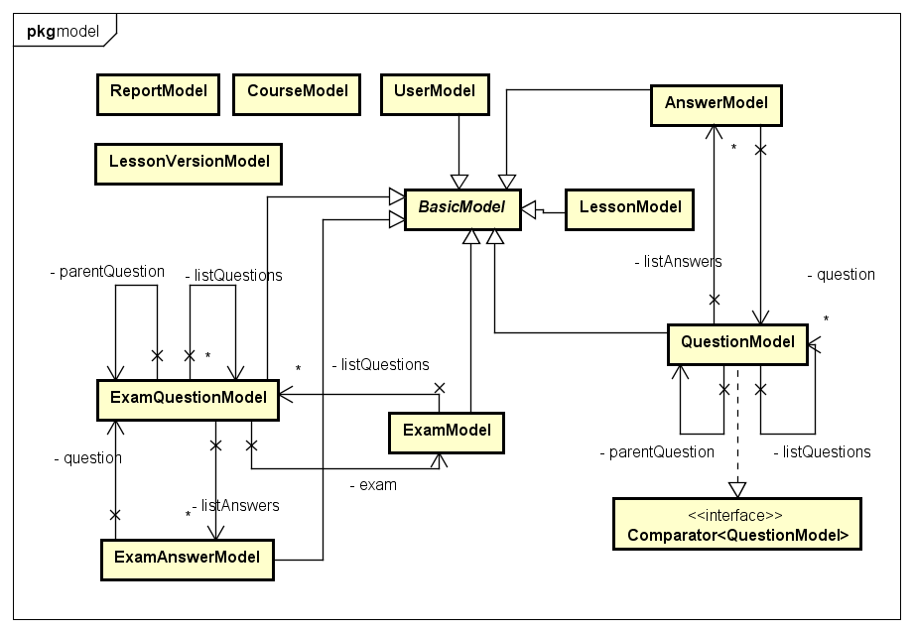

**Figure 6: Class diagram core.model package**

|  |  |  |
| --- | --- | --- |
| No | Class Name | Description |
| 1 | AnswerModel | Answer model |
| 2 | BasicModel | Basic model |
| 3 | CourseModel | Course model |
| 4 | ExamAnswerModel | Exam answer |
| 5 | ExamModel | Exam model |
| 6 | ExamQuestionModel | Exam question model |
| 7 | LessonModel | Lesson model |
| 8 | LessonVersionModel | Lesson version model |
| 9 | QuestionModel | Question model |
| 10 | ReportModel | Report model |
| 11 | UserModel | User model |

### AnswerModel Class

#### Attributes

|  |  |  |  |  |
| --- | --- | --- | --- | --- |
| No | Attribute | Type | Note | Description |
| 1 | answer | String | private | The question answer. |
| 2 | isRight | Boolean | private | The answer is correct or not |

### BasicModel Class

#### Attributes

|  |  |  |  |  |
| --- | --- | --- | --- | --- |
| No | Attribute | Type | Note | Description |
| 1 | id | Integer | private | The model id |
| 2 | createDate | Long | private | The date model is created |
| 3 | updateDate | Long | private | The last update date |
| 4 | deleteDate | Long | private | The date model is deleted |
| 5 | deleteFlag | Boolean | private | The model is deleted or not |

### CourseModel Class

#### Attributes

|  |  |  |  |  |
| --- | --- | --- | --- | --- |
| No | Attribute | Type | Note | Description |
| 1 | id | Integer | private | The course id |
| 2 | name | String | private | The course name |
| 3 | description | String | private | The course desciption |

### ExamAnswer Class

#### Attributes

|  |  |  |  |  |  |
| --- | --- | --- | --- | --- | --- |
| No | Attribute | Type | Default | Note | Description |
| 1 | answer | String |  | private | The answer. |
| 2 | isRight | Boolean |  | private | The answer is correct or not. |
| 3 | isSelected | Boolean |  | private | The answer is selected by learner or not. |

### ExamModel Class

#### Attributes

|  |  |  |  |  |
| --- | --- | --- | --- | --- |
| No | Attribute | Type | Note | Description |
| 1 | userId | Integer | private | The id of user who do exam |
| 2 | courseId | Integer | private | The course id of exam |
| 3 | questionSkill | Integer | private | The skill of exam |
| 4 | result | Double | private | The result |
| 5 | takenTime | Integer | private | The time user do exam |
| 6 | etaTime | Integer | private | The total time of exam |
| 7 | finishState | Boolean | private | The exam has been finished or not |

### ExamQuestionModel Class

#### Attributes

|  |  |  |  |  |
| --- | --- | --- | --- | --- |
| No | Attribute | Type | Note | Description |
| 1 | questionId | Integer | private | The question id |
| 2 | question | String | private | The question |
| 3 | questionType | Integer | private | The question type |
| 4 | numberOfQuestion | Integer | private | The number of child question |
| 5 | questionAnswerType | Integer | private | The question answer type |
| 6 | attachment | String | private | The file attach with question |
| 7 | isChanged | Boolean | private | The question has been changed or not |

### LessonModel Class

#### Attributes

|  |  |  |  |  |
| --- | --- | --- | --- | --- |
| No | Attribute | Type | Note | Description |
| 1 | index | Integer | private | The index of lesson in course. |
| 2 | courseId | Integer | private | The course id of lesson. |
| 3 | currentVersionId | Integer | private | The current lesson version id. |

### LessonVersionModel Class

#### Attributes

|  |  |  |  |  |
| --- | --- | --- | --- | --- |
| No | Attribute | Type | Note | Description |
| 1 | id | Integer | private | The lesson version id |
| 2 | createDate | Long | private | The create date. |
| 3 | updateDate | Long | private | The update date |
| 4 | lessonId | Integer | private | The lesson id. |
| 5 | version | Integer | private | The lesson version |
| 6 | state | Integer | private | The state of lesson version |
| 7 | title | String | private | The lesson title. |
| 8 | description | String | private | The lesson description. |
| 9 | creatorId | Integer | private | The creator id |
| 10 | vocabulary | String | private | The lesson vocabulary. |
| 11 | grammar | String | private | The lesson grammar. |
| 12 | reading | String | private | The lesson reading part. |
| 13 | listening | String | private | The lesson listening part. |
| 14 | practice | String | private | The lesson practice part. |
| 15 | article | String | private | The lesson article. |

### QuestionModel Class

#### Attributes

|  |  |  |  |  |
| --- | --- | --- | --- | --- |
| No | Attribute | Type | Note | Description |
| 1 | questionCode | Integer | private | The question code |
| 2 | creatorId | Integer | private | The creator id |
| 3 | questionAnswerType | Integer | private | The question answer type |
| 4 | questionType | Integer | private | The question type |
| 5 | questionSkill | Integer | private | The question skill |
| 6 | numberOfQuestion | Integer | private | The number of child questions |
| 7 | courseId | Integer | private | The course id |
| 8 | question | String | private | The question |
| 9 | content | List<Integer> | private | The child questions id |
| 10 | state | Integer | private | The question state |
| 11 | attachment | Integer | private | The file url attach with question |

### ReportModel Class

#### Attributes

|  |  |  |  |  |
| --- | --- | --- | --- | --- |
| No | Attribute | Type | Note | Description |
| 1 | id | Integer | private | The report id |
| 2 | createDate | Long | private | The create date |
| 3 | deleteDate | Long | private | The delete date |
| 4 | deleteFlag | Long | private | The report is deleted or not |
| 5 | senderId | Integer | private | The user who send report |
| 6 | receiverId | Integer | private | The user who receive report |
| 7 | readFlag | Boolean | private | Check if report is read or not |
| 8 | content | String | private | The report content |
| 9 | lessonId | Integer | private | The id of lesson is reported |
| 10 | questionId | Integer | private | The id of question is reported |

### UserModel Class

#### Attributes

|  |  |  |  |  |
| --- | --- | --- | --- | --- |
| No | Attribute | Type | Note | Description |
| 1 | email | String | private | The user email |
| 2 | userName | String | private | The user name |
| 3 | encryptedPassword | String | private | The password had been encrypted |
| 4 | firstName | String | private | The user first name. |
| 5 | lastName | String | private | The user last name. |
| 6 | dob | Long | private | Date of birth |
| 7 | joinDate | Long | private | The join date |
| 8 | address | String | private | The user address. |
| 9 | role | Integer | private | The user role |
| 10 | hobby | String | private | The user hobby. |
| 11 | bio | String | private | The user introduction. |
| 12 | website | String | private | The user website. |
| 13 | quote | String | private | Favorite quote |
| 14 | isBanned | Boolean | private | The user is banned or not |

### Sequence Diagram

## core.response Package

### C:\Users\CuHo\Desktop\Diagram v2\Response.pngClass diagram

**Figure 7: Class diagram core.response package**

|  |  |  |
| --- | --- | --- |
| No | Class Name | Description |
| 1 | AddQuestionResponse | Response for add question API |
| 2 | AnswerResponse | Answer of a question |
| 3 | BriefAnswerResponse | Brief of an answer |
| 4 | BriefLessonResponse | Brief of an lesson |
| 5 | BriefQuestionResponse | Brief of an question |
| 6 | CreateLessonResponse | Response for create lesson API |
| 7 | ExamAnswerResponse | Answer of a question in exam |
| 8 | ExamPartResponse | Response for a generated an exam |
| 9 | ExamQuestionResponse | Question in exam |
| 10 | ExamResultResponse | Result of exam |
| 11 | ExamSinglePartResponse | Response for generating a single-skill exam |
| 12 | GetCourseResponse | Response for get course API |
| 13 | GetExamResponse | Response for get exam API |
| 14 | GetLearnerExamsResponse | Response for get learner exam API |
| 15 | GetLessonResponse | Response for get lesson API |
| 16 | GetLessonVersionResponse | Response for get lesson version API |
| 17 | GetListUsersResponse | Response for get list users API |
| 18 | GetUserResponse | Response for get a user API |
| 19 | LoginResponse | Response for login API |
| 20 | QuestionResponse | Contain question content |
| 21 | Response | Response form for all API |
| 22 | ResponseCode | Return code for each API |
| 23 | StatsCourseAvgResponse | Response for get statistic of exam in a course API |
| 24 | StatsLastExamResponse | Response for get statistic of last exam API |
| 25 | StatsLessonsResponse | Response for get statistic of lesson API |
| 26 | StatsQuestionsResponse | Response for get statistic of question API |
| 27 | StatsSkillAvgResponse | Response for get statistic of exam in a skill API |
| 28 | StatsUsersResponse | Response for get statistic of an user API |
| 29 | UploadFileResponse | Response for upload file API |

### AddQuestionResponseData Class

#### Attributes

|  |  |  |  |  |  |
| --- | --- | --- | --- | --- | --- |
| No | Attribute | Type | Default | Note | Description |
| 1 | questionId | Integer |  | private | question id |

### AnswerResponse Class

#### Attributes

|  |  |  |  |  |
| --- | --- | --- | --- | --- |
| No | Attribute | Type | Note | Description |
| 1 | answer | String | private | The question answer. |
| 2 | isRight | Boolean | private | The answer is correct or not |

### BriefAnswerResponse Class

#### Attributes

|  |  |  |  |  |
| --- | --- | --- | --- | --- |
| No | Attribute | Type | Note | Description |
| 1 | answer | String | private | The question answer. |
| 2 | isRight | Boolean | private | The answer is correct or not |
| 3 | isSelected | Boolean | private | User choose answer or not |

### BriefLessonResponse Class

#### Attributes

|  |  |  |  |  |
| --- | --- | --- | --- | --- |
| No | Attribute | Type | Note | Description |
| 1 | lessonId | Integer | private | The lesson id |
| 2 | title | String | private | The lesson type |
| 3 | state | Integer | private | The lesson state |
| 4 | courseId | Integer | private | The course id |
| 5 | version | Integer | private | The lesson version |
| 6 | description | String | private | The lesson description |

### BriefQuestionResponse Class

#### Attributes

|  |  |  |  |  |
| --- | --- | --- | --- | --- |
| No | Attribute | Type | Note | Description |
| 1 | questionId | Integer | private | The question id |
| 2 | question | String | private | The question |
| 3 | attachment | String | private | The file url attach with question |

### CreateLessonResponse Class

#### Attributes

|  |  |  |  |  |
| --- | --- | --- | --- | --- |
| No | Attribute | Type | Note | Description |
| 1 | lessonId | Integer | private | The lesson version |
| 2 | courseId | Integer | private | The state of lesson version |
| 3 | version | Integer | private | The lesson version |
| 4 | lessonTitle | String | private | The lesson title. |
| 5 | description | String | private | The lesson description. |
| 6 | creatorId | Integer | private | The creator id |
| 7 | createDate | Long | private | The creation date |
| 8 | vocabulary | String | private | The lesson vocabulary. |
| 9 | grammar | String | private | The lesson grammar. |
| 10 | reading | String | private | The lesson reading part. |
| 11 | listening | String | private | The lesson listening part. |
| 12 | practice | String | private | The lesson practice part. |
| 13 | article | String | private | The lesson article. |

### ExamAnswerResponse Class

#### Attributes

|  |  |  |  |  |
| --- | --- | --- | --- | --- |
| No | Attribute | Type | Note | Description |
| 1 | answer | Integer | private | The question answer. |
| 2 | isRight | Boolean | private | The answer is correct or not |
| 3 | isSelected | Boolean | private | User choose answer or not |

### ExamPartResponse Class

#### Attributes

|  |  |  |  |  |
| --- | --- | --- | --- | --- |
| No | Attribute | Type | Note | Description |
| 1 | examId | Integer | private | The exam id |
| 2 | skill | Integer | private | The exam skill |
| 3 | etaTime | Integer | private | The total time of exam |
| 4 | offlineCheck | Boolean | private | The backend side check exam result or not |

### ExamQuestionResponse Class

#### Attributes

|  |  |  |  |  |
| --- | --- | --- | --- | --- |
| No | Attribute | Type | Note | Description |
| 1 | questionId | Integer | private | The question id |
| 2 | questionType | Integer | private | The question type |
| 3 | question | String | private | The question |
| 4 | numberOfQuestion | Integer | private | The number of child questions |
| 5 | questionAnswerType | Integer | private | The question answer type |
| 6 | attachment | String | private | The file url attach with question |
| 7 | isChanged | Boolean | private | The question has been changed or not |

### ExamResultResponse Class

#### Attributes

|  |  |  |  |  |
| --- | --- | --- | --- | --- |
| No | Attribute | Type | Note | Description |
| 1 | examId | Integer | private | The exam id |
| 2 | course | Integer | private | The course id |
| 3 | skill | Integer | private | The exam skill |
| 4 | offlineCheck | Boolean | private | The backend side check exam result or not |
| 5 | etaTime | Integer | private | The total time of exam |

### ExamSinglePartResponseClass

#### Attributes

|  |  |  |  |  |
| --- | --- | --- | --- | --- |
| No | Attribute | Type | Note | Description |
| 1 | examId | Integer | private | The exam id |
| 2 | result | Double | private | The exam result |

### GetCourseResponse Class

#### Attributes

|  |  |  |  |  |  |
| --- | --- | --- | --- | --- | --- |
| No | Attribute | Type | Default | Note | Description |
| 1 | name | String |  | private | The course name |
| 2 | description | String |  | private | The course desciption |

### GetExamResponse Class

#### Attributes

|  |  |  |  |  |
| --- | --- | --- | --- | --- |
| No | Attribute | Type | Note | Description |
| 1 | examId | Integer | private | The exam id |
| 2 | courseId | Integer | private | The course id |
| 3 | questionSkill | Integer | private | The question skill |
| 4 | result | Double | private | The exam result |
| 5 | takenTime | Integer | private | The time user do exam |
| 6 | etaTime | Integer | private | The total time of exam |

### GetLearnerExamsResponseData Class

#### Attributes

|  |  |  |  |  |
| --- | --- | --- | --- | --- |
| No | Attribute | Type | Note | Description |
| 1 | exams | ExamResponseData | private | Exam response data |

### GetLessonResponse Class

#### Attributes

|  |  |  |  |  |
| --- | --- | --- | --- | --- |
| No | Attribute | Type | Note | Description |
| 1 | lessonId | Integer | private | The lesson id |
| 2 | courseId | Integer | private | The course id |
| 3 | lessonTitle | String | private | The lesson title |
| 4 | description | String | private | The lesson description |
| 5 | updateDate | Long | private | The update date |
| 6 | state | Integer | private | The lesson state |
| 7 | version | Integer | private | The lesson version |
| 8 | vocabulary | String | private | The lesson vocabulary. |
| 9 | grammar | String | private | The lesson grammar. |
| 10 | conversation | String | private | The lesson conversation part. |
| 11 | listening | String | private | The lesson listening part. |
| 12 | practice | String | private | The lesson practice part. |
| 13 | reading | String | private | The lesson reading. |
| 14 | previousLessonId | Integer | private | The previous lesson on same course |
| 15 | nextLessonId | Integer | private | The next lesson on same course |

### GetLessonVersionResponse Class

#### Attributes

|  |  |  |  |  |
| --- | --- | --- | --- | --- |
| No | Attribute | Type | Note | Description |
| 1 | lessonId | Integer | private | The lesson id. |
| 2 | courseId | Integer | private | The lesson version |
| 3 | version | Integer | private | The lesson version |
| 4 | lessonTitle | String | private | The lesson title |
| 5 | description | String | private | The lesson description |
| 6 | creatorId | Integer | private | The creator id |
| 7 | createDate | Long | private | The creation date. |
| 8 | updateDate | Long | private | The update date |
| 9 | vocabulary | String | private | The lesson vocabulary. |
| 10 | grammar | String | private | The lesson grammar. |
| 11 | reading | String | private | The lesson reading part. |
| 12 | listening | String | private | The lesson listening part. |
| 13 | practice | String | private | The lesson practice part. |
| 14 | article | String | private | The lesson article. |
| 15 | listVersions | List< Integer> | private | List lesson version id in same lesson |

### GetListUsersResponseData Class

#### Attributes

|  |  |  |  |  |
| --- | --- | --- | --- | --- |
| No | Attribute | Type | Note | Description |
| 1 | listUsers | List<GetUserResponseData> | private |  |

### GetUserResponseData Class

#### Attributes

|  |  |  |  |  |
| --- | --- | --- | --- | --- |
| No | Attribute | Type | Note | Description |
| 1 | email | String | private | The user email |
| 2 | userName | String | private | The user name |
| 3 | firstName | String | private | The user first name. |
| 4 | lastName | String | private | The user last name. |
| 5 | dob | Long | private | Date of birth |
| 6 | joinDate | Long | private | The join date |
| 7 | address | String | private | The user address. |
| 8 | role | Integer | private | The user role |
| 9 | hobby | String | private | The user hobby. |
| 10 | bio | String | private | The user introduction. |
| 11 | website | String | private | The user website. |
| 12 | quote | String | private | Favorite quote |

### LoginResponse Class

#### Attributes

|  |  |  |  |  |
| --- | --- | --- | --- | --- |
| No | Attribute | Type | Note | Description |
| 1 | role | Integer | private | The role of user |

### QuestionResponse Class

#### Attributes

|  |  |  |  |  |
| --- | --- | --- | --- | --- |
| No | Attribute | Type | Note | Description |
| 1 | questionId | Integer | private | The question id |
| 2 | questionCode | Integer | private | The question code |
| 3 | questionAnswerType | Integer | private | The question answer type |
| 4 | questionType | Integer | private | The question type |
| 5 | questionSkill | Integer | private | The question skill |
| 6 | courseId | Integer | private | The course id |
| 7 | question | String | private | The question |
| 8 | state | Integer | private | The question state |
| 9 | createDate | Long | private | The creation date |
| 10 | updateDate | Long | private | The update date |

### Response Class

#### Attributes

|  |  |  |  |  |
| --- | --- | --- | --- | --- |
| No | Attribute | Type | Note | Description |
| 1 | code | Integer | private | Response code. |
| 2 | data | String | private | Response detail content. |

### ResponseCode Class

#### Attributes

|  |  |  |  |
| --- | --- | --- | --- |
| No | Attribute | Type | Value |
| 1. 1 | SUCCESS | int | 200 |
| 1. 2 | CREATED | int | 201 |
| 1. 3 | FOUND | int | 302 |
| 1. 3 | BAD_REQUEST | int | 400 |
|  | UNAUTHORIZED | int | 401 |
|  | PERMISSION_DENIED | int | 403 |
|  | REQUEST_TIMEOUT | int | 408 |
|  | INVALID_EMAIL | int | 410 |
|  | DUPLICATED_EMAIL | int | 411 |
|  | EMAIL_NOT_FOUND | int | 412 |
|  | DUPLICATED_USERNAME | int | 413 |
|  | CORRUPTED_FORM | int | 460 |
|  | USERNAME_EXPECTED | int | 461 |
|  | PASSWORD_EXPECTED | int | 462 |
|  | EMAIL_EXPECTED | int | 463 |
|  | INVALID_PASSWORD | int | 420 |
|  | INCORRECT_PASSWORD | int | 421 |
|  | USER_NOT_FOUND | int | 430 |
|  | USER_NOT_ALLOW | int | 431 |
|  | USER_INACTIVE | int | 432 |
|  | USER_EXAMS_NOT_FOUND | int | 433 |
|  | USERNAME_PASSWORD_NOT_MATCH | int | 470 |
|  | PASSWORD_INCORRECT | int | 471 |
|  | QUESTION_NOT_FOUND | int | 440 |
|  | INTERNAL_SERVER_ERROR | int | 500 |
|  | UNSUPPORTED_API | int | 600 |

### StatsLastExamResponse Class

#### Attributes

|  |  |  |  |  |
| --- | --- | --- | --- | --- |
| No | Attribute | Type | Note | Description |
| 1 | result | Double | private | Last exam result |

### StatsLessonsResponse Class

#### Attributes

|  |  |  |  |  |
| --- | --- | --- | --- | --- |
| No | Attribute | Type | Note | Description |
| 1 | numberOfLessons | Integer | private | The number of lesson in system. |

### StatsQuestionsResponse Class

#### Attributes

|  |  |  |  |  |
| --- | --- | --- | --- | --- |
| No | Attribute | Type | Note | Description |
| 1 | numberOfLessons | Integer | private | The number of question in system. |

### StatsSkillAvgResponse Class

#### Attributes

|  |  |  |  |  |
| --- | --- | --- | --- | --- |
| No | Attribute | Type | Note | Description |
| 1 | listening | Double | private | Average point in listening skills. |
| 2 | reading | Double | private | Average point in reading skills. |
| 3 | vocabulary | Double | private | Average point in vocabulary skills. |
| 4 | grammar | Double | private | Average point in grammar skills. |

### StatsUsersResponse Class

#### Attributes

|  |  |  |  |  |
| --- | --- | --- | --- | --- |
| No | Attribute | Type | Note | Description |
| 1 | activeUser | Integer | private | The number of user who isn’t banned |
| 2 | totalUser | Integer | private | The number of user in system |

### UploadFileResponse Class

#### Attributes

|  |  |  |  |  |
| --- | --- | --- | --- | --- |
| No | Attribute | Type | Note | Description |
| 1 | link | String | private | Uploaded file url. |

### Sequence Diagram

## core.security package

### Class diagram

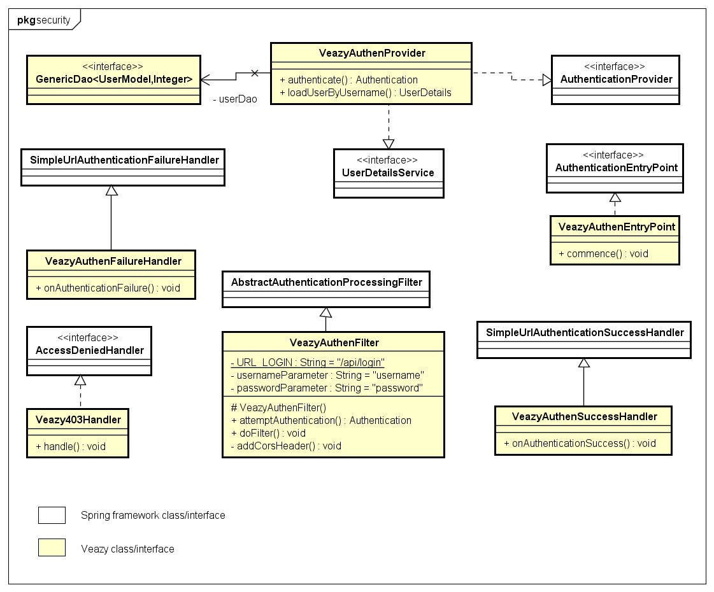

**Figure 8: Class diagram core.security package**

|  |  |  |
| --- | --- | --- |
| No | Class Name | Description |
| 1 | Veazy403Handler | Handles 403 forbidden error |
| 2 | VeazyAuthenEntryPoint | Handles anonymous requests |
| 3 | VeazyAuthenFailureHandler | Handles authentication failure requests |
| 4 | VeazyAuthenFilter | Filters authentication requests |
| 5 | VeazyAuthenProvider | Provides authentication mechanism |
| 6 | VeazyAuthenSuccessHandler | Handles authentication success requests |

### Veazy403Handler Class

#### Methods

|  |  |  |
| --- | --- | --- |
| No | Method | Description |
| 1 | handle() | Handles denied request |

### VeazyAuthenEntryPoint Class

#### Methods

|  |  |  |
| --- | --- | --- |
| No | Method | Description |
| 1 | commence() | Handles anonymous request |

### VeazyAuthenFailureHandler Class

#### Methods

|  |  |  |
| --- | --- | --- |
| No | Method | Description |
| 1 | onAuthenticationFailure() | Handles failed authentication event |

### VeazyAuthenFilter Class

#### Attributes

|  |  |  |  |  |
| --- | --- | --- | --- | --- |
| No | Attribute | Type | Note | Description |
| 1 | URL_LOGIN | String | private | Defines url string to filter the authentication request |
| 2 | usernameParameter | String | private | Defines the username parameter for UsernamePasswordAuthentication |
| 3 | passwordParameter | String | private | Defines the password parameter for UsernamePasswordAuthentication |

#### Methods

|  |  |  |
| --- | --- | --- |
| No | Method | Description |
| 1 | attemptAuthentication() | Attempts to authenticate the requested principal |
| 2 | doFilter() | Filters the authentication request |
| 3 | addCorsHeader() | Adds CORS header to response if needed |

### VeazyAuthenProvider Class

#### Methods

|  |  |  |
| --- | --- | --- |
| No | Method | Description |
| 1 | authenticate() | Authenticates the requested principal |
| 2 | loadUserByUsername() | Loads user details from requested principal |

### VeazyAuthenSuccessHandler Class

#### Methods

|  |  |  |
| --- | --- | --- |
| No | Method | Description |
| 1 | onAuthenticationSuccess() | Handles successful authentication event |

### Sequence Diagram

## core.service Package

### Class diagram

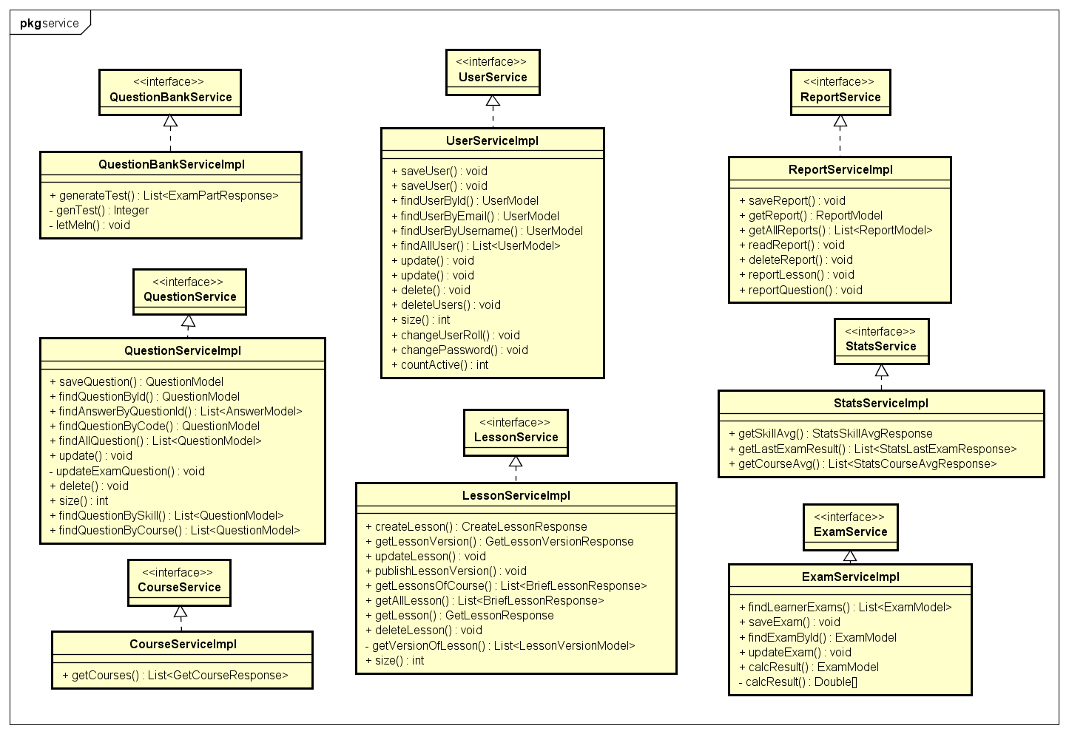

**Figure 9: Class diagram core.service package**

|  |  |  |
| --- | --- | --- |
| No | Class Name | Description |
| 1 | CourseServiceImpl | Contains business logical functions for processing course data |
| 2 | ExamServiceImpl | Contains business logical functions for processing test data |
| 3 | LessonServiceImpl | Contains business logical functions for processing lesson data |
| ~~4~~ | QuestionBankServiceImpl | Contains business logical functions for processing question bank data |
| 5 | QuestionServiceImpl | Contains business logical functions for processing question data |
| 6 | ReportServiceImpl | Contains business logical functions for processing report data |
| 7 | StatsServiceImpl | Contains business logical functions for processing statistic data |
| 8 | UserServiceImpl | Contains business logical functions for processing user data |

### CourseServiceImpl Class

#### Methods

|  |  |  |
| --- | --- | --- |
| No | Method | Description |
| 1 | getCourses() | Return list course |

### ExamServiceImpl Class

#### Methods

|  |  |  |
| --- | --- | --- |
| No | Method | Description |
| 1 | findLearnerExams() | Return all done exam of a user |
| 2 | saveExam() | Save an exam to database |
| 3 | findExamById() | Return an exam by its id |
| 4 | updateExam() | Update exam to database |
| 5 | calcResult() | Calculate exam result |

### LessonServiceImpl Class

#### Methods

|  |  |  |
| --- | --- | --- |
| No | Method | Description |
| 1 | createLesson() | Create new lesson |
| 2 | getLessonVersion() | Get a version of lesson |
| 3 | updateLesson() | Update a lesson |
| 4 | publishLessonVersion() | Make lesson as published version. Learner can see this lesson. |
| 5 | getLessonsOfCourse() | Return list lesson of a course. |
| 6 | getLesson() | Return a lesson. |
| 7 | deleteLesson() | Delete a lesson. |
| 8 | getAllLesson() | Return all lesson. |

### QuestionBankServiceImpl Class

#### Methods

|  |  |  |
| --- | --- | --- |
| No | Method | Description |
| 1 | generateExam() | Generates the exam response from the list of random questions |
| 2 | genExam() | Generates list of random questions |
| 3 | letMeIn() | Puts questions details to suitable list |

### QuestionServiceImpl Class

#### Methods

|  |  |  |
| --- | --- | --- |
| No | Method | Description |
| 1 | saveQuestion() | Save a question |
| 2 | findQuestionById() | Find a question by its id. |
| 3 | findAnswerByQuestionId() | Find all answer of a question by question id |
| 4 | findQuestionByCode() | Find a question by question code. |
| 5 | findAllQuestion() | Get all question. |
| 6 | update() | Update a question. |
| 7 | updateExamQuestion() | Update information of exam question what link to updated question. |
| 8 | delete() | Delete a question. |
| 9 | size() | Return the number of question in database. |
| 10 | findQuestionBySkill() | Find all question by a skill |
| 11 | findQuestionByCourse() | Find all question in a course |

### ReportServiceImpl Class

#### Methods

|  |  |  |
| --- | --- | --- |
| No | Method | Description |
| 1 | saveReport() | Save a report to database. |
| 2 | getReport() | Get a report. |
| 3 | getAllReports() | Get all report. |
| 4 | readReport() | Make a report as read state. |
| 5 | deleteReport() | Delete a report. |
| 6 | reportLesson() | User report a lesson. |
| 7 | reportQuestion() | User report a question |

### StatsServiceImpl Class

#### Methods

|  |  |  |
| --- | --- | --- |
| No | Method | Description |
| 1 | getSkillAvg() | Return average exam point for each skill of a user. |
| 2 | getLastExamResult() | Return last exam result of a user. |
| 3 | getCourseAvg() | Return average exam point for each course of a user. |

### UserServiceImpl Class

#### Methods

|  |  |  |
| --- | --- | --- |
| No | Method | Description |
| 1 | saveUser | Save new user. |
| 2 | findUserById | Find a user by id |
| 3 | findUserByEmail | Find a user by email |
| 4 | findUserByUsername | Find a user by user name |
| 5 | findAllUser | Get all user. |
| 6 | update | Update a user. |
| 7 | delete | Delete a user. |
| 9 | deleteUsers | Delete multiple user |
| 10 | size | Return the number of user in system. |
| 11 | changeUserRoll | Change user role |
| 12 | changePassword | Change user password |
| 13 | countActive | Return the number of active user |

## Screen Design

### Screen Flow

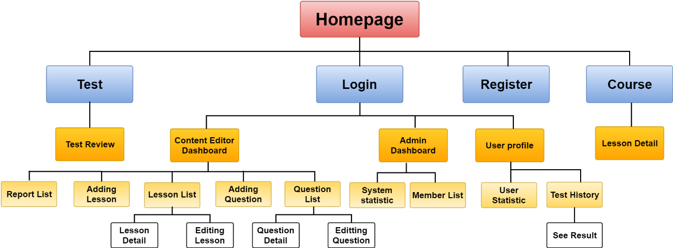

Figure 4-36: Screen Flow

|  |  |  |
| --- | --- | --- |
| No | Screen Name | Description |
| 1 | Homepage | Homepage |
| 2 | Login | Logging into Veazy system with a registered account |
| 3 | Register | Registering new account |
| 4 | Courses | Displaying list of courses and available lessons in each course |
| 5 | Lesson Detail | Displaying lesson content |
| 6 | Test | Setting up test |
| 7 | Test Review | Reviewing test |
| 8 | User Profile | Displaying detailed information of user |
| 9 | User Statistic | Displaying statistics of user |
| 10 | Test History | Displaying list of taken tests |
| 11 | See Result | Displaying content of taken test |
| 12 | Report List | Viewing list report |
| 13 | Lesson List (for content manager & content creator) | Displaying lesson list |
| 14 | Lesson Detail (for content manager & content creator) | Displaying lesson detail |
| 15 | Adding Lesson | Creating new lesson |
| 16 | Editing Lesson | Editing lesson content |
| 17 | Question List | Displaying list of questions intended to be generated in test |
| 18 | Question Detail | Displaying question content |
| 19 | Adding Question | Creating new question |
| 20 | Editing Question | Editing question content |
| 21 | System Statistic | Displaying system statistics |
| 22 | Member List | Displaying list of Veazy members |
| 23 | Test Hítory | Displaying list test history of member |

#### Guest

##### Homepage

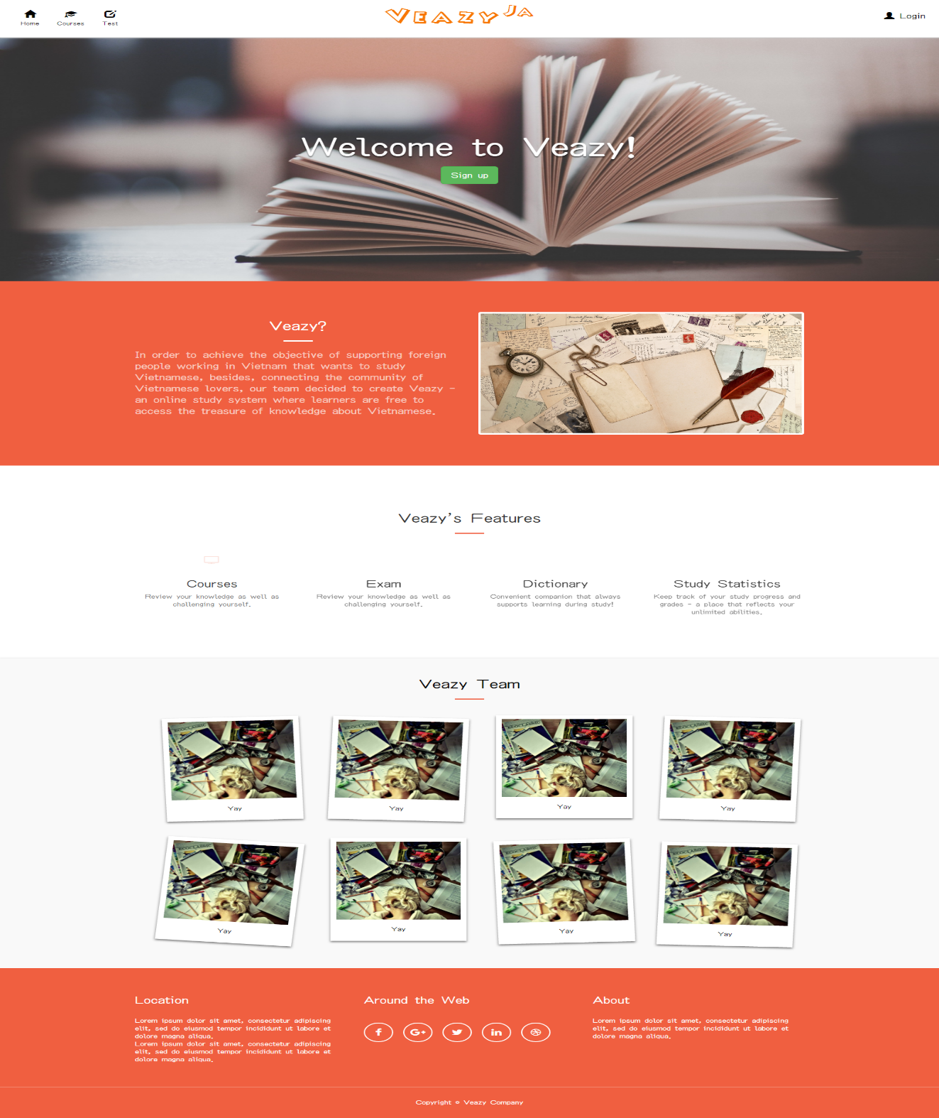

Figure 3. “Home” page

|  |  |  |  |  |  |
| --- | --- | --- | --- | --- | --- |
| **Field name** | **Type** | **Mandatory** | **Min**  **length** | **Max**  **length** | **Description** |
| Veazy | Hyperlink | N |  |  | Hyperlink that change language of website |
| Home | Hyperlink | N |  |  | Hyperlink that redirects to “Home” page |
| Courses | Select box | N |  |  | Select box that redirects to “Courses” page |
| Test | Hyperlink | N |  |  | Hyperlink that redirects to “Test” page |
| Dictionary | Hyperlink | N |  |  | Hyperlink that redirects to “Dictionary” page |
| Login | Hyperlink | N |  |  | Hyperlink that redirects to “Login” page |
| Sign Up | Hyperlink | N |  |  | Button for registering new account |

Table 2. Components of “Home” page

##### Login

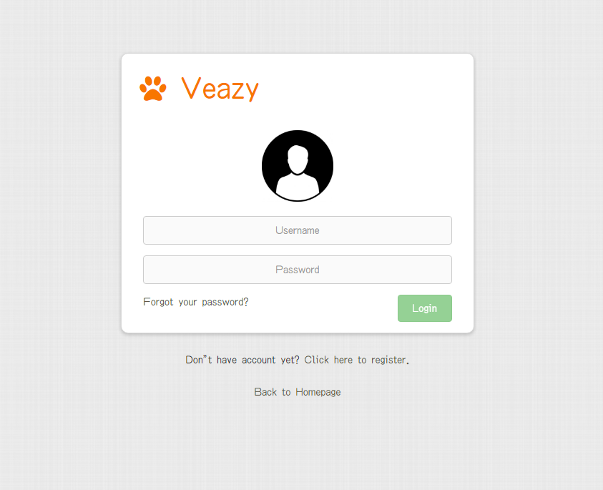

Figure 4. Login page

|  |  |  |  |  |  |
| --- | --- | --- | --- | --- | --- |
| **Field name** | **Type** | **Mandatory** | **Min**  **length** | **Max**  **length** | **Description** |
| Username | Textbox | Y | 6 | 30 | Textbox for entering username |
| Password | Textbox | Y | 6 | 32 | Textbox for entering password |
| Login | Button | Y |  |  | Button for submitting login form |
| Forgot your password? | Hyperlink | N |  |  | Hyperlink that redirects to “Password Recover” page |
| Click here to register. | Hyperlink | N |  |  | Hyperlink that redirects to “Register” page |
| Back to Home | Hyperlink | N |  |  | Hyperlink that redirects to “Home” page |

Table 3. Components of “Login” page

##### Register

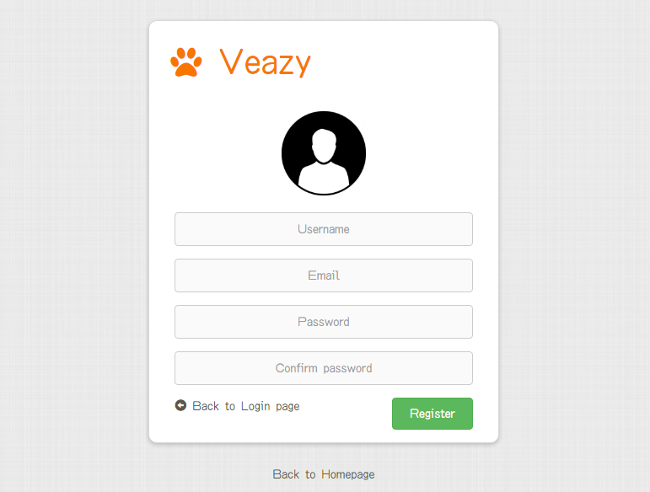

Figure 5. “Register” page

|  |  |  |  |  |  |
| --- | --- | --- | --- | --- | --- |
| **Field name** | **Type** | **Mandatory** | **Min**  **length** | **Max**  **length** | **Description** |
| Username | Textbox | Y | 8 | 30 | Textbox for entering username |
| Email | Textbox | Y | 6 | 254 | Textbox for entering email |
| Password | Textbox | Y | 8 | 32 | Textbox for entering password |
| Confirm Password | Textbox | Y | 8 | 32 | Textbox for re-entering password |
| Register | Button | Y |  |  | Button to submit register form |
| Back to Login page | Hyperlink | N |  |  | Hyperlink that redirects to “Login” page |
| Back to Homepage | Hyperlink | N |  |  | Hyperlink that redirects to “Home” page |

Table 4. Components of “Register” page

##### Courses

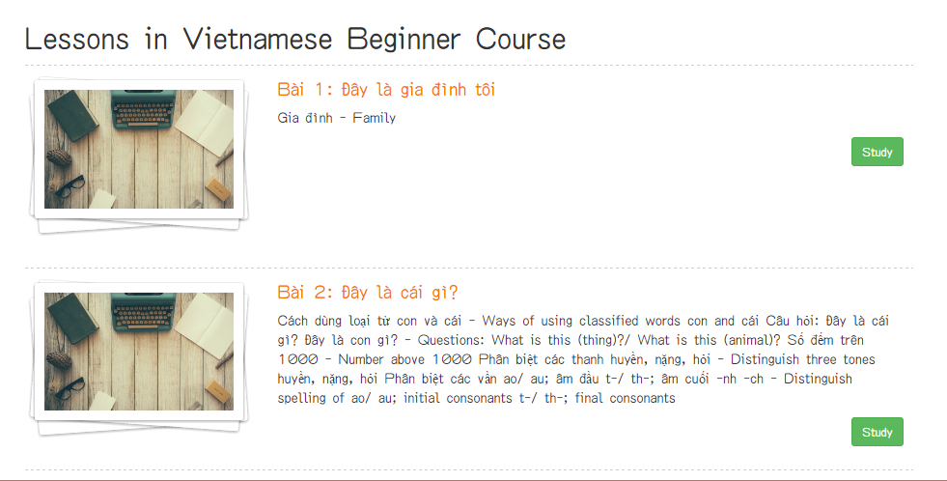

Figure 6. “Courses” page

|  |  |  |  |  |  |
| --- | --- | --- | --- | --- | --- |
| **Field name** | **Type** | **Mandatory** | **Min**  **length** | **Max**  **length** | **Description** |
| Study | Button | N |  |  | Button that redirects to “Lesson” page |

Table 5. Course page’s components

##### Lesson

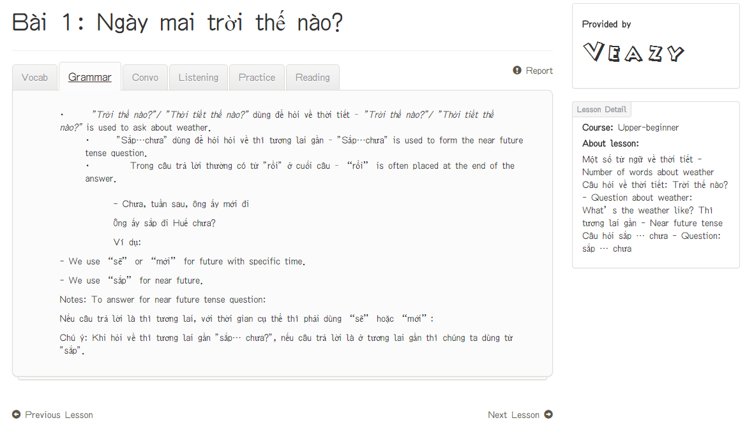

Figure 7. “Lesson Detail” page

|  |  |  |  |  |  |
| --- | --- | --- | --- | --- | --- |
| **Field name** | **Type** | **Mandatory** | **Min**  **length** | **Max**  **length** | **Description** |
| Vocab | Hyperlink | N |  |  | Hyperlink that displays content of Vocabulary section |
| Grammar | Hyperlink | N |  |  | Hyperlink that displays content of Grammar section |
| Convo | Hyperlink | N |  |  | Hyperlink that displays content of Conversation section |
| Listening | Hyperlink | N |  |  | Hyperlink that displays content of Listening section |
| Practice | Hyperlink | N |  |  | Hyperlink that displays content of Practice section |
| Reading | Hyperlink | N |  |  | Hyperlink that displays content of Reading section |
| Previous lesson | Hyperlink | N |  |  | Hyperlink that redirects to “Lesson” page which displays content of the previous lesson |
| Next lesson | Hyperlink | N |  |  | Hyperlink that redirects to “Lesson” page which displays content of the next lesson |
| Report | Hyperlink | N |  |  | Hyperlink to display lesson report dialog |

Table 6. Components of “Lesson” page

##### Test

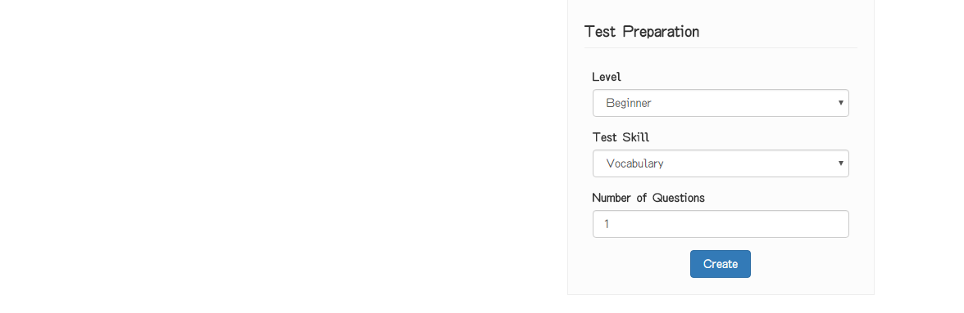

Figure 8. “Test” page

|  |  |  |  |  |  |
| --- | --- | --- | --- | --- | --- |
| **Field name** | **Type** | **Mandatory** | **Min**  **length** | **Max**  **length** | **Description** |
| Level | Select box | Y |  |  | Select box for selecting difficulty level of test |
| Test Skill | Select box | Y |  |  | Select box for selecting skill to be tested |
| Question Limit | Number | Y |  |  | Textbox for entering the number of questions |
| Create | Button | Y |  |  | Button for submitting test setup form and redirecting to “Take Test” page |

Table 7. Components of “Test” page

##### Taking Test

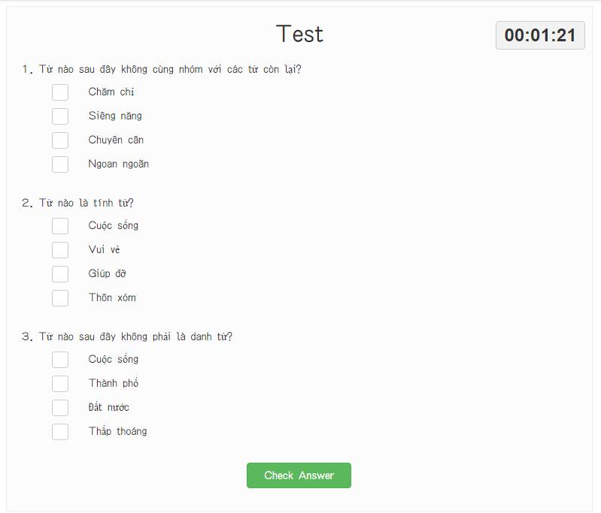

Figure 9. “Taking Test” page

|  |  |  |  |  |  |
| --- | --- | --- | --- | --- | --- |
| **Field name** | **Require** | **Mandatory** | **Min**  **length** | **Max**  **length** | **Description** |
| Answer | Click | Y |  |  | Radio button for choosing the correct answer |
| Check Answer | Click | Y |  |  | Button for submitting the test and redirecting to “Test Result” page |

Table 8. Components of “Taking Test” page

##### Test Result

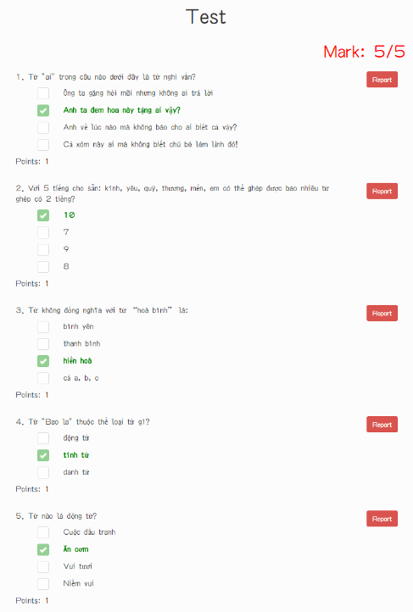

Figure 10. “Test Result” page

|  |  |  |  |  |  |
| --- | --- | --- | --- | --- | --- |
| **Field name** | **Type** | **Mandatory** | **Min**  **length** | **Max**  **length** | **Description** |
| Report | Button | Y |  |  | Button for submitting report about questions that user subjectively consider wrong content. |

Table 9. Components of “Test Result” page

#### Logged-in user

##### User Profile

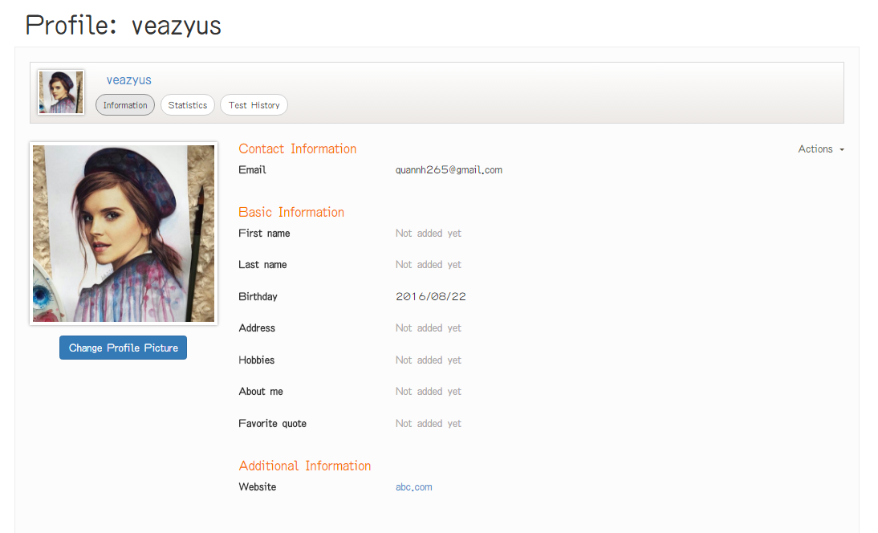

Figure 11. “User Profile” page

|  |  |  |  |  |  |
| --- | --- | --- | --- | --- | --- |
| **Field name** | **Type** | **Mandatory** | **Min**  **length** | **Max**  **length** | **Description** |
| Action | Dropdown | N |  |  | Dropdown that displays selectable options for user include editing information and changing current password |
| Information | Button | N |  |  | Button for displaying tab for viewing user information |
| Change Avatar Picture | Button | N |  |  | Button for displaying dialog for changing current avatar picture |
| Statistic | Button | N |  |  | Button for displaying tab for viewing user statistics |
| Test History | Button | N |  |  | Button for displaying tab for test history user statistics |

Table 10. Components of “User Profile” page

##### User Statistic

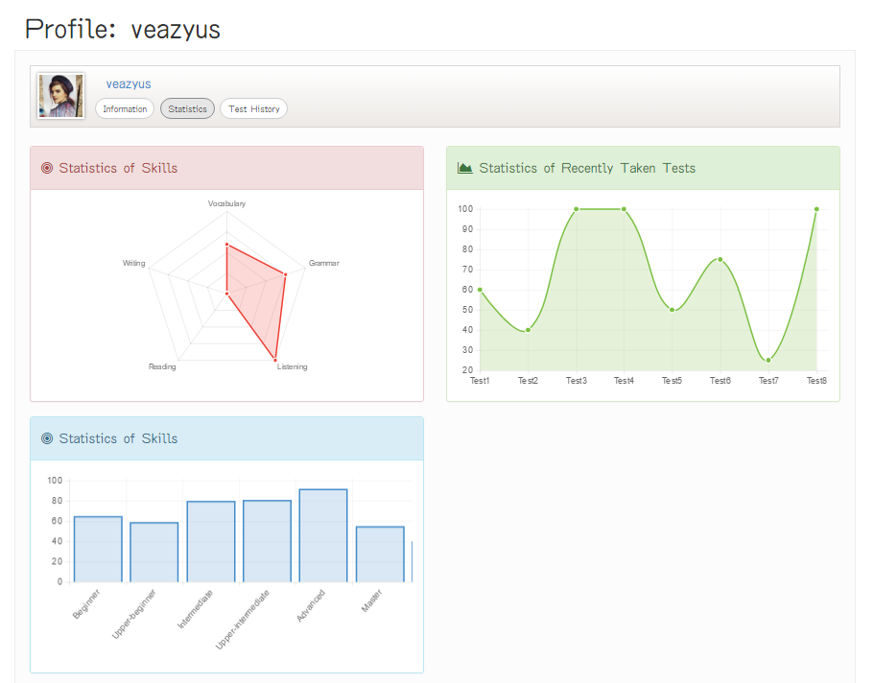

Figure 12. “User Statistic” page

|  |  |  |  |  |  |
| --- | --- | --- | --- | --- | --- |
| **Field name** | **Type** | **Mandatory** | **Min**  **length** | **Max**  **length** | **Description** |
| Information | Button | N |  |  | Button for displaying tab for viewing user information |
| Statistic | Button | N |  |  | Button for displaying tab for viewing user statistics |
| Test History | Button | N |  |  | Button for displaying tab for test history user statistics |

Table 11. Components of “User Statistic” page

##### Test History

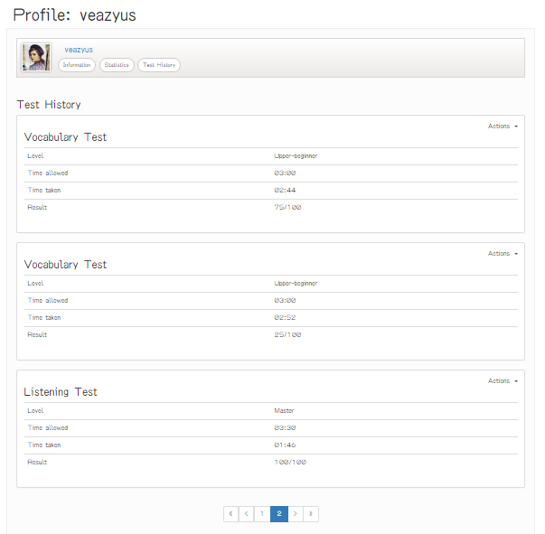

Figure 13. “Test History” page

|  |  |  |  |  |  |
| --- | --- | --- | --- | --- | --- |
| **Field name** | **Type** | **Mandatory** | **Min**  **length** | **Max**  **length** | **Description** |
| Information | Button | N |  |  | Button for displaying tab for viewing user information |
| Statistic | Button | N |  |  | Button for displaying tab for viewing user statistics |
| Test History | Button | N |  |  | Button for displaying tab for test history user statistics |
| Actions | Dropdown | N |  |  | Dropdown that displays selectable options for user include seeing result and retaking test |
| First | Button | N |  |  | Button for displaying the first 5 taken tests in table |
| Previous | Button | N |  |  | Button for navigating to 5 previous taken tests in table |
| Next | Button | N |  |  | Button for navigating to 5 next taken tests in table |
| Last | Button | N |  |  | Button for navigating to 5 last taken tests in table |

Table 12. Components of “Test History” page

##### See Result

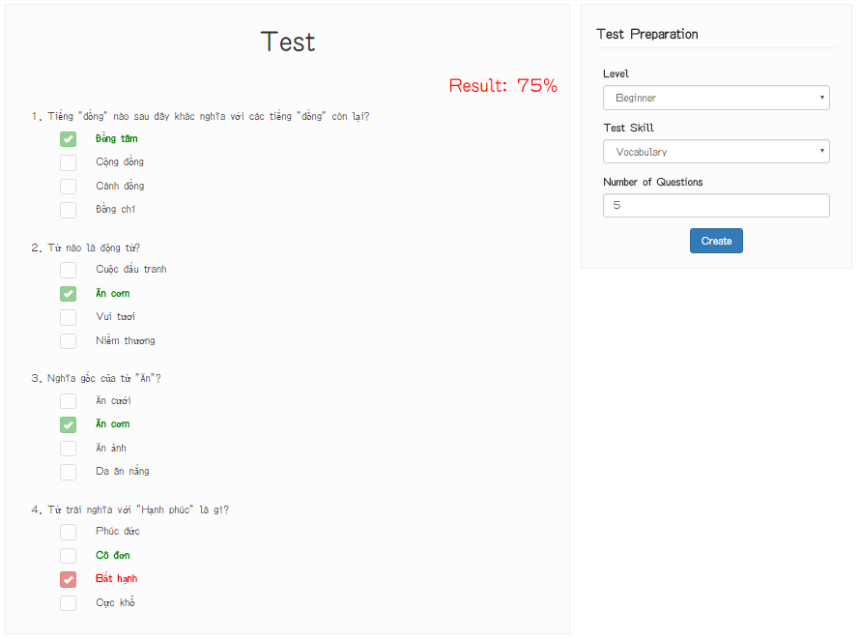

Figure 14. “See Result” page

|  |  |  |  |  |  |
| --- | --- | --- | --- | --- | --- |
| **Field name** | **Type** | **Mandatory** | **Min**  **length** | **Max**  **length** | **Description** |
| Level | Select box | Y |  |  | Select box for selecting difficulty level of test |
| Test Skill | Select box | Y |  |  | Select box for selecting skill to be tested |
| Question Limit | Number | Y |  |  | Textbox for entering the number of questions |
| Create | Button | Y |  |  | Button for submitting test setup form and redirecting to “Take Test” page |

Table 13. Components of “See Result” page

#### Content creator

##### Content Creator Dashboard

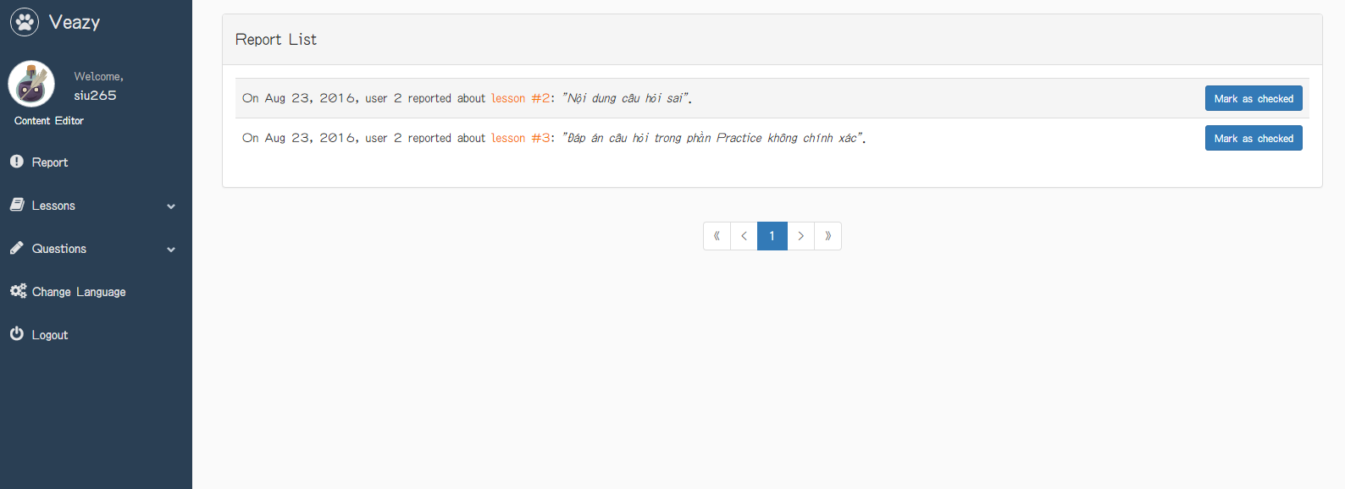

Figure 15. “Content Creator Dashboard” page

|  |  |  |  |  |  |
| --- | --- | --- | --- | --- | --- |
| **Field name** | **Type** | **Mandatory** | **Min**  **length** | **Max**  **length** | **Description** |
| Lessons | Hyperlink | N |  |  | Hyperlink that opens lesson management menu |
| Lesson List | Hyperlink | N |  |  | Hyperlink that redirects to “Lesson List” page |
| Add Lesson | Hyperlink | N |  |  | Hyperlink that redirects to “Adding Lesson” page |
| Question | Hyperlink | N |  |  | Hyperlink that opens question management menu |
| Question List | Hyperlink | N |  |  | Hyperlink that redirects to “Question List” page |
| Add Question | Hyperlink | N |  |  | Hyperlink that redirects to “Adding Question” page |
| Reports | Hyperlink | N |  |  | Hyperlink that redirects to “Report List” page |
| Logout | Hyperlink | N |  |  | Hyperlink that logs user out of Veazy system |
| First | Button | N |  |  | Button for displaying the first 5 reports in table |
| Previous | Button | N |  |  | Button for navigating to 5 previous reports in table |
| Next | Button | N |  |  | Button for navigating to 5 next reports in table |
| Last | Button | N |  |  | Button for navigating to 5 last taken tests in table |
| Mark as checked | Button | N |  |  | Button for marking checked report |
| Change Language | Hyperlink | N |  |  | Hyperlink that changes language of website |

Figure 14. Components of “Content Creator Dashboard”

##### Lesson List

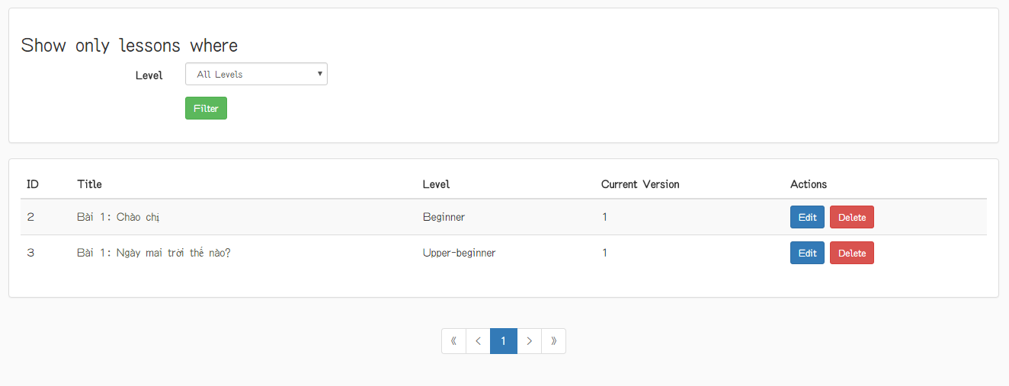

Figure 16. “Lesson List” page

|  |  |  |  |  |  |
| --- | --- | --- | --- | --- | --- |
| **Field name** | **Type** | **Mandatory** | **Min**  **length** | **Max**  **length** | **Description** |
| Lesson title | Hyperlink | N |  |  | Hyperlink that redirects to “Lesson Detail” page |
| Edit | Button | N |  |  | Hyperlink that redirects to “Editing Lesson” page |
| Delete | Button | N |  |  | Button for deleting corresponding lesson |
| First | Button | N |  |  | Button for displaying the first 5 lessons in table |
| Previous | Button | N |  |  | Button for navigating to 5 previous lessons in table |
| Next | Button | N |  |  | Button for navigating to 5 next lessons in table |
| Last | Button | N |  |  | Button for navigating to 5 last lessons in table |
| Level | Dropdown | N |  |  | Dropdown that displays selectable options for user selects level of lesson |
| Filter | Button | N |  |  | Button for filtering level of lesson |

Figure 15. Components of “Lesson List”

##### Lesson Detail

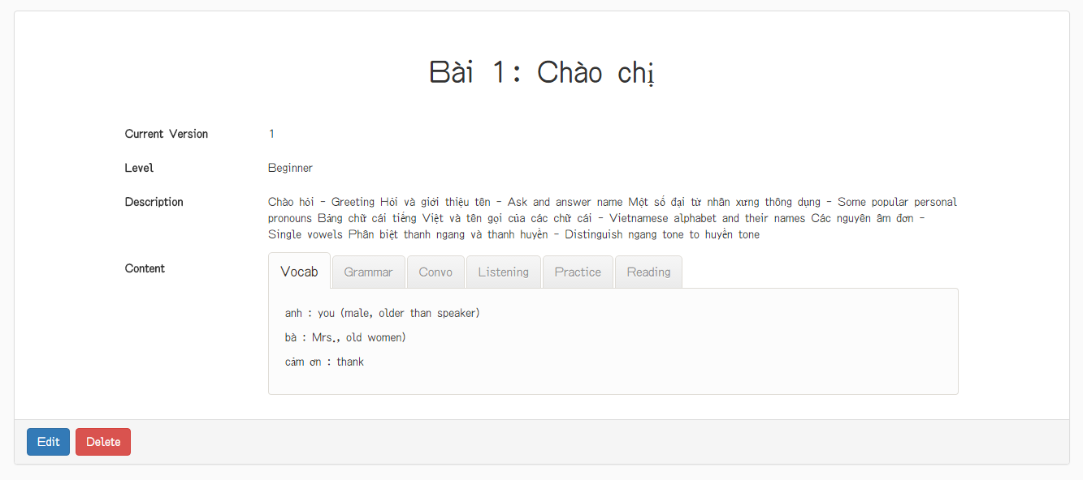

Figure 17. “Lesson List” page

|  |  |  |  |  |  |
| --- | --- | --- | --- | --- | --- |
| **Field name** | **Type** | **Mandatory** | **Min**  **length** | **Max**  **length** | **Description** |
| Vocab | Hyperlink | N |  |  | Hyperlink that displays content of Vocabulary section |
| Grammar | Hyperlink | N |  |  | Hyperlink that displays content of Grammar section |
| Convo | Hyperlink | N |  |  | Hyperlink that displays content of Conversation section |
| Listening | Hyperlink | N |  |  | Hyperlink that displays content of Listening section |
| Practice | Hyperlink | N |  |  | Hyperlink that displays content of Practice section |
| Reading | Hyperlink | N |  |  | Hyperlink that displays content of Reading section |
| Edit | Button | N |  |  | Hyperlink that redirects to “Editing Lesson” page |
| Delete | Button | N |  |  | Button for deleting corresponding lesson |

Figure 16. Components of “Lesson Detail”

##### Adding Lesson

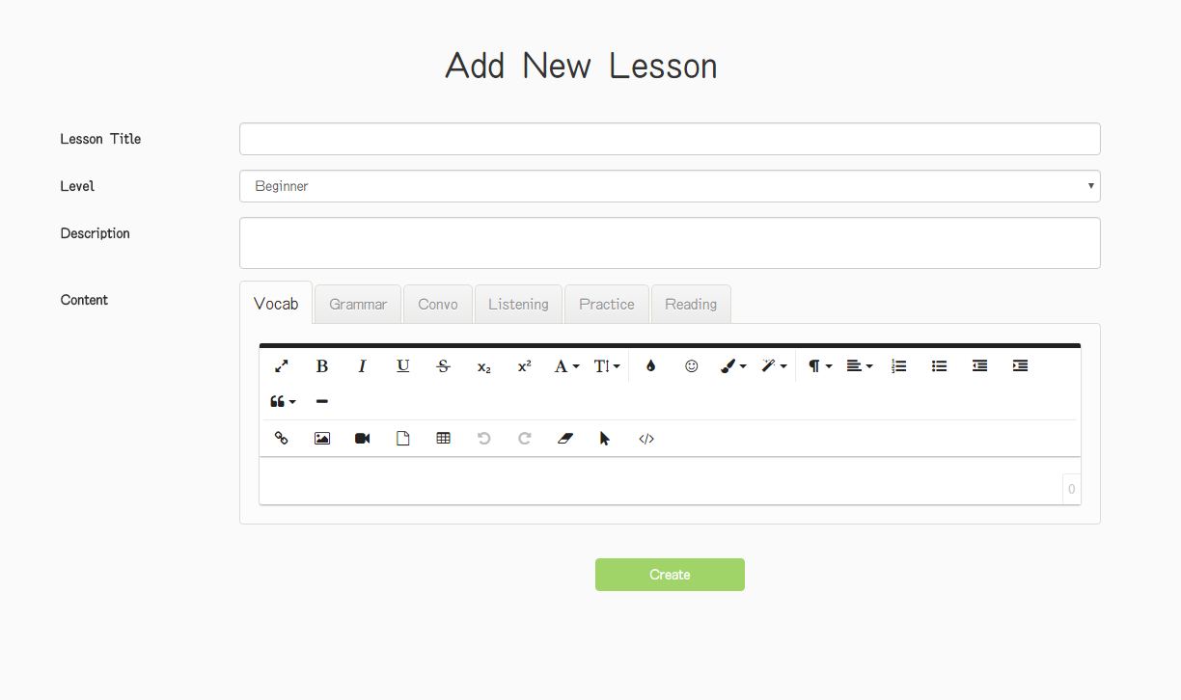

Figure 18. “Adding Lesson” page

|  |  |  |  |  |  |
| --- | --- | --- | --- | --- | --- |
| **Field name** | **Type** | **Mandatory** | **Min**  **length** | **Max**  **length** | **Description** |
| Lesson Title | Text | Y | 0 |  | Textbox for entering lesson title |
| Level | Select box | Y |  |  | Select box for choosing difficulty level of lesson |
| Description | Text area | Y |  |  | Text area for entering lesson description |
| Vocab | Hyperlink | Y |  |  | Hyperlink that displays editor of Vocabulary section |
| Text area | Y |  |  | Text area for entering content of Vocabulary section |
| Grammar | Hyperlink | Y |  |  | Hyperlink that displays editor of Grammar section |
| Text area | Y |  |  | Text area for entering content of Grammar section |
| Convo | Hyperlink | Y |  |  | Hyperlink that displays editor of Conversation section |
| Text area | Y |  |  | Text area for entering content of Conversation section |
| Listening | Hyperlink | Y |  |  | Hyperlink that displays editor of Listening section |
| Text area | Y |  |  | Text area for entering content of Listening section |
| Practice | Hyperlink | Y |  |  | Hyperlink that displays editor of Practice section |
| Text area | Y |  |  | Text area for entering content of Practice section |
| Reading | Hyperlink | Y |  |  | Hyperlink that displays editor of Reading section |
| Text area | Y |  |  | Text area for entering content of Reading section |
| Create | Button | Y |  |  | Button for submitting new lesson |

Table 17. Components of “Adding Lesson” page

##### Editing Lesson

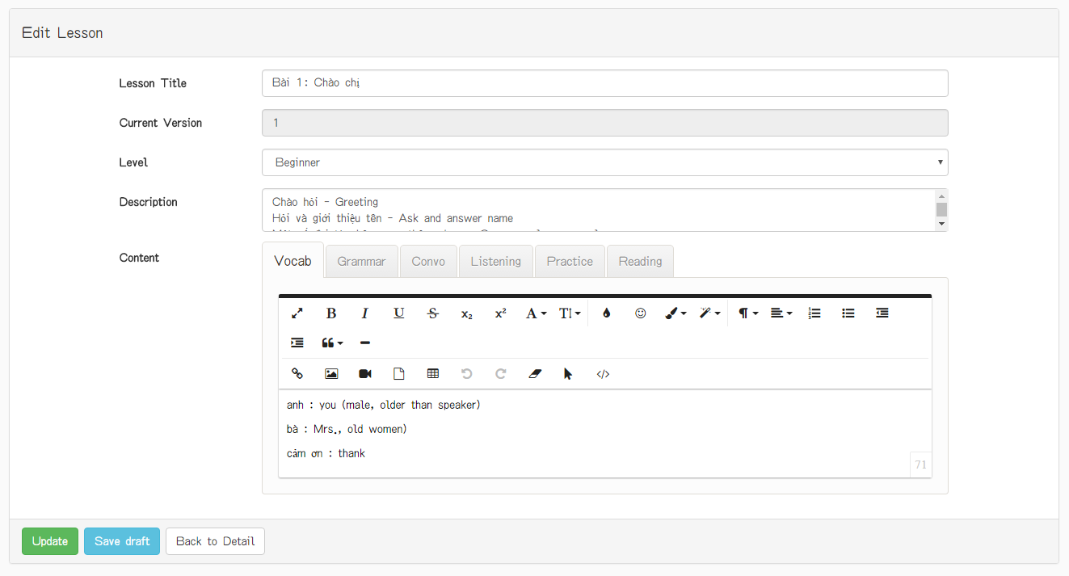

Figure 19. “Editing Lesson” page

|  |  |  |  |  |  |
| --- | --- | --- | --- | --- | --- |
| **Field name** | **Type** | **Mandatory** | **Min**  **length** | **Max**  **length** | **Description** |
| Lesson Title | Text | Y |  |  | Textbox for entering lesson title |
| Level | Select box | Y |  |  | Select box for choosing difficulty level of lesson |
| Description | Text area | Y |  |  | Text area for entering lesson description |
| Vocab | Hyperlink | Y |  |  | Hyperlink that displays editor of Vocabulary section |
| Text area | Y |  |  | Text area for entering content of Vocabulary section |
| Grammar | Hyperlink | Y |  |  | Hyperlink that displays editor of Grammar section |
| Text area | Y |  |  | Text area for entering content of Grammar section |
| Convo | Hyperlink | Y |  |  | Hyperlink that displays editor of Conversation section |
| Text area | Y |  |  | Text area for entering content of Conversation section |
| Listening | Hyperlink | Y |  |  | Hyperlink that displays editor of Listening section |
| Text area | Y |  |  | Text area for entering content of Listening section |
| Practice | Hyperlink | Y |  |  | Hyperlink that displays editor of Practice section |
| Text area | Y |  |  | Text area for entering content of Practice section |
| Reading | Hyperlink | Y |  |  | Hyperlink that displays editor of Reading section |
| Text area | Y |  |  | Text area for entering content of Reading section |
| Create | Button | Y |  |  | Button for submitting new lesson |
| Save Draft | Button | Y |  |  | Button for saving lesson |
| Back to Detail | Button | Y |  |  | Button for backing to detail of lesson page |

Table 18. Components of “Editting Lesson” page

##### Question List

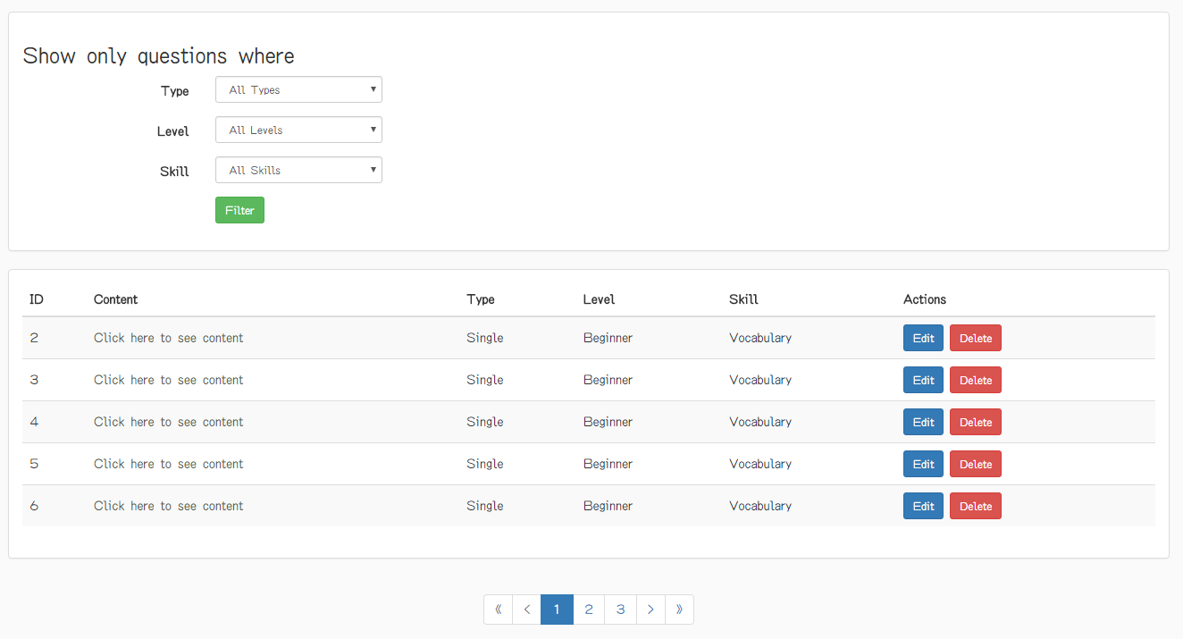

Figure 20. “Question List” page

|  |  |  |  |  |  |
| --- | --- | --- | --- | --- | --- |
| **Field name** | **Type** | **Mandatory** | **Min**  **length** | **Max**  **length** | **Description** |
| Click here to see content | Hyperlink | N |  |  | Hyperlink that redirects to “Question Detail” page |
| Edit | Button | N |  |  | Hyperlink that redirects to “Editing Question” page |
| Delete | Button | N |  |  | Button for deleting corresponding question |
| First | Button | N |  |  | Button for displaying the first 5 questions in table |
| Previous | Button | N |  |  | Button for navigating to 5 previous questions in table |
| Next | Button | N |  |  | Button for navigating to 5 next records in table |
| Last | Button | N |  |  | Button for navigating to 5 last questions in table |
| Type | Dropdown | N |  |  | Dropdown that displays selectable options for user selects type of question |
| Level | Dropdown | N |  |  | Dropdown that displays selectable options for user selects level of question |
| Skill | Dropdown | N |  |  | Dropdown that displays selectable options for user selects skill of question |
| Filter | Button | N |  |  | Button for filtering question |

Table 19. Components of “Question List page

##### Question Detail

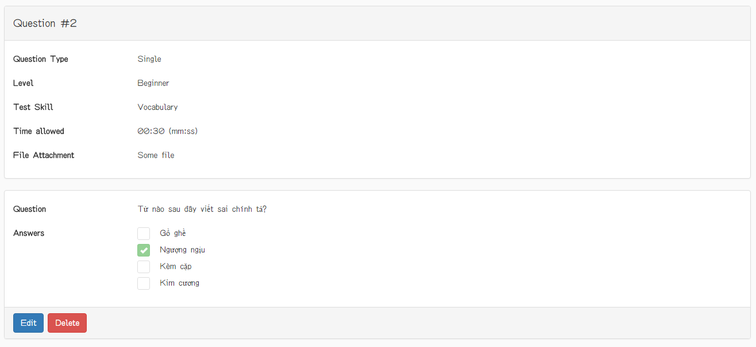

Figure 21. “Question Detail” page (single question)

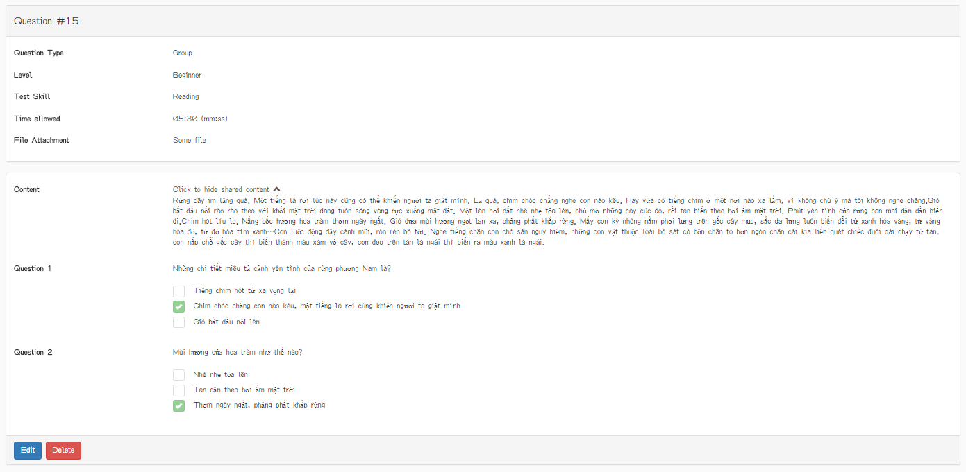

Figure 22. “Question Detail” page (group question)

|  |  |  |  |  |  |
| --- | --- | --- | --- | --- | --- |
| **Field name** | **Type** | **Mandatory** | **Min**  **length** | **Max**  **length** | **Description** |
| Click to show shared content | Hyperlink |  |  |  | Hyperlink that displays shared content of group question |
| Edit | Button | N |  |  | Button that redirects to “Editing Question” page |
| Delete | Button | N |  |  | Button for deleting question |

Table 20. Components of “Question Detail” page

##### Adding Question

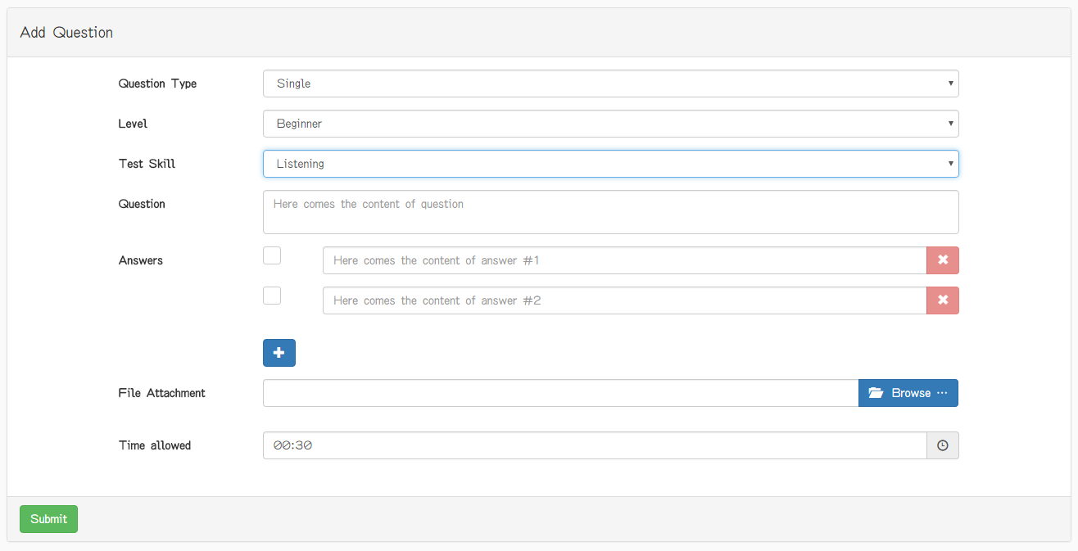

Figure 23. “Adding Question” page (single question)

|  |  |  |  |  |  |
| --- | --- | --- | --- | --- | --- |
| **Field name** | **Type** | **Mandatory** | **Min**  **length** | **Max**  **length** | **Description** |
| Question type | Select box | Y |  |  | Select box for choosing type of question |
| Level | Select box | Y |  |  | Select box for choosing difficulty level of question |
| Test Skill | Select box | Y |  |  | Select box for choosing skill to be tested of question |
| Question | Text | Y |  |  | Textbox for entering question |
| Check box | Check box | Y |  |  | Checkbox for marking which answer is true |
| Answer | Text | Y |  |  | Textbox for entering answer content |
| X | Button | N |  |  | Button for removing an answer |
| + | Button | N |  |  | Button for adding one more answer to the question |
| Browser | File | N |  |  | Button for display dialog of selection audio |
| Submit | Button | Y |  |  | Button for submitting new question |
| Time Allowed | Textbox | N |  |  | Textbox for displaying time of question |
| Clock | Icon | N |  |  | Textbox for setting time of question |

Table 21. Components of “Adding Question” page (single question)

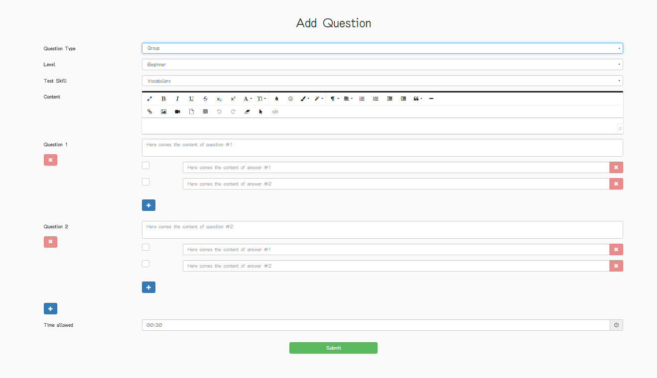

Figure 24. “Adding Question” page (group question)

|  |  |  |  |  |  |
| --- | --- | --- | --- | --- | --- |
| **Field name** | **Type** | **Mandatory** | **Min**  **length** | **Max**  **length** | **Description** |
| Question type | Select box | Y |  |  | Select box for choosing type of question |
| Level | Select box | Y |  |  | Select box for choosing difficulty level of question |
| Test Skill | Select box | Y |  |  | Select box for choosing skill to be tested of question |
| Content | Text area | Y |  |  | Text area for entering shared content of group question |
| Question | Textbox | Y |  |  | Textbox for entering content of question in group |
| X | Button | N |  |  | Button for removing question in group |
| Check box | Check box | Y |  |  | Checkbox that marks the correct answer in question |
| Answer | Textbox | Y |  |  | Textbox for entering content of answer |
| X | Button | Y |  |  | Button for removing answer in question |
| + | Button | N |  |  | Button for adding one more answer |
| + | Button | N |  |  | Button for adding one more question |
| Submit | Button | Y |  |  | Button for submitting new question |
| Time Allowed | Textbox | Y |  |  | Textbox for setting time of question |

Table 22. Components of “Adding Question” page (group question)

##### Editing Question

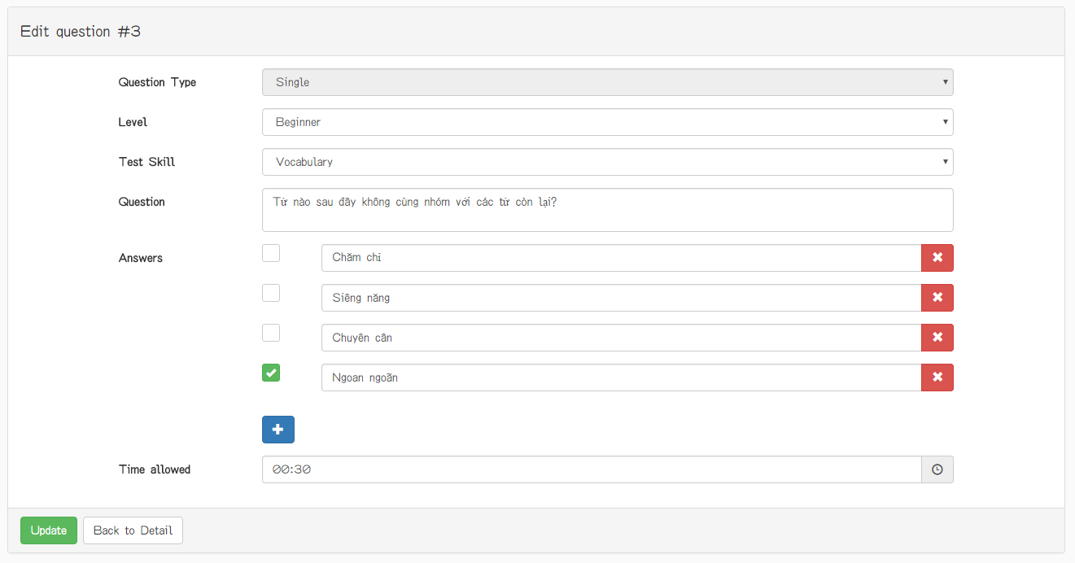

Figure 25. “Editing Question” page (single question) (1)

|  |  |  |  |  |  |
| --- | --- | --- | --- | --- | --- |
| **Field name** | **Type** | **Mandatory** | **Min**  **length** | **Max**  **length** | **Description** |
| Question type | Select box | Y |  |  | Select box for choosing type of question |
| Level | Select box | Y |  |  | Select box for choosing difficulty level of question |
| Test Skill | Select box | Y |  |  | Select box for choosing skill to be tested of question |
| Question | Textbox | Y |  |  | Textbox for entering content of question in group |
| Check box | Check box | Y |  |  | Checkbox that marks the correct answer in question |
| Answer | Textbox | Y |  |  | Textbox for entering content of answer |
| + | Button | N |  |  | Button for adding more selectable answers of the question |
| X | Button | N |  |  | Button for deleting answer of question |
| Submit | Button | Y |  |  | Button for submiting the question content |
| Back to Detail | Button | Y |  |  | Button for backing to Question Detail page |
| Time Allowed | Textbox | N |  |  | Textbox for displaying time of question |
| Clock | Icon | N |  |  | Textbox for setting time of question |

Table 23. Components of “Editing Question” page (single question) (1)

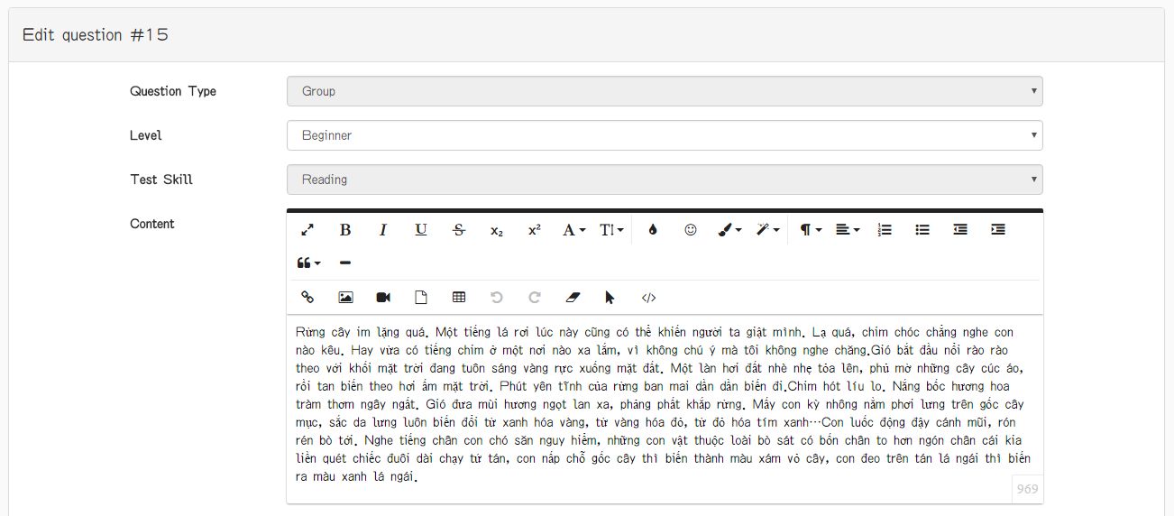

Figure 26. “Editing Question” page (group question) (2)

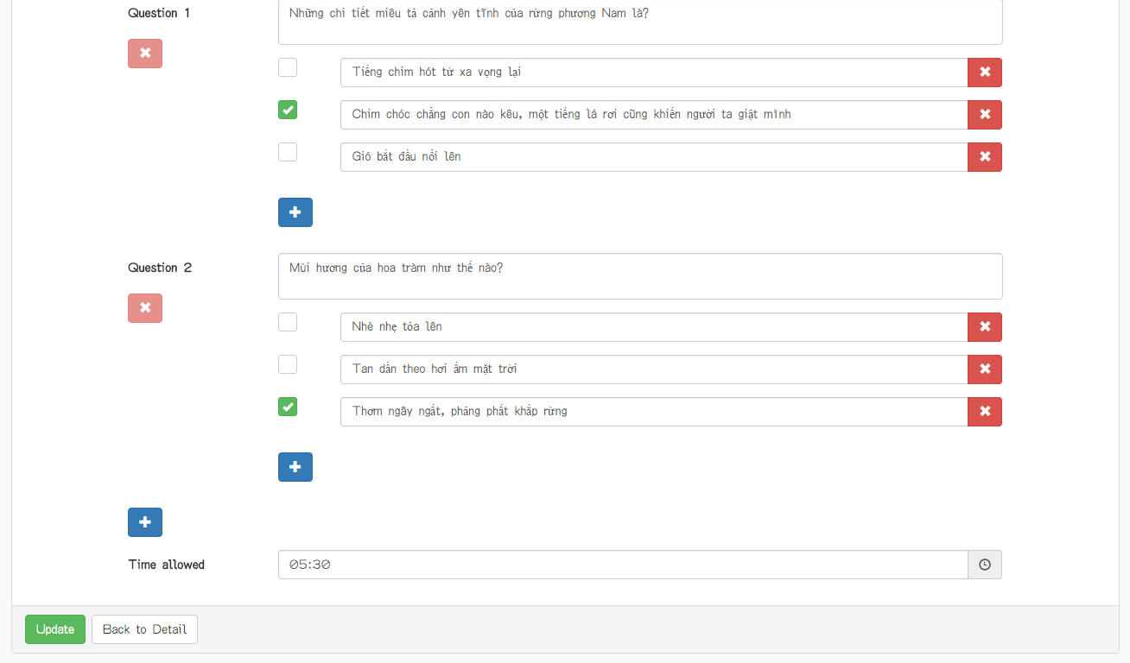

Figure 27. “Editing Question” page (group question) (3)

|  |  |  |  |  |  |
| --- | --- | --- | --- | --- | --- |
| **Field name** | **Type** | **Mandatory** | **Min**  **length** | **Max**  **length** | **Description** |
| Question type | Select box | Y |  |  | Select box for choosing type of question |
| Level | Select box | Y |  |  | Select box for choosing difficulty level of question |
| Test Skill | Select box | Y |  |  | Select box for choosing skill to be tested of question |
| Content | Text | Y |  |  | Textarea for entering the shared content used by all questions |
| Question | Text | Y |  |  | Textarea for entering content of a single question in group |
| X | Button | N |  |  | Button for deleting the corresponding question in group |
| Check box | Check box | Y |  |  | Checkbox that marks the correct answer in question |
| Answer | Text | Y |  |  | Textbox for entering content of answer |
| X | Button | Y |  |  | Button for deleting the corresponding answer |
| + | Button | N |  |  | Button for adding more question to the group |
| + | Button | N |  |  | Button for adding more answer to the question |
| Submit | Button | Y |  |  | Button for submitting the group question |
| Back to Detail | Button | Y |  |  | Button for backing to Question Detail page |
| Time Allowed | Textbox | N |  |  | Textbox for displaying time of question |
| Clock | Icon | N |  |  | Textbox for setting time of question |

Table 24. Components of “Editing Question” page (group question)(2)

#### Admin

##### Admin Dashboard

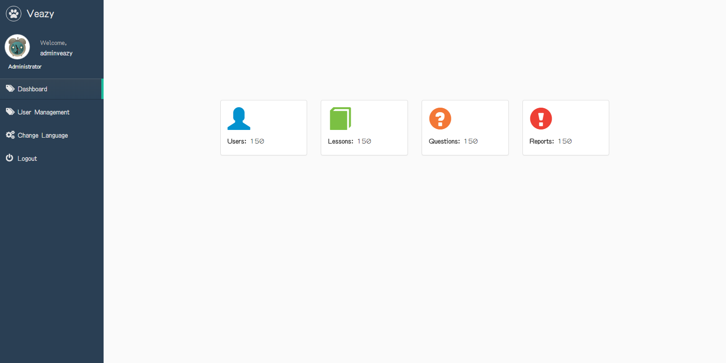

Figure 28. “Admin Dashboard” page

|  |  |  |  |  |  |
| --- | --- | --- | --- | --- | --- |
| **Field name** | **Type** | **Mandatory** | **Min**  **length** | **Max**  **length** | **Description** |
| Dashboard | Hyperlink | N |  |  | Hyperlink that redirects to “Admin Dashboard” page |
| User Management | Hyperlink | N |  |  | Hyperlink that redirects to “User management” page |
| Change Language | Hyperlink | N |  |  | Hyperlink that changes language of website |
| Logout | Hyperlink | N |  |  | Hyperlink that logs user out of Veazy system |

Table 25. Components of “Admin Dashboard” page

##### Member List

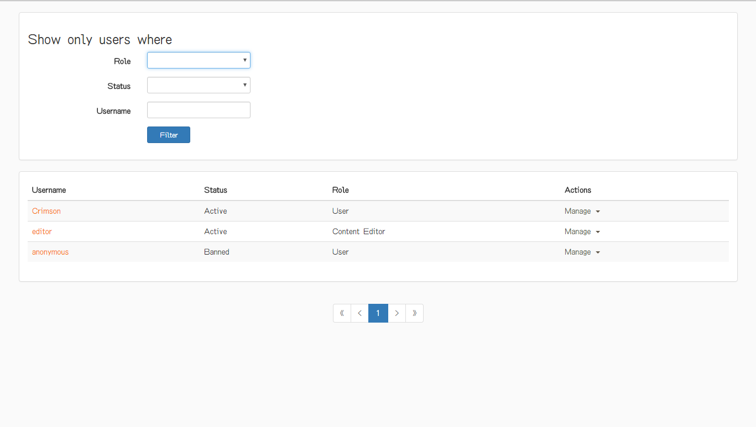

Figure 29. “Member List” page

|  |  |  |  |  |  |
| --- | --- | --- | --- | --- | --- |
| **Field name** | **Type** | **Mandatory** | **Min**  **length** | **Max**  **length** | **Description** |
| Role | Dropdown | N |  |  | Dropdown that displays selectable options for user to selects role of member |
| Status | Dropdown | N |  |  | Dropdown that displays selectable options for user to selects status of member |
| Username | Textbox | N |  |  | Textbox for entering username of member |
| Filter | Button | N |  |  | Button for filtering member by role, status or username |
| Username | Hyperlink | N |  |  | Hyperlink that shows “Member Information Detail” popup |
| Manage | Dropdown | N |  |  | Dropdown that displays selectable options for user include bans member, assigns as editor and assigns as admin |
| First | Button | N |  |  | Button for displaying the first 5 members in table |
| Previous | Button | N |  |  | Button for navigating to 5 previous members in table |
| Next | Button | N |  |  | Button for navigating to 5 next members in table |
| Last | Button | N |  |  | Button for navigating to 5 last members in table |

Table 26. Components of “Member List” page

## Database design

### Table diagram



Figure 4-66: Table diagram

n

**List of tables and brief description**

|  |  |  |
| --- | --- | --- |
| **No** | **Table Name** | **Description** |
|  | Course | Store course information |
|  | Exam | Store all exam of user. |
|  | Lesson | Store lesson information |
|  | LessonVersion | Store the version of lesson |
|  | Report | Store user report |
|  | User | Store user information |
|  | Answer | Store question answer |
|  | ExamAnswer | Store answer of a question in exam |
|  | ExamQuestion | Store question of an exam |
|  | Question | Store question information |

### Course table

|  |  |  |  |  |  |  |  |  |
| --- | --- | --- | --- | --- | --- | --- | --- | --- |
| No | Field Name | Type | Max  Length | Null | Unique | P/F Key | Default | Description |
| 1 | id | integer |  | NOT |  | P |  |  |
| 2 | des | character | 255 |  |  |  |  | description |
| 3 | name | character | 50 | NOT | U |  |  |  |

### Exam table

|  |  |  |  |  |  |  |  |
| --- | --- | --- | --- | --- | --- | --- | --- |
| No | Field Name | Type | Null | Unique | P/F Key | Default | Description |
| 1 | id | serial | NOT |  | P |  |  |
| 2 | createdate | bigint |  |  |  |  |  |
| 3 | deletedate | bigint |  |  |  |  |  |
| 4 | deleteflag | bool | NOT |  |  | FALSE |  |
| 5 | updatedate | bigint |  |  |  |  |  |
| 6 | courseid | integer | NOT |  |  |  |  |
| 7 | etatime | integer | NOT |  |  | 0 | estimate time |
| 8 | finishstate | bool | NOT |  |  |  |  |
| 9 | questionskill | integer |  |  |  |  |  |
| 10 | result | real | NOT |  |  | 0.0 |  |
| 11 | takentime | integer | NOT |  |  | 0 |  |
| 12 | userid | integer | NOT |  |  |  |  |

### Lesson table

|  |  |  |  |  |  |  |  |
| --- | --- | --- | --- | --- | --- | --- | --- |
| No | Field Name | Type | Null | Unique | P/F Key | Default | Description |
| 1 | id | serial | NOT |  | P |  |  |
| 2 | createdate | bigint |  |  |  |  |  |
| 3 | deletedate | bigint |  |  |  |  |  |
| 4 | deleteflag | bool | NOT |  |  | FALSE |  |
| 5 | updatedate | bigint |  |  |  |  |  |
| 6 | courseid | integer | NOT |  |  |  |  |
| 7 | versionid | integer |  |  |  |  |  |
| 8 | index | serial | NOT |  |  |  |  |

### LessonVersion table

|  |  |  |  |  |  |  |  |  |
| --- | --- | --- | --- | --- | --- | --- | --- | --- |
| No | Field Name | Type | Max  Length | Null | Unique | P/F Key | Default | Description |
| 1 | id | serial |  | NOT |  | P |  |  |
| 2 | article | text |  |  |  |  |  |  |
| 3 | createdate | bigint |  |  |  |  |  |  |
| 4 | creatorid | integer |  | NOT |  |  | FALSE |  |
| 5 | description | text |  | NOT |  |  |  |  |
| 6 | grammar | text |  |  |  |  |  |  |
| 7 | lessonid | integer |  | NOT |  |  |  |  |
| 8 | listening | text |  |  |  |  |  |  |
| 9 | practice | text |  |  |  |  |  |  |
| 10 | reading | text |  |  |  |  |  |  |
| 11 | state | integer |  | NOT |  |  | 1 |  |
| 12 | title | varchar | 254 | NOT |  |  |  |  |
| 13 | updatedate | bigint |  |  |  |  |  |  |
| 14 | version | integer |  | NOT |  |  | 1 |  |
| 15 | vocab | text |  |  |  |  |  |  |

### Report table

|  |  |  |  |  |  |  |  |
| --- | --- | --- | --- | --- | --- | --- | --- |
| No | Field Name | Type | Null | Unique | P/F Key | Default | Description |
| 1 | id | serial | NOT |  | P |  |  |
| 2 | createdate | bigint |  |  |  |  |  |
| 3 | deletedate | bigint |  |  |  |  |  |
| 4 | deleteflag | bool | NOT |  |  | FALSE |  |
| 5 | updatedate | bigint |  |  |  |  |  |
| 6 | lessonid | integer |  |  |  |  |  |
| 7 | questionid | integer |  |  |  |  |  |
| 8 | isread | bool | NOT |  |  | FALSE |  |
| 9 | receiverid | integer |  |  |  |  |  |
| 10 | senderid | integer |  |  |  |  |  |

### User table

|  |  |  |  |  |  |  |  |  |
| --- | --- | --- | --- | --- | --- | --- | --- | --- |
| No | Field Name | Type | Max  Length | Null | Unique | P/F Key | Default | Description |
| 1 | id | serial |  | NOT |  | P |  | Auto increase |
| 2 | createdate | bigint |  |  |  |  |  |  |
| 3 | deletedate | bigint |  |  |  |  |  |  |
| 4 | deleteflag | bool |  | NOT |  |  | FALSE |  |
| 5 | updatedate | bigint |  |  |  |  |  |  |
| 6 | address | varchar | 255 |  |  |  |  |  |
| 7 | bio | varchar | 255 |  |  |  |  | biographic |
| 8 | dob | bigint |  |  |  |  |  | date of birth |
| 9 | email | varchar | 254 | NOT | U |  |  |  |
| 10 | password | char(32) |  | NOT |  |  |  |  |
| 11 | firstname | varchar | 30 |  |  |  |  |  |
| 12 | hobby | varchar | 255 |  |  |  |  |  |
| 13 | isbanned | bool |  | NOT |  |  | FALSE |  |
| 14 | joindate | bigint |  | NOT |  |  |  |  |
| 15 | lastname | varchar | 30 |  |  |  |  |  |
| 16 | quote | varchar | 255 |  |  |  |  |  |
| 17 | role | integer |  | NOT |  |  | 3 |  |
| 18 | username | varchar | 30 |  | U |  |  |  |
| 19 | website | varchar | 255 |  |  |  |  |  |

### Answer table

|  |  |  |  |  |  |  |  |  |
| --- | --- | --- | --- | --- | --- | --- | --- | --- |
| No | Field Name | Type | Max Length | Null | Unique | P/F Key | Default | Description |
| 1 | id | serial |  | NOT |  | P |  | Auto increase |
| 2 | createdate | bigint |  |  |  |  |  |  |
| 3 | deletedate | bigint |  |  |  |  |  |  |
| 4 | deleteflag | bool |  | NOT |  |  | FALSE |  |
| 5 | updatedate | bigint |  |  |  |  |  |  |
| 6 | answer | varchar | 255 | NOT |  |  |  |  |
| 7 | isright | bool |  | NOT |  |  | FALSE |  |
| 8 | questionmodel_id | integer |  | NOT |  | F |  |  |

### ExamAnswer table

|  |  |  |  |  |  |  |  |  |
| --- | --- | --- | --- | --- | --- | --- | --- | --- |
| No | Field Name | Type | Max Length | Null | Unique | P/F Key | Default | Description |
| 1 | id | serial |  | NOT |  | P |  | Auto increase |
| 2 | createdate | bigint |  |  |  |  |  |  |
| 3 | deletedate | bigint |  |  |  |  |  |  |
| 4 | deleteflag | bool |  | NOT |  |  | FALSE |  |
| 5 | updatedate | bigint |  |  |  |  |  |  |
| 6 | answer | varchar | 255 | NOT |  |  |  |  |
| 7 | isright | bool |  | NOT |  |  | FALSE |  |
| 8 | isselected | bool |  | NOT |  |  | FALSE |  |
| 9 | examquestionmodel_id | integer |  |  |  | F |  |  |

### ExamQuestion table

|  |  |  |  |  |  |  |  |  |
| --- | --- | --- | --- | --- | --- | --- | --- | --- |
| No | Field Name | Type | Max Length | Null | Unique | P/F Key | Default | Description |
| 1 | id | serial |  | NOT |  | P |  | Auto increase |
| 2 | createdate | bigint |  |  |  |  |  |  |
| 3 | deletedate | bigint |  |  |  |  |  |  |
| 4 | deleteflag | bool |  | NOT |  |  | FALSE |  |
| 5 | updatedate | bigint |  |  |  |  |  |  |
| 6 | attachment | varchar | 255 |  |  |  |  |  |
| 7 | ischanged | bool |  |  |  |  |  |  |
| 8 | numberofquestion | integer |  | NOT |  |  | 1 |  |
| 9 | question | text |  | NOT |  |  |  |  |
| 10 | questionanswertype | integer |  | NOT |  |  | 1 |  |
| 11 | questionid | integer |  | NOT |  |  |  |  |
| 12 | questiontype | integer |  | NOT |  |  | 1 |  |
| 13 | exammodel_id | integer |  |  |  | F |  |  |
| 14 | parentquestion_id | integer |  |  |  | F |  |  |

### Question table

|  |  |  |  |  |  |  |  |  |
| --- | --- | --- | --- | --- | --- | --- | --- | --- |
| No | Field Name | Type | Max Length | Null | Unique | P/F Key | Default | Description |
| 1 | id | serial |  | NOT |  | P |  | Auto increase |
| 2 | createdate | bigint |  |  |  |  |  |  |
| 3 | deletedate | bigint |  |  |  |  |  |  |
| 4 | deleteflag | bool |  | NOT |  |  | FALSE |  |
| 5 | updatedate | bigint |  |  |  |  |  |  |
| 6 | attachment | varchar | 255 |  |  |  |  |  |
| 7 | courseid | integer |  | NOT |  |  |  |  |
| 8 | creatorid | integer |  | NOT |  |  |  |  |
| 9 | numberofquestion | integer |  | NOT |  |  | 1 |  |
| 10 | question | text |  | NOT |  |  |  |  |
| 11 | questionanswertype | integer |  | NOT |  |  | 1 |  |
| 12 | questioncode | serial |  | NOT |  |  |  |  |
| 13 | questionetatime | integer |  | NOT |  |  | 60 |  |
| 14 | questionskill | integer |  | NOT |  |  | 1 |  |
| 15 | questiontype | integer |  | NOT |  |  | 1 |  |
| 16 | parentquestion_id | integer |  |  |  | F |  |  |

# Software Source Code

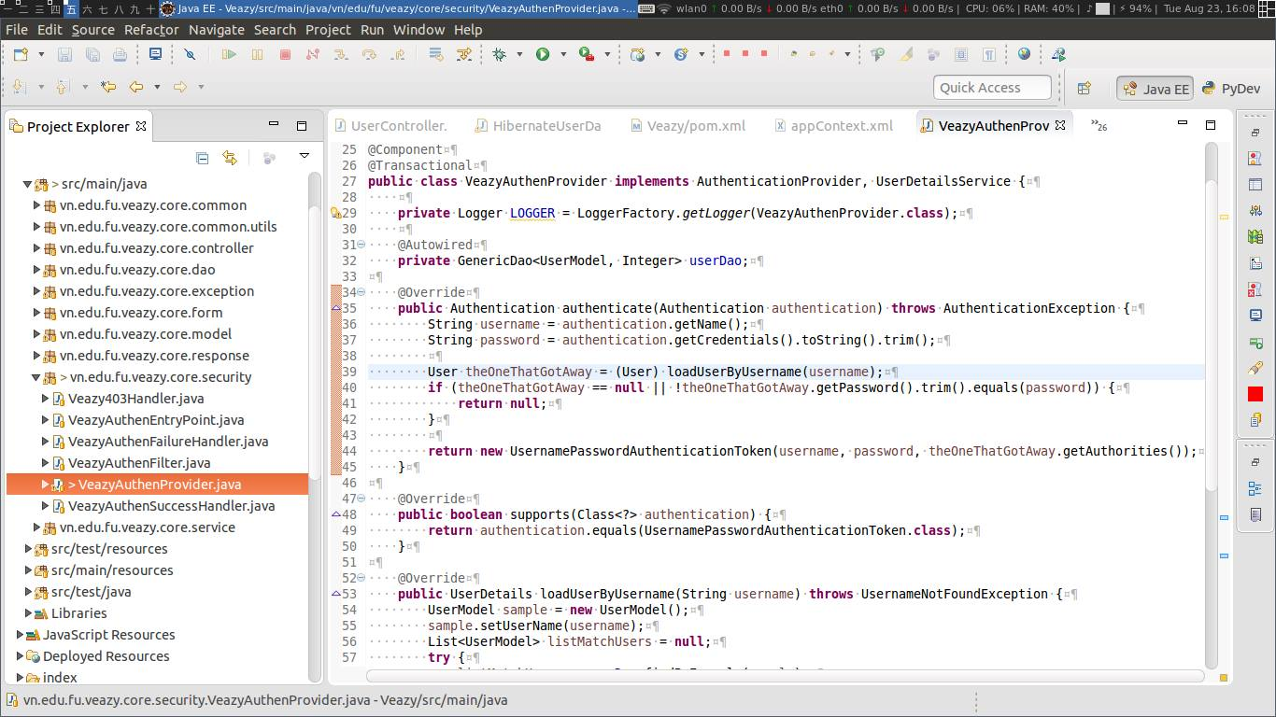

Figure 5-1: Sample of Source Code (VeazyAuthenProvider)

# Software Test Documentation

## INTRODUCTION

### Purposes

This is the comprehensive test plan of the Veazy project. The purpose of the document is to describe the scopes of test and activities which need to be taken during test process of project.

## TEST PLAN

### Scope of Testing

VEAZY will be tested by five phases:

**Phase 1: Unit testing**

* Unit testing will be done by developers
* Developers user While Box Testing technique to do
* When executing unit testing, if any bugs are found, developers have to log bug on “Defect Log Management” file and fix it until it is correct.

**Rule for filling test result:**

|  |  |
| --- | --- |
| **Test result pass** | Pass |
| **Test result fail** | Fail |
| **Do not test** | Untested |
| **Cannot test** | N/A (Not available) |

**Phase 2: Component testing**

* Component testing will be performed by testers using Black Box Testing technique.
* Material are component test cases based on low- level design.
* When executing component test, if any bugs are found, testers have to log bug into “Defect Log Management” file and assign developer to fix it and repeat this process until the bug is fixed correctly.
* When executing component testing, if any bugs are found, testers have to log on “Defect Log Management” file and assign to developer fix it and redo this process until it is correct.

**Rule for filling test result:**

|  |  |
| --- | --- |
| **Test result pass** | Pass |
| **Test result fail** | Fail |
| **Do not test** | Untested |
| **Cannot test** | N/A (Not available) |

**Phase 3: Integration testing**

* After finishing component testing, Integration testing will be performed by testers.
* Material are integration test cases, high- level design and test tools.
* Doing test by checking flows between functions and items which have relation.
* When executing integration test, if any bugs are found, testers have to log on “Defect Log Management” file and assign developer to fix it and repeat this process until it is fixed correctly

**Rule for filling test result:**

|  |  |
| --- | --- |
| **Test result pass** | Pass |
| **Test result fail** | Fail |
| **Do not test** | Untested |
| **Cannot test** | N/A (Not available) |

**Phase 4: System testing**

* After finishing integration testing and developers collect all functions and items, testers will be performed system testing, it means doing test whole system.
* Material area system test case, SRS
* If any bugs are found, developers have to fix and testers will verify them. System test is ended only when test cases are passed and no bug is found.

**Rule for filling test result:**

|  |  |
| --- | --- |
| **Test result pass** | Pass |
| **Test result fail** | Fail |
| **Do not test** | Untested |
| **Cannot test** | N/A (Not available) |

**Phase 5: Acceptance testing**

* Base on customer/user requirement specification, system is tested again, for ensure there is not lacking or mistake any requirement.
* If there is any problem, developers have to fix/update and tester will verify them.
* Acceptance testing is ended only when whole system met requirement specification.

#### Test Items

|  |  |  |
| --- | --- | --- |
| No |  | Functions |
| 1 | Guest | * Register * Login * Take Test * View Result Test * View Lesson List * View Lesson Detail |
| 2 | Member | * Log in / Log out * Take Test * View Result Test * View List Test History * Retake Test * Report Question * View Lesson List * View Lesson Detail * Report Question * View Profile * Edit Profile * Change Password * View Test Statistic |
| 3 | Content Editor | * Log in / Log out * View Profile * Edit Profile * Change Password * View Lesson List * Edit Lesson * Delete Lesson * View Lesson Detail * Create Lesson * View Report * View Question List * Edit Question * Delete Question * View Question Details * Create Question |
| 4 | Administrator | * Log in / Log out * View Profile * Change Password * View Uses List * View User Profile * Ban User * Unban User * Set User Role * Search User * View System Statistics |

#### Acceptance Test Criteria

* Criteria for Unit test of Development team, for Test team accepts to start testing:
* Number of UTC/KLOC: 31 UTC/KLOC
* Number defects/KLOC: 2-4 defects/KLOC
* Statement coverage: 97%
* Branch coverage: 100%
* Path coverage: 100%
* Criteria for Integration test:
* Number of ITC/KLOC: 30 ITC/KLOC
* Number defects/KLOC: 2-4 defects/KLOC
* Criteria for System test:
* Number of STC/KLOC: 60 STC/KLOC
* Number defects/KLOC: 4-6 defects/KLOC
* Criteria for Acceptance test:
* Number defects/KLOC: 1-2 defects/KLOC

#### Testing Risks

|  |  |  |  |
| --- | --- | --- | --- |
| **No** | **Risk** | **Solution** | **Impact** |
| 1 | Qualifications of project team members are not enough to complete all the work of the project. | - Training existing resources to respond necessary skills.  - The members of the group support each other. | High |
| 2 | Lack of resources, hardware and software to ensure the process of testing. | - Check existing computer systems, taking suggestions from members about hardware and software of computer capable of catering the process of testing. | High |
| 3 | Later than the scheduled time. | - Using MS Project to manage and assign tasks to each member. | High |
| 4 | Not enough time to write all test cases, execute test or re-test for fixed bug. | - Regular monitoring, reminding and supporting members.  - Increase working time. | High |
| 5 | Tester can be ill during the testing phase. | - All members of the group must be instructed to backup testing for ill members. | High |
| 6 | The computer may be damaged or stolen. | - Prepare 1 or 2 backup device.  - Backup your data to multiple copies. | High |

### Test Strategies

#### Test Model

VEAZY project follows V-Model process:

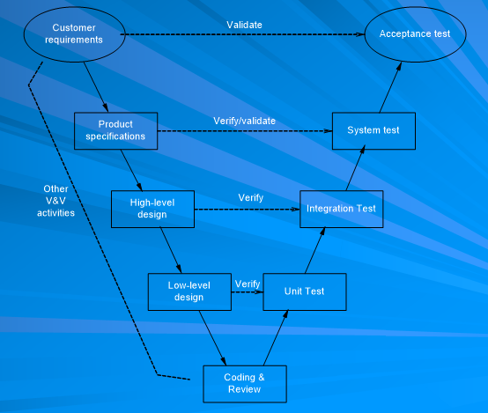

Figure 6-1: V-Model

Testing progress is divided to five phases include: Unit test, Component test, Integration test, System test and Acceptance test

* **Unit test:**
* Unit testing is used to verify a single minimal unit of source code. The purpose of unit testing is to isolate the smallest testable parts of VEAZY and verify that they function properly in isolation.
* Unit testing is the first level of testing and is perform prior to component testing.
* Unit testing will be done by developer.
* **Component test:**
* Component testing is used to validate a combined many minimal units of source code.
* Component testing is performed after unit testing and before integration testing.
* Component testing will be done by tester
* **Integration test:**
* Integration testing is a level of the software testing process where individual units or component are combined and tested as a group.
* The purpose is to expose faults in the interaction between integrated units.
* Integration testing is performed after component testing.
* Integration testing will be done by tester.
* There are two methods of doing integration testing: Bottom-up Integration testing and Top Down Integration testing:

|  |  |
| --- | --- |
| No | Integration Testing Method |
| 1 | Bottom-up integration  This testing begins with unit testing, followed by tests of progressively higher-level combinations of units called modules. |
| 2 | Top- Down integration  This testing, the highest-level modules are tested first and progressively lower-level modules are tested after that |

Table 6-1: Integration test

* **System test:**
* System Testing is a level of the software testing process where a complete, integrated system is tested
* The purpose is to evaluate the system’s compliance with the specified requirements
* System testing is performed after integration testing
* System testing will be done by tester
* **Acceptance test:**
* Acceptance testing is performed after system testing
* Acceptance testing will be performed by the test leader and team leader.
* The acceptance test will be done for a period of 1 weeks after completion of the system test process.

#### Types of Testing

##### Function Testing

* Functionality testing of all implemented functions on the Veazy system.
* Functionality testing is performed to verify that a software application performs and functions correctly according to the functional requirements/specifications.
* Functions are tested by feeding them input and examining the output. This type of testing is not concerned with how processing occurs, but rather, with the results of processing.
* During functional testing, [Black Box Testing](http://softwaretestingfundamentals.com/black-box-testing/) technique is used in which the internal logic of the system being tested is not known to the tester.
* Functional testing typically involves these steps:
  + The identification of functions that the software is expected to perform
  + The creation of input data based on the function's specifications
  + The determination of output based on the function's specifications
  + The execution of the test case
  + The comparison of actual and expected outputs

|  |  |
| --- | --- |
| **Test Objective** | Verify the application and its internal processes by interacting with the application via the Graphical User Interface (GUI) and analyzing the outputs or results |
| **Technique** | Executing each use case, use-case flow, or function, using valid and invalid data, to verify the following:   * The expected results occur when valid data is used. * The appropriate error or warning messages are displayed when invalid data is used. * Each business rule is properly applied. |
| **Completion Criteria** | * All planned tests have been executed. * All identified defects have been addressed and closed. |
| **Special Considerations** | Testing may be stopped when   * Time runs out * A certain number of defects found * Test coverage > 97% * Stop when testing becomes unproductive |

Table 6-2: Function Testing

##### User Interface Testing

* GUI testing is the process of testing a product's graphical user interface to ensure it meets its specifications
* GUI test will be performed fully on all screens.
* GUI testing evaluates design elements such as layout, colors, [fonts](http://whatis.techtarget.com/definition/font), font sizes, labels, text boxes, text formatting, captions, buttons, lists, icons, links, content and more.
* For instance, it must be able to provide inputs to the input fields.
  + Check Error Messages are displayed correctly.
  + Check Font used in application is readable.
  + Check the Color of the font and warning messages is aesthetically pleasing.
  + Check the alignment of the text is proper.
  + Check that the images have good clarity.
  + Check the positioning of GUI elements for different screen resolution.

|  |  |
| --- | --- |
| **Test Objective** | Navigation through the target-of-test properly reflects business functions and requirements, including screen to screen, field-to-field, and use of access methods. Objects and characteristics, such as menus, size, position, state, and focus conform to standards. |
| **Technique** | Create or modify tests for each window to verify proper navigation and object states for each application window and objects. |
| **Completion Criteria** | Each window successfully verified to remain consistent with benchmark version or within acceptable standard |
| **Special Considerations** | Not all properties for custom and third party objects can be accessed. |

Table 6-3: GUI Testing

##### Data and Database Integrity Testing

* The databases and the database processes should be tested as a subsystem within the Project. These subsystems should be tested without the target-of-test’s User Interface as the interface to the data.  Additional research into the Database Management System (DBMS) needs to be performed to identify the tools and techniques that may exist to support the testing identified below.

|  |  |
| --- | --- |
| **Test Objective** | Ensure database access methods and processes function properly and without data corruption. |
| **Technique** | * Invoke each database access method and process, seeding each with valid and invalid data or requests for data. * Inspect the database to ensure the data has been populated as intended, all database events occurred properly, or review the returned data to ensure that the correct data was retrieved for the correct reasons. |
| **Completion Criteria** | All database access methods and processes function as designed and without any data corruption. |
| **Special Considerations** | * Testing may require a DBMS development environment or drivers to enter or modify data directly in the databases. * Processes should be invoked manually. * Small or minimally sized databases (limited number of records) should be used to increase the visibility of any non-acceptable events. |

Table 6-4: Data and Data Integrity Testing

##### Performance Testing

|  |  |
| --- | --- |
| **Test Objective:** | Verify performance behaviors for designated transactions or business functions under the following conditions:   * Normal anticipated workload( Normal time to load a page) * Anticipated worst case workload (Longest time to load a page) |
| **Technique:** | * Use Test Procedures developed for Function or Business Cycle Testing. * Modify data files to increase the number of transactions or the scripts to increase the number of iterations each transaction occurs. * Scripts should be run on one machine (best case to benchmark single user, single transaction) and be repeated with multiple clients (virtual or actual). |
| **Completion Criteria:** | * Single Transaction or single user: Successful completion of the test scripts without any failures and within the expected or required time allocation per transaction. * Multiple transactions or multiple users: Successful completion of the test scripts without any failures and within acceptable time allocation. |
| **Special Considerations:** | * Comprehensive performance testing includes having a background workload on the server. * There are several methods that can be used to perform this, including: * Use multiple physical clients, each running test scripts to place a load on the system. * Performance testing should be performed on a dedicated machine or at a dedicated time. This permits full control and accurate measurement. * The databases used for Performance Testing should be either actual size or scaled equally. |

#### Test stages

* Clearly state the stage in which the test will be executed. Identified below are the stages in which common test are executed

|  |  |  |  |  |  |
| --- | --- | --- | --- | --- | --- |
| **Type of Tests** | **Stage of Test** | | | | |
| **Unit** | **Component** | **Integration** | **System** | **User Acceptance** |
| **Function Testing** | **X** | **X** | **X** | **X** | **X** |
| **User Interface Testing** |  |  | **X** | **X** |  |
| **Data & Data Integrity Testing** |  |  | **X** | **X** |  |
| **Performance Testing** | **X** |  | **X** |  |  |

#### Tools/Environments

##### Hardware

|  |  |  |
| --- | --- | --- |
| **System resources** | | |
| **Resource** | **Quantity** | **Name and Type** |
| Tester PCs | 3 |  |
| CPU | 1 | Intel Dual Core i3 |
| RAM | 2 | 2G |
| Hardware | 1 | 250GB |

**Table 5-1:** Hardware

##### Software

|  |  |  |
| --- | --- | --- |
| **Name** | **Version** | **Type and Others Notes** |
| Windows | 7, 8, 8.1, 10 | Operating system |
| IE | 8, 9, 10, 11 | Web browser |
| Firefox | 47.0.1 | Web browser |
| Chrome | 52.0.2743.82 | Web browser |
| Office | 2010, 2013 | Microsoft office |

**Table 5-2:** Software

##### Infrastructure

|  |  |  |  |  |
| --- | --- | --- | --- | --- |
| **Name** | **Purpose** | **Detail** | **Vendor/In-house** | **Version** |
| Veazy_Defect Log Management_v1.0_EN.xls | Tracking bug during testing time | Microsoft Excel 2010, 2013 | FPT University | v1.0 |

Table 5-3: Infrastructure

### Resources

|  |  |  |
| --- | --- | --- |
| **Worker/Doer** | **Role** | **Specific Responsibilities/Comments** |
| **Nguyen Trong Duy** | **Test Leader** | Provides management oversight.  Responsibilities include:   * + Manage Test Resource and assign test tasks.   + Create and review Test Plan.   + Review Test Case.   + Review Test Report |
| **Nguyen Hong Quan** | **Tester** | * Create and review Test Case. * Execute test. * Create Test viewpoints * Create and review Test Report |
| **Pham Duc Thang** | **Tester** | * Create and review Test Case. * Execute test. * Create Test viewpoints * Create and review Test Report |

Table 6-7: Resources

### Test Milestones

|  |  |  |  |
| --- | --- | --- | --- |
| **Milestone Task** | **Effort (pd)** | **Start Date** | **End Date** |
| Create TP | 1 | 08/06/2016 | 09/06/2016 |
| Review & update TP | 1 | 09/06/2016 | 10/06/2016 |
| Create Integration TC | 5 | 20/06/2016 | 27/06/2016 |
| Review & Update Integration TC | 2 | 27/06/2016 | 29/06/2016 |
| Create System TC | 4 | 29/06/2016 | 05/07/2016 |
| Review & Update System TC | 2 | 05/07/2016 | 07/07/2016 |
| Execute IT phase 1 | 2 | 01/08/2016 | 03/08/2016 |
| Execute IT phase 2 | 2 | 03/08/2016 | 05/08/2016 |
| Execute ST phase 1 | 4 | 03/08/2016 | 09/08/2016 |
| Execute ST phase 2 | 1 | 09/08/2016 | 11/08/2016 |

Table 6-8: Test milestone

## TEST CASES

### Integration Test Case

Refer to VEAZY_Integration Test Case_v1.0_EN to see detail all test cases.

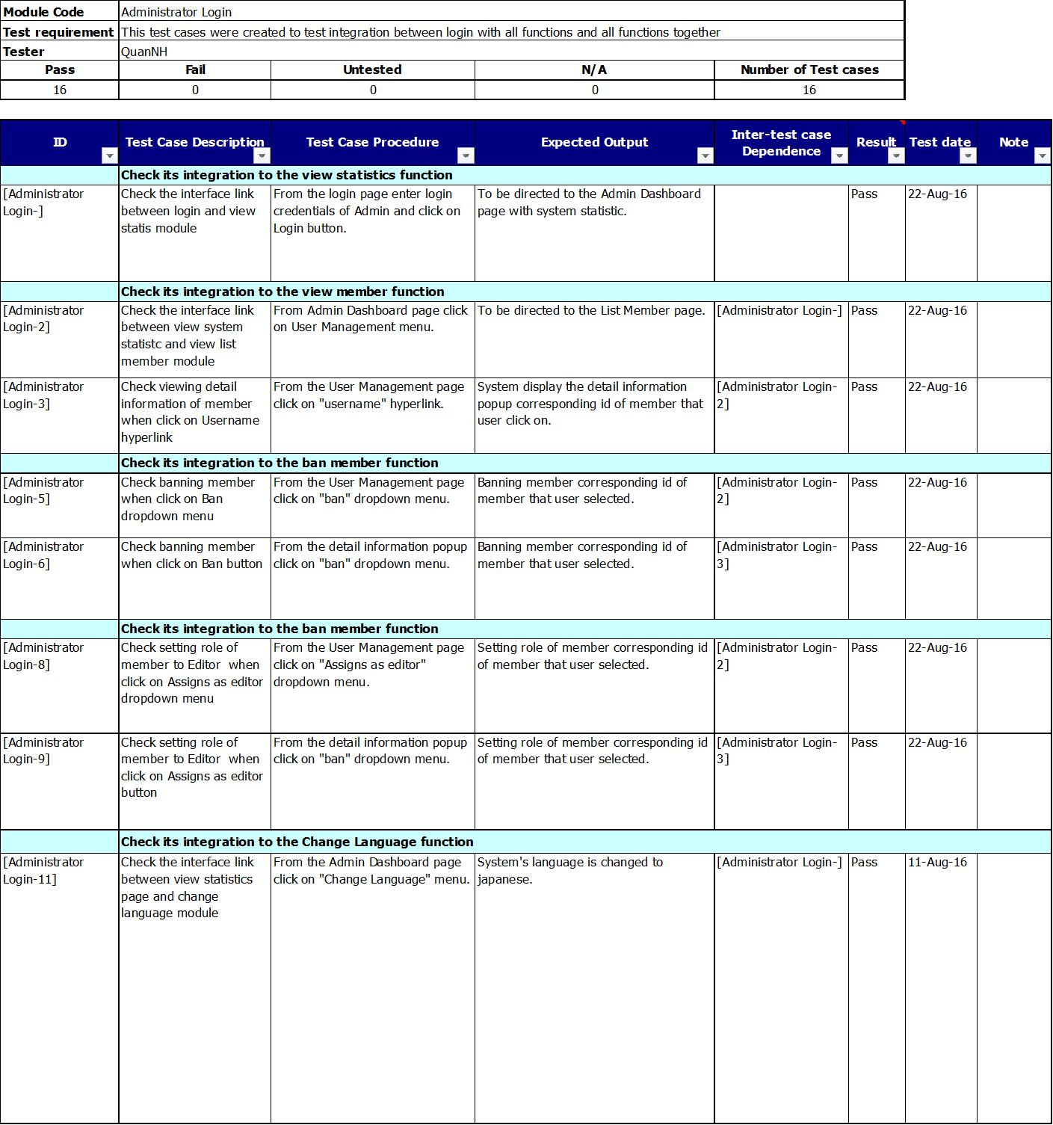

### System Test Case

Refer to VEAZY_System Test Case_v1.0_EN to see detail all test cases.

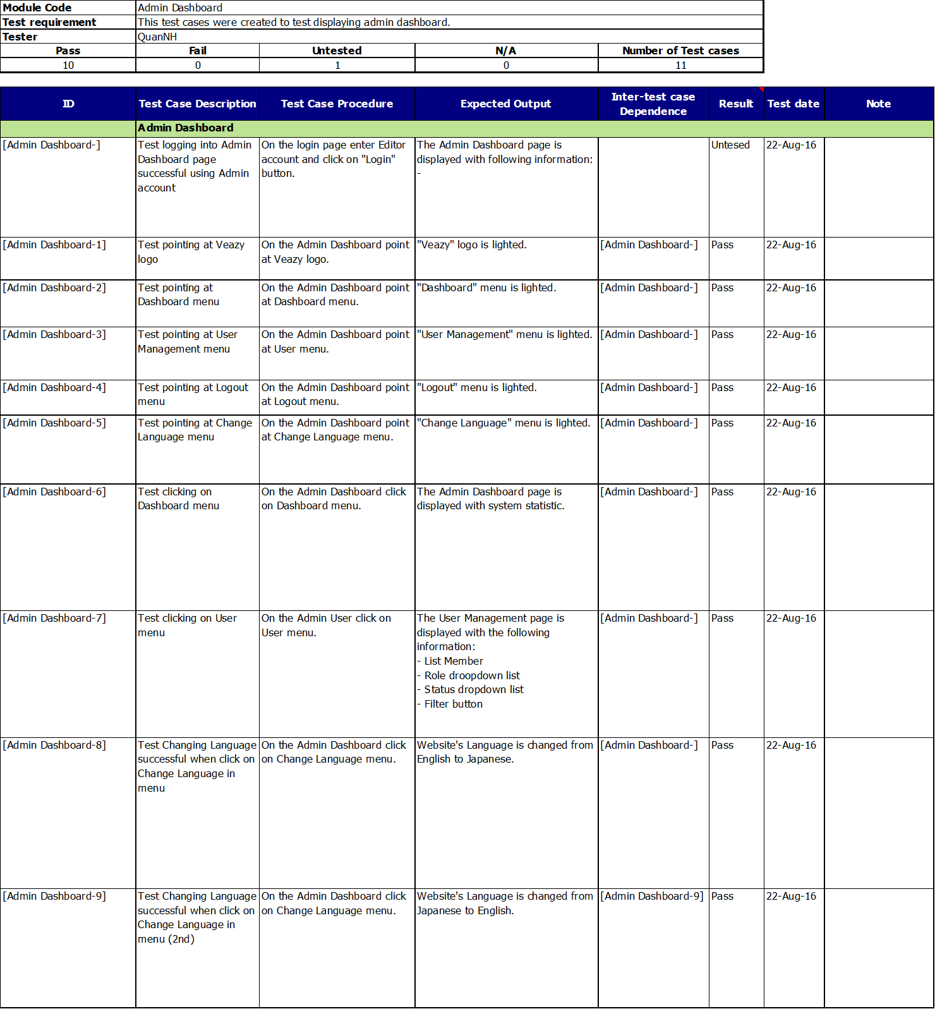

## CHECKLISTS

### Test Checklist

|  |  |  |  |  |  |
| --- | --- | --- | --- | --- | --- |
| **Question** | **Yes** | **No** | **N/A** | **Note** | **Priority** |
| **DOCUMENT CONTROL** |  |  |  |  |  |
| Verify whether document control procedures have been followed by checking for the following: |  |  |  |  |  |
| *Does the title page contain the document name, version number, release date and issued date?* | X |  |  |  |  |
| *Does the header and footer correctly specify the name, and version of the document?* | X |  |  |  |  |
| *Does the page – numbering scheme indicate the total number of pages in the document?* | X |  |  |  |  |
| *Is the history traceable?* | X |  |  |  | Mandatory |
| *Does it include list of reference documents?* | X |  |  |  |  |
| *Are all documents checked Spelling and Grammar in MS Word or similar tools?* | X |  |  |  |  |

Table 6-9: System Test Checklist

|  |  |  |  |  |  |
| --- | --- | --- | --- | --- | --- |
| **TEST CASE REVIEW CHECKLIST** |  |  |  |  |  |
| Do test cases cover all requirements? | X |  |  |  | Mandatory |
| Do test cases cover all Testing types described in Test plan? | X |  |  |  | Mandatory |
| Has each test case been assigned a test case identifier? | X |  |  |  | Mandatory |
| Does each test case specify: |  |  |  |  |  |
| *Actions* | X |  |  |  | Mandatory |
| *Test condition* | X |  |  |  | Mandatory |
| *Expected result* | X |  |  |  | Mandatory |
| Have the expected results been recorded in detail? | X |  |  |  | Mandatory |
| Do test cases for field validations, record validations and database updates include the following? |  |  |  |  |  |
| *Valid conditions* | X |  |  |  | Mandatory |
| *Invalid conditions* | X |  |  |  | Mandatory |
| *Boundary or unusual conditions* | X |  |  |  | Mandatory |
| Is error message/message code specified in expected result for abnormal cases? | X |  |  |  |  |
| Do the test cases for reports include the test data along with the expected output? | X |  |  |  |  |
| Have the inter test case dependencies been described? | X |  |  |  |  |
| Have all requested environments been specified ? | X |  |  |  | Mandatory |
| Are pre-conditions for the test specified? | X |  |  |  |  |
| Are all metrics of test cases meet standards? | X |  |  |  |  |
|  |  |  |  |  |  |
| <Add more rows if needed> |  |  |  |  |  |

Table 6-9: Checklist Test Plan

### GUI checklist

Refer to VEAZY_GUI Checklist_v1.0_EN to see all detail.

## TEST LOGS

### Defect Logs

Refer to VEAZY_Defect Log Management_v1.0_ENC:\Users\admin\AppData\Roaming\Microsoft\Report_5_Test\DefectLogs to see detail all Bug List.

|  |  |  |  |  |
| --- | --- | --- | --- | --- |
| **Defects** | **Logged** | **%Closed** | **%Invalid** | **%Open** |
| **Critical** | 0 | 0% | 0% | 0% |
| **High** | 0 | 0% | 0% | 0% |
| **Medium** | 9 | 100% | 0% | 0% |
| **Low** | 15 | 100% | 0% | 0% |
| **Total** | 24 | 100% | 0% | 0% |

Tabel 6-11: Defect Logs

### 

### Test Reports

This is Test report of VEAZY project during Test process.

Refer to:

* VEAZY_Unit Test Report_v1.0_EN
* VEAZY_Component Test Report_v1.0_EN
* VEAZY_Integration Test Report_v1.0_EN
* VEAZY_System Test Report_v1.0_EN

To see detail test report for each phase.

|  |  |  |  |  |  |  |  |
| --- | --- | --- | --- | --- | --- | --- | --- |
| **Phase** | **# Test cases Planned** | **#Defects Planned** | **#Test cases Actual(cases)** | **#Defects Actual** | **% Tests Executed** | **% Tests Passed** | **% Tests Fail** |
| **Unit Test** | 31TC/KLOC | 2-4 defects/KLOC | 542 | 0 | 100% | 100% | 0% |
| **Integration Test** | 30TC/KLOC | 2-4 defects/KLOC | 284 | 1 | 100% | 100% | 0% |
| **System Test** | 60TC/KLOC | 4-6 defects/KLOC | 1493 | 7 | 100% | 100% | 0% |
| **Total** | 3400 | 240 – 340 defects/KLOC | 3070 | 24 | 100% | 100% | 0% |

Table 6-12: Test Report

|  |  |  |  |  |  |  |  |  |
| --- | --- | --- | --- | --- | --- | --- | --- | --- |
| **Phase** | **Round 1** | | | | **Round 2** | | | |
| Pass | Fail | Untested | Bug | Pass | Fail | Untested | Bug |
| **Unit Test** | 439 | 0 | 0 | 0 | 103 | 0 | 0 | 0 |
| **Component Test** | 477 | 0 | 0 | 12 | 274 | 0 | 0 | 4 |
| **Integration Test** | 118 | 0 | 0 | 0 | 166 | 0 | 0 | 1 |
| **System Test** | 996 | 0 | 0 | 6 | 497 | 0 | 0 | 1 |
| **Total** | 2030 | 0 | 0 | 18 | 1040 | 0 | 0 | 6 |

Table 6-13: Test Report

### Quality Report

|  |  |  |  |  |
| --- | --- | --- | --- | --- |
|  |  |  | **Defect (No of Def/KLOC)** | |
| **#** | **Product** | **Quality Control Activity** | **Plan** | **Actual** |
| **1** | Test case | Unit Test | 3-4 | 18 |
| Component Test | 3-4 | 16 |
| IT | 2-3 | 9 |
| System test | 4-6 | 13 |
| Leakage (UAT) | 1-2 |  |
| **2** | Requirements | Review | 10 | 6 |
| **3** | Design | Review | 15 | 21 |
| **4** | Code | Review | 30 | 15 |
| **5** | Project Plan | Review | 10 | 3 |
| **6** | Project Schedule | Review | 10 | 6 |
| **7** | Test Plan | Review | 10 | 4 |
| **8** | Other document | Review | 15 | 10 |
| **Total** |  |  |  | 121 |

# Software User Manual

## Installation guide

### Introduction

This document contains guide-lines step by step to deploy Veazy website, and set up its own database.

### Environment

|  |  |  |  |
| --- | --- | --- | --- |
| No | Name | Version | Description |
| 1 | Windows | Windows XP or higher | Operating System |
| 2 | JDK | 8 | Java environment to run Tomcat |
| 3 | Tomcat | 7 | To deploy website |
| 4 | PostgreSQL | 9.4 or higher | To deploy database system |
| 5 | Browser | Firefox 20, Chrome 36 or higher | To browse the website |

### Application Installation

#### Install web browser

* Chrome can be download from

<https://www.google.com/intl/vi/chrome/browser/desktop/index.html>

* Firefox can be download from

<https://www.mozilla.org/vi/firefox/new/>

#### Install PostgreSQL 9.5.3

* Download and install PosgreSQL from:

<https://www.postgresql.org/download/>

* By default, the website server will listen on port 5432

#### Create Database

* In Windows start bar find and open “pgAdmin III”

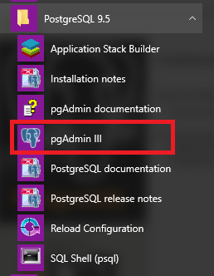

* Create new role

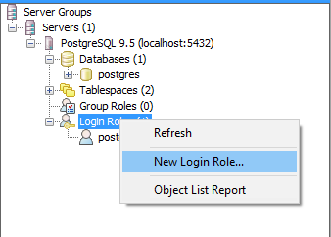

* Enter “veazy” to “Role name” box

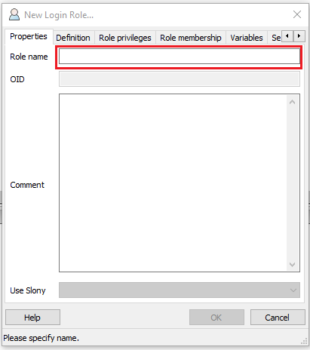

* Select “Definition” tab and enter “veazy” to password box

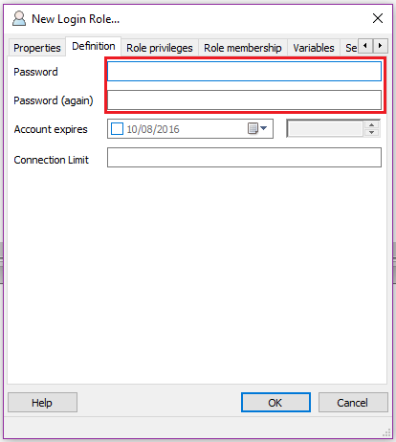

* Click “OK” button and see new role “veazy” has been created.

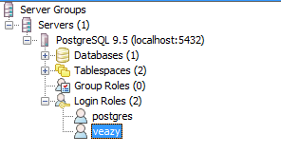

* Create new database

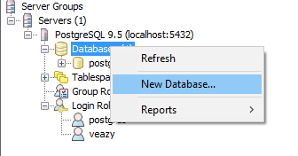

* Enter “veazy_system” into “Name” box and select “veazy” in “Owner” drop-down list

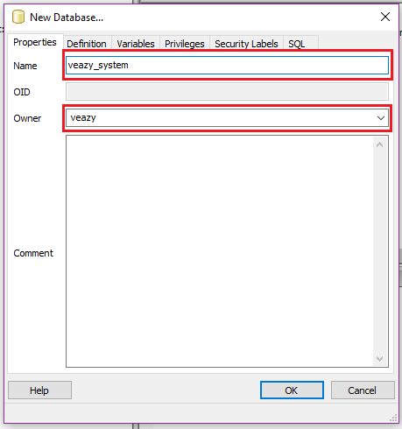

* Click “OK” button and see new database “veazy_system” has been created.

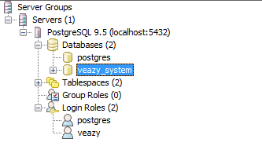

* Click  button on toolbar



* Click button on toolbar of new window



* Open “veazy.sql” file

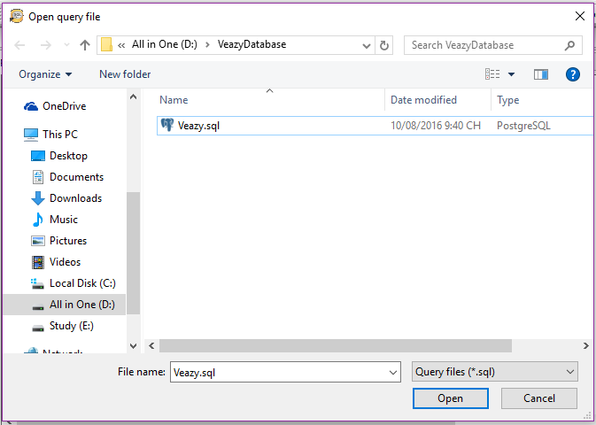

* Click  button on toolbar to run script



* Database was created with some table that contained data

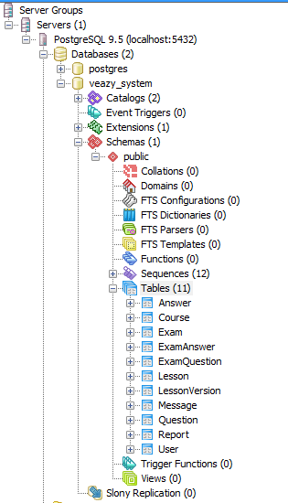

#### Install JDK 8

* Go to link Install Java Platform (JDK) 8u101 (or later) from

<http://www.oracle.com/technetwork/java/javase/downloads/index.html>

* Set up JAVA_HOME follow guide

<https://docs.oracle.com/cd/E19182-01/820-7851/inst_cli_jdk_javahome_t/>

#### Install Tomcat 7

* Download and install Tomcat 7 Core from

<https://tomcat.apache.org/download-70.cgi>

* Extract downloaded file and see extracted folder

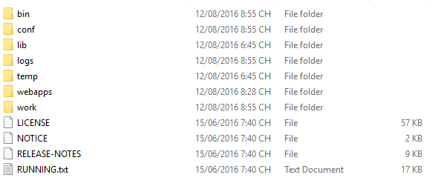

## User Guide

### Overview

This user's manual has been developed to help users better understand the requirements that may apply to use this website by providing them simple step by step tutorials. This manual is intended to help make website's functions more accessible and their associated requirements more understandable to users.

### Details guidelines

#### Homepage

The first page which user will see is the homepage. From this page the user can go to every page they want.

Open browser and enter to the address bar:

http://localhost:3003/#/home



#### How to Login

To login account on website, the users do the steps below:

Step 1: Click on “Login” hyperlink in homepage



Step 2: User needs input username and password

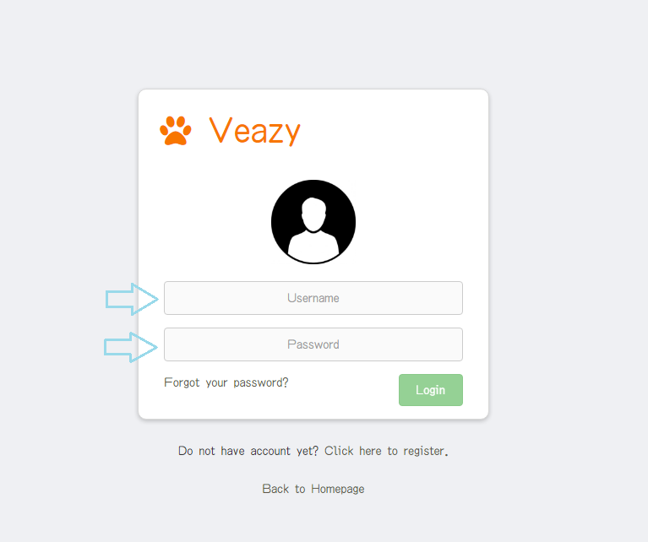

Step 3: Click on “Login” button

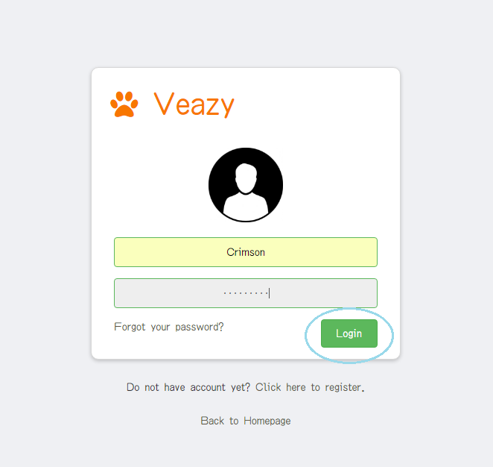

Step 4: System redirects to homepage if user login to member account successfully.



System redirects to editor dashboard if user login to editor account successfully.

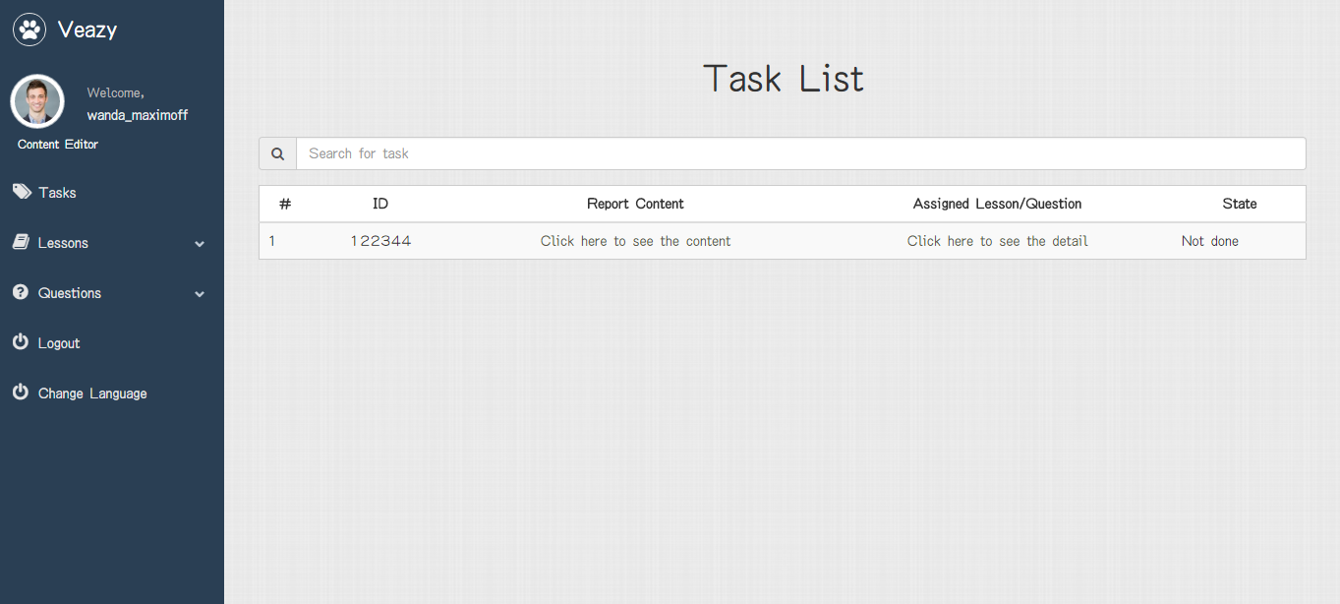

System redirects to admin dashboard if user login to admin account successfully.

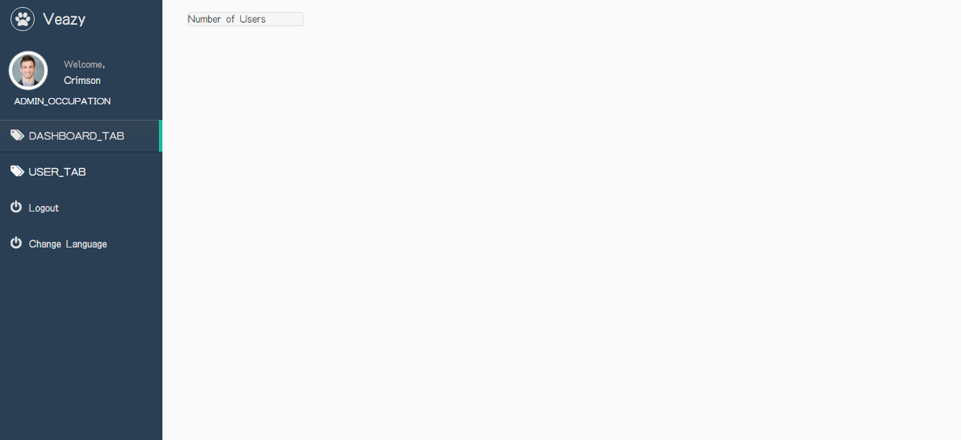

#### How to Register

To register account on website, users do the steps below:

Step 1: Click on “Sign up” button in homepage or click “Click here to register” hyperlink in “Login” page



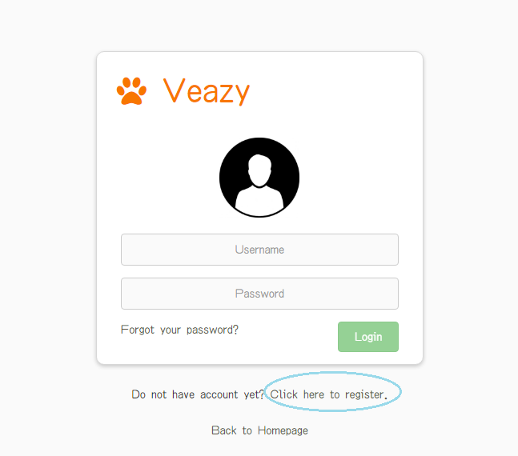

Step 2: System redirects to “Register” page

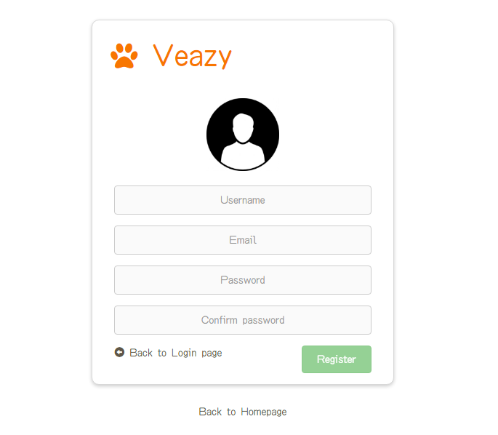

Step 3: User fill in user information into the textbox

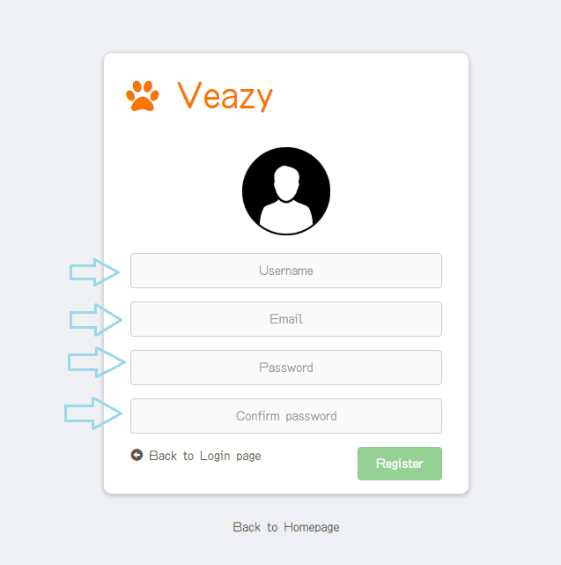

Step 4: Click “Register” button

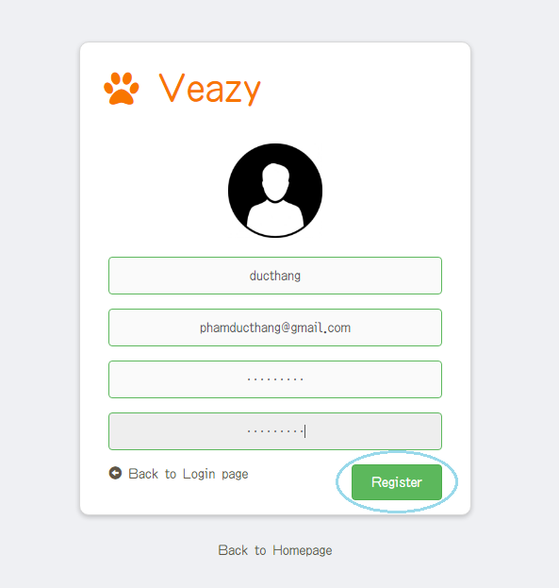

Step 5: System redirects to “Home” page



#### How to Change Language

To change language on website, the users do the steps below:

Step 1: User clicks on “Veazy” logo at the top of menu in homepage

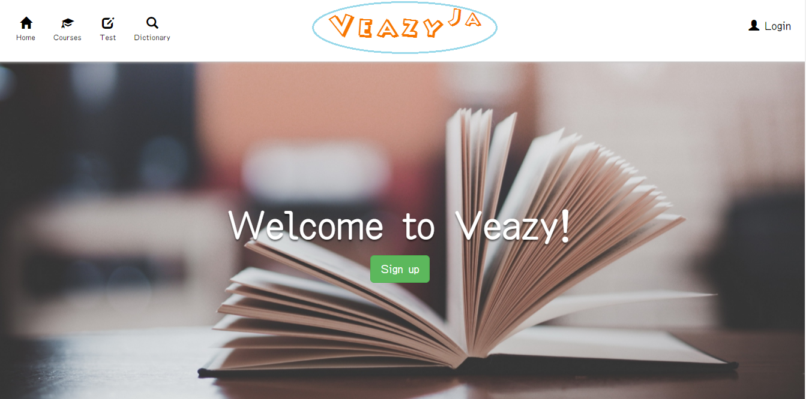

Step 2: System changed language



#### How to Learn Courses

##### Select Course

To select courses on website, the users do the steps below:

Step 1: User clicks on “Courses” hyperlink at the top menu in homepage

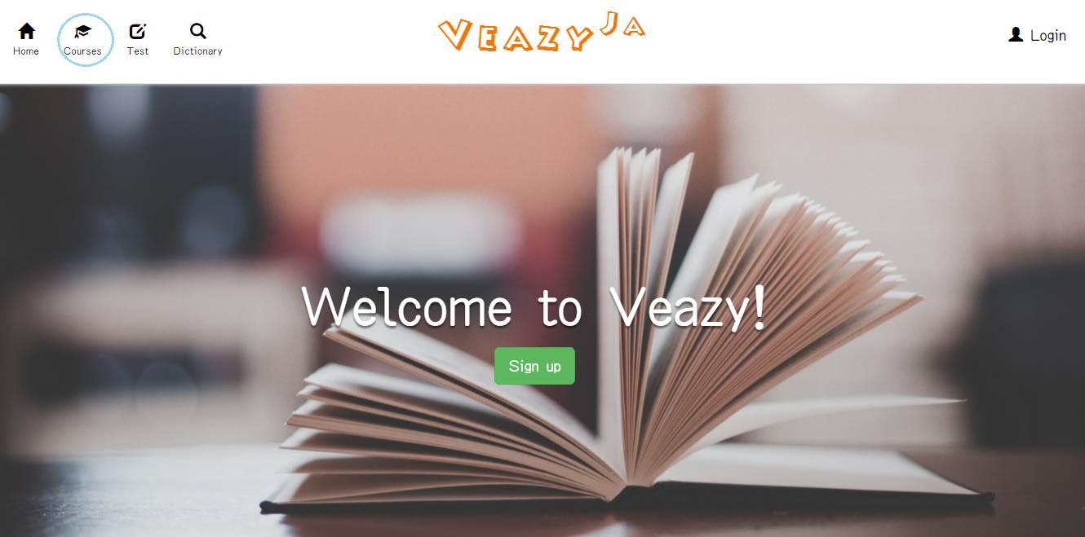

Step 2: User clicks on level hyperlink in dropdown list

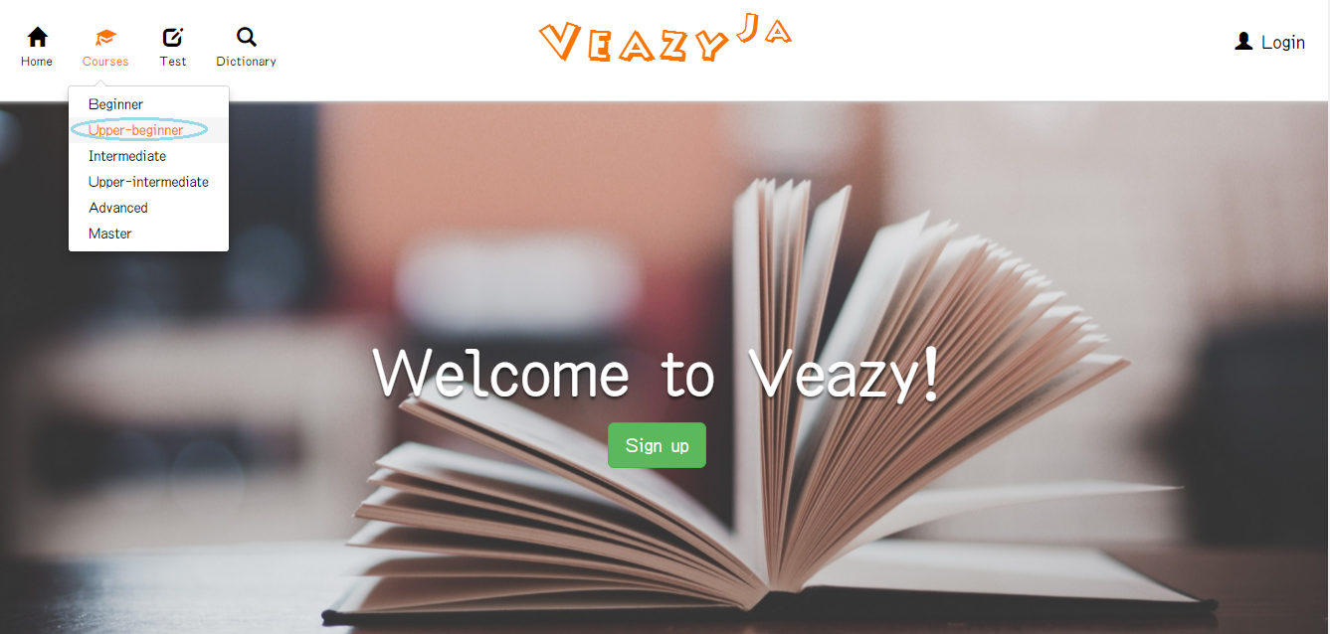

Step 3: System will redirects to “Courses” page

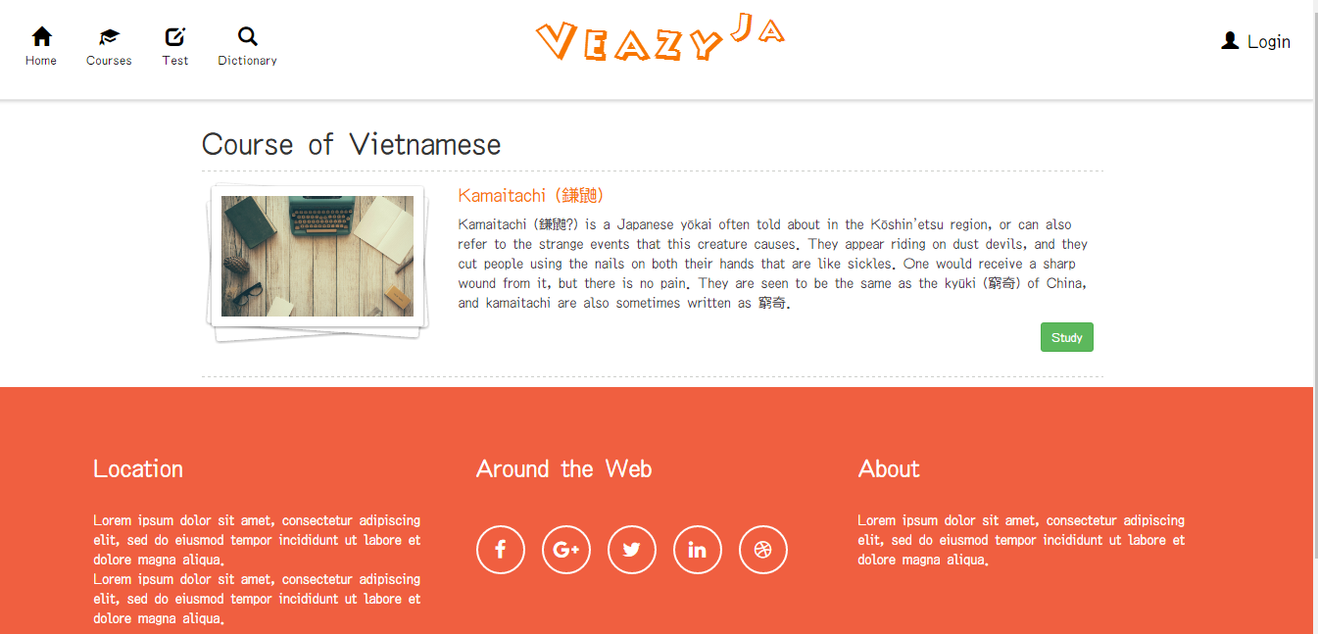

##### Start Study Lesson

To study lesson on website, the users do the steps below:

Step 1: User clicks on “Study” button in courses page

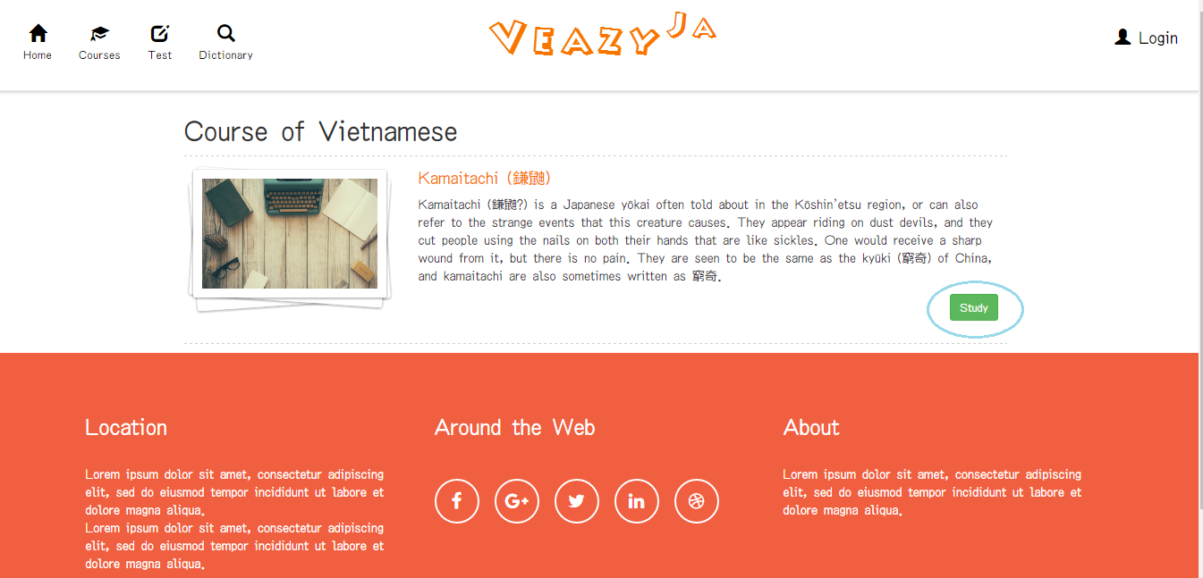

Step 2: System redirects to “Lesson” page

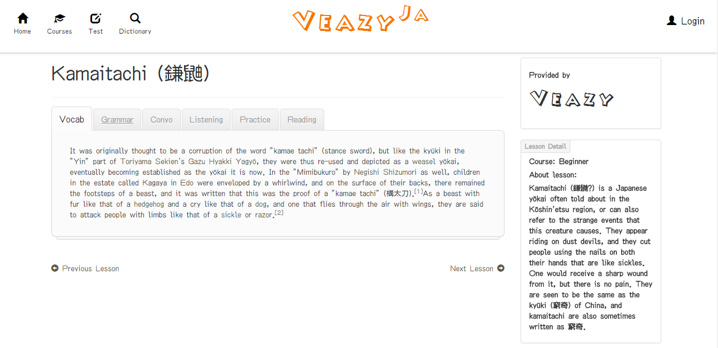

##### Learn Vocabulary

To learn vocabulary on website, the users do the steps below:

Step 1: User clicks “Vocab” link in “Lessons” page

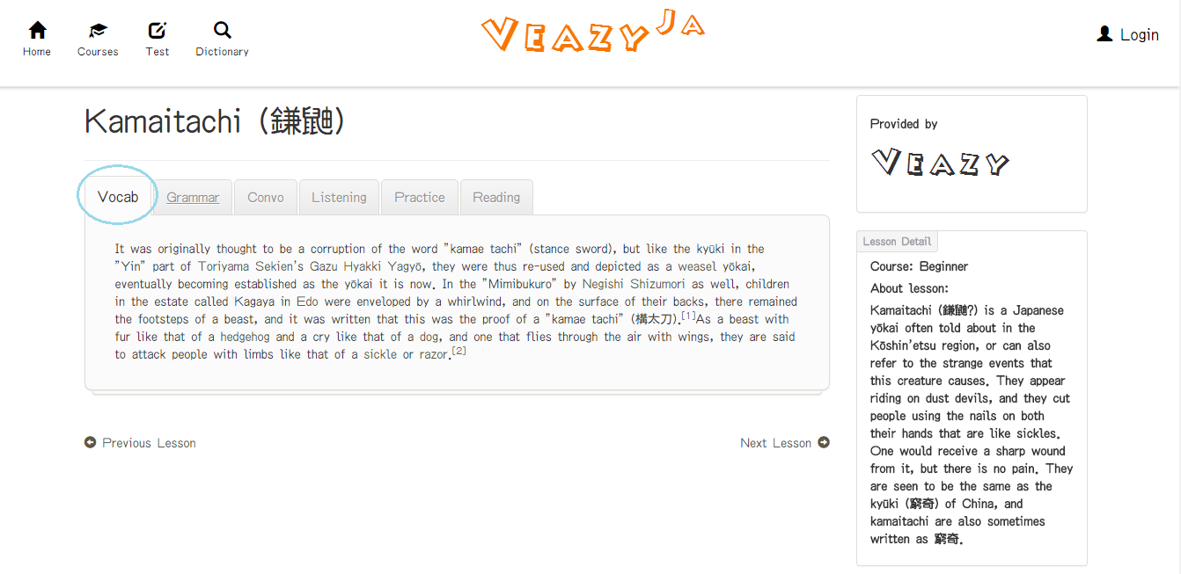

##### Learn Grammar

To learn grammar on website, the users do the steps below:

Step 1: User clicks “Grammar” link in “Lessons” page

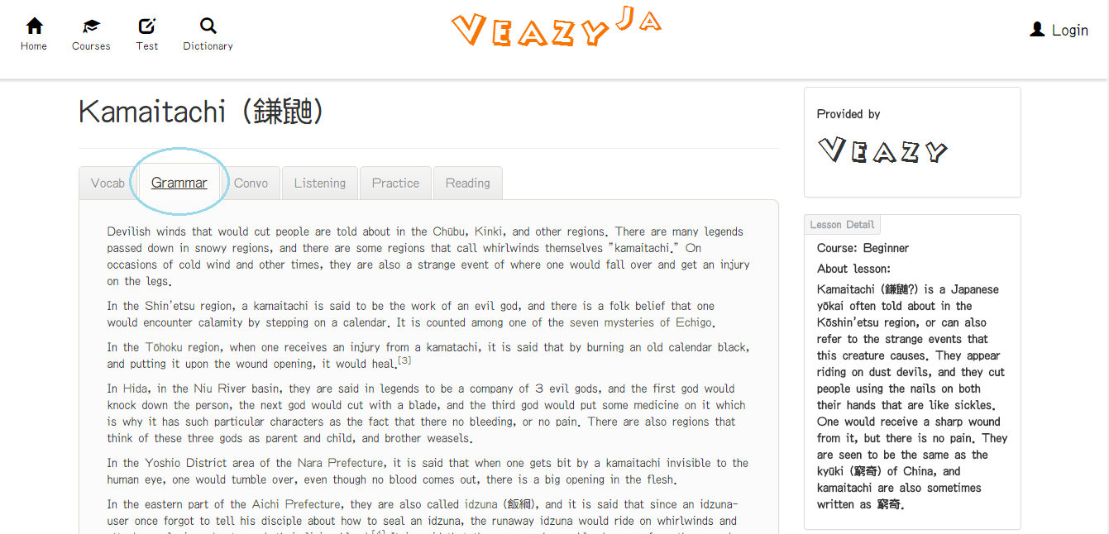

##### Learn Conversation Skill

To learn conversation on website, the users do the steps below:

Step 1: User clicks “Convo” link in “Lessons” page

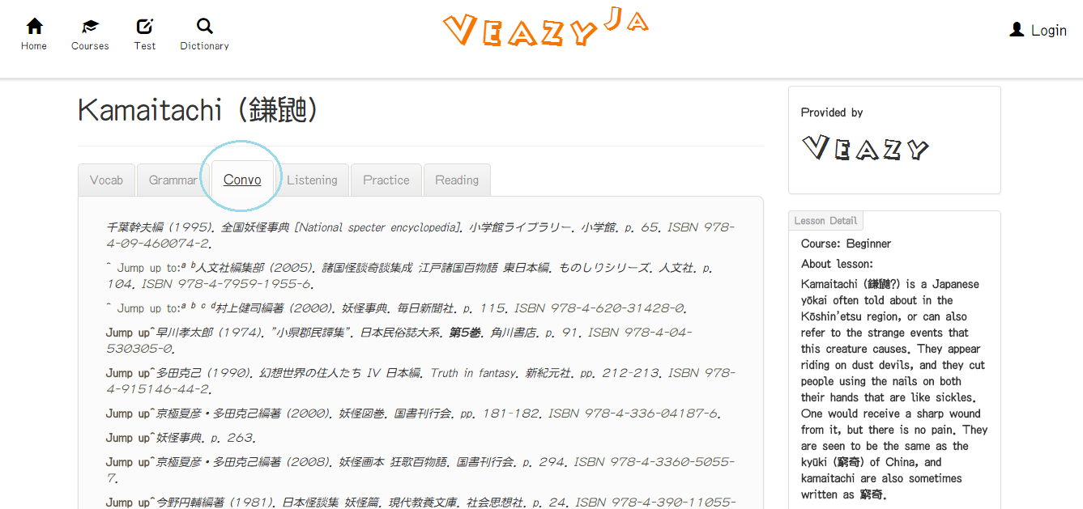

##### Learn Listening Skill

To listening on website, the users do the steps below:

Step 1: User clicks “Listening” link in “Lessons” page

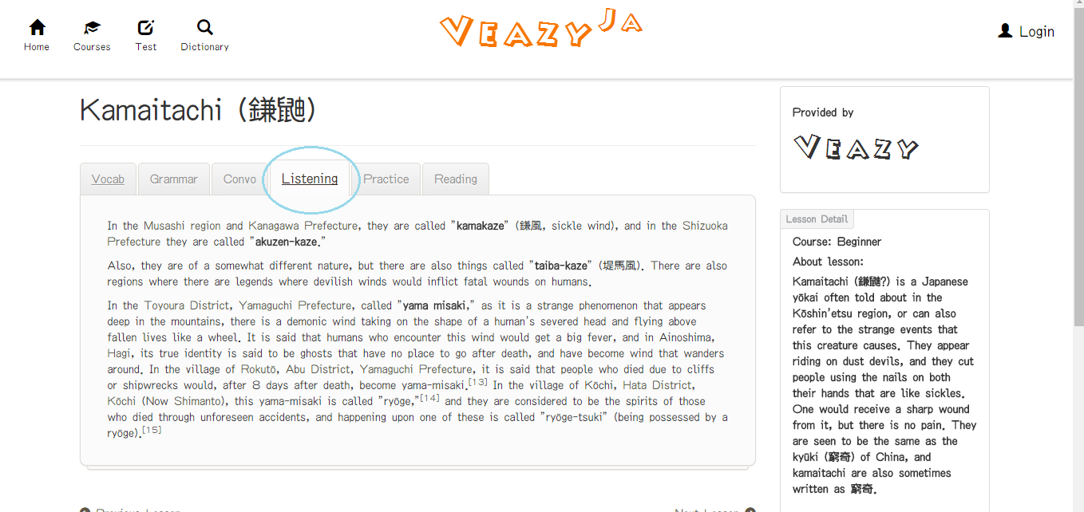

##### Do Practice

To do practice on website, the users do the steps below:

Step 1: User clicks “Pratice” link in “Lessons” page

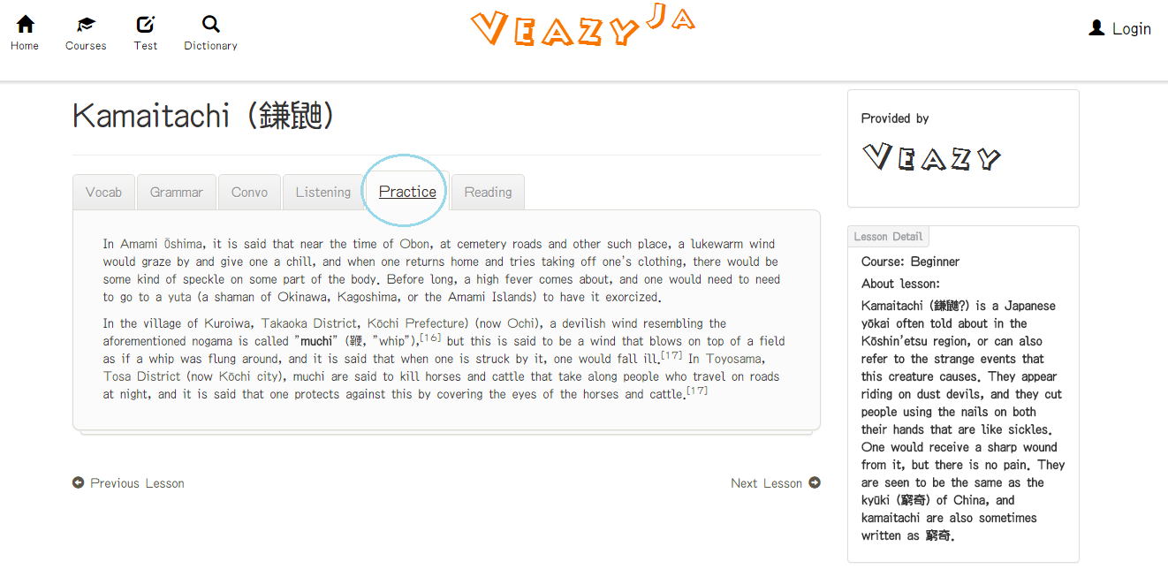

##### Learn reading skill

To reading on website, the users do the steps below:

Step 1: User clicks “Reading” link in “Lessons” page

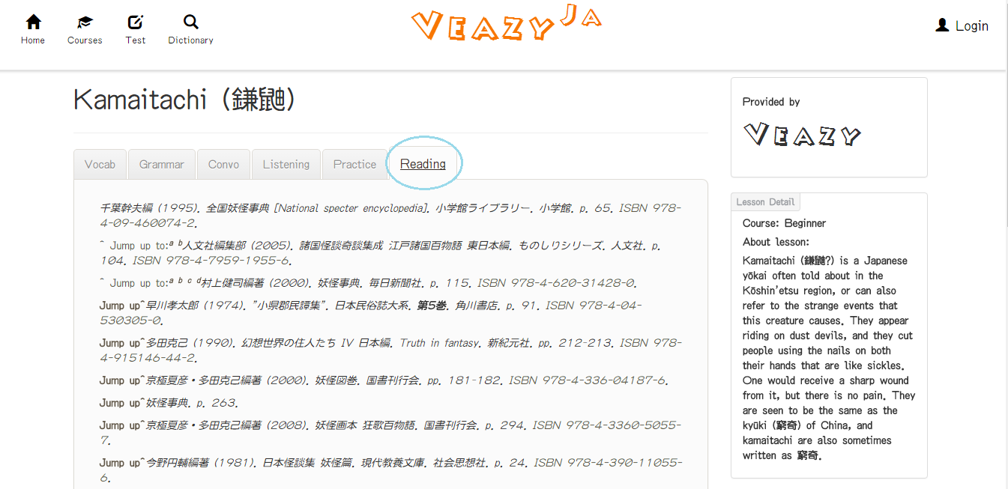

##### Previous Lesson

To previous lesson on website, the users do the steps below:

Step 1: User clicks “Previous Lesson” link in “Lessons” page

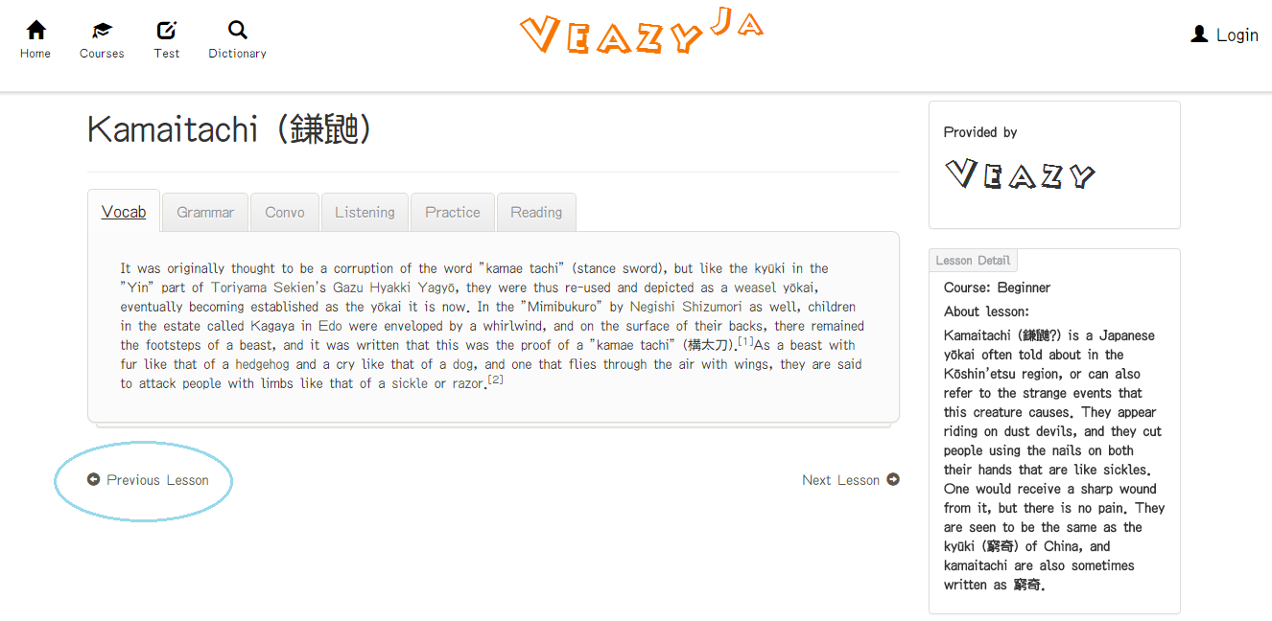

##### Next Lesson

To next lesson on website, the users do the steps below:

Step 1: User clicks “Next Lesson” link in “Lessons” page

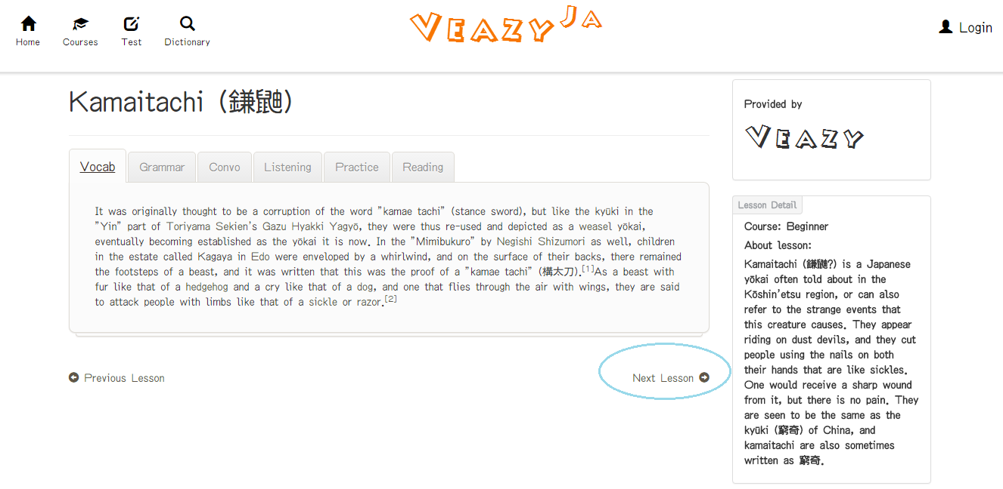

#### How to Test

##### Start Create Test

To create test on website, the users do the steps below:

Step 1: User clicks on “Test” link at the top menu in homepage

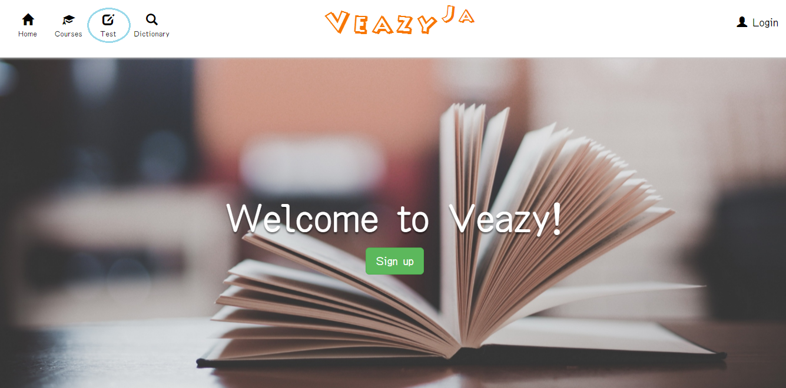

Step 2: Systems redirects to “Test” page

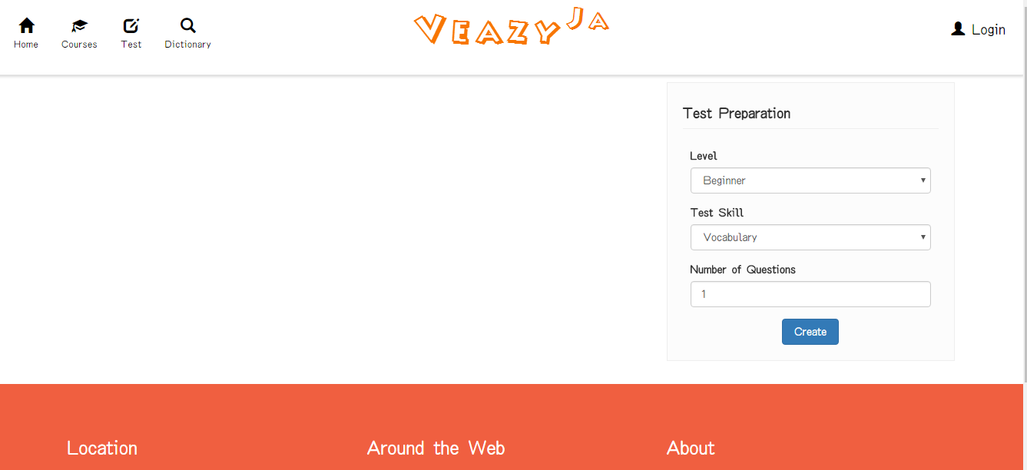

Step 3: User clicks on “Level” dropdown list to select difficulty level and click on “Test skill” dropdown list to select the skill that user wants to test and input the number of questions

Step 4: Click on “Create” button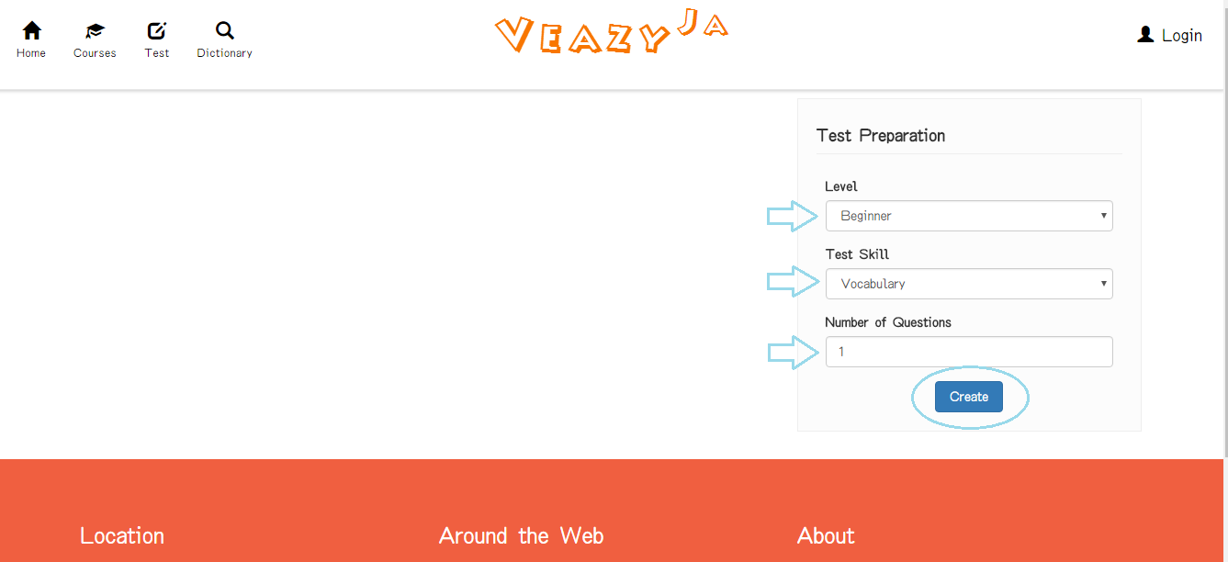

Step 5: System shows test

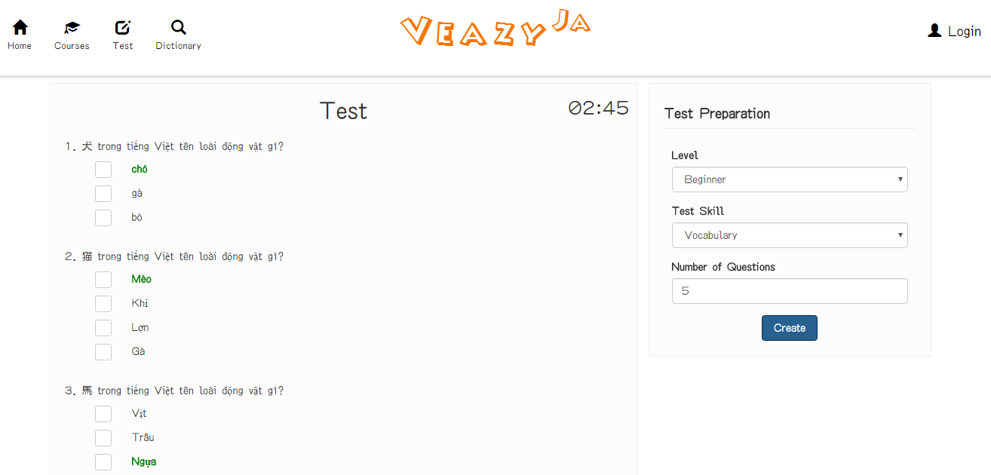

##### Submit Test

To view result test on website, the users do the steps below:

Step 1: User clicks on “Submit” button in take test page

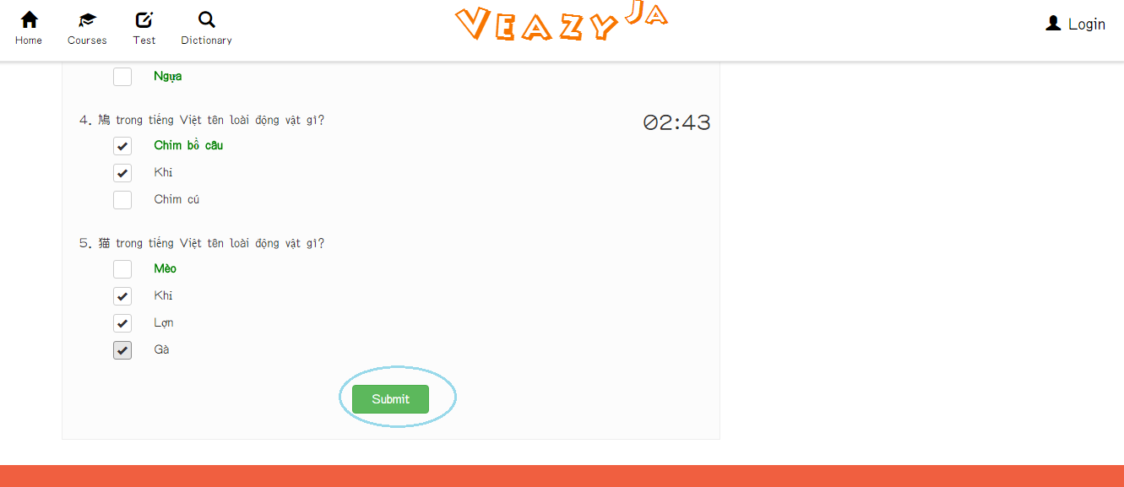

Step 2: System redirects to test result page

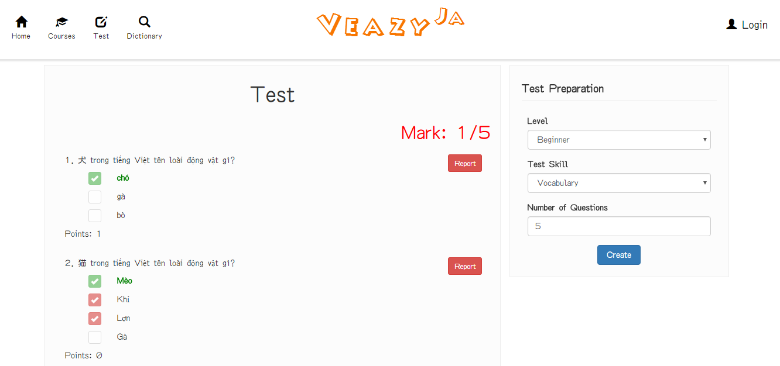

#### User is Member

Member logged in the website

##### Sent Question Report

To report question on website, the users do the steps below:

Step 1: User clicks on “Report” button in “Test Result” page

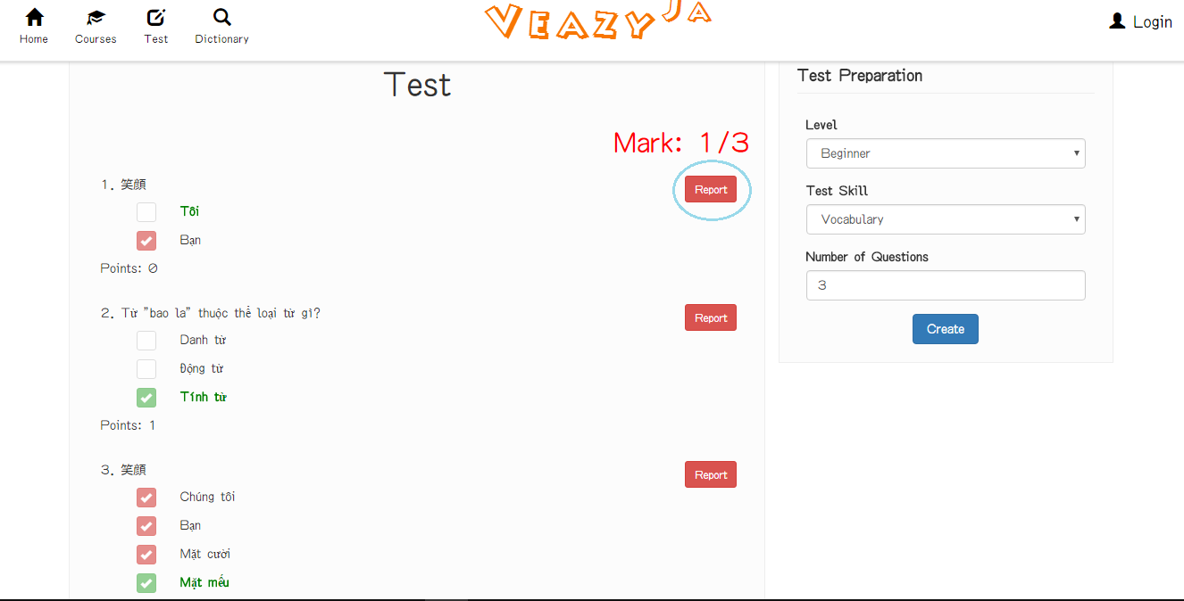

Step 2: User inputs content message

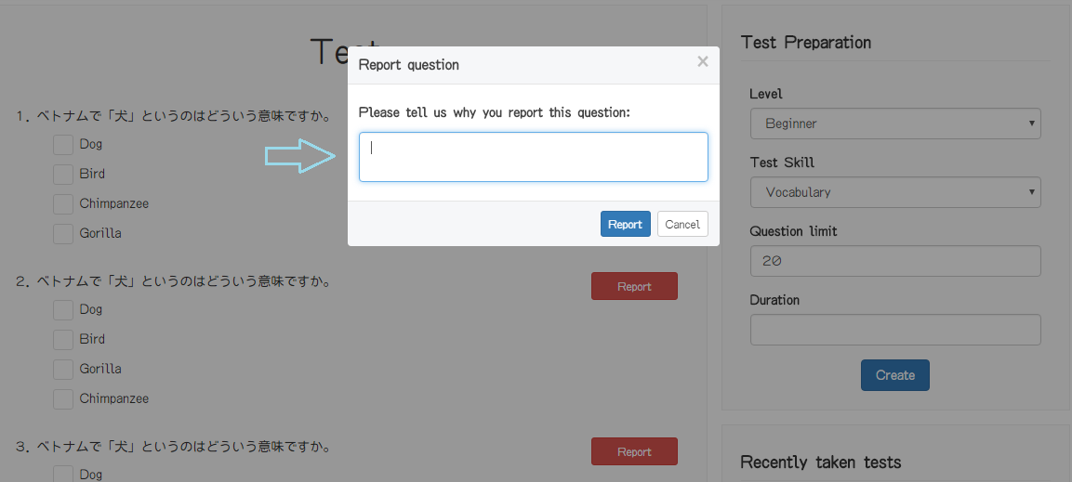

Step 3: User clicks on “Report” button in “Report question” popup

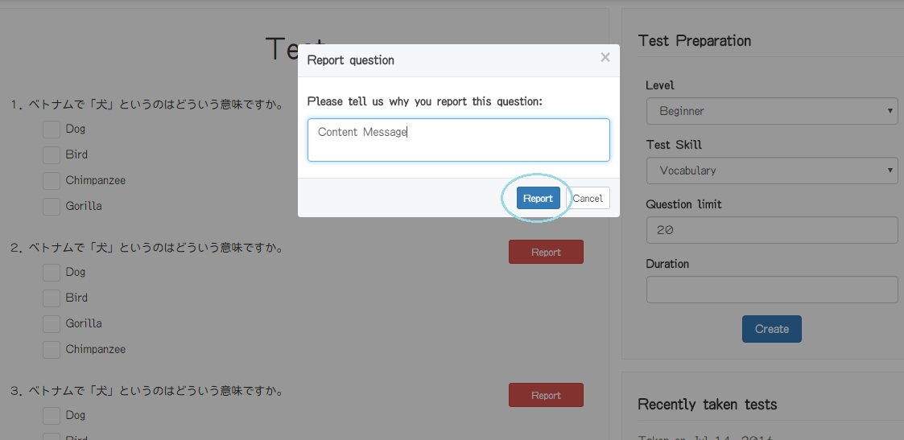

##### View List Test History

To view list test history on website, the users do the steps below:

Step 1: User clicks on “Test” link at the top menu in homepage

##### View Test History

##### Retake Test

##### View Member Profile

To view profile on website, the users do the steps below:

Step 1: User clicks on username hyperlink at the right top of menu



Step 2: Click on “Show Profile” hyperlink in dropdown list

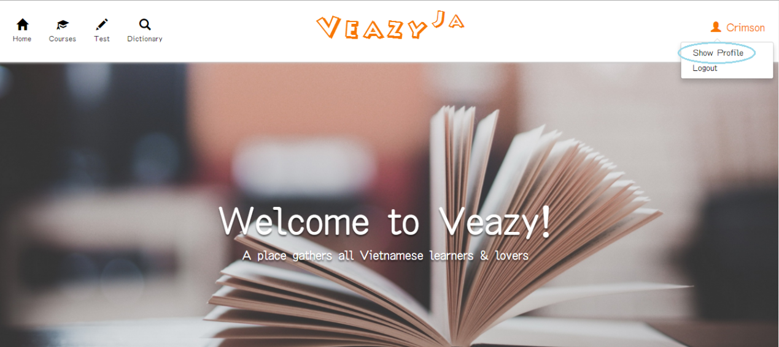

Step 3: System redirects to “Profile” Page if view profile successful

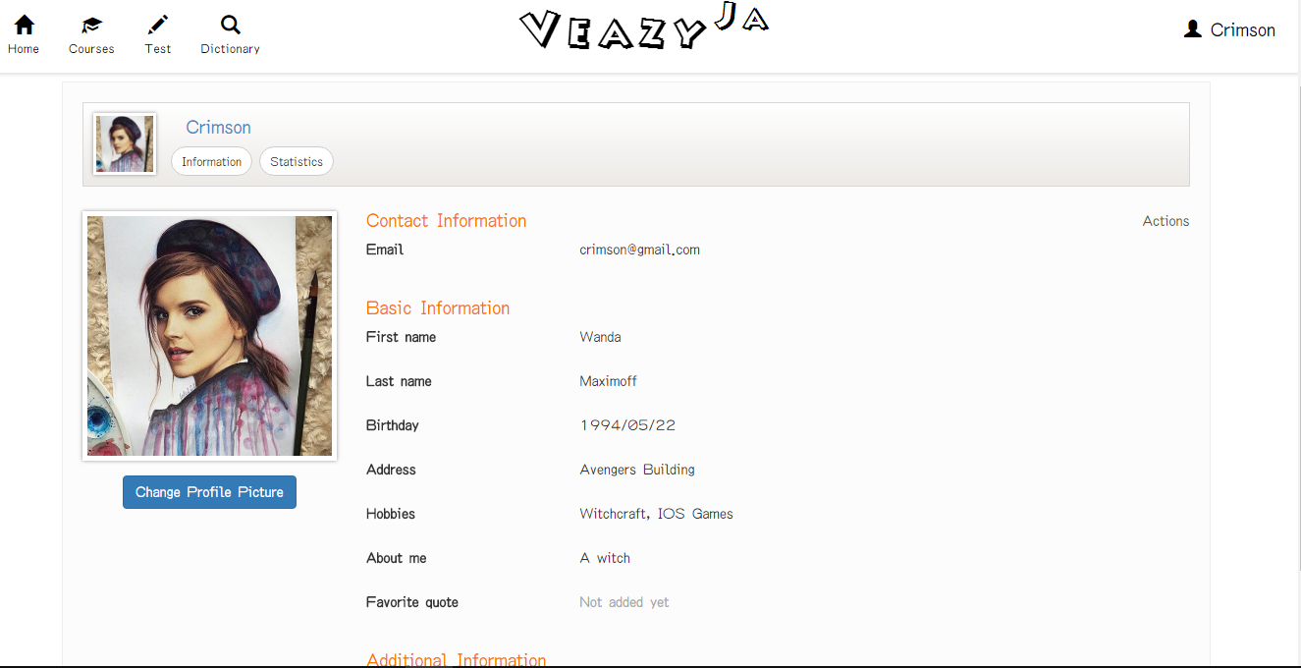

##### Update Profile

To update profile on website, the users do the steps below:

Step 1: User clicks on “Update Profile” in “Actions” dropdown list

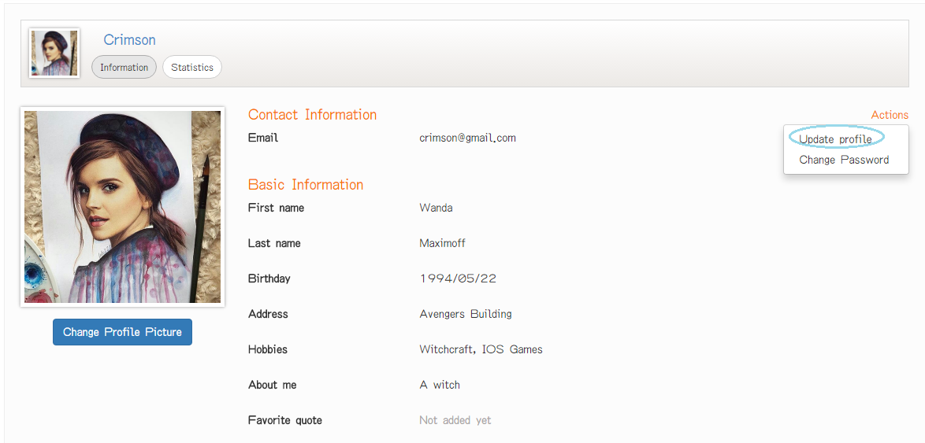

Step 2: Update information

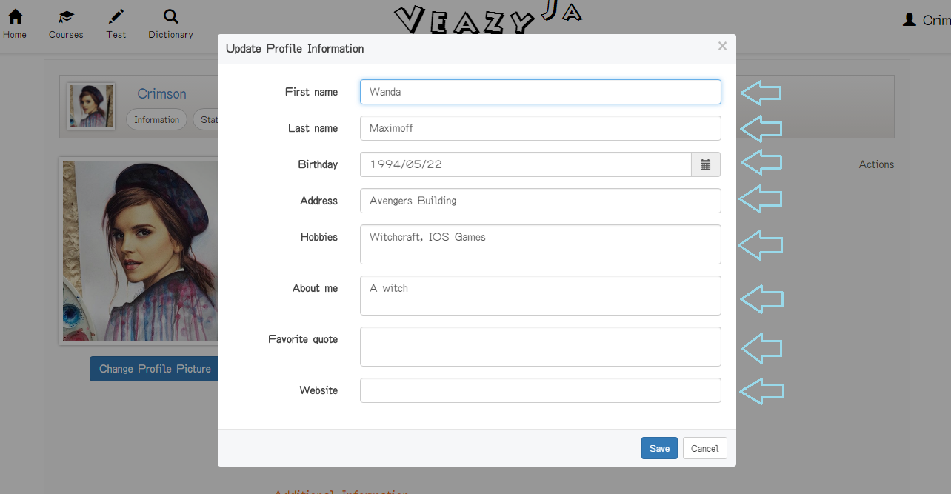

Step 3: User clicks on “Save” button

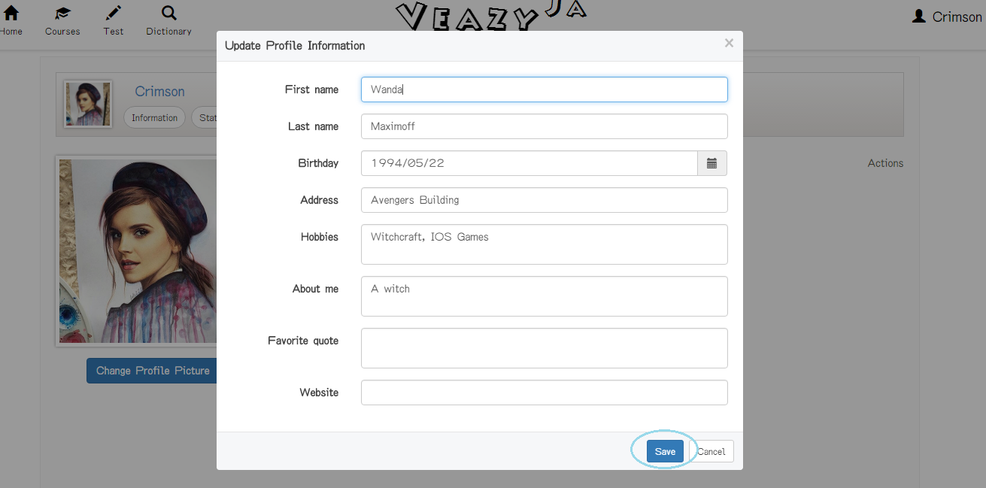

If user clicks “Cancel’ button, system cancel editing profile action and close “Update Profile Information” popup

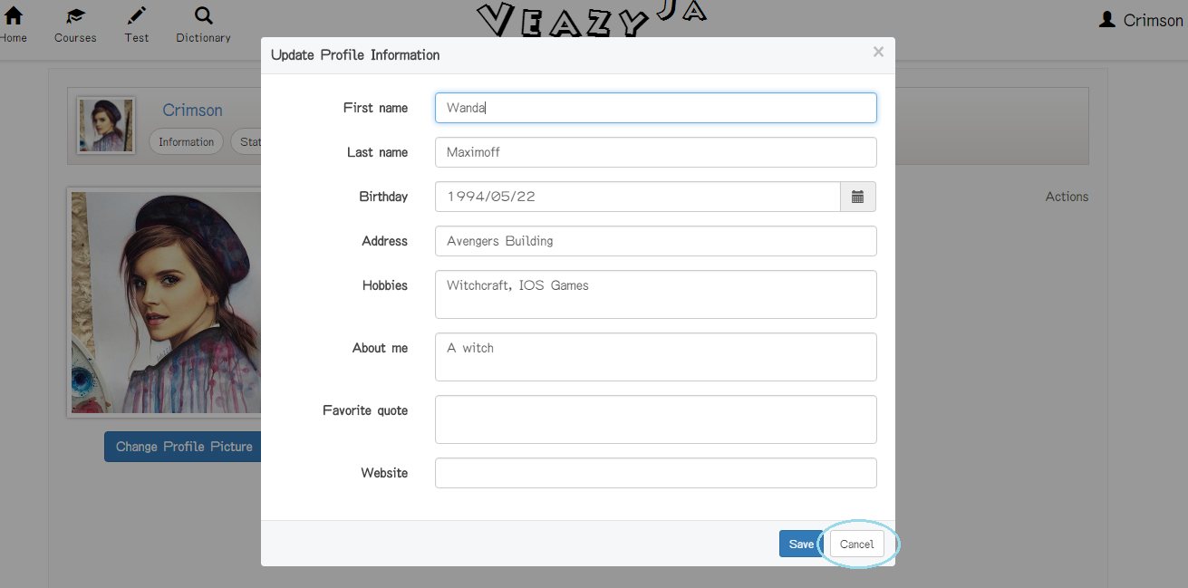

##### Change Password

To update profile on website, the users do the steps below:

Step 1: User clicks on “Change Password” in “Actions” dropdown list

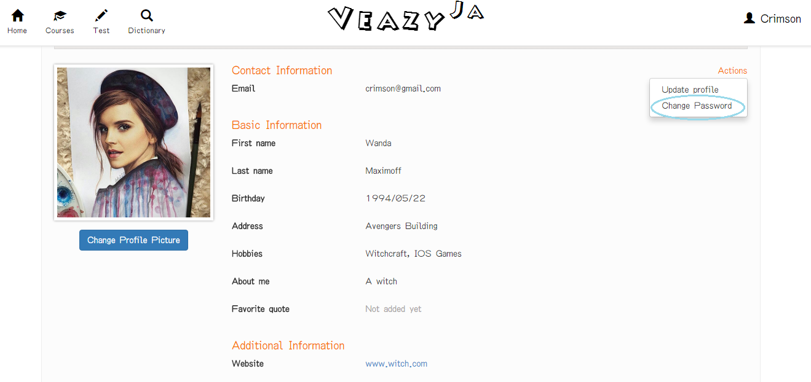

Step 2: Input information

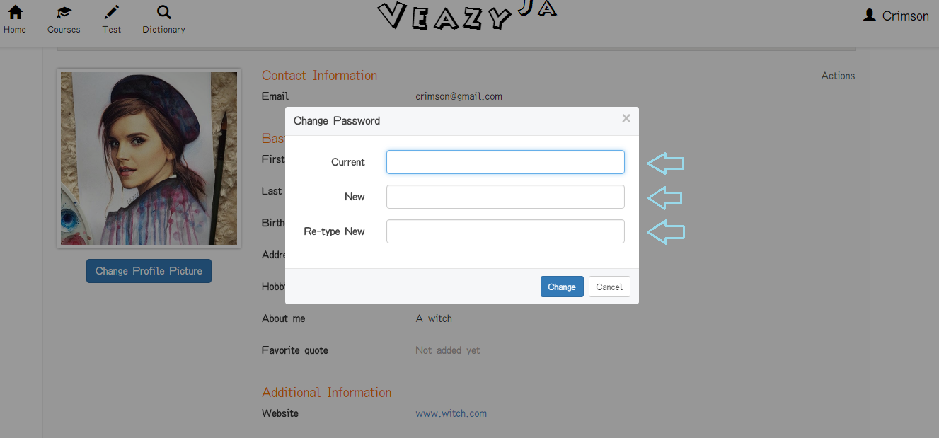

Step 3: Click on “Change” button.

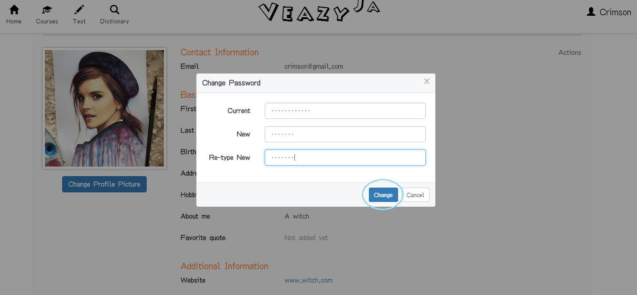

If user clicks “Cancel’ button, system cancel change password action and close “Change Password” popup

##### Change Profile Picture

##### View Statistics

To view statistics on website, the users do the steps below:

Step 1: User clicks on “Statistics” button in “Profile” page

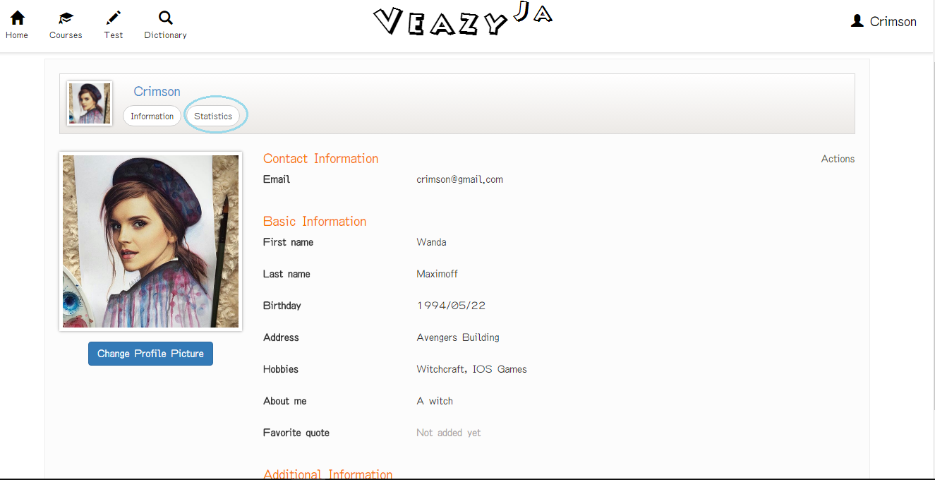

Step 2: System show statistics tab

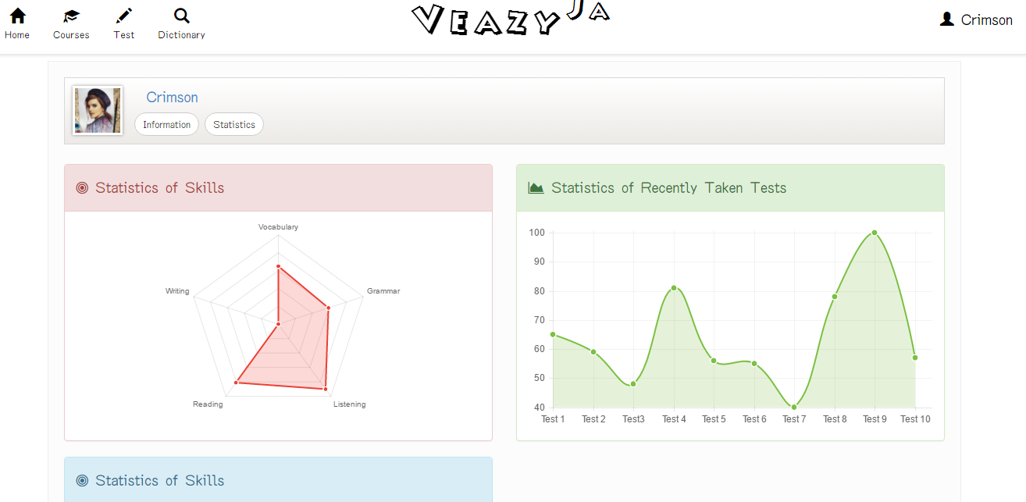

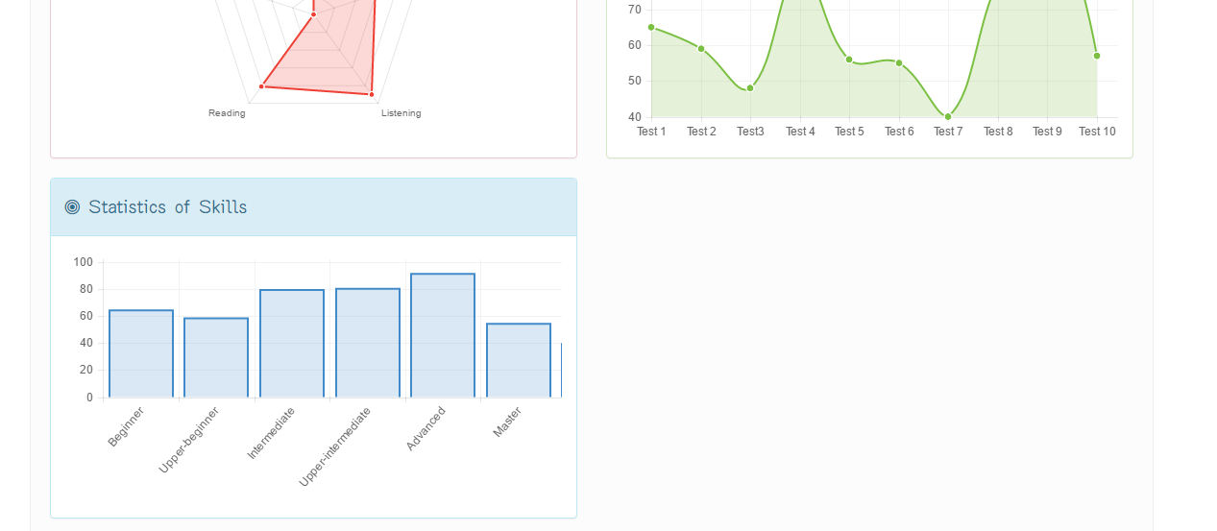

#### The User is Content Editor

Content Editor logged in the website

##### View Profile

##### Update Profile

##### Change Password

##### Change Profile Picture

##### Logout

To logout on website, the users do the steps below:

Step 1: User clicks on “Logout” link in sidebar

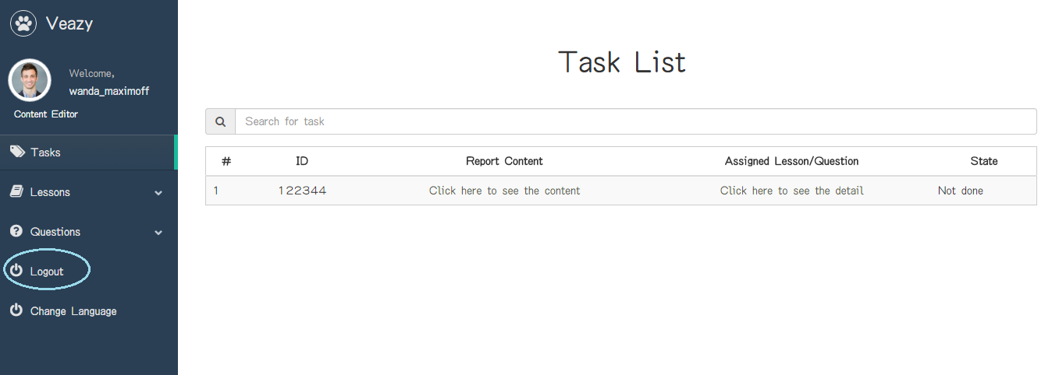

Step 2: Systems redirects to “Login” page

##### View Lessons List

To view lessons list on website, the users do the steps below:

Step 1: Click on “Lessons” link at dashboard

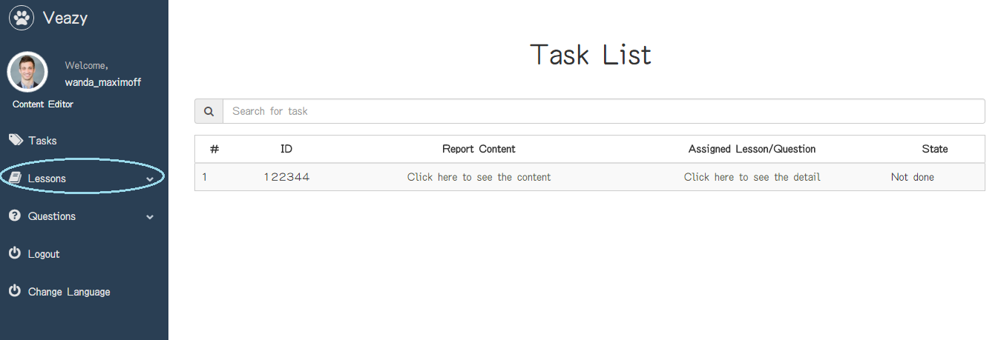

Step 2: User clicks on “Lesson List” hyperlink at dashboard in editor dashboard page

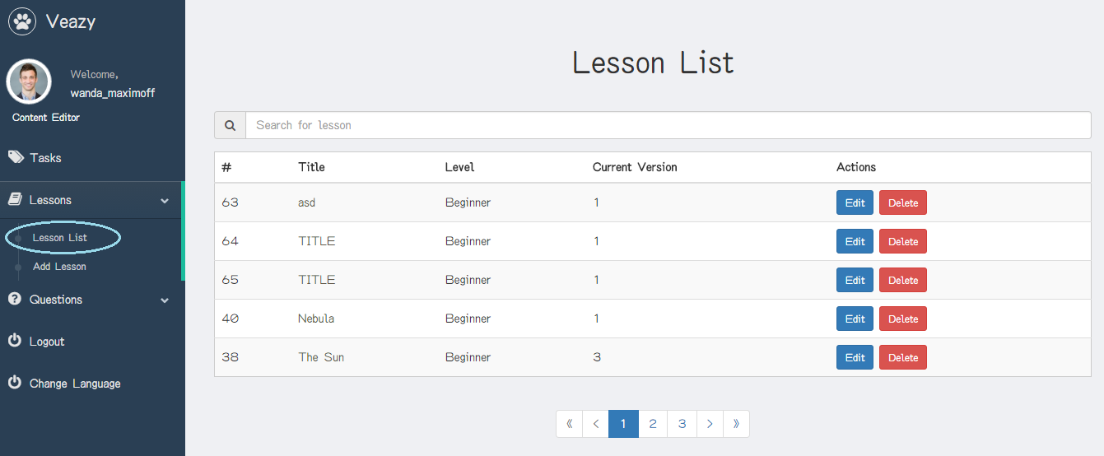

Step 3: System redirects to lesson list page

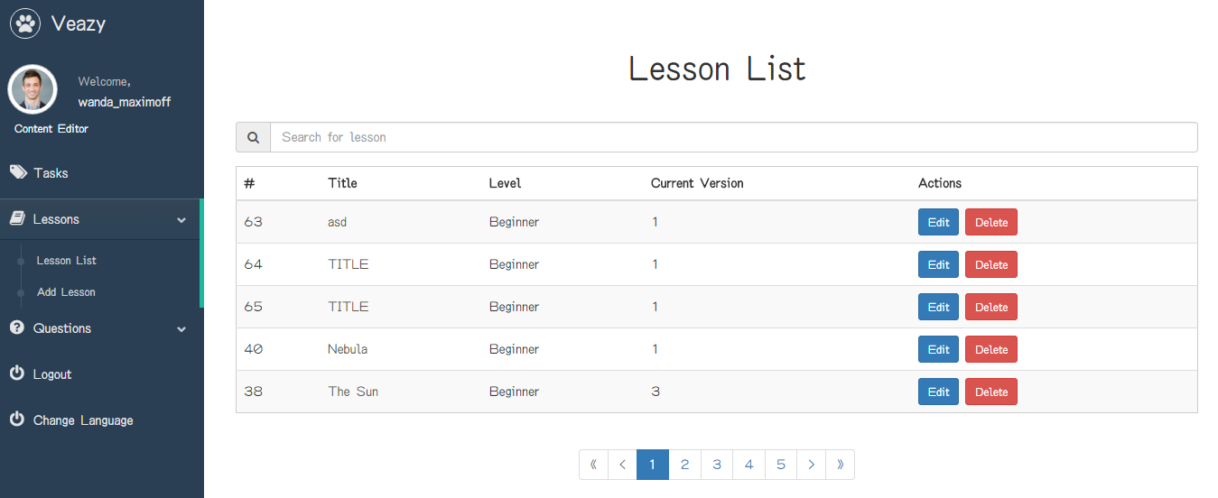

##### Search Lesson

To search lesson on website, the users do the steps below:

Step 1: User inputs text to the search box

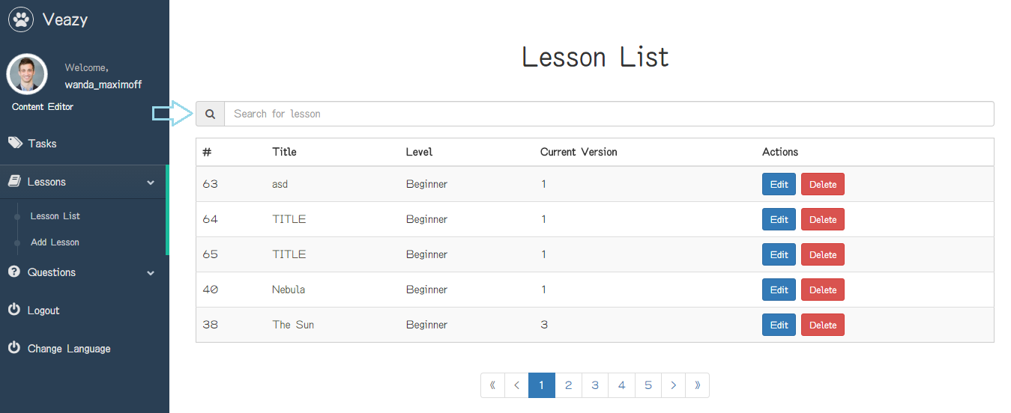

Step 2: User clicks on “Search” button

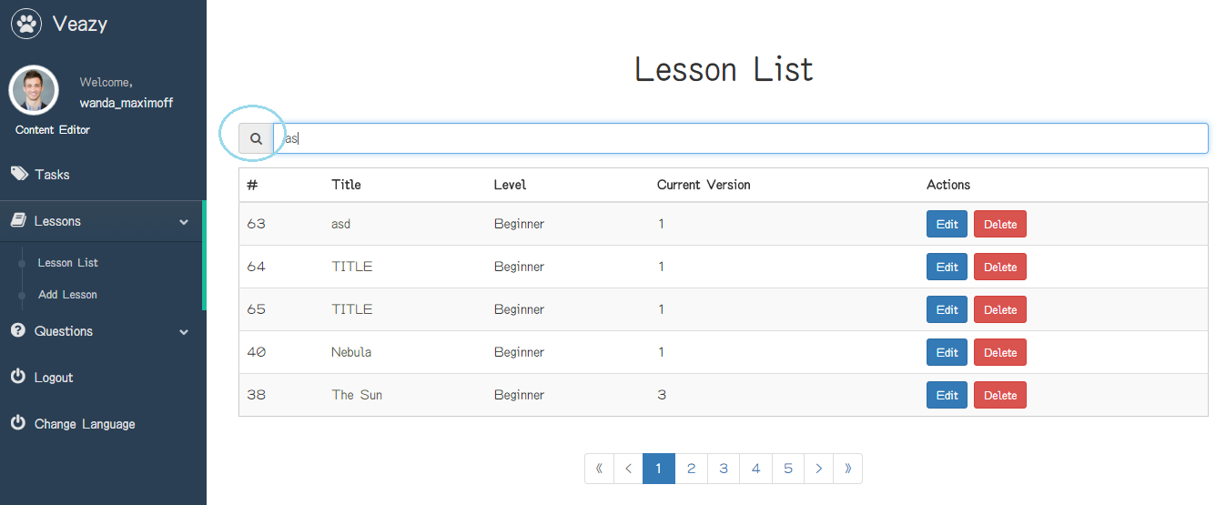

Step 3: System will filter and display result if search lesson successful

##### View Lesson Details

To view lesson details on website, the users do the steps below:

Step 1: User clicks on title name link of table in lesson list page

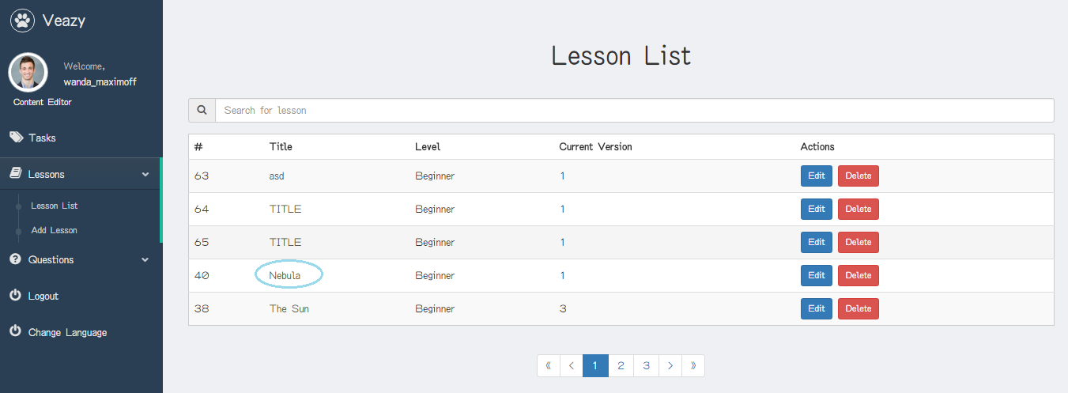

Step 2: System redirects to lesson details page if view lesson details successful

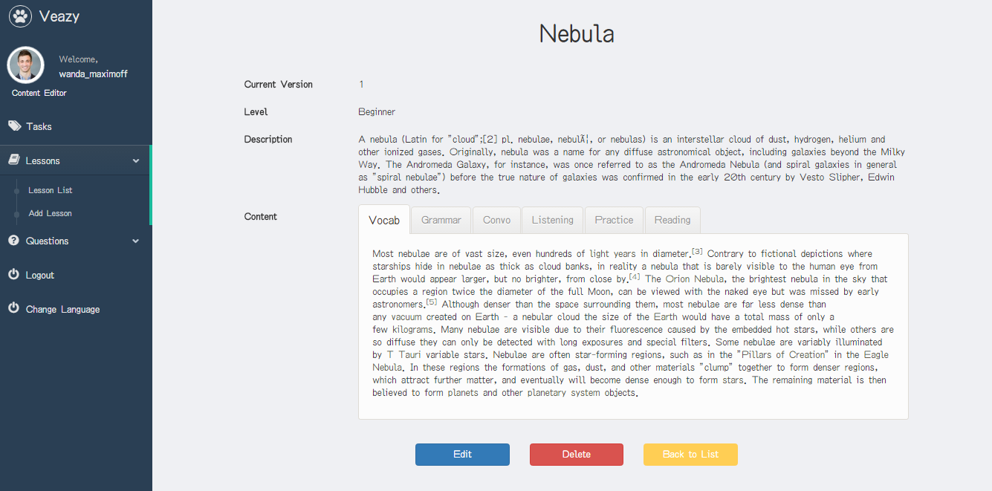

##### Create Lesson

To create lesson on website, the users do the steps below:

Step 1: User clicks on “Lessons” link at dashboard



Step 2: User clicks on “Add Lesson” hyperlink at dashboard in editor dashboard page

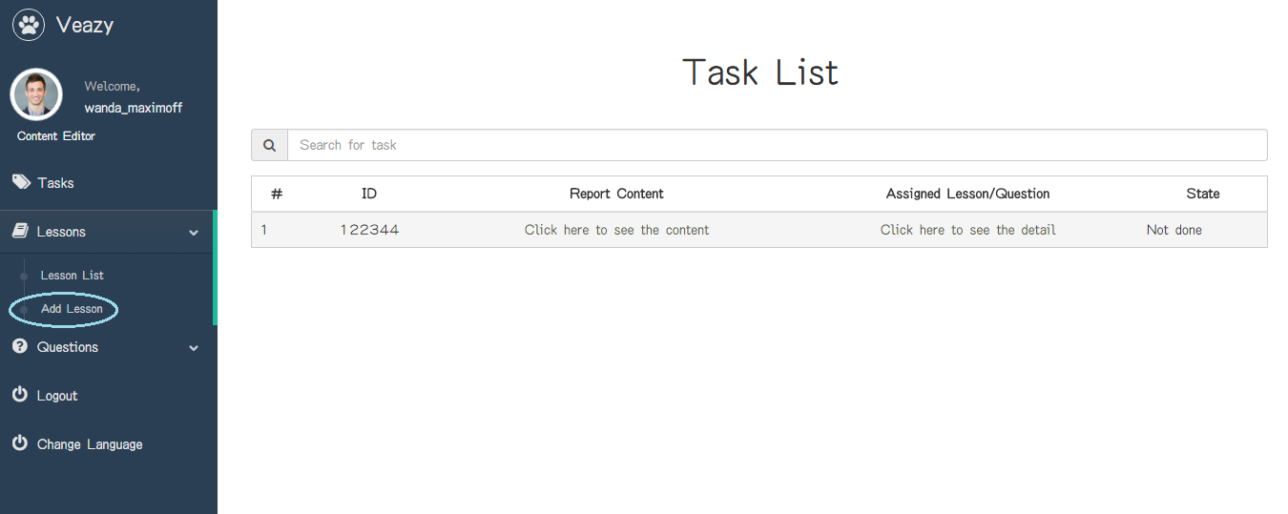

Step 3: User inputs information

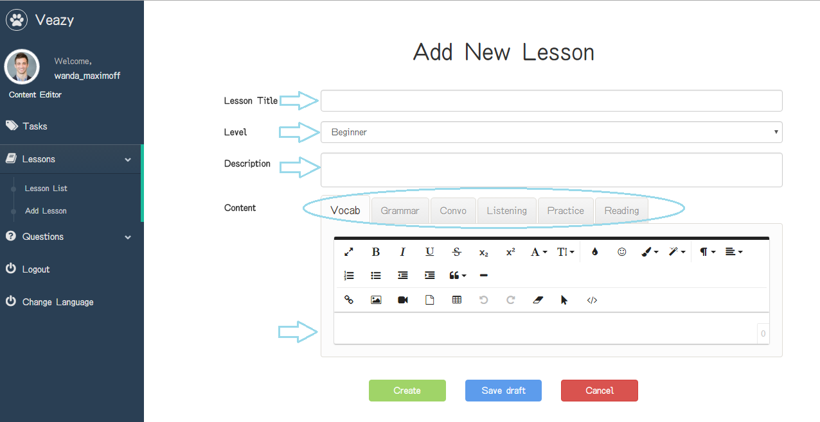

Step 4: User clicks on “Create” button

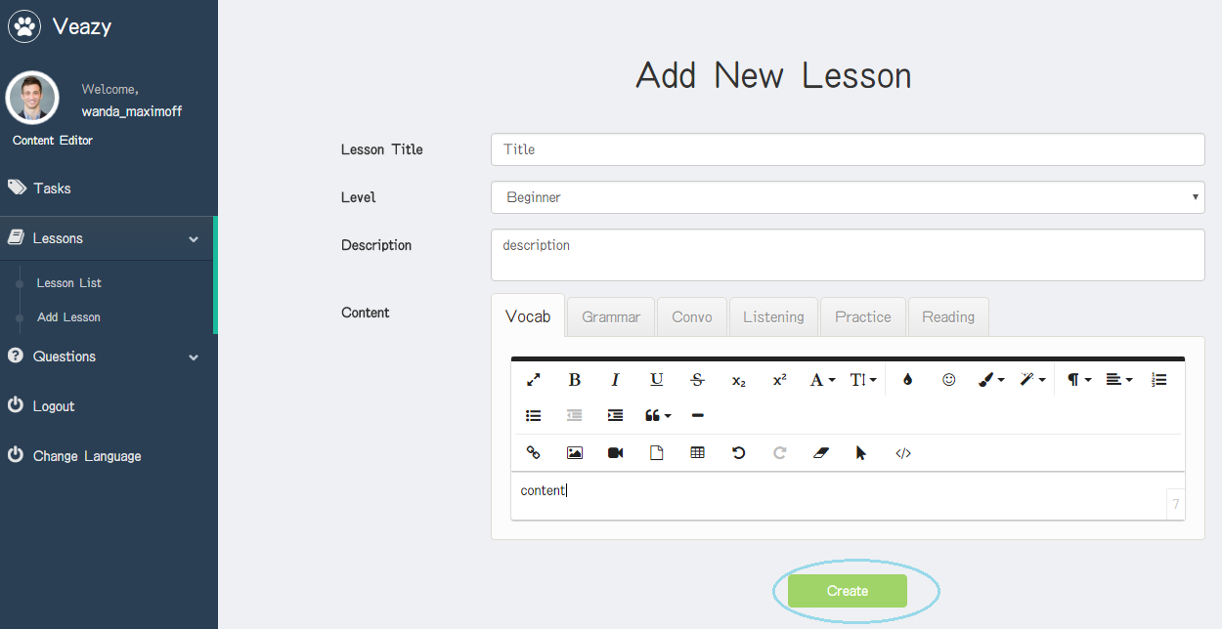

Step 5: System redirects to lesson list page and add new lesson

##### Save Draft Lesson

To save draft lesson on website, the users do the steps below:

Step 1: User clicks on “Save draft” button in edit lesson page

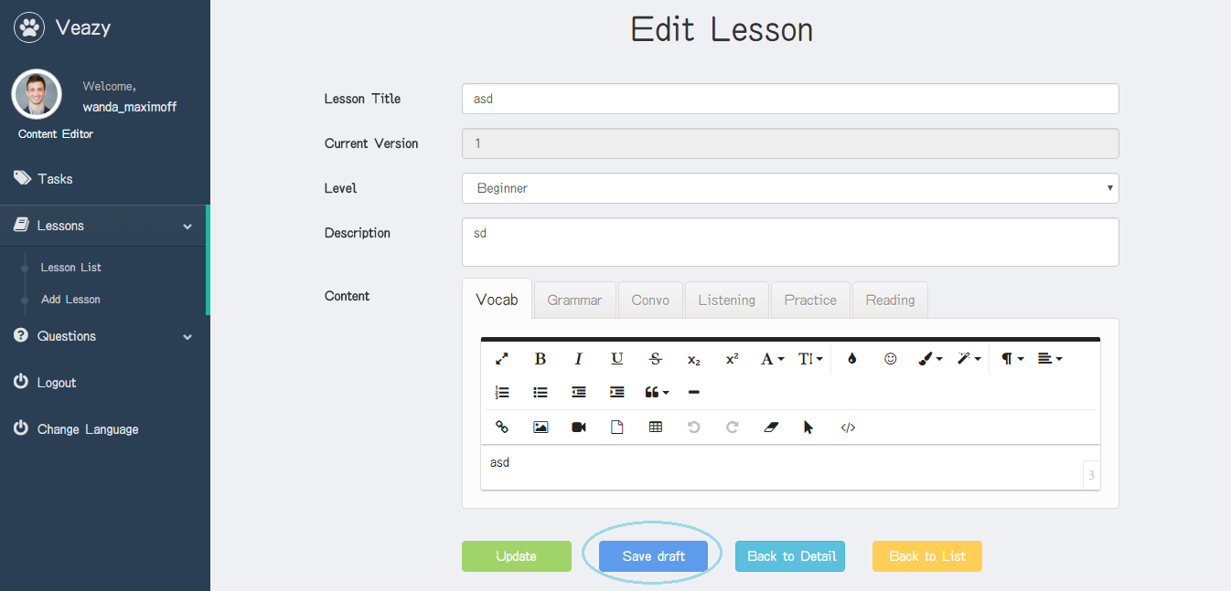

##### Edit Lesson

To edit lesson on website, the users do the steps below:

Step 1: User clicks on “Edit” button in lesson list page

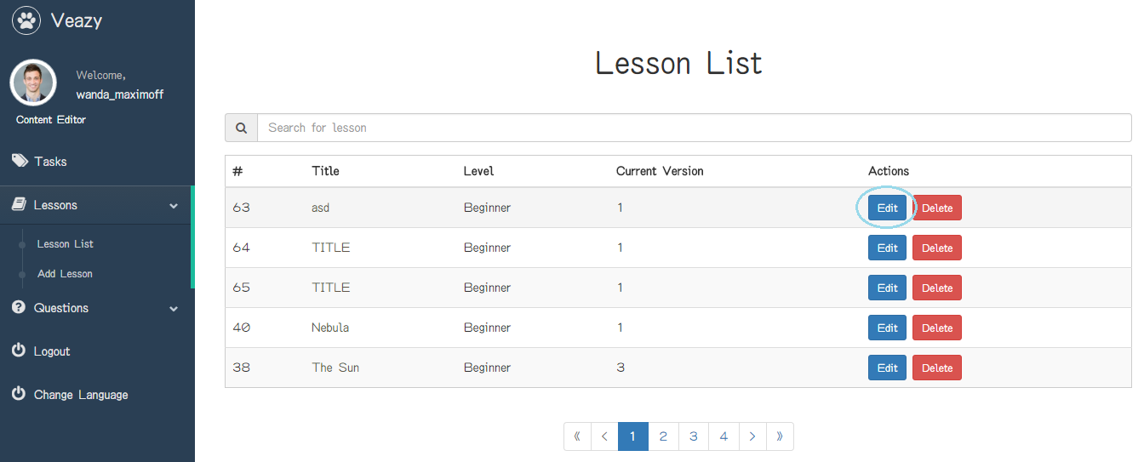

Step 2: User updates information

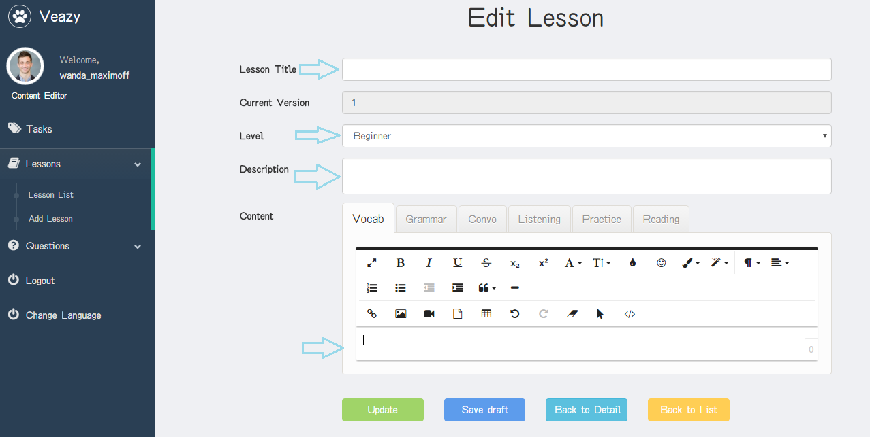

Step 3: User clicks on “Update” button

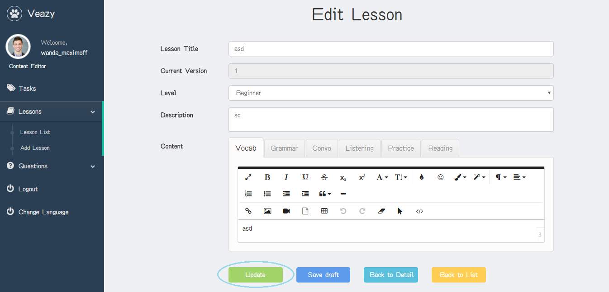

##### Delete Lesson

To delete lesson on website, the users do the steps below:

Step 1: User clicks on “Delete” button in lesson list page

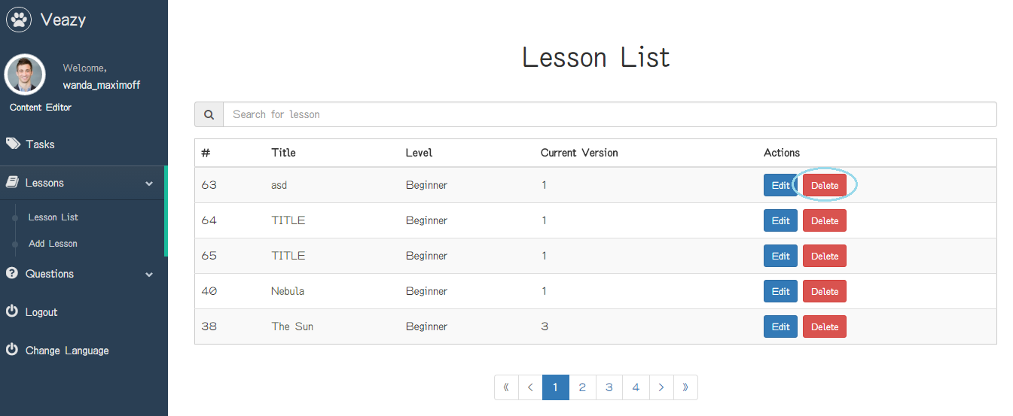

Step 2: User clicks on “Delete” button in “Delete Lesson” popup

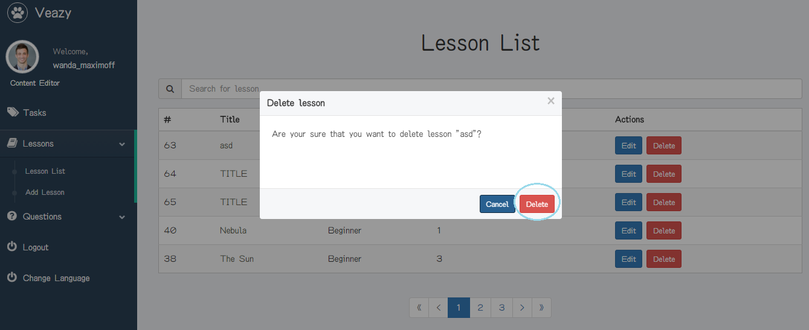

##### View Lesson Report

To view lesson report, the users do the steps below:

Step 1: User clicks on “Tasks” link at dashboard in content editor dashboard page

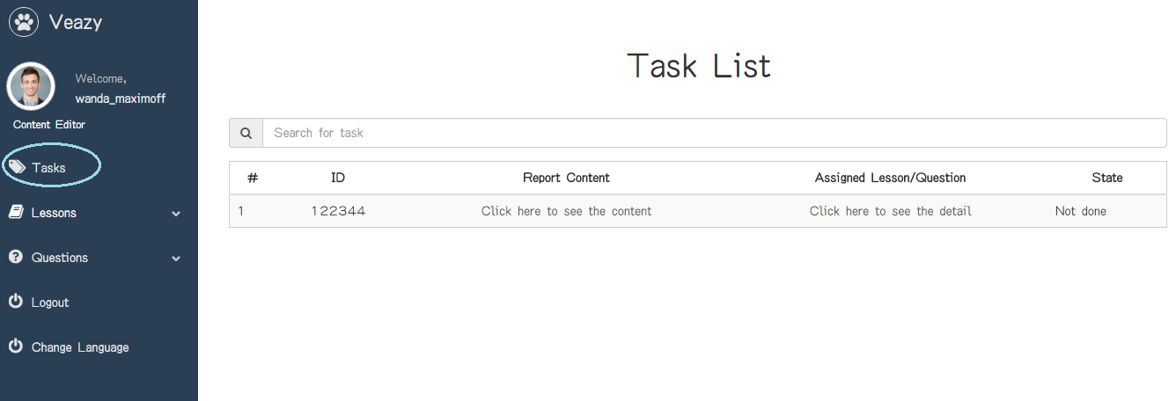

Step 2: System redirects to view report page

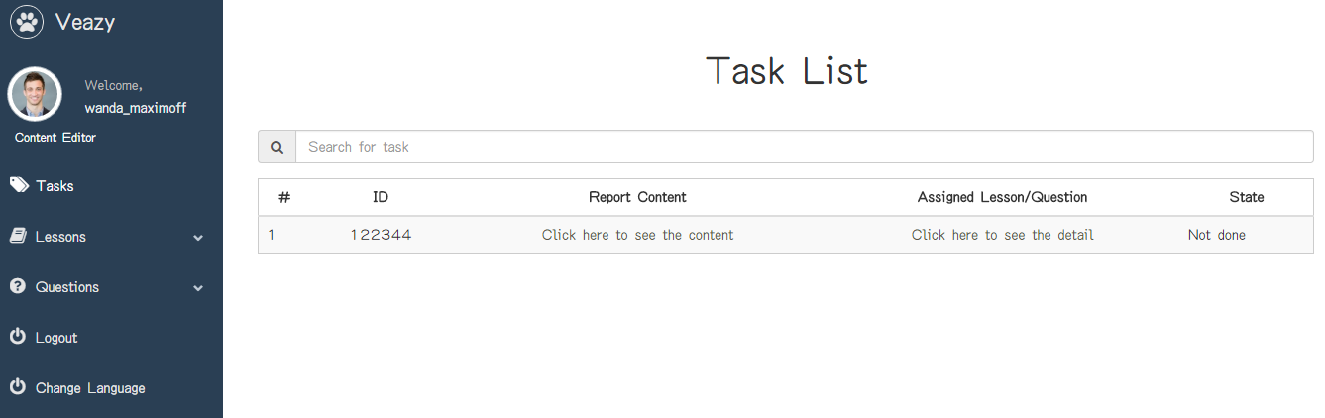

##### View Questions List

To view question list on website, the users do the steps below:

Step 1: User clicks on “Questions” link at dashboard

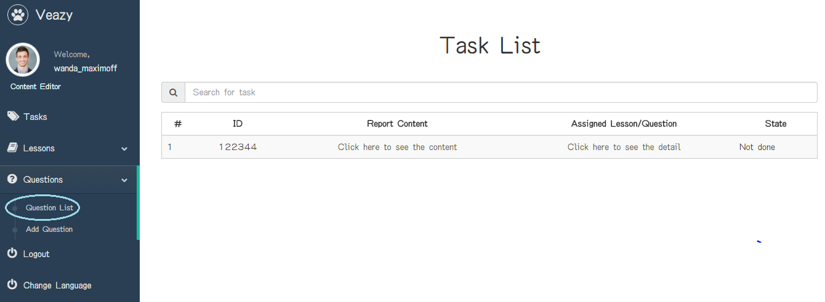

Step 2: User clicks on “Question List” hyperlink at dashboard in editor dashboard page



Step 3: System redirects to question list page

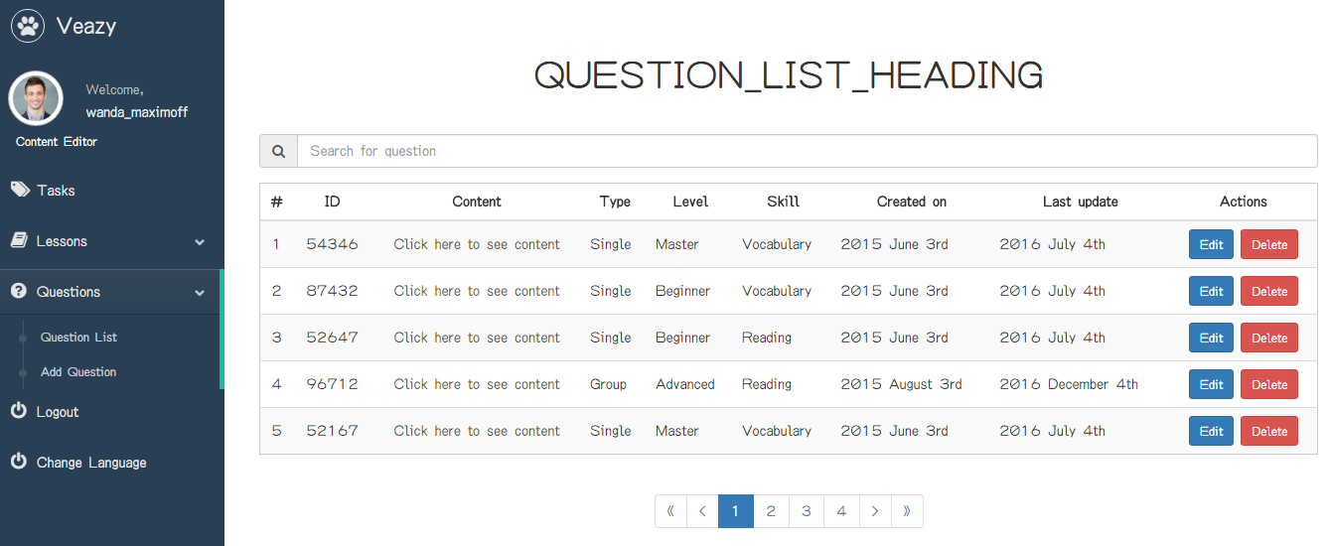

##### Search Question

To search question list on website, the users do the steps below:

Step 1: User inputs text to the search box

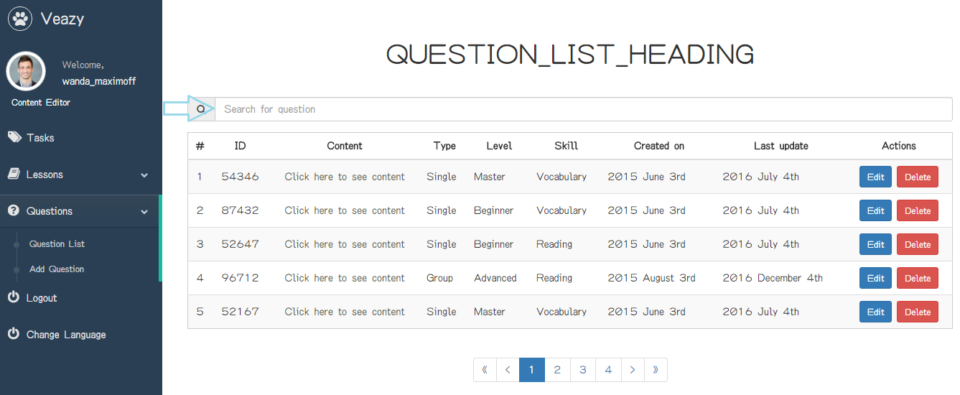

Step 2: User clicks on “Search” button

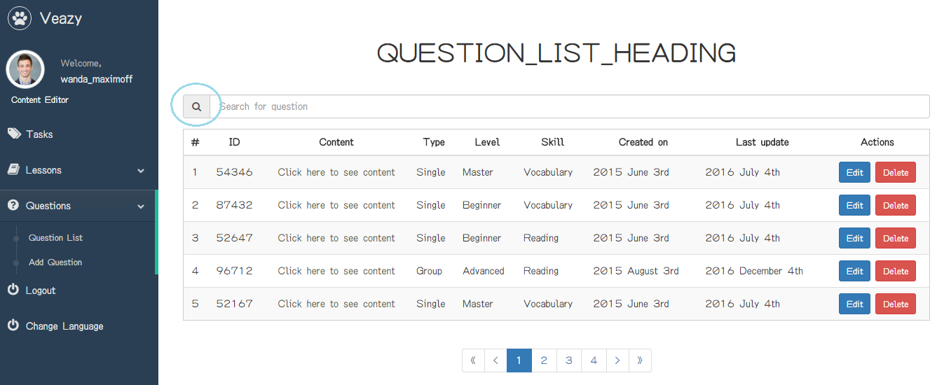

##### View Question Details

To view question details on website, the users do the steps below:

Step 1: User clicks on “Click here to see content” link of each question

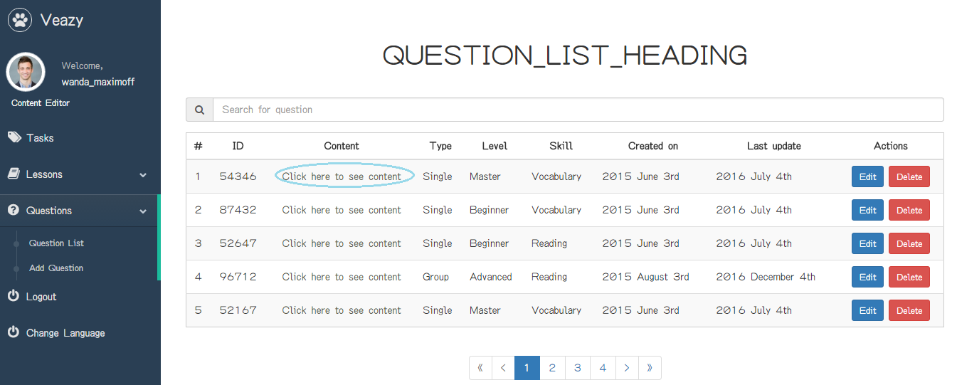

Step 2: System redirects to question details page if view question details successful

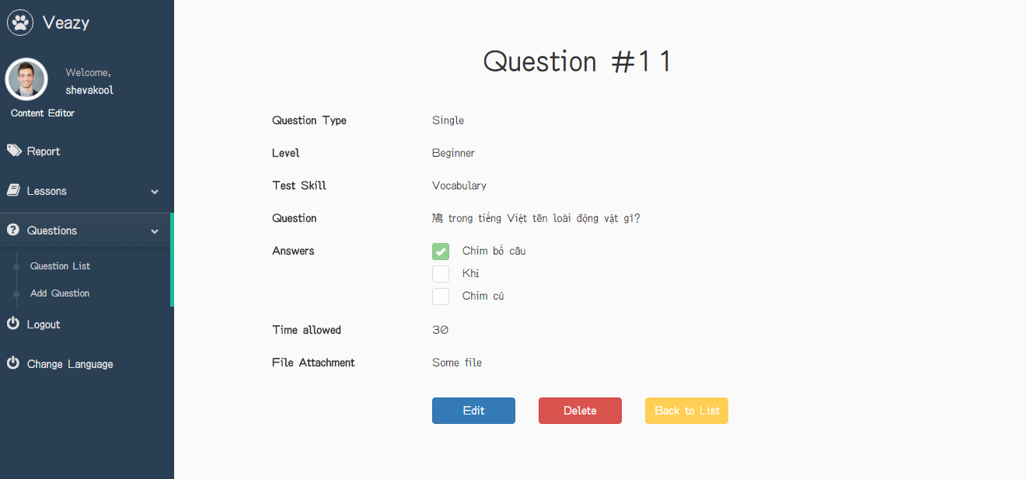

##### Create Single Question

To create single question on website, the users do the steps below:

Step 1: User clicks on “Add Question” hyperlink in “Editor Dashboard” page

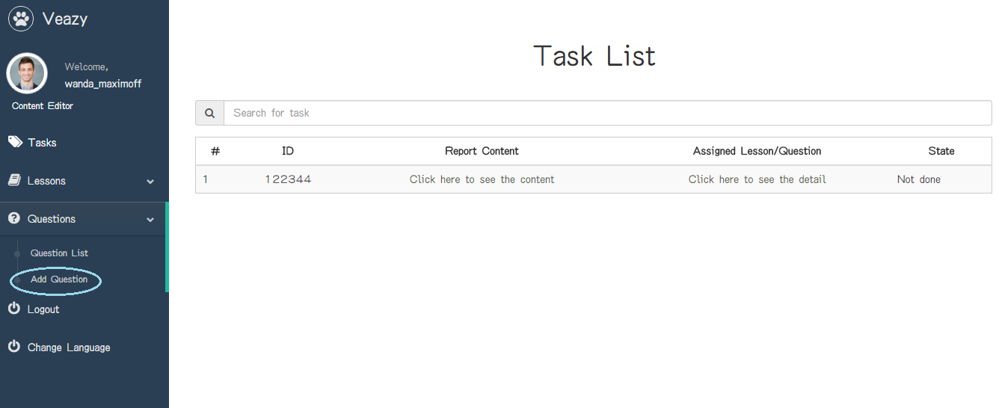

Step 2: User chooses “Single” in “Question Type” dropdown list

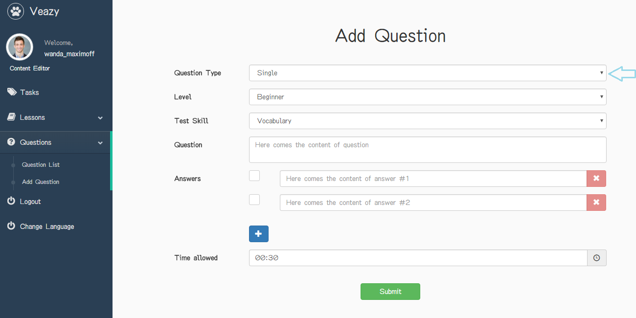

Step 3: User chooses question level in “Level” dropdown list

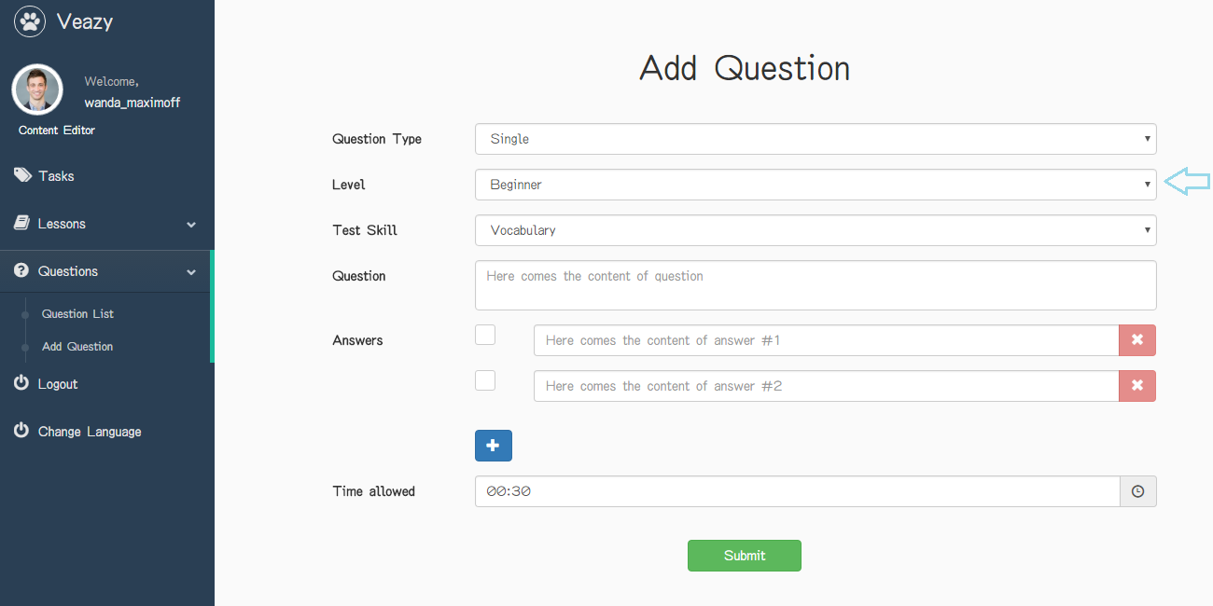

Step 4: User chooses question skill in “Test Skill” dropdown list

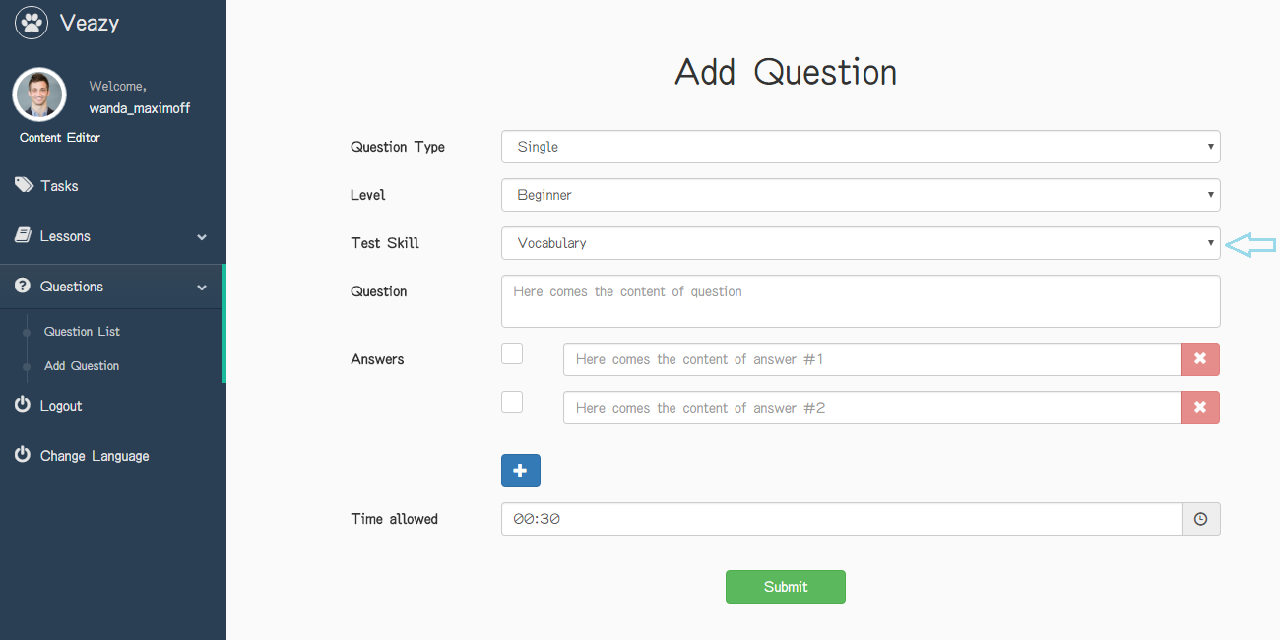

Step 5: User inputs question and answer and choose right answer

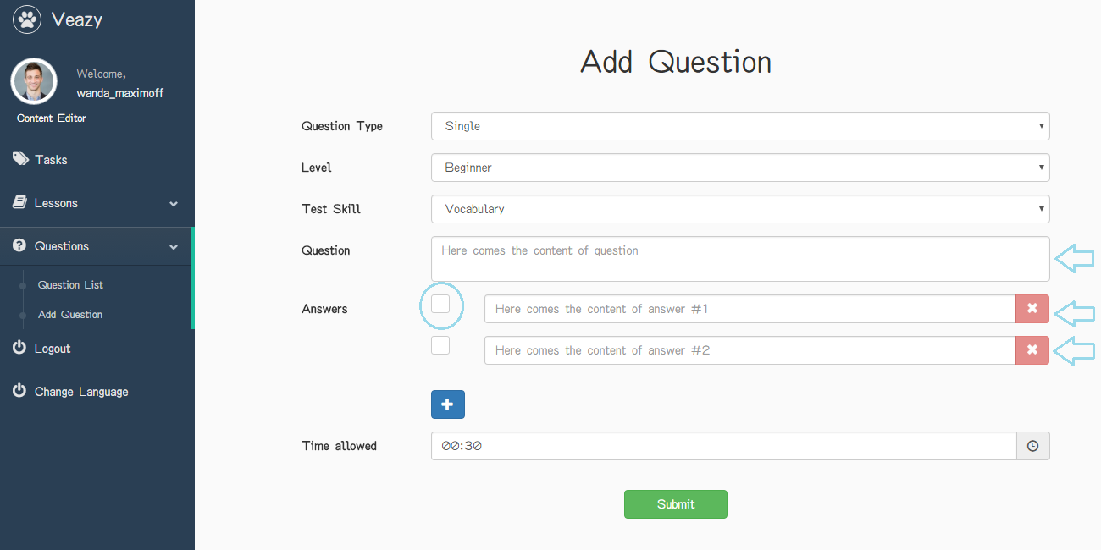

Step 6: User clicks on time icon to select time allowed in section “Time allowed”

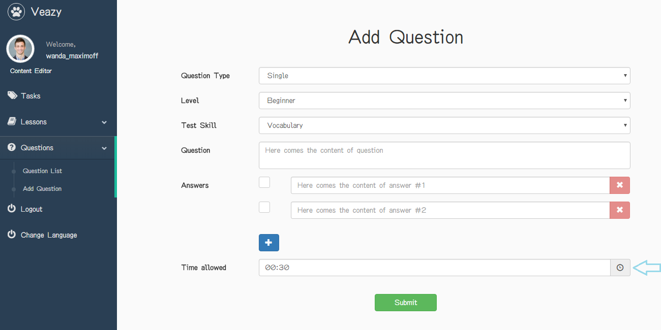

Step 7: Click on “+” button under answer field to add more answer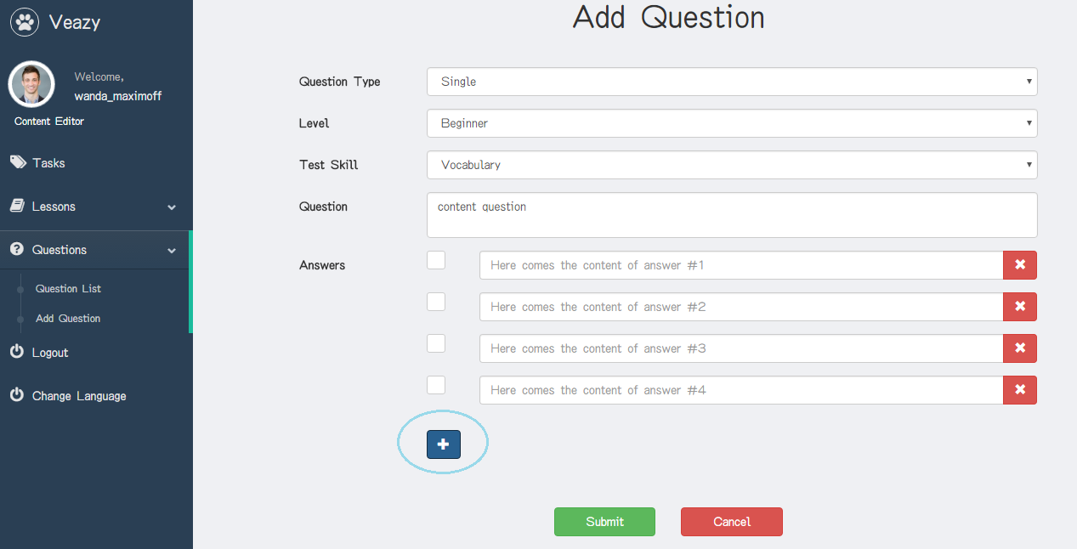

Step 8: User clicks on “x” button under answer field to delete answer

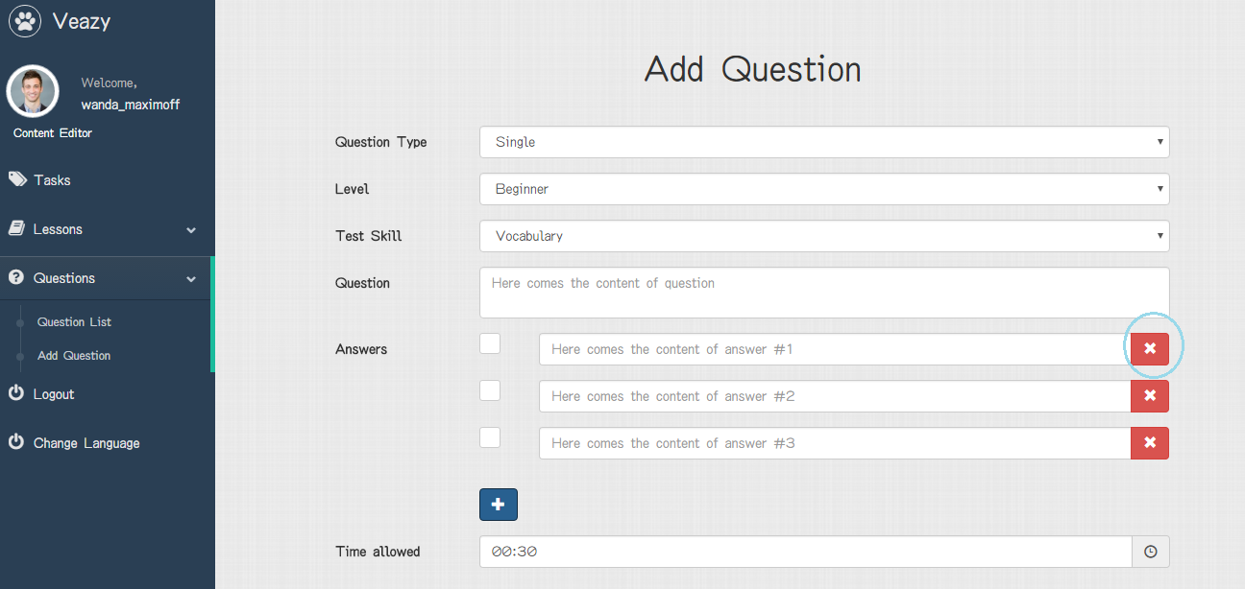

Step 9: User clicks on “Submit” button

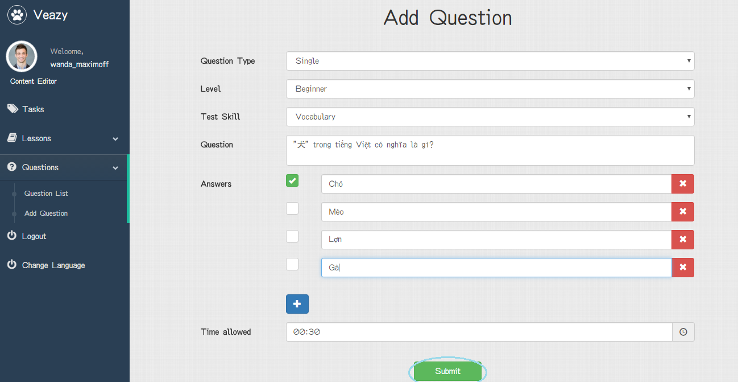

Step 10: System redirects to question list page and add new lesson



##### Create Question Group

To create single question on website, the users do the steps below:

Step 1: User clicks on “Add Question” hyperlink in “Editor Dashboard” page



Step 2: User chooses “Group” in “Question Type” dropdown list

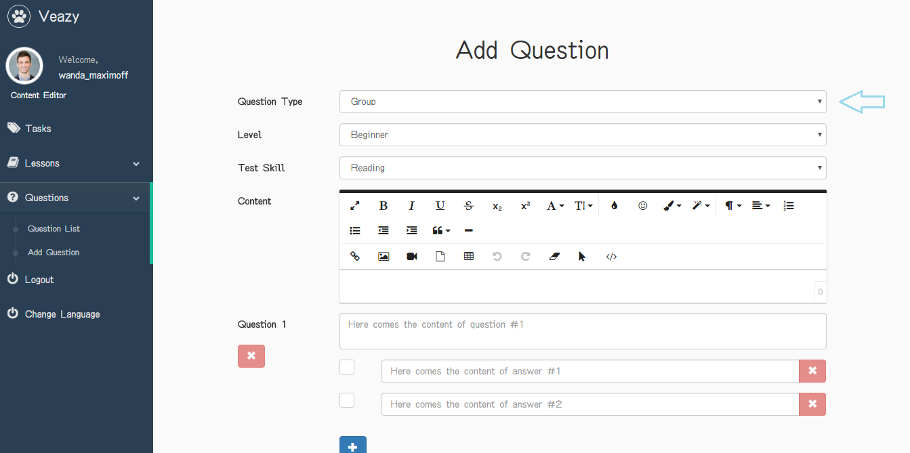

Step 3: User chooses question level in “Level” dropdown list

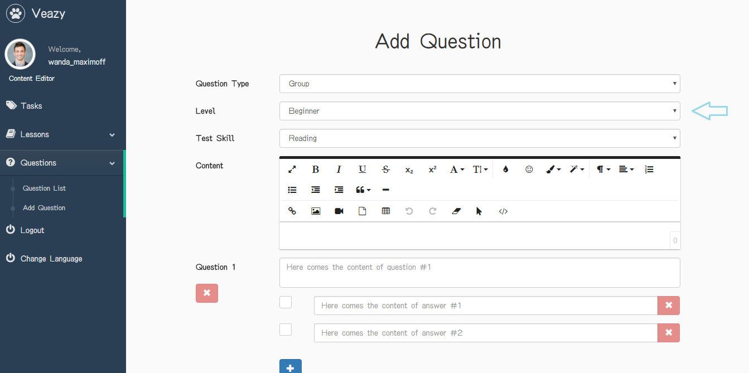

Step 4: User inputs question and answer and choose right answer

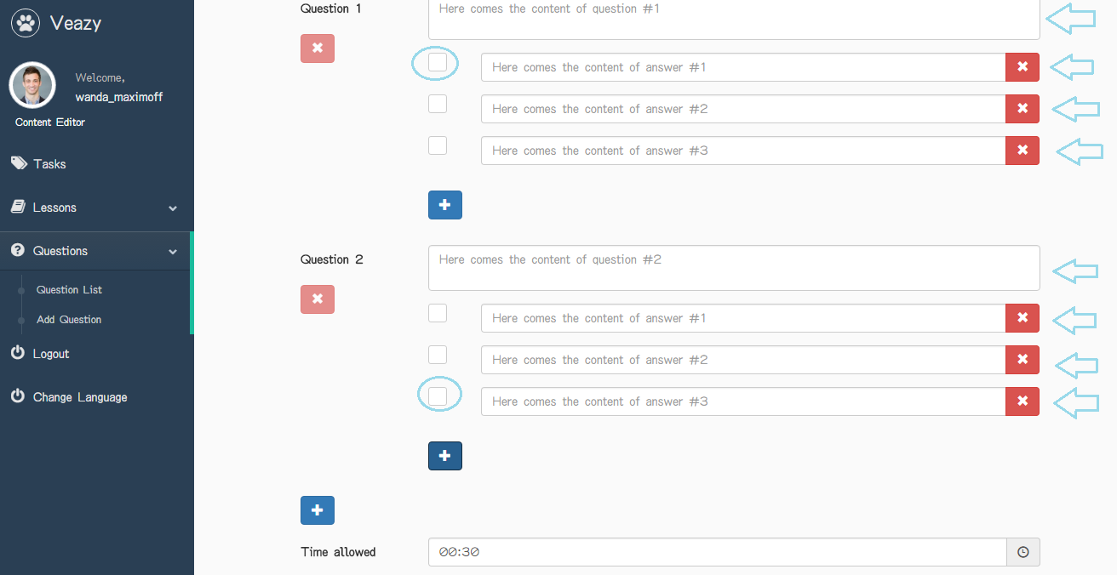

Step 5: User inputs information in section “Content”

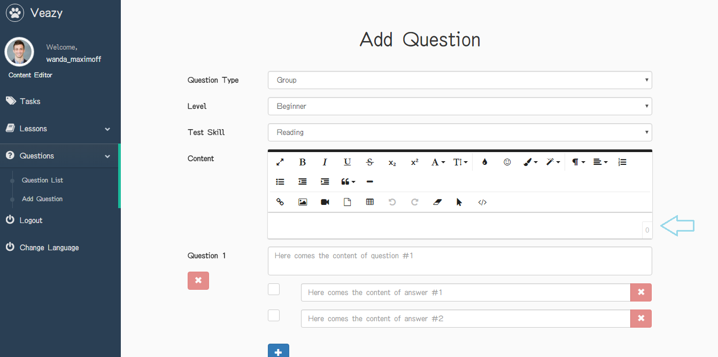

Step 6: User clicks on “+” button under answer field to add more answer

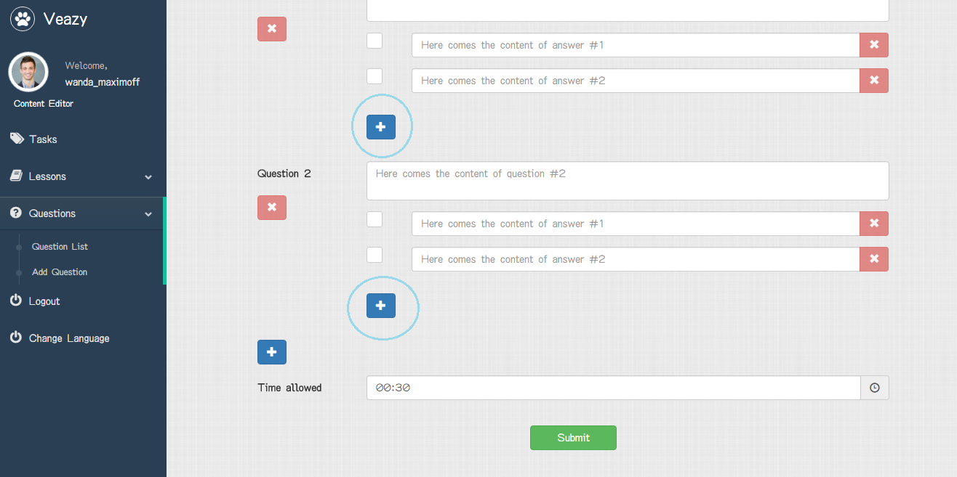

Step 7: User clicks on “+” button under question to add more question

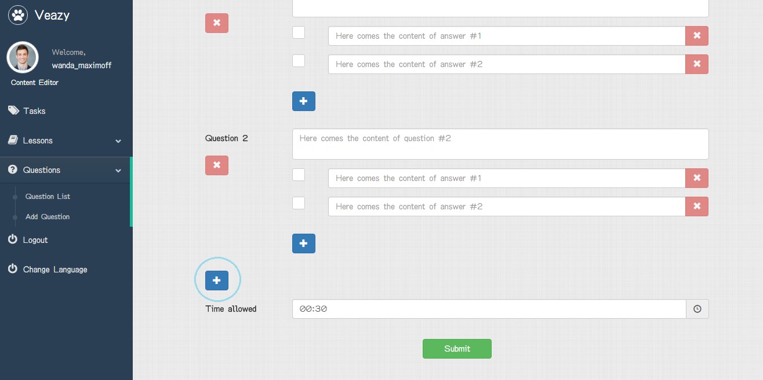

Step 8: Click on “x” button under answer field to delete answer or question

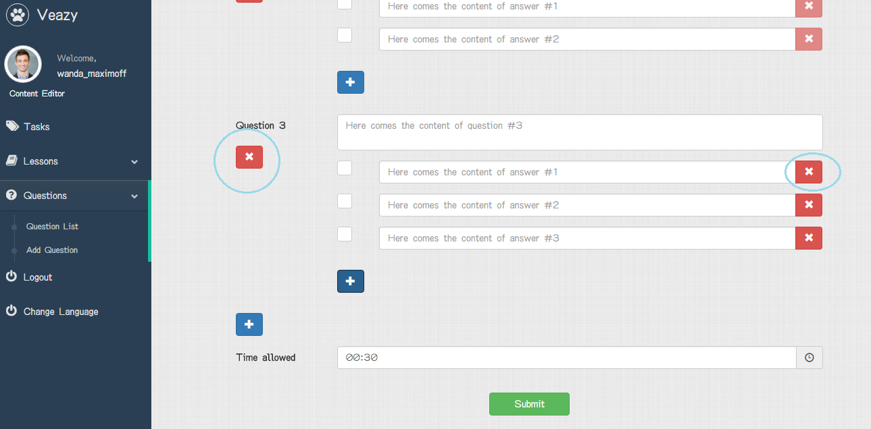

Step 9: User clicks on time icon to select time allowed in section “Time allowed”

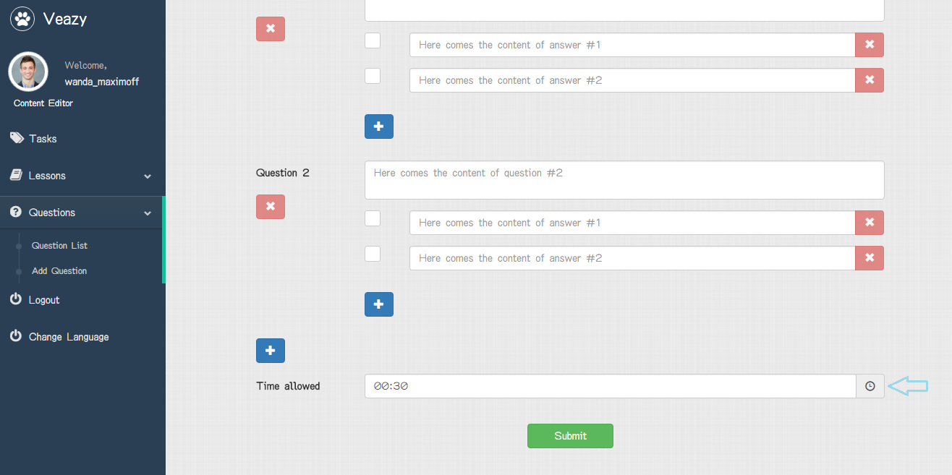

Step 10: User clicks on “Submit” button

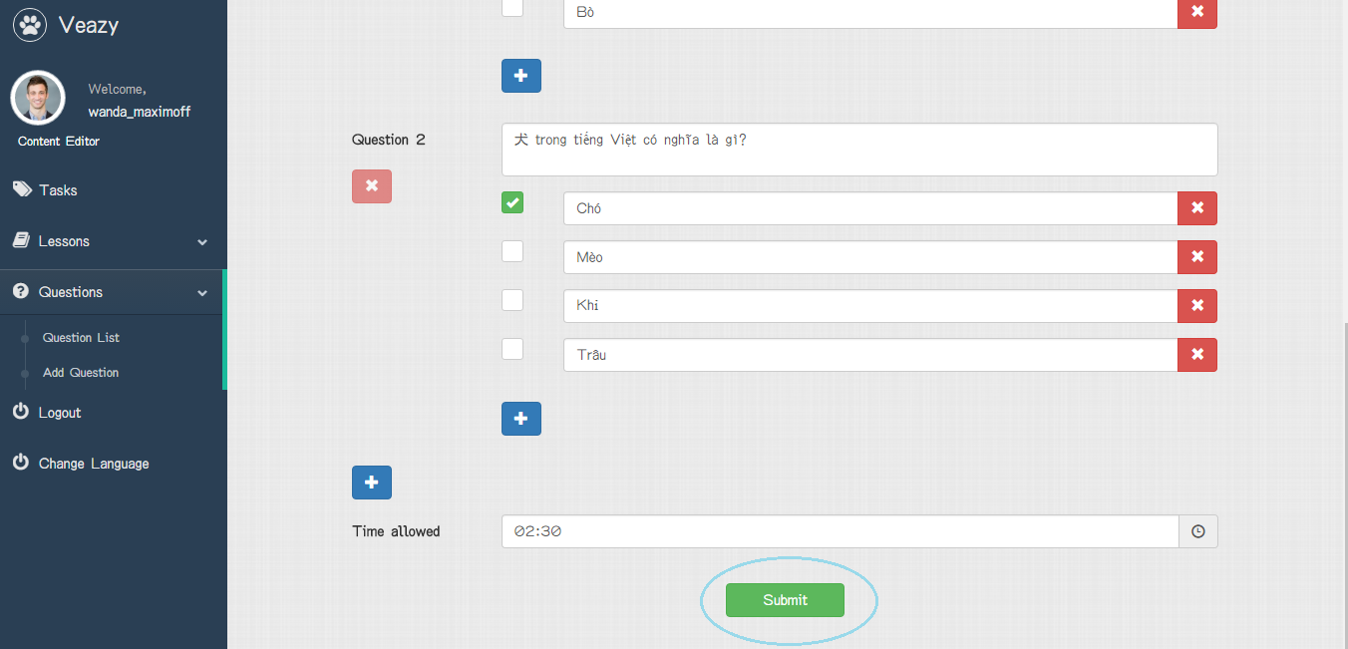

##### Edit Single Question

To edit single question on website, the users do the steps below:

Step 1: User clicks on “Edit” button

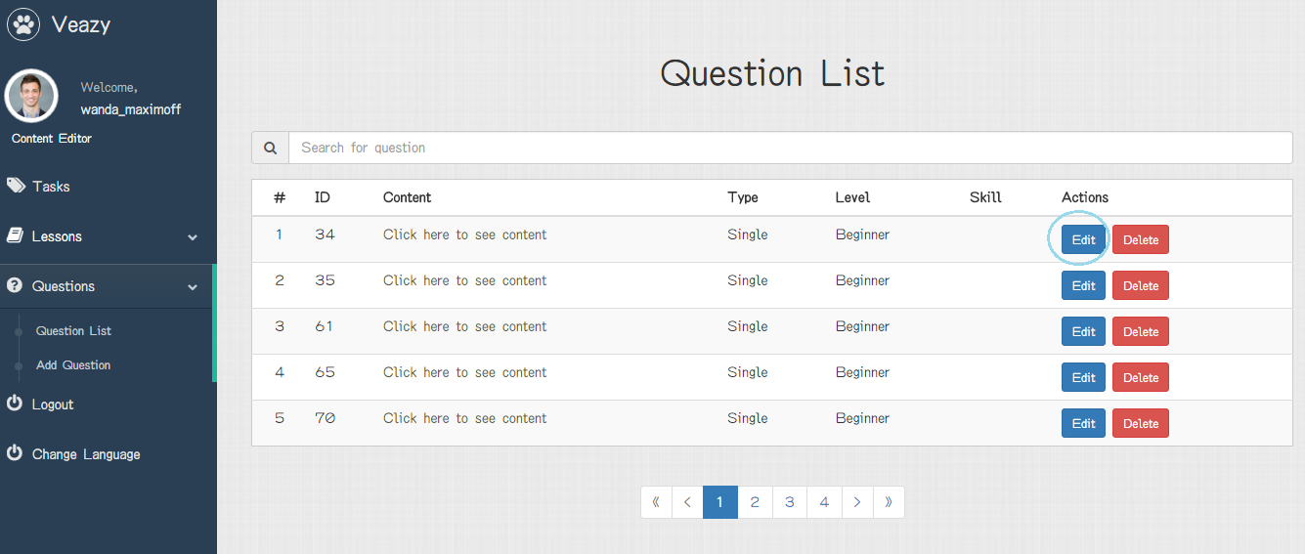

Step 2: User updates question level in “Level” dropdown list

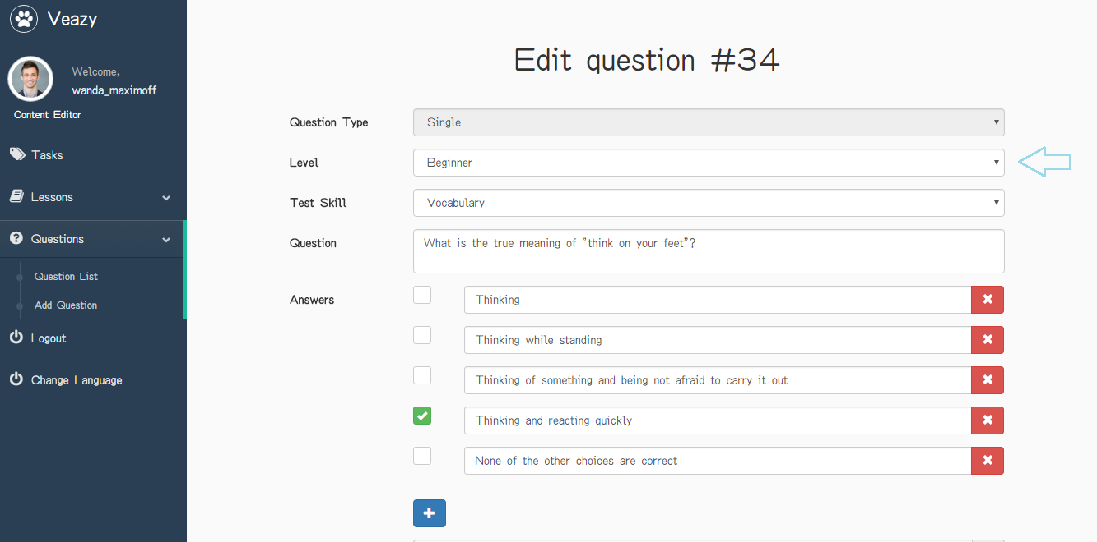

Step 3: User updates question skill in “Test Skill” dropdown list

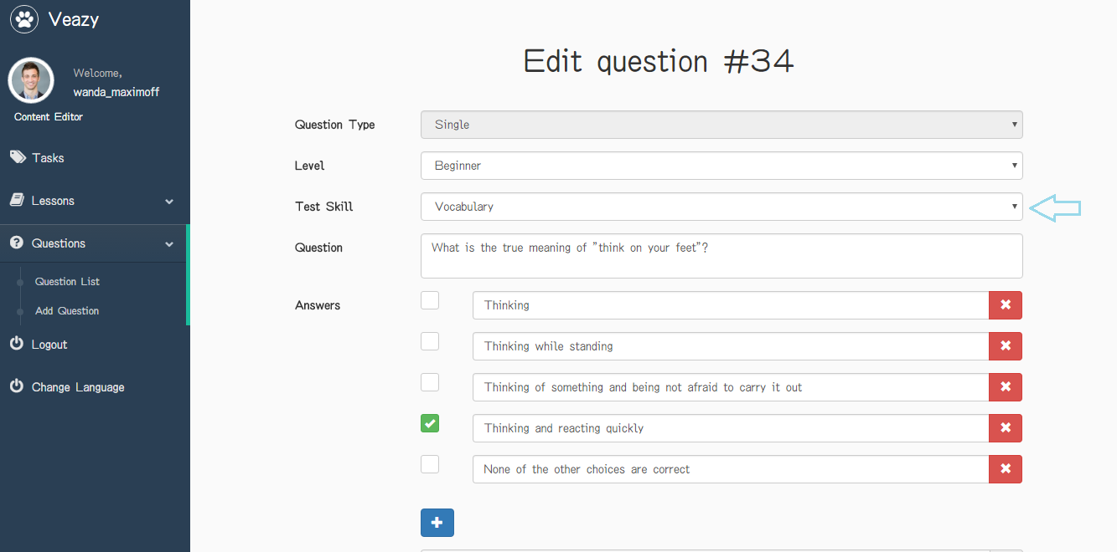

Step 4: User updates information in section “Question” and “Answers” and edits right answer

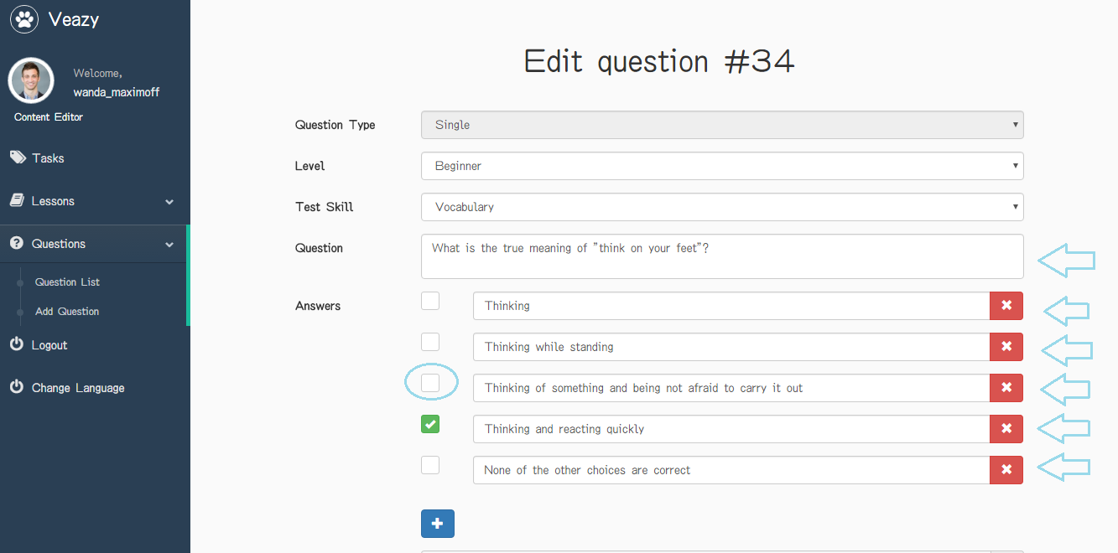

Step 5: User clicks on “+” button under answer field to add more answer

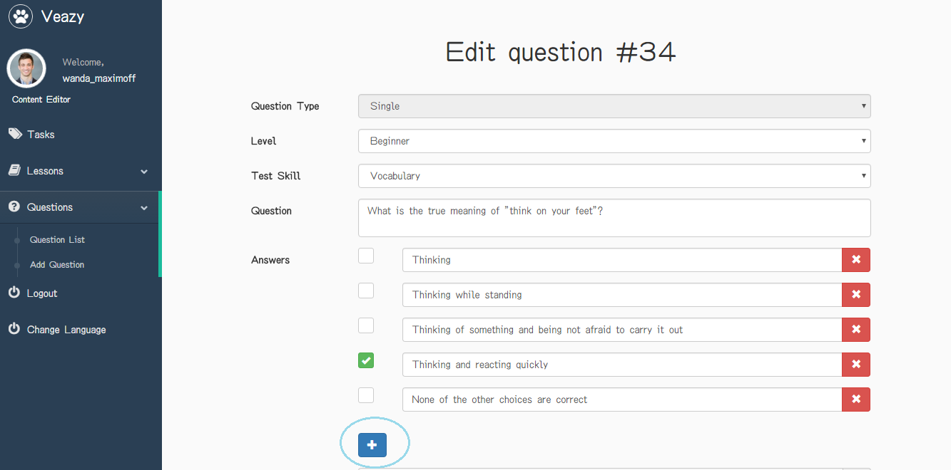

Step 6: User clicks on “x” button under answer field to delete answer

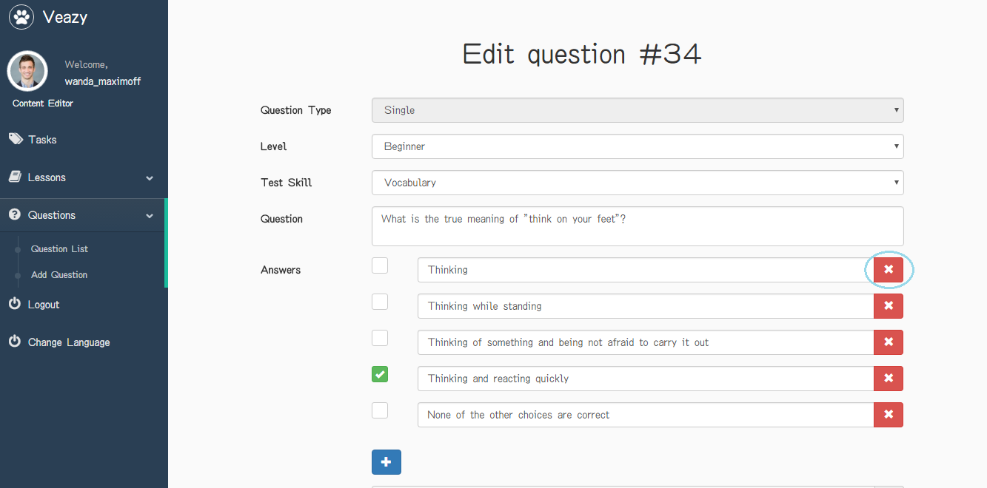

Step 7: User clicks on time icon to update time allowed in section “Time allowed”

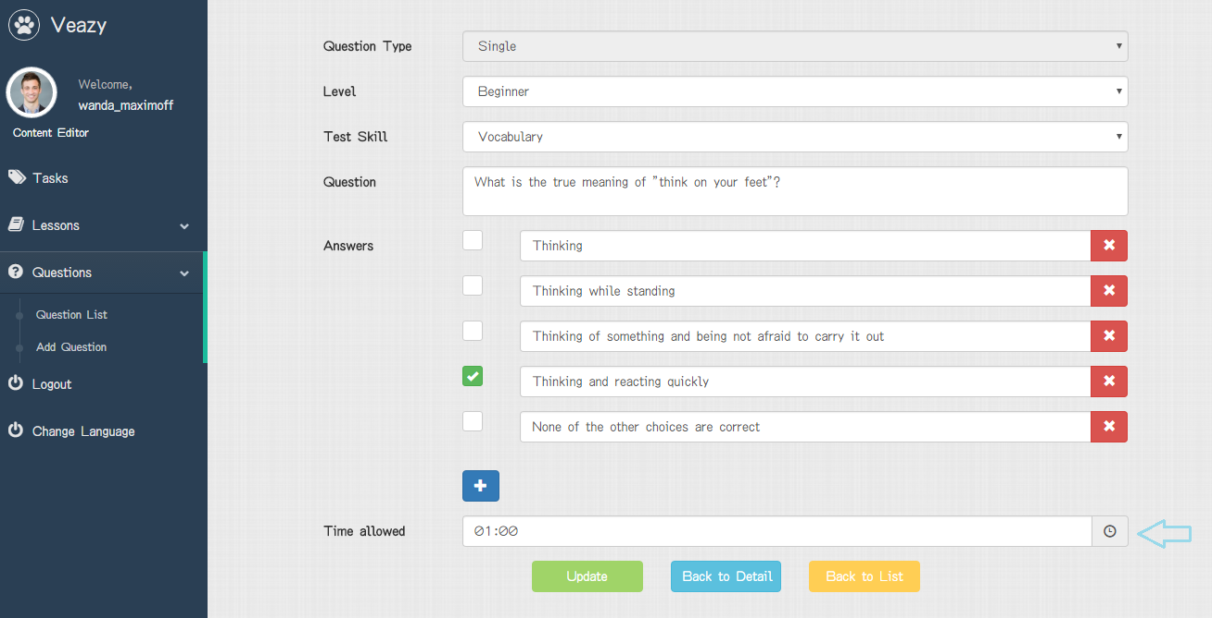

Step 8: User clicks on “Update” button

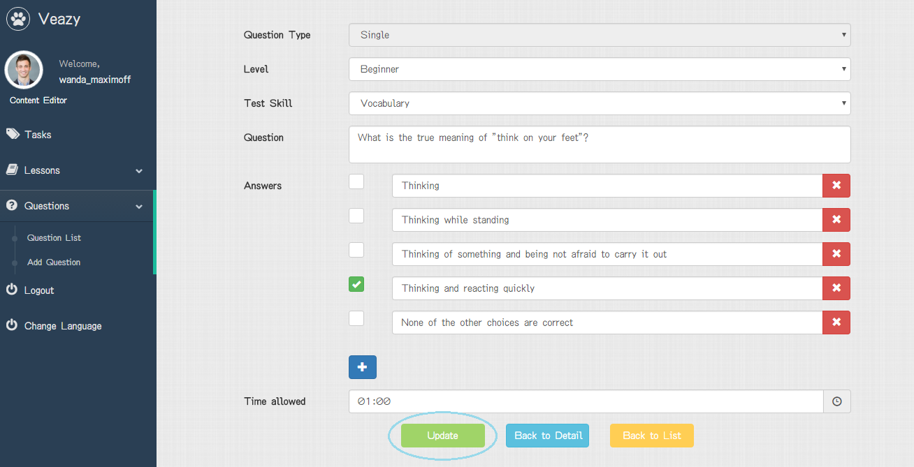

Step 9: System redirects to question list page and edited lesson



##### Edit Question Group

To edit group question on website, the users do the steps below:

Step 1: User clicks on “Edit” button

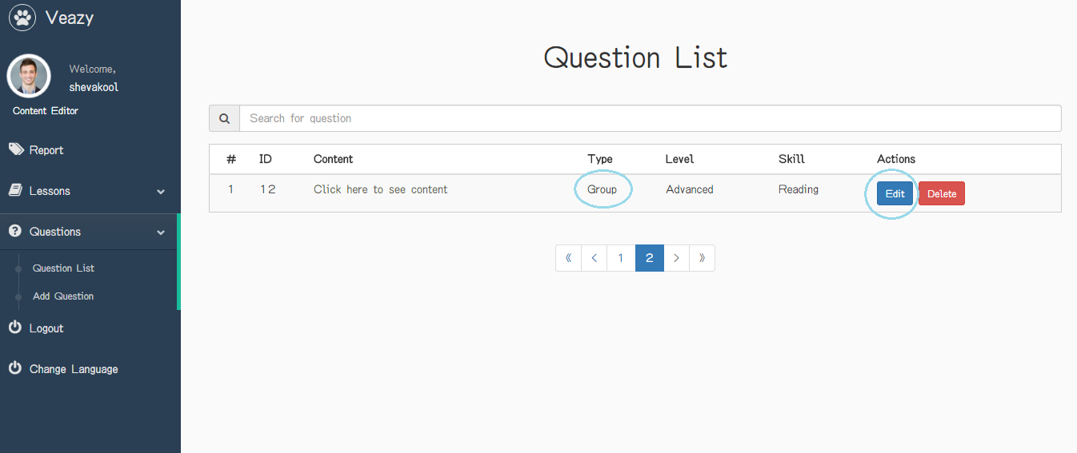

Step 2: User updates question level in “Level” dropdown list

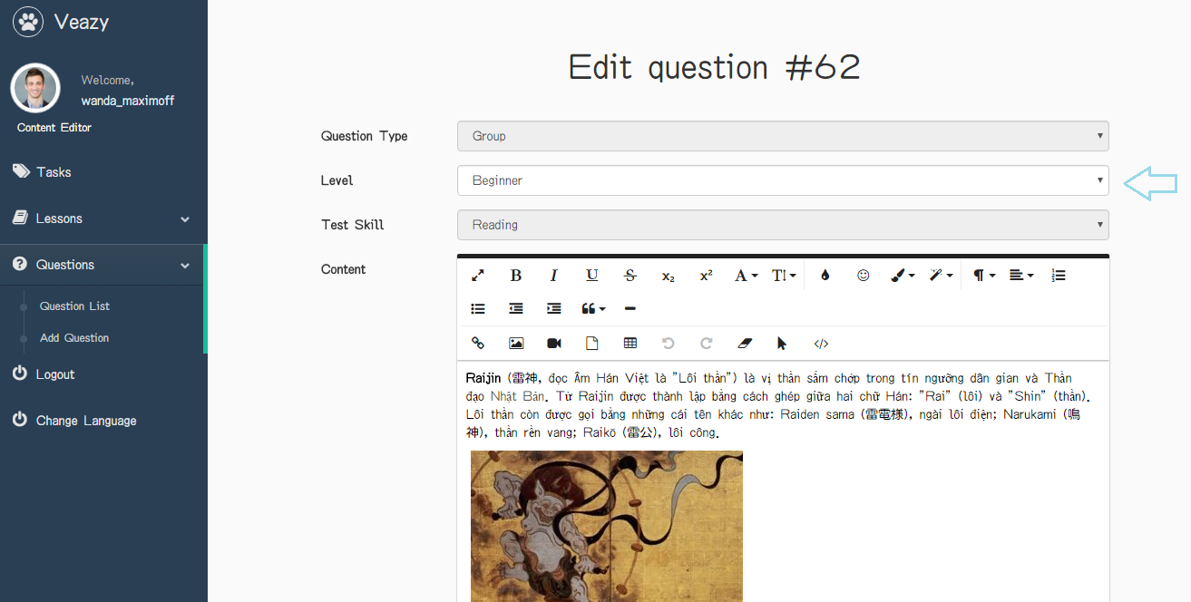

Step 3: User updates information in section “Content”

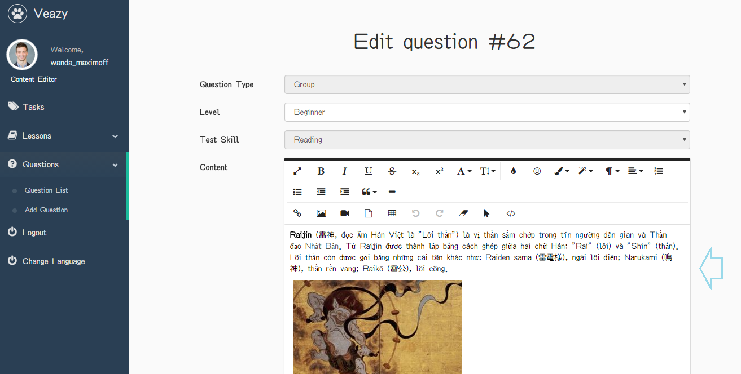

Step 3: User updates information in section “Question” and “Answers” and edits right answer

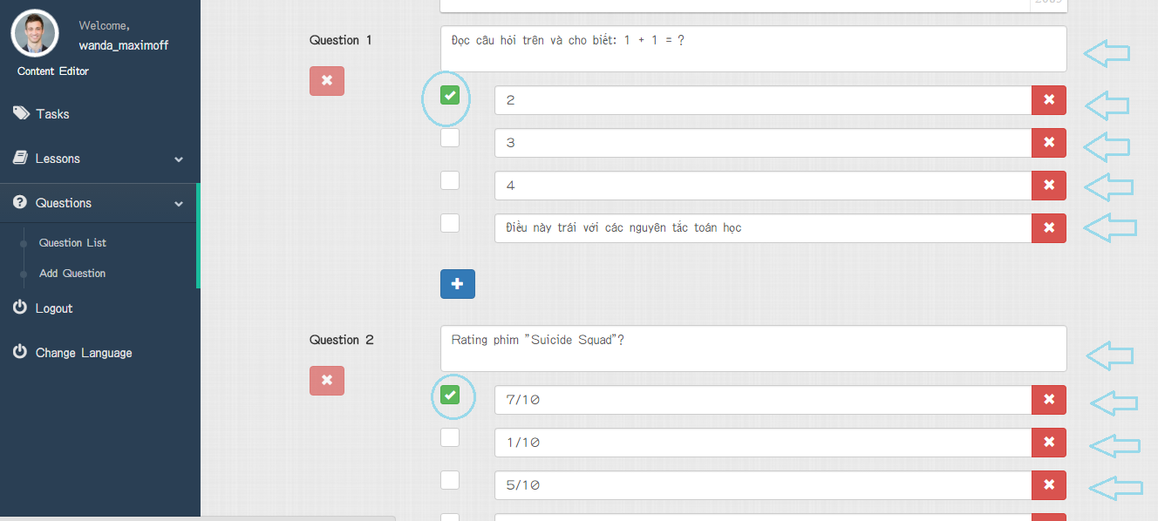

Step 4: User clicks on “+” button under answer field to add more answer

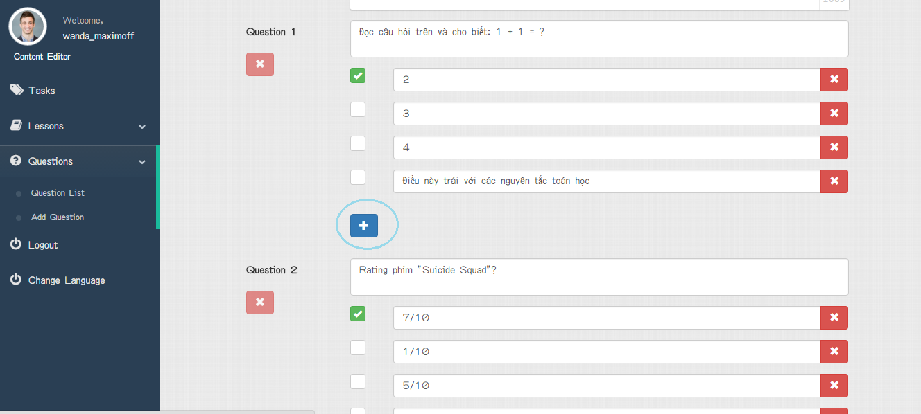

Step 5: User clicks on “x” button under answer field to delete answer or question

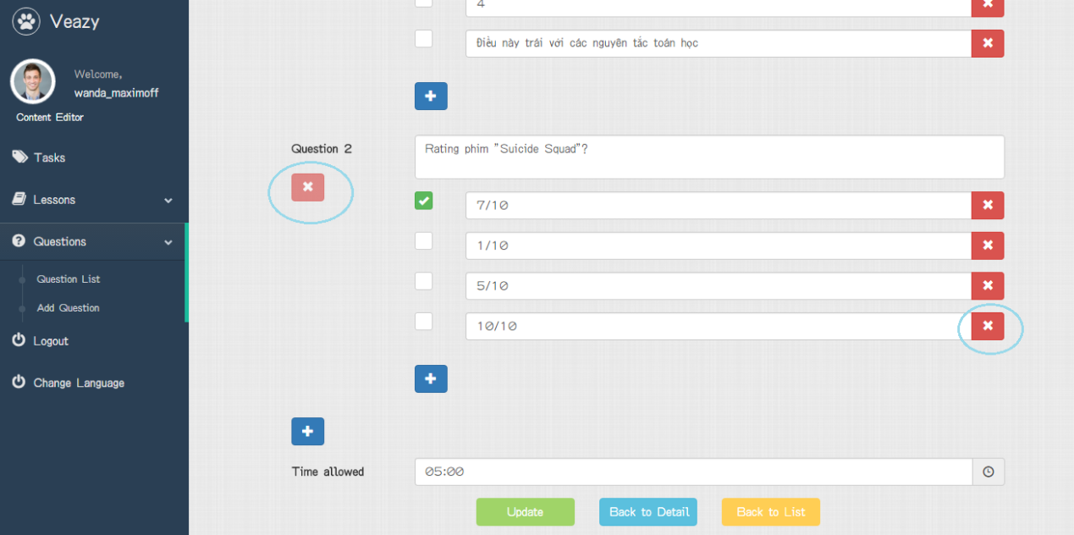

Step 6: User clicks on time icon to update time allowed in section “Time allowed”

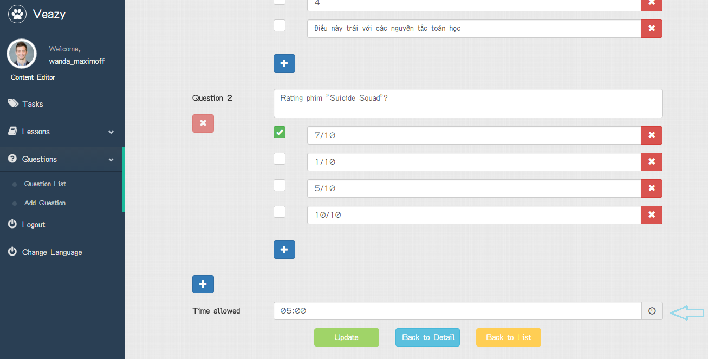

Step 7: User clicks on “Update” button

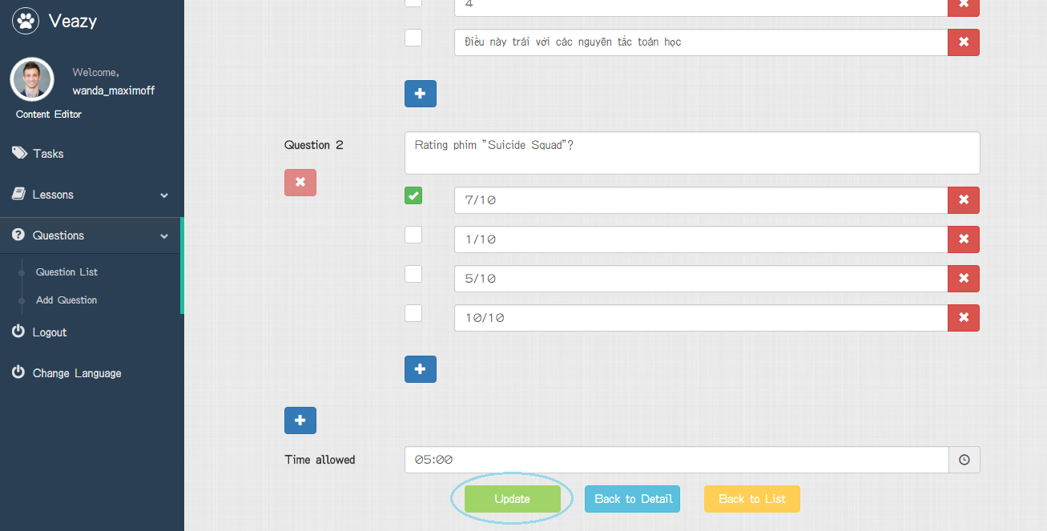

Step 8: redirects to question list page and edited lesson



##### Delete Question

To delete question on website, the users do the steps below:

Step 1: User clicks on “Delete” button in lesson list page

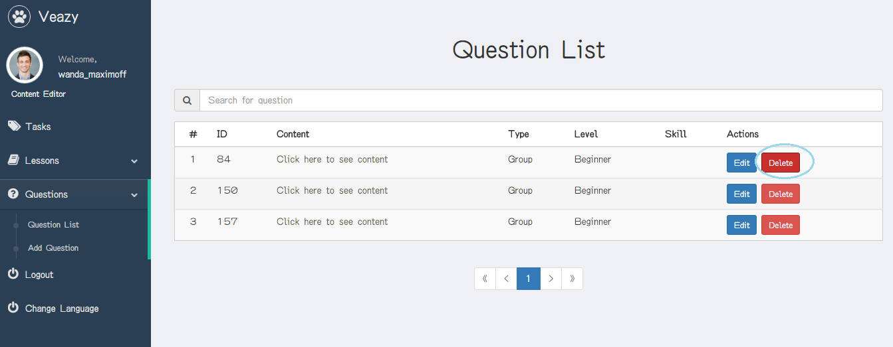

Step 2: User clicks on “Delete” button in “Delete question” popup

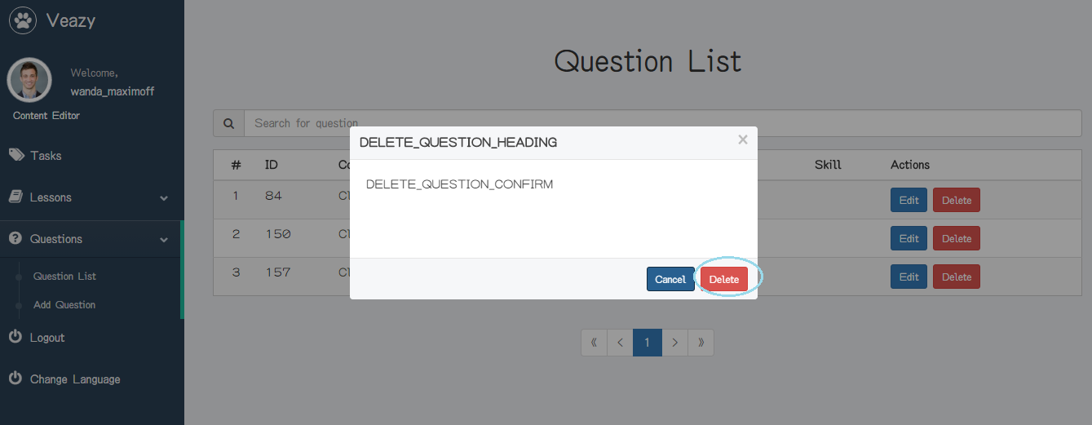

##### View Question Report

To view question report, the users do the steps below:

Step 1: User clicks on “Tasks” link at dashboard in content editor dashboard page



Step 2: System redirects to view report page



##### Search Task

To search task, the users do the steps below:

Step 1: User inputs text to the search box

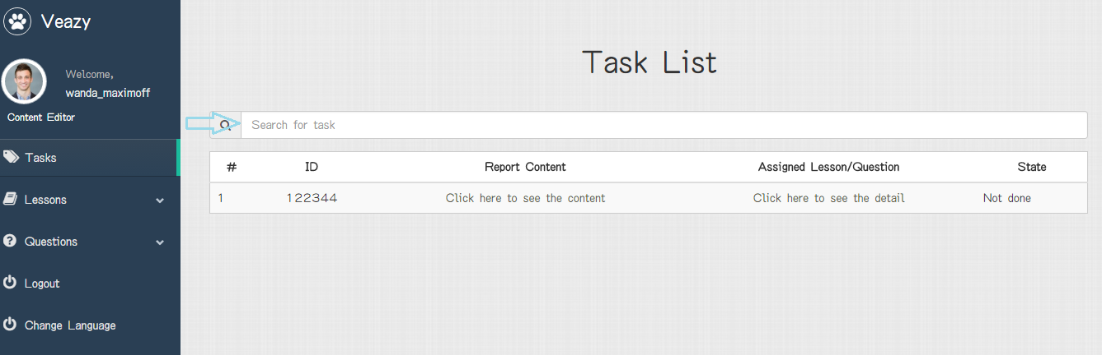

Step 2: User clicks on “Search” button

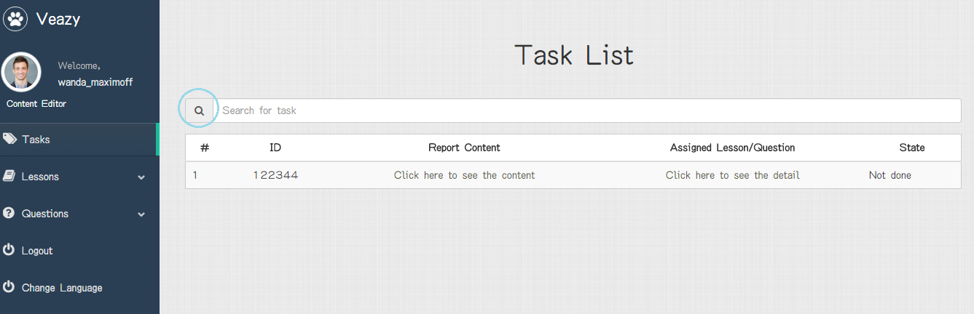

##### Change Language

To change language, the users do the steps below:

Step 1: User clicks on “Change Language” link at dashboard

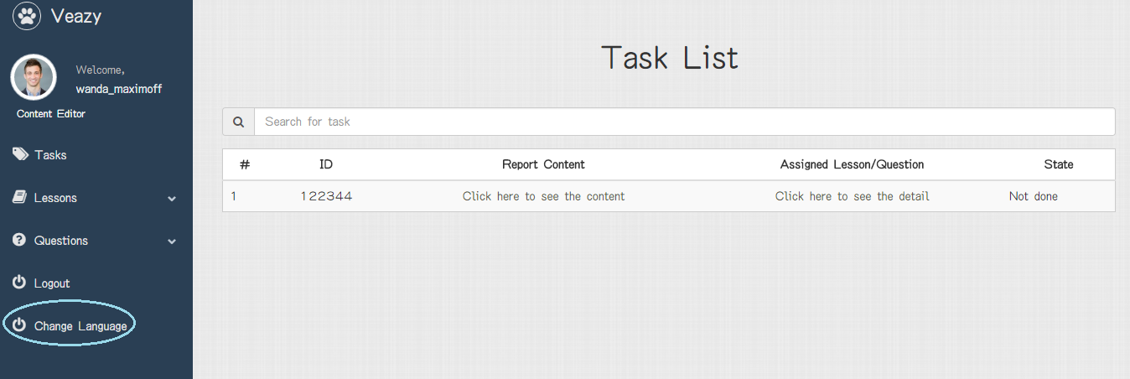

Step 2: System changed language of website

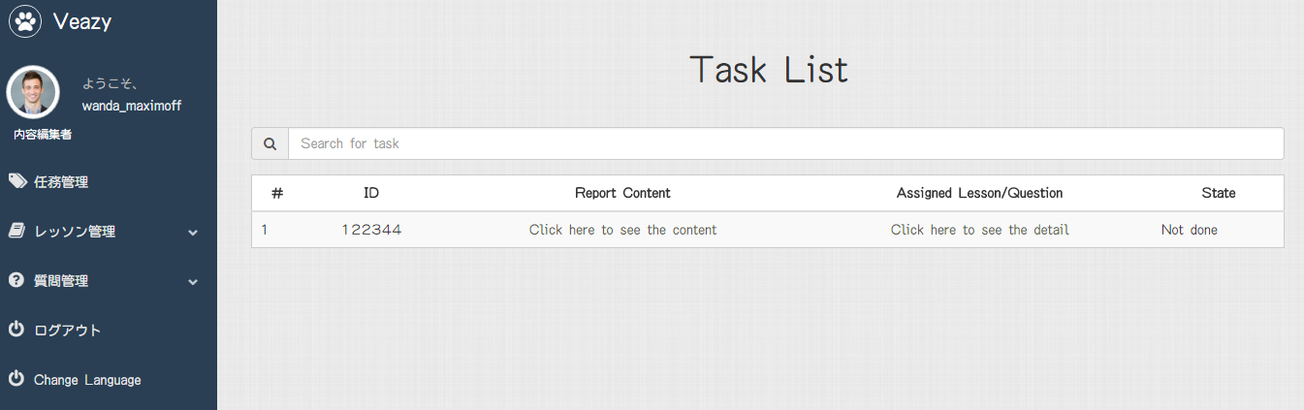

#### Administrator

##### Manage Account

###### View Profile

###### Update Profile

###### Change Password

###### Logout

##### Manage User

###### View User’s List

###### View User Profile

###### Set Role User

###### Ban User

###### Unban User

###### View System Statistics

## Product Judging

#### Advantage of VEAZY System

The idea of the Useful Vietnamese Study System for Japanese project is to develop a new website that inherits the advantages and improve issues and learns from other website. And the new website would have the opportunity to add a lot of enhancements.

As the goals that we have set before started the project, the Useful Vietnamese Study System for Japanese project has been developed in a right direction. And what it provides to users is in the list below:

The user using Useful Vietnamese Study System for Japanese system will save time, save money but can learn Japanese most convenient.

• **Guest:**

+ Useful Vietnamese Study System for Japanese system support guest search and reading document in website fastest.

• **Member:**

+ Useful Vietnamese Study System for Japanese support doing test that check member knowledge and view learning process.

#### Current Limitations

* GUI and function meet demand of almost of user about searching vocabulary, searching conversation and practicing listening Japanese. However, interface also has some limitations like not support on Mobile version, user interface is not support English.
* Not have money for upload website to host.

#### Expectation in Future

* Upload to host that user easy to use.
* Product can get many attracking from user, who care Japanese.
* Providing more function to user and expect to commercialized product in the future.

### Product Summary

|  |  |  |  |  |
| --- | --- | --- | --- | --- |
| **Project Title** | | **Vietnamese Study System for Japanese** | | |
| **Project Supervisor** | | Nguyễn Văn Sang | | |
| **Committers (4)** | | | | |
| **1** | **Project Manager** | Nguyễn Ngọc Minh | mr.noone1945@gmail.com | |
| **2** | **Project Technical Leader** | Đào Thanh Tùng | trumdongnat@gmail.com | |
| **3** | **Test Leader** | Nguyễn Trọng Duy | fuujin0904@gmail.com | |
| **4** | **Tester** | Nguyễn Hồng Quân | quannh265@gmail.com | |
| **Main objective** | | This website provides Vietnamese studying for Japanese people. | | |
| **Source Repository** | | **https://github.com/sangnvus/201605JS01** | | |
|  | | **Plan** | | **Actual** |
| **Start Date** | | 09/05/2016 | | 09/05/2016 |
| **End Date** | | 24/08/2016 | | 01/09/2016 |
| **Releases version** | | 1.0 | | 1.0 |
| **Duration** | | 75 | | 84 |
| **Effort (person-day)** | | 450 | | 504 |
| **Test cases** | | 700 | | 780 |
| **Defects** | | 150~200 | | 121 |
| **Lines of code** | | ~12000 | | 15414 |

### Lessons Learnt

* Working in group and working individual.
* Be open to get the better opinions from other member.
* Manage time and make the plan.
* Limit and resolve conflicts between members.
* Improve coding skill with new technology and writting document skill.

## Reference

**Introduction**

[1] [www.123vietnamese.com](http://www.123vietnamese.com)

[2] [www.l-lingo.com](http://www.l-lingo.com)

**Software Project Management**

1. Template_Project_Plan, (2010), FPT University, Hanoi, Vietnam.
2. Ian Sommerville, Software Engineering, 8th edition, (2007), USA at FPT University.
3. Kathy Schwalbe, Managing Information Technology Projects, 6th edition, Cengage Learning, (2009), Canada.
4. Rational Unified Process - *Best Practices for Software Development Teams*, Rational Software Corporation (1998), Canada.
5. <http://en.wikipedia.org/wiki/IBM_Rational_Unified_Process>
6. <http://en.wikibooks.org/wiki/RUP_-_IBM_Rational_Unified_Process/Phases>
7. <http://msdn.microsoft.com/en-us/library/ff926074.aspx>

**Software Requirement Specification**

1. Template Software_Requirements_Specification, (2010), FPT Software, Hanoi, Vietnam.

**Software Design Description**

1. Template Software_Design_Template, (2010), FPT Software, Hanoi, Vietnam.
2. Internal_Design_Template, FPT Software, Hanoi, Vietnam.
3. Kai Qian, Software Architecture and Design Illuminated, Jones & Bartlett Learning, (2010), USA.

**Software Test Documentation**

1. Templates for Test case & Defect log, FPT Software, Hanoi, Vietnam.